|  |  |  |  |
| --- | --- | --- | --- |
| **monlau-pequeño** | | **M3 - Programació** | |
| **UF1** | **2/10/19** |
| ***Edgar Rosa Rey*** | | | |
| **Práctica Nº: 02** | ***Operaciones*** | | |

**1-Option1: Order the temperature value in degrees and display its equivalent in Fahrenheit and Kelvin.2)**

**2-Option2:Ask the user's first and last name and height in meters and display their equivalent data in inchs and foot(feet-feet)The final result: last name, first name: height: xxxx unit3)**

**3-Option3: Ask for the name, surname andthe city of the user and ask the distancein km from your city with respect to Barcelona. Displays user data and distance enyard and mile. The final result: last name, name lives in city: xxxx distance x xxx unit4)**

**4-Option4: Ask for the name, surname and the User ID and their weight in kg and display their weight in poundsThe final result: last name, first name –DNI; weight: xxxx pounds**

**5-Option5: ask a number of seconds and say how many minutes are**

**6-Option6: ask a number of seconds and say how many minutes and seconds are**

**7-Option7: Ask for the name of 2 cities and ask the distance (in km) and the speed of the train that joins them (in km/h). Say the time it takes for the train: -in seconds; -in hours-min-sec.8-invents a case9-insale a case10-menu with switch**

1.

|  |
| --- |
| **/\***  27/09/19  */  //Author: Edgar  package m3.uf1p02;  //Libraries:  import java.util.Scanner;  public class M3UF1P02 {  static Scanner keyboard= new Scanner(System.in);  public static void main(String[] args) {  keyboard.useDelimiter("\n");  P2_1();  }  public static void P2_1(){  //declaration of local variables:  System.out.print("Celsius ?:");  float celsius= keyboard.nextFloat();  float kelvin=celsius + 273.15f; //assignment  System.out.println(celsius+ "ºC = "+kelvin+"ºF");  float fahrenheit= 9/5*celsius + 32;  System.out.println(celsius+ "ºC = "+fahrenheit+"ºF");  }  } |

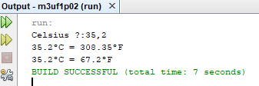

2.

|  |
| --- |
| /*  27/09/19  */  //Author: Edgar  package m3.uf1p02;  //Libraries:  import java.util.Scanner;  public class M3UF1P02 {  static Scanner keyboard= new Scanner(System.in);  public static void main(String[] args) {  keyboard.useDelimiter("\n");  P2_2();  }    public static void P2_2(){  //ask for names and surnames  float height, inches, foots;  System.out.print("Name ?:");  String name= keyboard.next();  System.out.print("Surnames ?:");  String surnames= keyboard.next();  System.out.println("How tall are you?");  height= keyboard.nextFloat();  inches= 39.3701f*height;  foots= 12*39.3701f*height;    System.out.println(height+ " meters = "+inches+" inches");  System.out.println(height+ " meters = "+foots+" foots");    }  } |

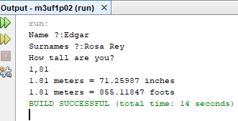

3.

|  |
| --- |
| /*  30/09/19  */  //Author: Edgar  package m3.uf1p02;  //Libraries:  import java.util.Scanner;  public class M3UF1P02 {  static Scanner keyboard= new Scanner(System.in);  public static void main(String[] args) {  keyboard.useDelimiter("\n");  P2_3();  }  public static void P2_3(){  //Ask for the name, surname and city of the user  String name, surnames, city;  System.out.print("Name ?:");  name= keyboard.next();  System.out.print("Surnames ?:");  surnames= keyboard.next();  System.out.println("What city do you live? ");  city=keyboard.next();  //Ask the distance in km of your city from Barcelona  System.out.println("How many km are you from bcn?");  int km= keyboard.nextInt();  float yards, miles;  yards= km*1093.61f;  miles= km*0.621371f;  System.out.println(surnames +" "+ name + " live in "+ city +" and the distance respect to Barcelona is "+km+ "km, "+yards+ "yards, "+miles+ "miles");    }  } |

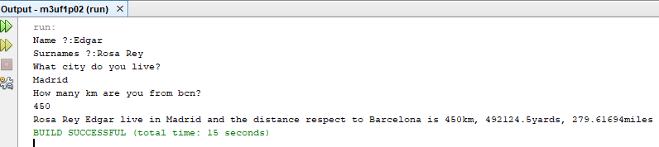

4.

|  |
| --- |
| /*  1/10/19  */  //Author: Edgar  package m3uf1p02;  //Libraries:  import java.util.Scanner;  public class M3uf1p02 {  static Scanner keyboard= new Scanner(System.in);  public static void main(String[] args) {  keyboard.useDelimiter("\n");  P2_4();  }  public static void P2_4(){  //Ask for the user's name and surnames and NDI and their weight in kg  String name, surnames, ndi;  float kg, pounds;  System.out.print("Name ?:");  name= keyboard.next();  System.out.print("Surnames ?:");  surnames= keyboard.next();  System.out.print("NDI ?:");  ndi=keyboard.next();  System.out.println("How much do you weigh?");  kg=keyboard.nextFloat();  //Visualize your weight in pounds  pounds= kg*2.20462f;  System.out.println(surnames +" "+ name + "-DNI:"+ndi+" weight:"+pounds+"pounds");  }  } |

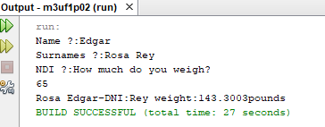

5.

|  |
| --- |
| /*  1/10/19  */  //Author: Edgar  package m3uf1p02;  //Libraries:  import java.util.Scanner;  public class M3uf1p02 {  static Scanner keyboard= new Scanner(System.in);  public static void main(String[] args) {  keyboard.useDelimiter("\n");  P2_5();  }  public static void P2_5(){  //Ask a number of seconds and say how many minutes are  int sec;  float min;  System.out.print("Seconds ?:");  sec= keyboard.nextInt();  min= sec/60f;  System.out.println(sec+"seconds are "+min+"minuts");  }  } |

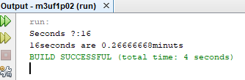

6.

|  |
| --- |
| /*  1/10/19  */  //Author: Edgar  package m3uf1p02;  //Libraries:  import java.util.Scanner;  public class M3uf1p02 {  static Scanner keyboard= new Scanner(System.in);  public static void main(String[] args) {  keyboard.useDelimiter("\n");  P2_6();  }  public static void P2_6(){  //Ask a number of seconds and say how many minutes are  int sec;  float min, min2,sec2;  System.out.print("Seconds ?:");  sec= keyboard.nextInt();  min= sec/60;  min2= sec/60f;  sec2= min2-min;  System.out.println(sec+"seconds are "+min+"minuts and "+sec2+"seconds");  }  } |

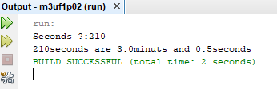

7.

|  |
| --- |
| /*  1/10/19  */  //Author: Edgar  package m3uf1p02;  //Libraries:  import java.util.Scanner;  public class M3uf1p02 {  static Scanner keyboard= new Scanner(System.in);  public static void main(String[] args) {  keyboard.useDelimiter("\n");  P2_7();  }  public static void P2_7(){  //Ask for the name of 2 cities  String city1, city2;  System.out.print("First city ?:");  city1= keyboard.next();  System.out.print("Second city ?:");  city2= keyboard.next();  /*Ask the distance (in km) and the speed of the train that connects them (in  km / h)*/  int km,speed;  float hours, min, sec;  System.out.println("How many km are between those two cities?");  km=keyboard.nextInt();  System.out.println("How fast do you want the train to go?");  speed=keyboard.nextInt();  hours=km/speed;  min=km/speed*60;  sec=km/speed*3600;  System.out.println("The train will take "+hours+"hours ="+min+"minuts ="+sec+"seconds to reach its destination");  }  } |

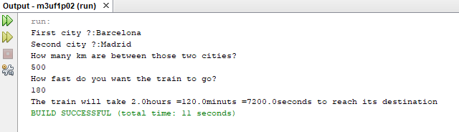

8.

|  |
| --- |
| /*  1/10/19  */  //Author: Edgar  package m3uf1p02;  //Libraries:  import java.util.Scanner;  public class M3uf1p02 {  static Scanner keyboard= new Scanner(System.in);  public static void main(String[] args) {  keyboard.useDelimiter("\n");  P2_8();  }  public static void P2_8(){  //Ask for an important monument of a city  String monument;  System.out.print("Monument ?:");  monument= keyboard.next();  //Say how much it measures in meters  int m,cm,mm;  System.out.println("How many meters is the monument?");  m=keyboard.nextInt();  cm=m*100;  mm=m*1000;  System.out.println("The monument measures "+m+"m = "+cm+"cm = "+mm+"mm");  }  } |

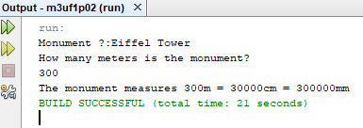

9.

|  |
| --- |
| /*  1/10/19  */  //Author: Edgar  package m3uf1p02;  //Libraries:  import java.util.Scanner;  public class M3uf1p02 {  static Scanner keyboard= new Scanner(System.in);  public static void main(String[] args) {  keyboard.useDelimiter("\n");  P2_9();  }  public static void P2_9(){  //Ask about a soccer player's footwear  String player;  System.out.println("Who is your favorite soccer player?");  player= keyboard.next();  int footwear;  System.out.println("What footwear does he use?");  footwear= keyboard.nextInt();  //Pass the footwear from cm to inches  float inches;  inches= footwear*0.393701f;  System.out.println("The "+player+" has foot "+footwear+"="+inches+"inches of footwear");  }  } |

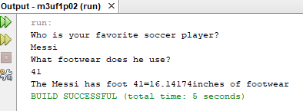

10.

|  |
| --- |
| /*  2/10/19  */  //Author: Edgar  package m3uf1p02;  //Libraries:  import java.util.Scanner;  import java.util.InputMismatchException;  public class M3uf1p02 {  static Scanner keyboard= new Scanner(System.in);  public static void main(String[] args) {  keyboard.useDelimiter("\n");  P2_10();  }  public static void P2_10(){  int option; //We will save the user's option  boolean leave = false;  while (leave);  {  System.out.println("1. Option 1");  System.out.println("2. Option 2");  System.out.println("3. Option 3");  System.out.println("4. Exit");  }  try {  System.out.println("Write one of the options");  option = keyboard.nextInt();    switch (option) {  case 1:  System.out.println("You have selected the option 1");  break;  case 2:  System.out.println("You have selected the option 2");  break;  case 3:  System.out.println("You have selected the option 3");  break;  case 4:  leave= true;  break;  default:  System.out.println("Only numbers between 1 and 4");  }  }  catch (InputMismatchException e) {  System.out.println("You must insert a number");  keyboard.next();  System.out.println("1. Opcion 1");  System.out.println("2. Opcion 2");  System.out.println("3. Opcion 3");  System.out.println("4. Exit");  System.out.println("Write one of the options");  option = keyboard.nextInt();  switch (option) {  case 1:  System.out.println("You have selected the option 1");  break;  case 2:  System.out.println("You have selected the option 2");  break;  case 3:  System.out.println("You have selected the option 3");  break;  case 4:  leave= true;  break;  }  }  }  } |

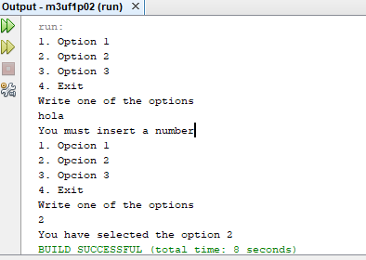

We can also leave without choosing any option:

