|  |  |  |  |
| --- | --- | --- | --- |
| **monlau-pequeño** | | **M3 - Programación** | |
| **UF1** | **17/11/19** |
| ***Edgar Rosa Rey*** | | | |
| **Práctica Nº: 10** | **Conversor** | | |

|  |
| --- |
| package M3P10;  import java.awt.Color;  import java.text.DecimalFormat;  import java.util.HashSet;  import java.util.Scanner;  import java.util.Set;  public class **NewJFrameConversor1** extends javax.swing.JFrame {  static Scanner *keyboard* = new Scanner(System.*in*);  public **NewJFrameConversor1**() {  initComponents();  boolean Window = false;  this.getContentPane().setBackground(Color.*red*);  this.setLocationRelativeTo(this);  this.setResizable(false);  //Window.setAlwaysOnTop(boolean);  }  @SuppressWarnings("unchecked")  // <editor-fold defaultstate="collapsed" desc="Generated Code">  private void **initComponents**() {  jTextFieldºC = new javax.swing.JTextField();  TgC = new javax.swing.JTextField();  jLabel1 = new javax.swing.JLabel();  exit = new javax.swing.JButton();  TgK = new javax.swing.JTextField();  TgF = new javax.swing.JTextField();  jTextFieldºK = new javax.swing.JTextField();  jTextFieldºF = new javax.swing.JTextField();  jButton1 = new javax.swing.JButton();  setDefaultCloseOperation(javax.swing.WindowConstants.*EXIT_ON_CLOSE*);  jTextFieldºC.setBackground(new java.awt.Color(0, 204, 255));  jTextFieldºC.setHorizontalAlignment(javax.swing.JTextField.*CENTER*);  jTextFieldºC.setText("Temperature in ºC");  jTextFieldºC.addActionListener(new java.awt.event.ActionListener() {  public void **actionPerformed**(java.awt.event.ActionEvent evt) {  jTextFieldºCActionPerformed(evt);  }  });  TgC.setBackground(new java.awt.Color(51, 255, 51));  TgC.addActionListener(new java.awt.event.ActionListener() {  public void **actionPerformed**(java.awt.event.ActionEvent evt) {  TgCActionPerformed(evt);  }  });  jLabel1.setIcon(new javax.swing.ImageIcon(getClass().getResource("/imagenes/image.PNG"))); // NOI18N  exit.setBackground(new java.awt.Color(51, 204, 255));  exit.setText("Exit");  exit.addActionListener(new java.awt.event.ActionListener() {  public void **actionPerformed**(java.awt.event.ActionEvent evt) {  exitActionPerformed(evt);  }  });  TgK.setBackground(new java.awt.Color(51, 255, 51));  TgK.addActionListener(new java.awt.event.ActionListener() {  public void **actionPerformed**(java.awt.event.ActionEvent evt) {  TgKActionPerformed(evt);  }  });  TgF.setBackground(new java.awt.Color(51, 255, 51));  TgF.addActionListener(new java.awt.event.ActionListener() {  public void **actionPerformed**(java.awt.event.ActionEvent evt) {  TgFActionPerformed(evt);  }  });  jTextFieldºK.setBackground(new java.awt.Color(0, 204, 255));  jTextFieldºK.setHorizontalAlignment(javax.swing.JTextField.*CENTER*);  jTextFieldºK.setText("Kelvin");  jTextFieldºK.addActionListener(new java.awt.event.ActionListener() {  public void **actionPerformed**(java.awt.event.ActionEvent evt) {  jTextFieldºKActionPerformed(evt);  }  });  jTextFieldºF.setBackground(new java.awt.Color(0, 204, 255));  jTextFieldºF.setHorizontalAlignment(javax.swing.JTextField.*CENTER*);  jTextFieldºF.setText("Fahrenheit");  jButton1.setText("Convert");  jButton1.addActionListener(new java.awt.event.ActionListener() {  public void **actionPerformed**(java.awt.event.ActionEvent evt) {  jButton1ActionPerformed(evt);  }  });  javax.swing.GroupLayout layout = new javax.swing.GroupLayout(getContentPane());  getContentPane().setLayout(layout);  layout.setHorizontalGroup(  layout.createParallelGroup(javax.swing.GroupLayout.*Alignment*.*LEADING*)  .addGroup(layout.createSequentialGroup()  .addContainerGap()  .addGroup(layout.createParallelGroup(javax.swing.GroupLayout.*Alignment*.*LEADING*)  .addGroup(javax.swing.GroupLayout.*Alignment*.*TRAILING*, layout.createSequentialGroup()  .addGap(0, 0, Short.*MAX_VALUE*)  .addGroup(layout.createParallelGroup(javax.swing.GroupLayout.*Alignment*.*LEADING*)  .addGroup(javax.swing.GroupLayout.*Alignment*.*TRAILING*, layout.createSequentialGroup()  .addComponent(TgC, javax.swing.GroupLayout.*PREFERRED_SIZE*, 168, javax.swing.GroupLayout.*PREFERRED_SIZE*)  .addGap(20, 20, 20))  .addGroup(javax.swing.GroupLayout.*Alignment*.*TRAILING*, layout.createSequentialGroup()  .addComponent(exit)  .addGap(31, 31, 31))))  .addGroup(javax.swing.GroupLayout.*Alignment*.*TRAILING*, layout.createSequentialGroup()  .addGroup(layout.createParallelGroup(javax.swing.GroupLayout.*Alignment*.*TRAILING*)  .addComponent(jTextFieldºC, javax.swing.GroupLayout.*Alignment*.*LEADING*)  .addComponent(jTextFieldºK, javax.swing.GroupLayout.*Alignment*.*LEADING*)  .addComponent(jTextFieldºF, javax.swing.GroupLayout.*Alignment*.*LEADING*))  .addGap(43, 43, 43)  .addGroup(layout.createParallelGroup(javax.swing.GroupLayout.*Alignment*.*LEADING*)  .addComponent(TgK, javax.swing.GroupLayout.*PREFERRED_SIZE*, 166, javax.swing.GroupLayout.*PREFERRED_SIZE*)  .addComponent(TgF, javax.swing.GroupLayout.*PREFERRED_SIZE*, 166, javax.swing.GroupLayout.*PREFERRED_SIZE*))  .addGap(20, 20, 20))))  .addGroup(layout.createSequentialGroup()  .addGroup(layout.createParallelGroup(javax.swing.GroupLayout.*Alignment*.*LEADING*)  .addGroup(layout.createSequentialGroup()  .addGap(111, 111, 111)  .addComponent(jLabel1))  .addGroup(layout.createSequentialGroup()  .addGap(72, 72, 72)  .addComponent(jButton1, javax.swing.GroupLayout.*PREFERRED_SIZE*, 265, javax.swing.GroupLayout.*PREFERRED_SIZE*)))  .addGap(0, 69, Short.*MAX_VALUE*))  );  layout.setVerticalGroup(  layout.createParallelGroup(javax.swing.GroupLayout.*Alignment*.*LEADING*)  .addGroup(layout.createSequentialGroup()  .addGap(32, 32, 32)  .addGroup(layout.createParallelGroup(javax.swing.GroupLayout.*Alignment*.*BASELINE*)  .addComponent(jTextFieldºC, javax.swing.GroupLayout.*PREFERRED_SIZE*, javax.swing.GroupLayout.*DEFAULT_SIZE*, javax.swing.GroupLayout.*PREFERRED_SIZE*)  .addComponent(TgC, javax.swing.GroupLayout.*PREFERRED_SIZE*, javax.swing.GroupLayout.*DEFAULT_SIZE*, javax.swing.GroupLayout.*PREFERRED_SIZE*))  .addGap(30, 30, 30)  .addGroup(layout.createParallelGroup(javax.swing.GroupLayout.*Alignment*.*BASELINE*)  .addComponent(TgK, javax.swing.GroupLayout.*PREFERRED_SIZE*, javax.swing.GroupLayout.*DEFAULT_SIZE*, javax.swing.GroupLayout.*PREFERRED_SIZE*)  .addComponent(jTextFieldºK, javax.swing.GroupLayout.*PREFERRED_SIZE*, javax.swing.GroupLayout.*DEFAULT_SIZE*, javax.swing.GroupLayout.*PREFERRED_SIZE*))  .addGap(39, 39, 39)  .addGroup(layout.createParallelGroup(javax.swing.GroupLayout.*Alignment*.*BASELINE*)  .addComponent(jTextFieldºF, javax.swing.GroupLayout.*PREFERRED_SIZE*, javax.swing.GroupLayout.*DEFAULT_SIZE*, javax.swing.GroupLayout.*PREFERRED_SIZE*)  .addComponent(TgF, javax.swing.GroupLayout.*PREFERRED_SIZE*, javax.swing.GroupLayout.*DEFAULT_SIZE*, javax.swing.GroupLayout.*PREFERRED_SIZE*))  .addGap(46, 46, 46)  .addComponent(jButton1, javax.swing.GroupLayout.*PREFERRED_SIZE*, 65, javax.swing.GroupLayout.*PREFERRED_SIZE*)  .addPreferredGap(javax.swing.LayoutStyle.*ComponentPlacement*.*RELATED*, 49, Short.*MAX_VALUE*)  .addComponent(exit)  .addGap(5, 5, 5)  .addComponent(jLabel1))  );  pack();  }// </editor-fold>  private void **jTextFieldºCActionPerformed**(java.awt.event.ActionEvent evt) {  }  private void **exitActionPerformed**(java.awt.event.ActionEvent evt) {  System.*exit*(0);  exit.setBackground(Color.*cyan*);  }  private void **TgKActionPerformed**(java.awt.event.ActionEvent evt) {  }  private void **TgFActionPerformed**(java.awt.event.ActionEvent evt) {  }  private void **jTextFieldºKActionPerformed**(java.awt.event.ActionEvent evt) {  }  private void **jButton1ActionPerformed**(java.awt.event.ActionEvent evt) {  DecimalFormat df = new DecimalFormat("##.00 ");  float c = 0, k = 0, f = 0;  c = Float.*parseFloat*(TgC.getText());  TgC.setText("" +(df.format(c)));  k = c + 273;  TgK.setText("" +(df.format(k)));  f = (1.8f * c) + 32;  TgF.setText("" +(df.format(f)));  if (c >= 100) {  jTextFieldºC.setBackground(Color.*blue*);  }  if (k >= 373) {  jTextFieldºK.setBackground(Color.*blue*);  }  if (f >= 212) {  jTextFieldºF.setBackground(Color.*blue*);  }  if (c <= 0) {  jTextFieldºC.setBackground(Color.*yellow*);  }  if (k <= 273) {  jTextFieldºK.setBackground(Color.*yellow*);  }  if (f <= 32) {  jTextFieldºF.setBackground(Color.*yellow*);  }  if (c >= 0 && c <= 100) {  jTextFieldºC.setBackground(Color.*pink*);  }  if (k >= 273 && k <= 373) {  jTextFieldºK.setBackground(Color.*pink*);  }  if (f >= 32 && f <= 212) {  jTextFieldºF.setBackground(Color.*pink*);  }  }  private void **TgCActionPerformed**(java.awt.event.ActionEvent evt) {  }  public static void ***main***(String args[]) {  java.awt.EventQueue.*invokeLater*(new Runnable() {  public void **run**() {  new NewJFrameConversor1().setVisible(true);  }  });  }  // Variables declaration - do not modify  private javax.swing.JTextField TgC;  private javax.swing.JTextField TgF;  private javax.swing.JTextField TgK;  private javax.swing.JButton exit;  private javax.swing.JButton jButton1;  private javax.swing.JLabel jLabel1;  private javax.swing.JTextField jTextFieldºC;  private javax.swing.JTextField jTextFieldºF;  private javax.swing.JTextField jTextFieldºK;  // End of variables declaration  } |

**-Color inferior a 0ºC**

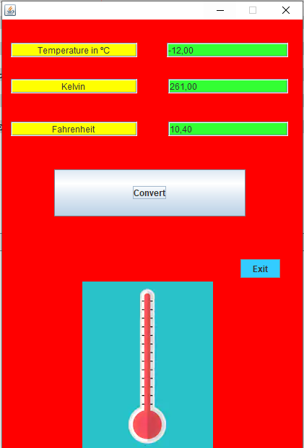

**-Color de 0 a 100ºC**

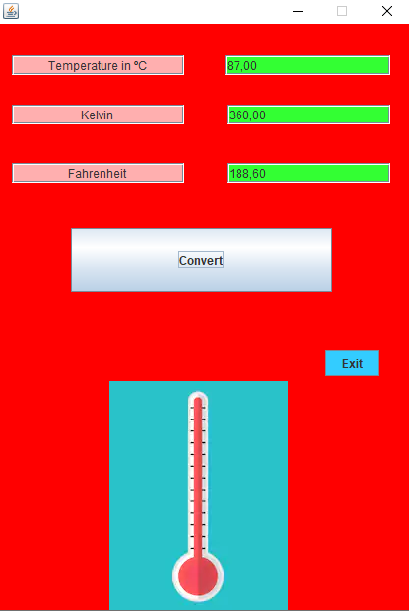

**-Color superior a 100ºC**

