|  |  |  |  |
| --- | --- | --- | --- |
| **D:_MONLAU\Logos\monlau-pequeño.jpg** | | **M3 - Programació** | |
| **UF1** | **04/10/19** |
| ***Rosa Rey, Edgar*** | | | |
| **Práctica Nº: 03** | **Operations** | | |

Write a Java program that takes two numbers as inputand

1.Print the sum of them.

 2.Divide them

3. Display the product of two numbers.

Test Data:

Input first number:25

Input second number: 5

Expected Output :

20x 5 = 1004.

|  |
| --- |
| /*  04/10/19  */  //Author: Edgar  package m3p3;  //Libraries:  import java.util.Scanner;  public class M3p3 {  //Global Declarations:  static Scanner keyboard=new Scanner(System.in);  public static void main(String[] args) {  P5();  }  public static void P5(){  System.out.print("Number1 ?:");  int number1=keyboard.nextInt();  System.out.print("Number2 ?:");  int number2=keyboard.nextInt();  int number3=number1+number2;  System.out.println("sum="+number3);  //div  float number4=(float)number1/number2;  //product  int number5=number1*number2;    System.out.println("div="+number4+" product="+number5);    }  } |

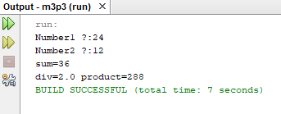

4. Write a Java program to add two binary numbers.

Input Data:

Input first binary number: 10

Input second binary number: 11

Expected Output

Sum of two binary numbers: 101

|  |
| --- |
| /*  06/10/19  */  //Author: Edgar  package m3p3;  //Libraries:  import java.util.Scanner;  public class M3p3 {  //Global Declarations:  static Scanner keyboard=new Scanner(System.in);  public static void main(String[] args) {  P4();  }  public static void P4(){  int a,b,c,d,e,f;  System.out.print("Number1 ?:");  a=keyboard.nextInt();  System.out.print("Number2 ?:");  b=keyboard.nextInt();  if(a==1&&b==1){  c=10;  }  if(a==1&&b==0)  {  d=1;  }  if(a==0&&b==0)  {  e=0;  }  if(a==0&&b==1)  {  f=1;  }  else{  System.out.println("Please enter a number that has a 1 or a 0");  }    }  } |

5. Write a Java program to print the result of the following operations.

 Test Data:

a. -5+ 8* 6

b. (55+9) % 9

c. 20 + -3*5 / 8

d. 5 + 15 / 3 * 2 +8 % 3

Expected Output :

43

1

19

17

|  |
| --- |
| /*  04/10/19  */  //Author: Edgar  package m3p3;  //Libraries:  import java.util.Scanner;  public class M3p3 {  //Global Declarations:  static Scanner keyboard=new Scanner(System.in);  public static void main(String[] args) {  P5();  }  public static void P5(){  float a,b,c,d;  a=-5+8*6;  b=(55+9)%9;  c=20 + -3*5 / 8;  d=5 + 15 / 3 * 2 +8 % 3;  System.out.println("a="+a);  System.out.println("b="+b);  System.out.println("c="+c);  System.out.println("d="+d);  System.out.println("a="+-5+8*6);  System.out.println("b="+(55+9)%9);  System.out.println("c="+20 + -3*5 / 8);  System.out.println("d="+5 + 15 / 3 * 2 +8 % 3);  }  } |

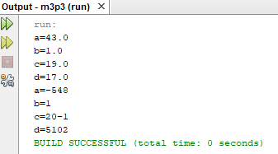

6. Write a Java program to print the sum (addition), multiply, subtract, divide and remainder of two numbers.

Test Data:

Input first number: 125

Input second number: 24

Expected Output : 125 + 24 = 149

125 - 24 = 101

125 x 24 = 3000

125 / 24 = 5

125 mod 24 = 5

|  |
| --- |
| /*  04/10/19  */  //Author: Edgar  package m3p3;  //Libraries:  import java.util.Scanner;  public class M3p3 {  //Global Declarations:  static Scanner keyboard=new Scanner(System.in);  public static void main(String[] args) {  P6();  }  public static void P6(){  System.out.print("Number1 ?:");  int number1=keyboard.nextInt();  System.out.print("Number2 ?:");  int number2=keyboard.nextInt();  //sum  int number3=number1+number2;  System.out.println("sum="+number3);  //subtract  int number6=number1-number2;  System.out.println("substract="+number6);  //div  int number4=number1/number2;  //product  int number5=number1*number2;    System.out.println("product="+number5+" div="+number4);    }  } |

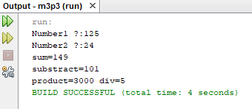

7. Write a Java program that takes a number as input and prints its multiplication table upto 10.

Test Data:

Input a number: 8

Expected Output :

8 x 1 = 8 8 x 2 = 16

8 x 3 = 24

... 8 x 10 = 80

8. Write a Java program to print the area and perimeter of a circle.

Test Data:

Radius = 7.5

Expected Output

Perimeter is = 47.12388980384689

Area is = 176.71458676442586

9. Write a Java program that takes three numbers as input to calculate and print the average of the numbers.

10. Write a Java program to print the area and perimeter of a rectangle.

Test Data:

Width = 5.5

Height = 8.5

Expected Output

Area is 5.6 * 8.5 = 47.60

Perimeter is 2 * (5.6 + 8.5) = 28.20