|  |  |  |  |
| --- | --- | --- | --- |
| **monlau-pequeño** | | **M3 - Programació** | |
| **UF1** | **13/10/19** |
| ***Edgar Rosa Rey*** | | | |
| **Práctica Nº: 05** | ***Exam*** | | |

1)-Opción1(entrada de parque): El precio de la entrada del parque de atracciones TibiTibi es

de 30€ y en el caso de socios es de 20€.

Para las entradas (tanto socios como no socios) se aplica un descuento según el siguiente criterio:

Si la edad es entre 3 años y 12 : descuento de 80%;

Si la edad es entre 12 años y 18 : descuento de 50%;

Si la edad es entre 18 años y 30: descuento de 20%;

Si la edad es superior a 70 años o inferior a 3 años: gratis;

Pedir la edad , preguntar si es socio y decir el precio de entrada.

Se puede aplicar el descuento a los socios

|  |
| --- |
| /*  13/10/19  */  //Author: Edgar  package PK_EDGAR;  //Libraries:  import java.util.Scanner;  public class **NewMain** {  //Global Declarations:  static Scanner *keyboard*= new Scanner(System.*in*);  public static void ***main***(String[] args) {  *keyboard*.useDelimiter("**\n**");  *P1*();    }  public static void ***P1***(){  String partner;  int age;  float discount, price;  System.*out*.println("Are you partner?");  partner=*keyboard*.next();  if(partner.equals("yes"))  {  System.*out*.println("You are partner,so the price is 20 euros");  System.*out*.println("How old are you?");  age=*keyboard*.nextInt();  if(age>=3 && age<=12)  {  System.*out*.println("You have a discount of 80%");  discount=20*0.8f;  price=20-discount;  System.*out*.println("Total price="+price);  }  else if(age>=13 && age<=18)  {  System.*out*.println("You have a discount of 50%");  discount=20*0.5f;  price=20-discount;  System.*out*.println("Total price="+price);  }  else if(age>=19 && age<=30)  {  System.*out*.println("You have a discount of 20%");  discount=20*0.2f;  price=20-discount;  System.*out*.println("Total price="+price);  }  else if(age>=31 && age<=70)  {  System.*out*.print("And you don't have any discount for your age so it costs you 20 euros");  }  //if the client is over 70 years old or less than 3, it is free  else  {  System.*out*.println("But you have free admission for your age");  }    }  else if(partner.equals("no"))  {  System.*out*.println("You are not partner,so the price is 30 euros");  System.*out*.println("How old are you?");  age=*keyboard*.nextInt();  if(age>=3 && age<=12)  {  System.*out*.println("You have a discount of 80%");  discount=30*0.8f;  price=30-discount;  System.*out*.println("Total price="+price);  }  else if(age>=13 && age<=18)  {  System.*out*.println("You have a discount of 50%");  discount=30*0.5f;  price=30-discount;  System.*out*.println("Total price="+price);  }  else if(age>=19 && age<=30)  {  System.*out*.println("You have a discount of 20%");  discount=30*0.2f;  price=30-discount;  System.*out*.println("Total price="+price);  }  else if(age>=31 && age<=70)  {  System.*out*.print("And you don't have any discount for your age so it costs you 30 euros");  }    //if the client is over 70 years old or less than 3, it is free  else  {  System.*out*.println("But you have free admission for your age");  }  }  //if the client does not respond yes or not asked again  else  {  System.*out*.println("Please tell me yes or no");  System.*out*.println("Are you partner?");  partner=*keyboard*.next();  if(partner.equals("yes"))  {  System.*out*.println("You are partner,so the price is 20 euros");  System.*out*.println("How old are you?");  age=*keyboard*.nextInt();  if(age>=3 && age<=12)  {  System.*out*.println("You have a discount of 80%");  discount=20*0.8f;  price=20-discount;  System.*out*.println("Total price="+price);  }  else if(age>=13 && age<=18)  {  System.*out*.println("You have a discount of 50%");  discount=20*0.5f;  price=20-discount;  System.*out*.println("Total price="+price);  }  else if(age>=19 && age<=30)  {  System.*out*.println("You have a discount of 20%");  discount=20*0.2f;  price=20-discount;  System.*out*.println("Total price="+price);  }  else if(age>=31 && age<=70)  {  System.*out*.print("And you don't have any discount for your age so it costs you 20 euros");  }  //if the client is over 70 years old or less than 3, it is free  else  {  System.*out*.println("But you have free admission for your age");  }    }    else if(partner.equals("no"))  {  System.*out*.println("You are not partner,so the price is 30 euros");  System.*out*.println("How old are you?");  age=*keyboard*.nextInt();  if(age>=3 && age<=12)  {  System.*out*.println("You have a discount of 80%");  discount=30*0.8f;  price=30-discount;  System.*out*.println("Total price="+price);  }  else if(age>=13 && age<=18)  {  System.*out*.println("You have a discount of 50%");  discount=30*0.5f;  price=30-discount;  System.*out*.println("Total price="+price);  }  else if(age>=19 && age<=30)  {  System.*out*.println("You have a discount of 20%");  discount=30*0.2f;  price=30-discount;  System.*out*.println("Total price="+price);  }  else if(age>=31 && age<=70)  {  System.*out*.print("And you don't have any discount for your age so it costs you 30 euros");  }  //if the client is over 70 years old or less than 3, it is free  else  {  System.*out*.println("But you have free admission for your age");  }  }  }  }  } |

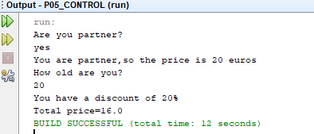

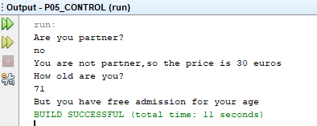

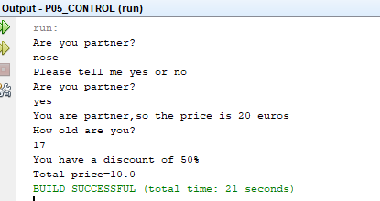

2)- Opción2(dentro de un Intervalo): Pedir un intervalo: número superior y número inferior. Preguntar un valor y decir si el valor introducido está o no dentro del intervalo. (usar And)

|  |
| --- |
| /*  13/10/19  */  //Author: Edgar  package PK_EDGAR;  //Libraries:  import java.util.Scanner;  public class NewMain {  //Global Declarations:  static Scanner keyboard= new Scanner(System.in);  public static void main(String[] args) {  keyboard.useDelimiter("\n");  P2();  }  public static void P2(){  int first,last,num;  System.out.println("First number within the interval?:");  first=keyboard.nextInt();  System.out.println("Last number within the interval ?:");  last=keyboard.nextInt();  //ask a number that you want  System.out.println("Number ?:");  num=keyboard.nextInt();  if (num>=first && num<=last)  {  System.out.println("Within the interval");    }  else {  System.out.println("Out of the interval");    }  }  } |

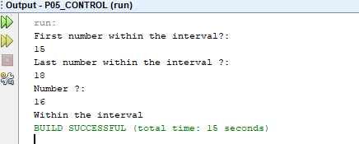

3)- Opción3(fuera de un Intervalo): Pedir un intervalo: número superior y número inferior. Preguntar un valor y decir si el valor introducido está fuera del intervalo. (usar or)

|  |
| --- |
| /*  13/10/19  */  //Author: Edgar  package PK_EDGAR;  //Libraries:  import java.util.Scanner;  public class **NewMain** {  //Global Declarations:  static Scanner *keyboard*= new Scanner(System.*in*);  public static void ***main***(String[] args) {  *keyboard*.useDelimiter("**\n**");  *P3*();  }  public static void ***P3***(){  int first,last,num;  System.*out*.println("First number within the interval?:");  first=*keyboard*.nextInt();  System.*out*.println("Last number within the interval ?:");  last=*keyboard*.nextInt();  //ask a number that you want  System.*out*.println("Number ?:");  num=*keyboard*.nextInt();  if (num<first || num>last)  {  System.*out*.println("Out of the interval");    }  else {  System.*out*.println("Within the interval");    }  }  } |

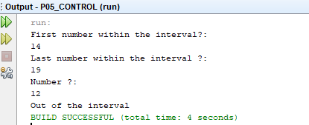

- Opción4(Pertenecer a un club):

Pedir el nombre de un club deportivo. Pedir el intervalo de edad

admitido. Pedir la edad de user y decir si puede pertenecer al club o no.

Ejemplo:

Dime el nombre del club: FC-Monlau

Dime el límite de edad menor: 17

Dime el límite superior de edad: 25

Introduce la edad de user: 19

******* Enhorabuena puedes pertenecer al club FC-Monlau ********

|  |
| --- |
| /*  13/10/19  */  //Author: Edgar  package PK_EDGAR;  //Libraries:  import java.util.Scanner;  public class **NewMain** {  //Global Declarations:  static Scanner *keyboard*= new Scanner(System.*in*);  public static void ***main***(String[] args) {  *keyboard*.useDelimiter("**\n**");  *P4*();  }  public static void ***P4***(){  String club;  int lower,higher,userAge;  System.*out*.println("Club Name ?:");  club=*keyboard*.next();  System.*out*.println("Lower age limit ?:");  lower=*keyboard*.nextInt();  System.*out*.println("Higher age limit ?:");  higher=*keyboard*.nextInt();  System.*out*.println("User age ?:");  userAge=*keyboard*.nextInt();  if(userAge>=lower && userAge<=higher)  {  System.*out*.println("******Congratulations you can belong to the "+club+" club******");    }  else  {  System.*out*.println("Sorry you can't stay at our club");  }  }  } |

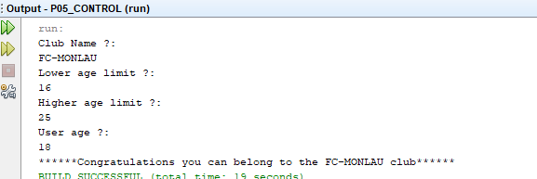

5)- Opción5(duración de un vuelo en segundos) : Pedir la duración de un vuelo ensegundos y decir la duración en horas, minutos y segundos. Tener en cuenta que la duración de un vuelo en esta compaña no supera 1diani puede ser inferior a 30 minutos.

Ejemplo:

Introduce la duración del vuelo:4200

Horas: 1

Minutos: 10

Segundos: 0

******* La duración es de 4200 segundos ********

|  |
| --- |
| /*  13/10/19  */  //Author: Edgar  package PK_EDGAR;  //Libraries:  import java.util.Scanner;  public class **NewMain** {  //Global Declarations:  static Scanner *keyboard*= new Scanner(System.*in*);  public static void ***main***(String[] args) {  *keyboard*.useDelimiter("**\n**");  *P5*();  }  public static void ***P5***(){  int sec,h,h1,min,min1,sec1;  System.*out*.println("Flight in seconds ?:");  sec=*keyboard*.nextInt();  //set this value from seconds to hours,minutes and seconds  h=sec/3600;  h1=sec%3600;  min=h1/60;  min1=min*60;  sec1=h1-min1;  System.*out*.println("hours:"+h);  System.*out*.println("minuts:"+min);  System.*out*.println("seconds:"+sec1);  }  } |

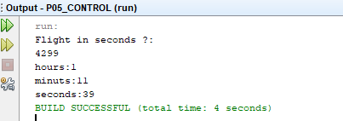

6)- Opción6(Pedir 3 números y ordenarlos de menor a mayor:

ejemplo:

Dime numero1: 7

Dime numero2: 9

Dime numero3: 1

Los números introducidos son: 1, 7, 9

|  |
| --- |
| /*  13/10/19  */  //Author: Edgar  package PK_EDGAR;  //Libraries:  import java.util.Scanner;  public class **NewMain** {  //Global Declarations:  static Scanner *keyboard*= new Scanner(System.*in*);  public static void ***main***(String[] args) {  *keyboard*.useDelimiter("**\n**");  *P6*();  }  public static void ***P6***(){  int a,b,c;  System.*out*.println("First number ?:");  a=*keyboard*.nextInt();  System.*out*.println("Second number ?:");  b=*keyboard*.nextInt();  System.*out*.println("Third number ?:");  c=*keyboard*.nextInt();  //order from lowest to highest  if (a<b && b<c)  {  System.*out*.println(a+","+b+","+c);    }  else if (a<c && c<b)  {  System.*out*.println(a+","+c+","+b);    }  else if (b<a && a<c)  {  System.*out*.println(b+","+a+","+c);    }  else if (b<c && c<a)  {  System.*out*.println(b+","+c+","+a);    }  else if (c<a && a<b)  {  System.*out*.println(c+","+a+","+b);    }  else if (c<b && b<a)  {  System.*out*.println(c+","+b+","+a);    }  }  } |

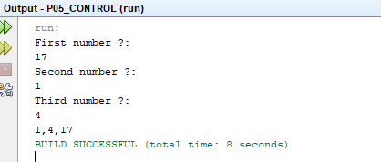

7)- Opción7(Tienda Online)Una tienda online vende sus productos con un descuento de 30% a mujeres de 16 a 40años. Preguntar si user es mujer y en caso afirmativo preguntar la edad. En el caso de cumplir los requisitos decir “Bienvenida a la tienda puedes usar nuestro servicio con un descuento de 30%”.

Ejemplo:

Eres mujer?: false (o No)

“Bienvenida a la tienda Online”

Ejemplo:

Eres mujer?: true ( o sí)

“Bienvenida a la tienda Online”

Dime tu edad: 30

“Bienvenida a la tienda puedes usar nuestro servicio con un descuento de 30%”.

|  |
| --- |
| /*  13/10/19  */  //Author: Edgar  package PK_EDGAR;  //Libraries:  import java.util.Scanner;  public class NewMain {  //Global Declarations:  static Scanner keyboard= new Scanner(System.in);  public static void main(String[] args) {  keyboard.useDelimiter("\n");  P7();  }  public static void P7(){  boolean woman;  int age;  System.out.println("Are you woman?");  woman=keyboard.nextBoolean();  //if the user is not a woman:  if(woman==false)  {  System.out.println("“Welcome to the Online Store”");  }  //if the user is a woman:  if(woman==true)  {  System.out.println("How old are you?");  age=keyboard.nextInt();  if(age>=16 && age<=40)  {  System.out.println("\"Welcome to the store you can use our service with a 30% discount.\"");    }  }  }  } |

