**MAKERERE UNIVERSITY**

**COLLEGE OF ENGINEERING, DESIGN, ART AND**

**TECHNOLOGY**

**DEPARTMENT OF ELECTRICAL AND COMPUTER ENGINEERING**

**COURSE UNIT; COMPUTER COMMUNICATION NETWORKS**

|  |  |
| --- | --- |
| NAME | REG NO. |
| TAMALE JIMMY | 16/U/1174 |
| NAJJUKO CLAIRE |  |
| NYOMBI WALTER WILLIAMS | 16/U/10669/PS |
| WERE HENRY |  |
| SSENGENDO EDDIE | 16/U/1147 |

**LECTURER: DR. DOROTHY OKELLO**

**TITLE: A LABORATORY PRACTICAL USING CISCO EQUIPMENT TO CONFIGURE TELNET, DHCP,STATIC ROUTES AND OSPF IN REAL WORKING ENVIRONMENT.**

**OBJECTIVES:**

* To understand subnetting using the network 172.16.0.0/20
* To create vlans of a subnet of /24.
* To configure static ip addresses for all the connected PCs.
* To configure telnet on the routers so that we can access both routers remotely.
* To configure static routes to allow communication between routers without the use of dynamic routing.
* To configure both routers as DHCP servers to dynamically assign ip addresses to the connected hosts.
* To configure OSPF as a dynamic routing protocol to allow communication between routers.
* To verify all our configurations.

**APPARATUS**

* 2 Cisco routers
* 2 Cisco switches
* 7 Ethernet cables
* 4 laptops

**THEORY**

**STATIC IP ADDRESSES AND DHCP(DYNAMIC HOST CONFIGURATION PROTOCOL)**

Once an organization has obtained a block of addresses, it can assign individual IP addresses to the host and router interfaces in its organization. A system administrator will typically manually configure the IP addresses into the router (often remotely, with a network management tool).This is called assigning IP statically. Host addresses can also be configured manually, but more often this task is now done using the Dynamic Host ConfigurationProtocol (DHCP). DHCP allows a host to obtain (be allocated) an IP address automatically. A network administrator can configure DHCP so that a given host receives the same IP address each time it connects to the network, or a host may be assigned a temporary IP address that will be different each time the host connects to the network. In addition to host IP address assignment, DHCP also allows a host to learn additional information, such as its subnet mask, the address of its first-hop router (often called the default gateway), and the address of its local DNS server. [1]

**TELNET**

*Telnet* is the chameleon of protocols—its specialty is terminal emulation. Itallows a user on a remote client machine, called the Telnet client, to accessthe resources of another machine, the Telnet server.Telnet achieves this bypulling a fast one on the Telnet server and making the client machine appearas though it were a terminal directly attached to the local network. This projectionis actually a software image, a virtual terminal that can interact withthe chosen remote host.These emulated terminals are of the text-mode type and can executerefined procedures like displaying menus that give users the opportunity tochoose options from them and access the applications on the duped server.Users begin a Telnet session by running the Telnet client software and thenlogging on to the Telnet server. [2]

**OSPF**

The OSPF (Open Shortest Path First) protocol is one of a family of IP Routing protocols, and is an Interior Gateway Protocol (IGP) for the Internet, used to distribute IP routing information throughout a single Autonomous System (AS) in an IP network.The OSPF protocol is a link-state routing protocol, which means that the routers exchange topology information with their nearest neighbors. The topology information is flooded throughout the AS, so that every router within the AS has a complete picture of the topology of the AS. This picture is then used to calculate end-to-end paths through the AS, normally using a variant of the Dijkstra algorithm. Therefore, in a link-state routing protocol, the next hop address to which data is forwarded is determined by choosing the best end-to-end path to the eventual destination.

The main advantage of a link state routing protocol like OSPF is that the complete knowledge of topology allows routers to calculate routes that satisfy particular criteria. This can be useful for traffic engineering purposes, where routes can be constrained to meet particular quality of service requirements. The main disadvantage of a link state routing protocol is that it does not scale well as more routers are added to the routing domain. Increasing the number of routers increases the size and frequency of the topology updates, and also thelength of time it takes to calculate end-to-end routes. This lack of scalability means that a link state routing protocol is unsuitable for routing across the Internet at large, which is the reason why IGPs only route traffic within a single AS. Each OSPF router distributes information about its local state (usable interfaces and reachable neighbors, and the cost of using each interface) to other routers using a Link State Advertisement (LSA) message. Each router uses the received messages to build up an identical database that describes the topology of the AS. From this database, each router calculates its own routing table using a Shortest Path First (SPF) or Dijkstra algorithm. This routing table contains all the destinations the routing protocol knows about, associated with a next hop IP address and outgoing interface.•The protocol recalculates routes when network topology changes, using the Dijkstra algorithm, and minimises the routing protocol traffic that it generates.

•It provides support for multiplepaths of equal cost.

•It provides a multi-level hierarchy (two-level for OSPF) called "area routing," so that information about the topology within a defined area of the AS is hidden from routers outside this area. This enables an additional level of routing protection and a reduction in routing protocol traffic.

•All protocol exchanges can be authenticated so that only trusted routers can join in the routing exchanges for the AS. [1]

**Brief theory of the subnetting:**

We were provided with a network of 172.16.0.0/20.

We used the first /30 subnet for the point to point link between the routers hence the ip addresses 172.16.0.1/30 for the first router and 172.16.0.1/30 for the second router.

In the remaining address space, we used four /24 networks for the vlans namely;

|  |  |  |
| --- | --- | --- |
| VLAN NAME | SUBNET ADDRESS | DEFAULT GATEWAY |
| VLAN 10 | 172.16.5.0/24 | 172.16.5.1 |
| VLAN 20 | 172.16.6.0/24 | 172.16.6.1 |
| VLAN 30 | 172.16.7.0/24 | 172.16.7.1 |
| VLAN 40 | 172.16.8.0/24 | 172.16.5.1 |

**PROCEDURE:**

The laboratory practical was set up as shown below:

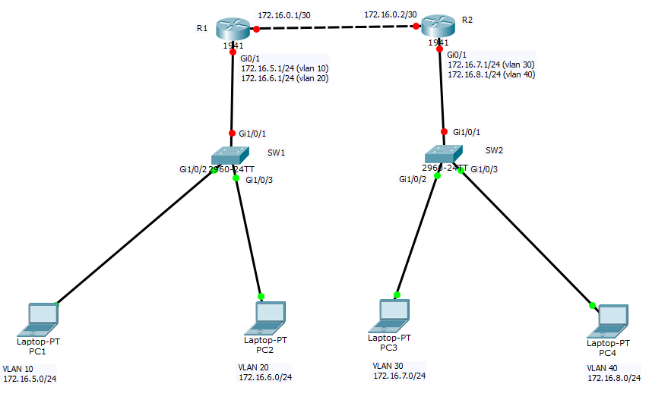

1. **We started with writing configurations on the switches as shown below:**

**SWITCH 1:**

**The code below was written to erase the previous configurations on the switch and reload the switch.**

SW1>enable

SW1# write erase

SW1#reload

switch>

Switch>

Switch>en

Switch#config t

**Naming the switch:**

Switch(config)#hostname SW1

**Creating vlans on switch 1**

SW1(config)#vlan 10

SW1(config-vlan)#vlan 20

SW1(config-vlan)#exit

SW1(config)#exit

SW1#

SW1#show vlan

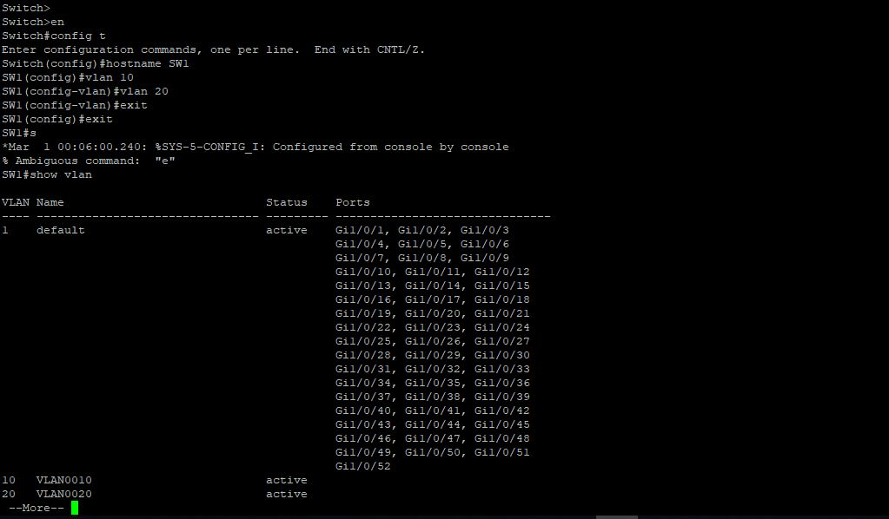

**Making the ports access ports and assigning them to vlans on switch 1.**

SW1#

SW1#config t

SW1(config)# int Gi1/0/2

SW1(config-if)#switchport mode access

SW1(config-if)#switchport access vlan 10

SW1(config-if)#int Gi1/0/3

SW1(config-if)#switchport mode access

SW1(config-if)#switchport access vlan 20

SW1(config-if)#^Z

SW1#show vlan

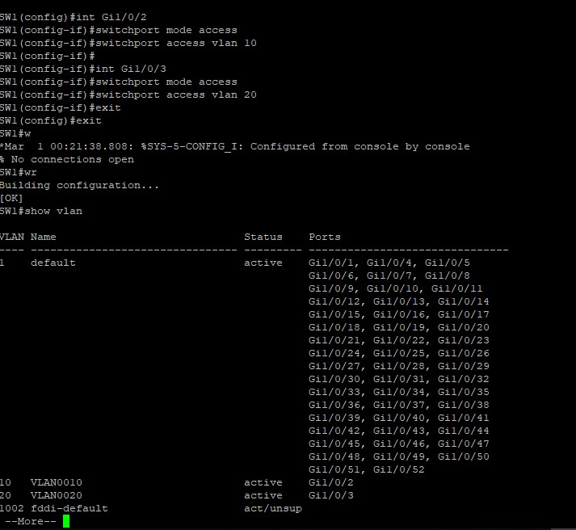

**Creating a trunk port and assigning it an interface on switch 1**

SW1#

SW1#conf t

SW1(config)#int Gi1/0/1

SW1(config-if)#switchport trunk encapsulation dot 1Q

SW1(config-if)#switchport mode trunk

SW1(config-if)#^Z

SW1#

SW1#show int Gi1/0/1 switchport

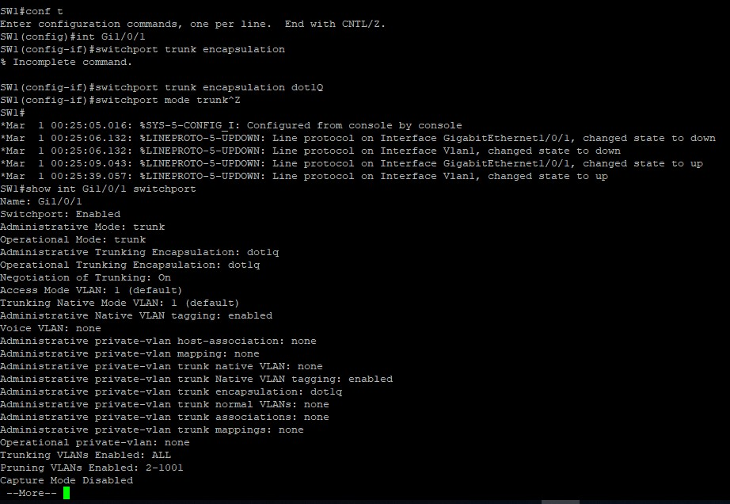

**SWITCH 2**

**Erasing the previous code on switch 2 and reloading switch 2.**

SW2>enable

SW2# write erase

SW2#reload

**Naming switch 2:**

Switch>

Switch(config)#hostname SW2

**Creating vlans on switch 2**

SW2(config)#vlan 30

SW2(config-vlan)#vlan 40

SW2(config-vlan)#exit

SW2(config)#exit

SW2#

SW2#show vlan

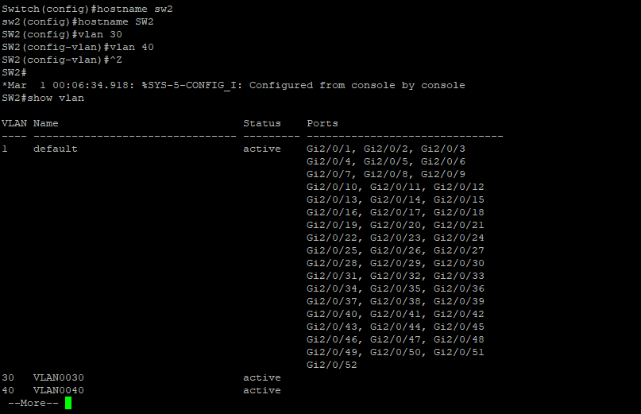

**Creating access ports on the switch and assigning them vlans on switch 2**

SW2#

SW2#conf t

SW2(config)#intGi2/0/2

SW2(config-if)#switchport mode access

SW2(config-if)#switchport access vlan 30

SW2(config-if)#int Gi2/0/3

SW2(config-if)#switchport mode access

SW2(config-if)#switchport access vlan 40

SW2(config-if)#^Z

SW2#write

**Creating a trunk port on the switch 2**

SW2(config)#int Gi2/0/1

SW2(config-if)#switchport trunk encapsulation dot1Q

SW2(config-if)#switchport mode trunk

SW2(config-if)#^Z

SW2#show intswitchport

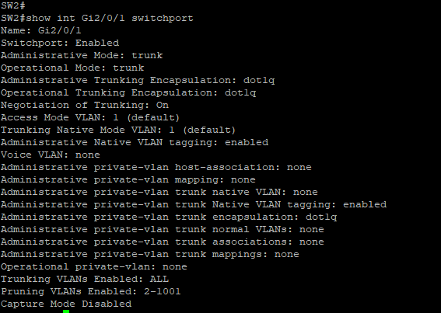

1. **ROUTER CONFIGURATIONS**

**ROUTER 1**

**Erasing the previous code on router 1 and reloading router 1.**

R1>enable

R1# write erase

R1#reload

**Naming router 1:**

Router>en

Router#config t

Router(config)#

Router(config)#hostname R1

**Creating subinterfaces on router 1 and assigning them ip addresses:**

R1(config)#int Gi0/1

R1(config-if)#no ip add

R1(config-if)#

R1(config-if)#no shut

R1(config-if)#description link to SW1

R1(config-if)#

R1(config-if)#int Gi0/1.10

R1(config-subif)#

R1(config-subif)#encapsulation dot1Q 10

R1(config-subif)#ip add 172.16.5.1 255.255.255.0

R1(config-subif)#intGi0/1.20

R1(config-subif)#encapsulation dot1Q 20

R1(config-subif)#ip add 172.16.6.1 255.255.255.0

R1(config-subif)#^Z

R1#

R1#show ipintbri

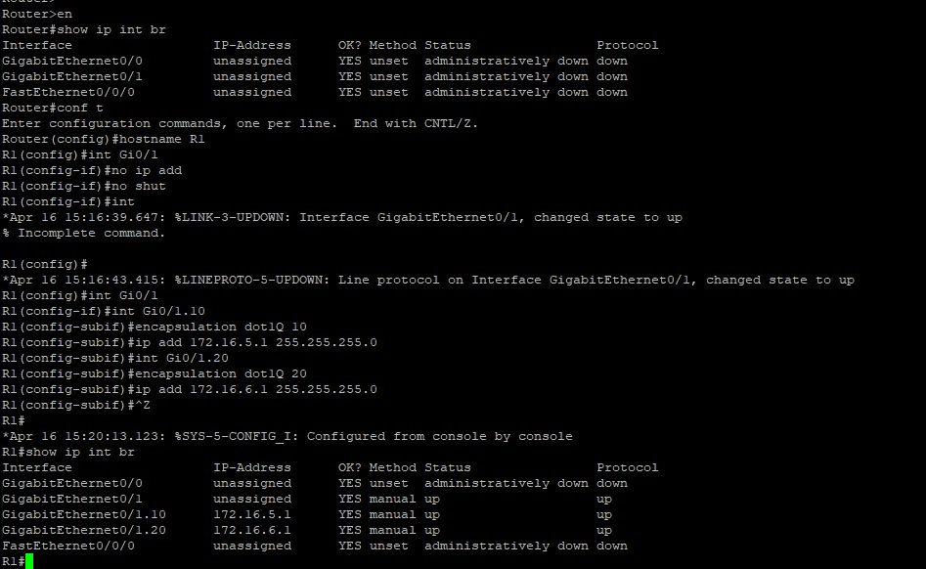

**Assigning int Gi0/0 an ip address and putting it up**

R1(config)#int Gi0/0

R1(config-if)#no shut

R1(config-if)#ip add 172.16.0.1 255.255.255.252

R1(config-if)#description link to R2

R1(config-if)#^Z

R1#

R1#sh ipint brief

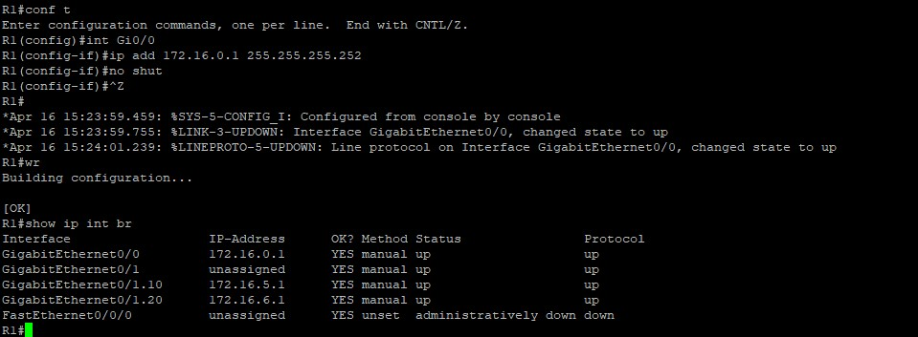

**ROUTER 2**

**Erasing the previous code on router 2 and reloading router 2.**

R2>enable

R2# write erase

R2#reload

**Naming router 2:**

Router>en

Router#config t

Router(config)#

Router(config)#hostname R2

**Creating subinterfaces on router 2 and assigning them ip addresses:**

R2(config)#int Gi0/1

R2(config-if)#no ip add

R2(config-if)#no shut

R2(config-if)#description link to SW2

R2(config-if)#

R2(config-if)#int Gi0/1.30

R2(config-subif)#

R2(config-subif)#encapsulation dot1Q 30

R2(config-subif)#ip add 172.16.7.1 255.255.255.0

R2(config-subif)#intGi0/1.40

R2(config-subif)#encapsulation dot1Q 40

R2(config-subif)#ip add 172.16.8.1 255.255.255.0

R2(config-subif)#^Z

R2#

R2#show ipint brief

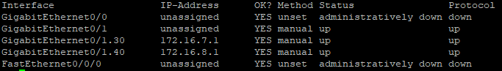

**Assigning int Gi0/0 an ip address and putting it up**

R2(config)#int Gi0/0

R2(config-if)#no shut

R2(config-if)#ip add 172.16.0.2 255.255.255.252

R2(config-if)#description link to R2

R2(config-if)#^Z

R2#

R1#sh ipint brief

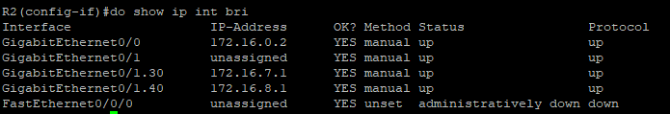

1. **CONFIGURING TELNET**

**ROUTER 1**

R1#

R1#conf t

R1(config)#username R1 privilege 15 secret R1

R1(config)#line vty 0 4

R1(config-line)#login local

R1(config-line)#^Z

**ROUTER 2**

R2#

R2#conf t

R2(config)#username R2 privilege 15 secret R2

R2(config)#line vty 0 4

R2(config-line)#login local

R2(config-line)#^Z

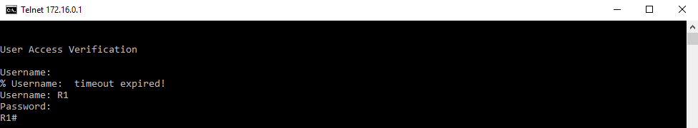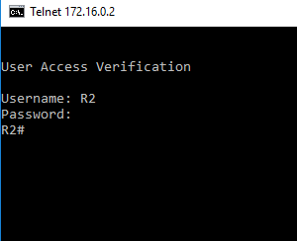

**Assigning static routes to R2 on R1**

R1

R1#

R1#config t

R1(config)#ip route 172.16.7.0 255.255.255.0 172.16.0.2

R1(config)#ip route 172.16.8.0 255.255.255.0 172.16.0.2

R1(config)#^Z

R1#

R1#show ip route

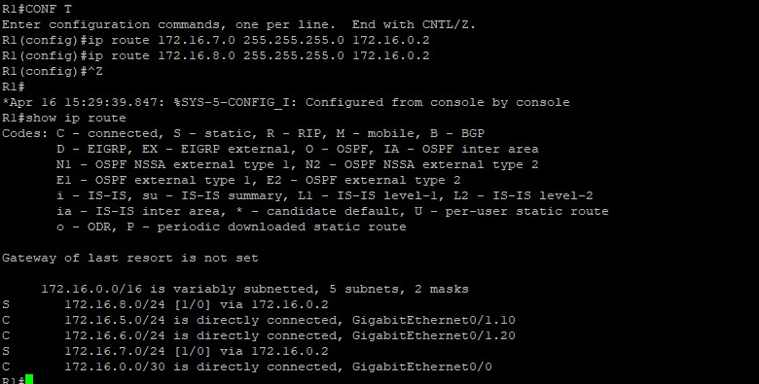

**Assigning routes to R1 on R2**

R2#

R2#config t

R2(config)#ip route 172.16.5.0 255.255.255.0 172.16.0.1

R2(config)#ip route 172.16.6.0 255.255.255.0 172.16.0.1

R2(config)#^Z

R2#

R2#show ip route

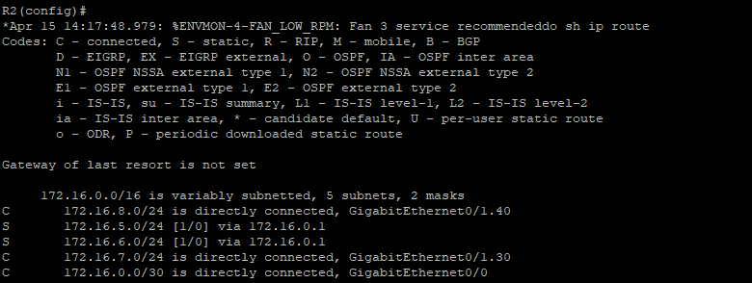

**Pinging PCs across the routers to check reachability via the static routes:**

* First , the PCs were all assigned ip addresses manually according to the vlans in which they belonged.
* Then the PCs on different networks were pinged. We realized that it was important to turn off firewall on all the PCs inorder to enable reachability of packets to the PCs.

**Pinging results from PC 3**

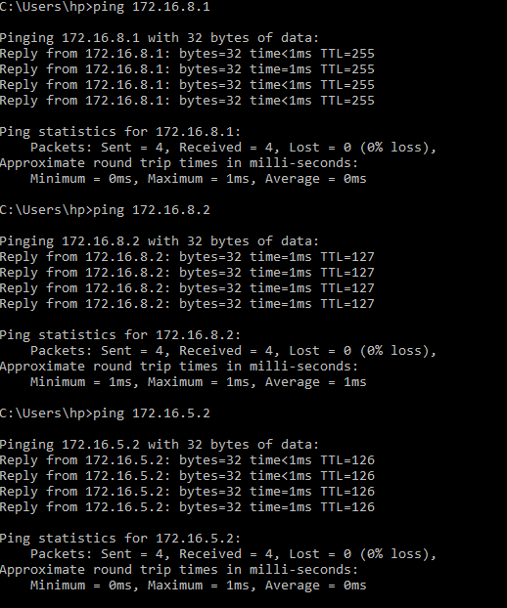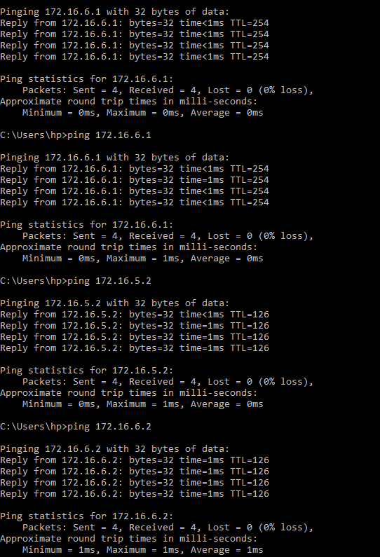

**Pinging results from PC 2**

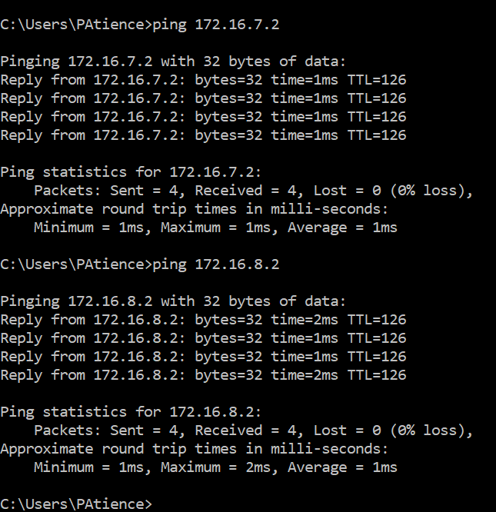

1. **Configuring OSPF on the routers:**

Before configuring OSPF routes on the routers, the static routes had to first be removed from the routers. Then we proceeded to configure OSPF.

**Removing the static routes from R1**

R1(config)#no ip route 172.16.7.0 255.255.255.0 172.16.0.2

R1(config)#no ip route 172.16.8.0 255.255.255.0 172.16.0.2

R1(config)#^Z

R1#

R1#sh ip route

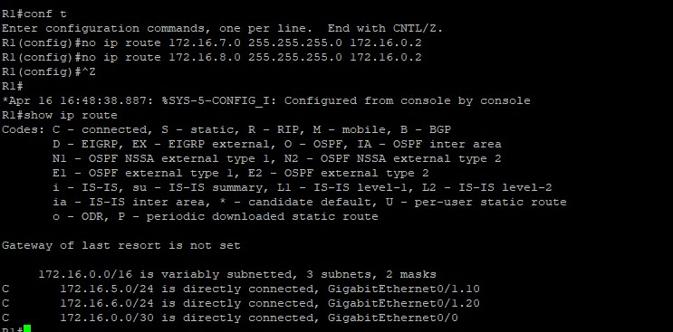

**Configuring OSPF on R1**

R1#

R1#CONF T

R1(config)#router ospf 101

R1(config-router)#network 172.16.5.0 0.0.0.255 area 0

R1(config-router)#network 172.16.6.0 0.0.0.255 area 0

R1(config-router)#network 172.16.0.0 0.0.0.3 area 0

R1(config-router)#^Z

R1#

R1#sh ip route

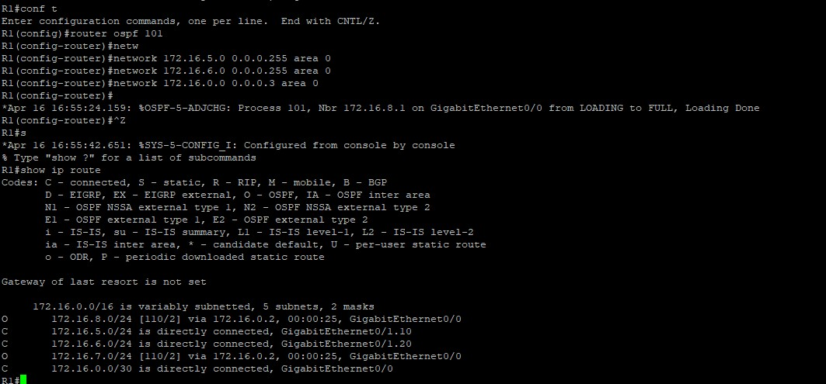

**Removing static routes from R2:**

R2(config)#no ip route 172.16.5.0 255.255.255.0 172.16.0.1

R2(config)#no ip route 172.16.6.0 255.255.255.0 172.16.0.1

R2(config)#^Z

R2#

**On pinging across the router without static routes, we got an unreacheable host reply.**

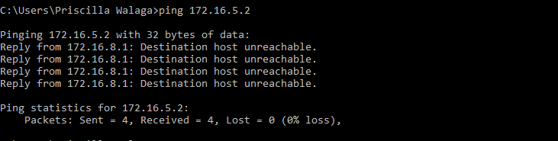

**Configuring ospf on R2**

R2#

R2#conf t

R2(config)#router ospf 101

R2(config-router)#network 172.16.7.0 0.0.0.255 area 0

R2(config-router)#network 172.16.8.0 0.0.0.255 area 0

R2(config-router)#network 172.16.0.0 0.0.0.3 area 0

R2(config-router)#^Z

R2#sh ip route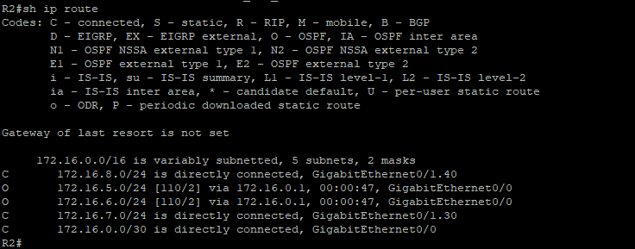

**Pinging results after assigning OSPF on the routers**

* Pinging PC 3 and 4 on PC 2



* Pinging PC 3 and 4 on PC 1

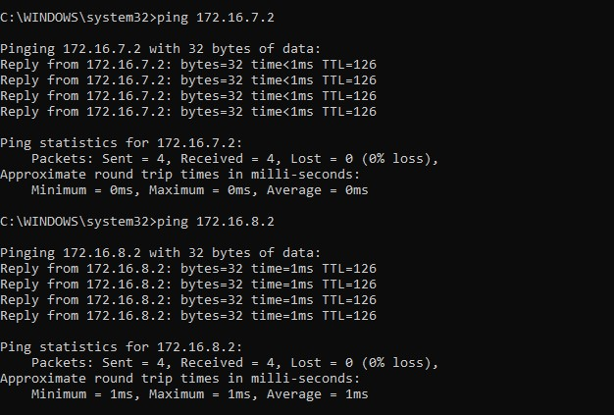

* Pinging PC 1 and 2 on PC 3

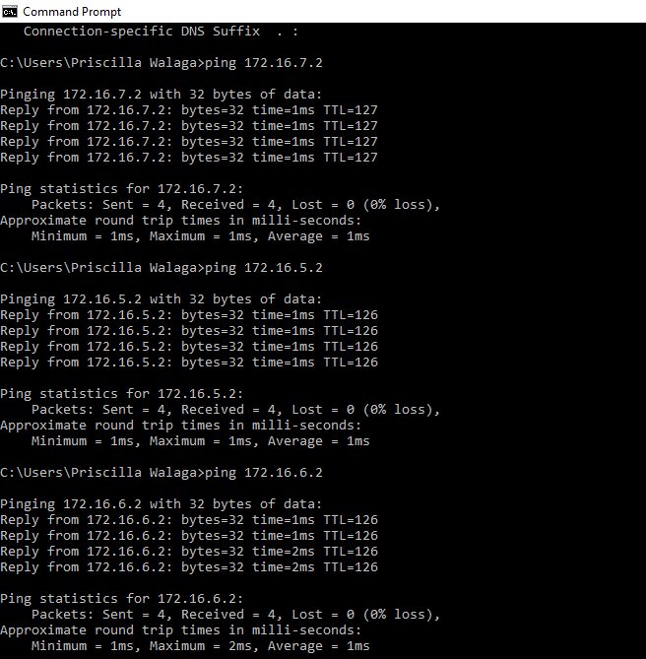

1. **Configuring DHCP on the routers**

R1#

R1#conf t

R1(config)#ipdhcp pool GROUPG

R1(dhcp-config)#network 172.16.5.0 255.255.255.0

R1(dhcp-config)#default-router 172.16.5.1

R1(dhcp-config)#dns-server 8.8.8.8

R1(dhcp-config)#ip domain-name vlan10.com

R1(config)#ipdhcp excluded-address 172.16.5.1

R1(config)#service dhcp

R1#

R1#conf t

R1(config)#ipdhcp pool GROUPG1

R1(dhcp-config)#network 172.16.6.0 255.255.255.0

R1(dhcp-config)#default-router 172.16.6.1

R1(dhcp-config)#dns-server 8.8.8.8

R1(dhcp-config)#ip domain-name vlan20.com

R1(config)#ipdhcp excluded-address 172.16.6.1

R1(config)#service dhcp

**IPs assigned dynamically on PCs 1 and 2**

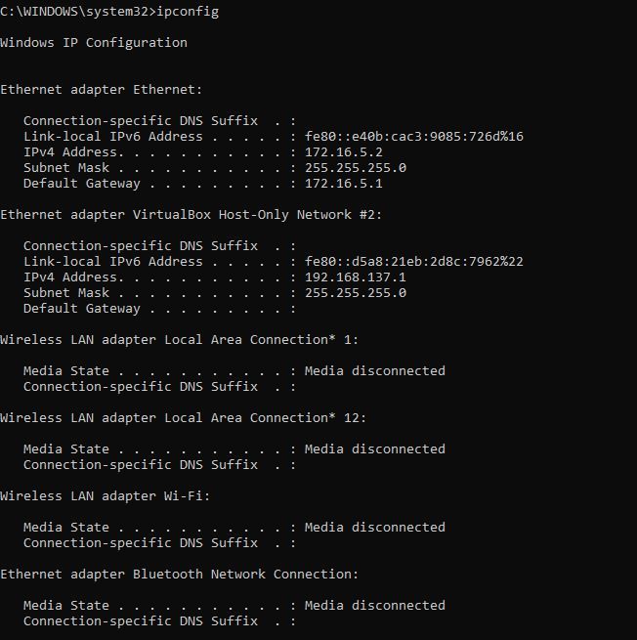

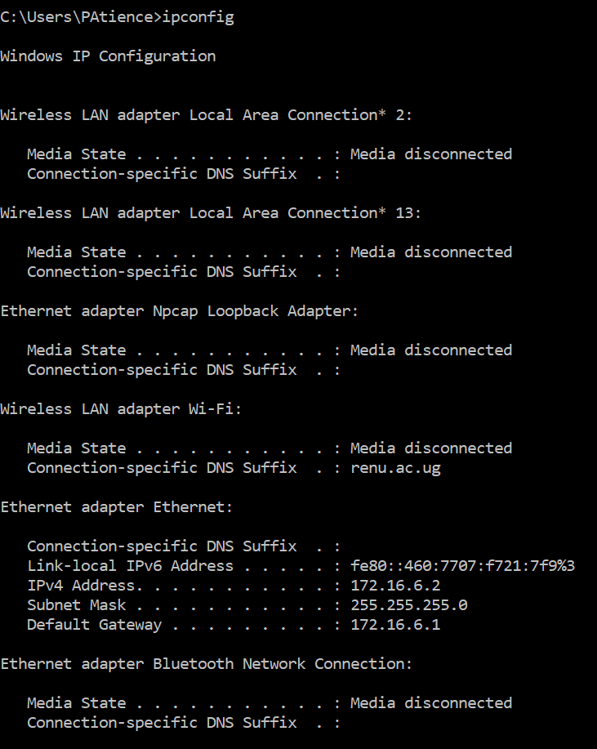

R2#

R2#conf t

R2(config)#ipdhcp pool GROUPG

R2(dhcp-config)#network 172.16.7.0 255.255.255.0

R2(dhcp-config)#default-router 172.16.7.1

R2(dhcp-config)#dns-server 8.8.8.8

R2(dhcp-config)#ip domain-name GROUPG1.com

R2(config)#ipdhcp excluded-address 172.16.7.1

R2(config)#service dhcp

R2#

R2#conf t

R2(config)#ipdhcp pool GROUPG2

R2(dhcp-config)#network 172.16.8.0 255.255.255.0

R2(dhcp-config)#default-router 172.16.8.1

R2(dhcp-config)#dns-server 8.8.8.8

R2(dhcp-config)#ip domain-name GROUPG3.com

R2(config)#ipdhcp excluded-address 172.16.8.1

R2(config)#service dhcp

* **IPs Assigned dynamically on PCS 3 and 4**

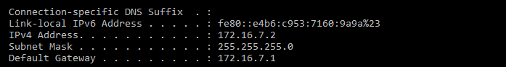

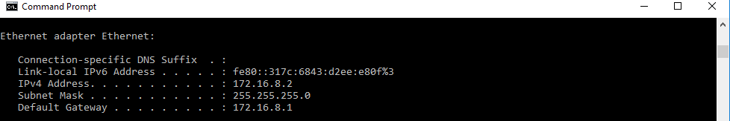

# References

|  |  |
| --- | --- |
| [1] | K. W. R. James F. Kurose, Computer networking : a top-down approach, New Jersey: Pearson Education, Inc, 2013. |
| [2] | [Online]. Available: http://coeosmanabad.com/cse/manual/CN-II_TE.pdf. [Accessed 20 April 2019]. |

# References

|  |  |
| --- | --- |
| [1] | K. W. R. James F. Kurose, Computer networking : a top-down approach, New Jersey: Pearson Education, Inc, 2013. |
| [2] | T. Lammle, CCNA Cisco Certified Network Associate Study Guide, San Francisco: SYBEX Inc., 2000. |
| [3] | [Online]. Available: http://coeosmanabad.com/cse/manual/CN-II_TE.pdf. [Accessed 20 April 2019]. |