Setting: VSEL0_Pin = 0, VSEL1_Pin = 1

36.4V on Driver

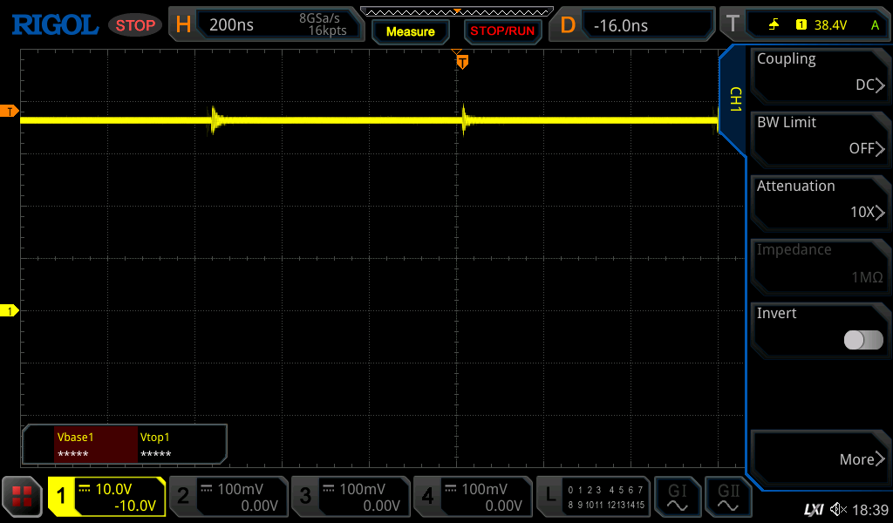

TP701

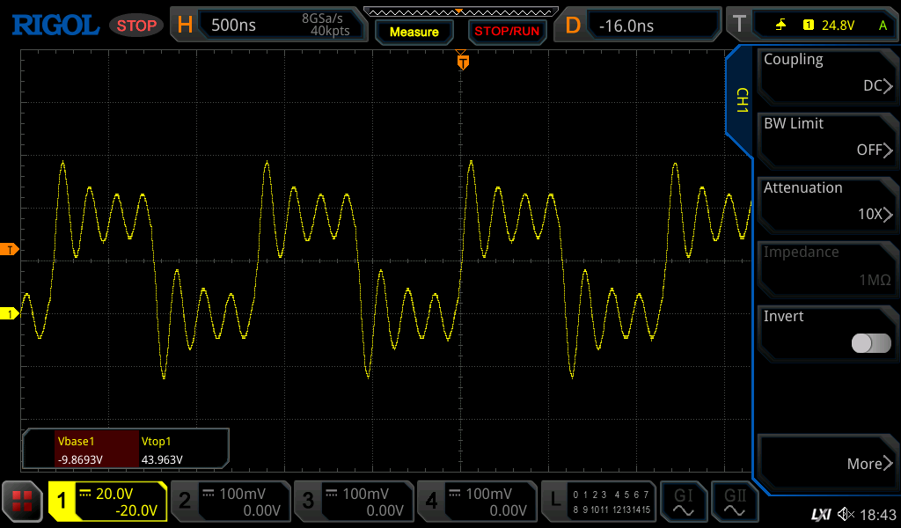

TP705

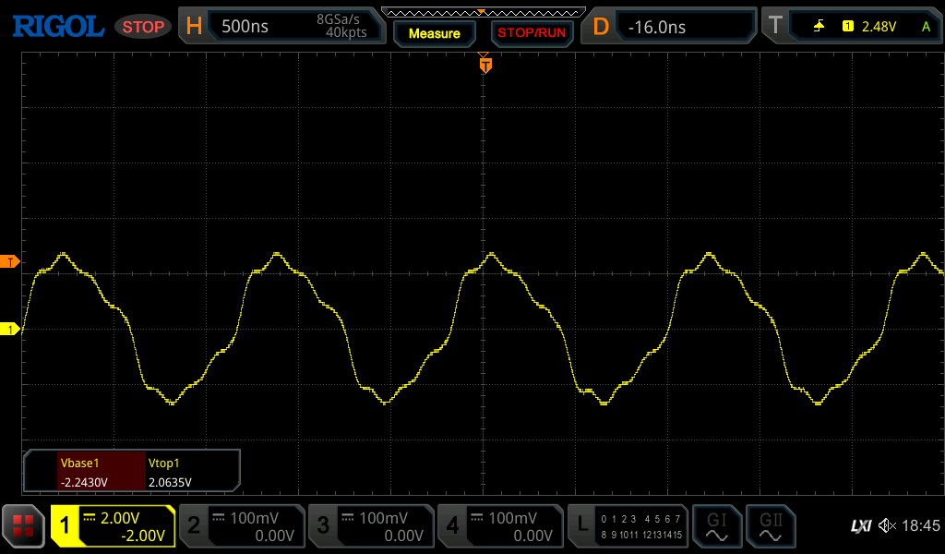

TP704

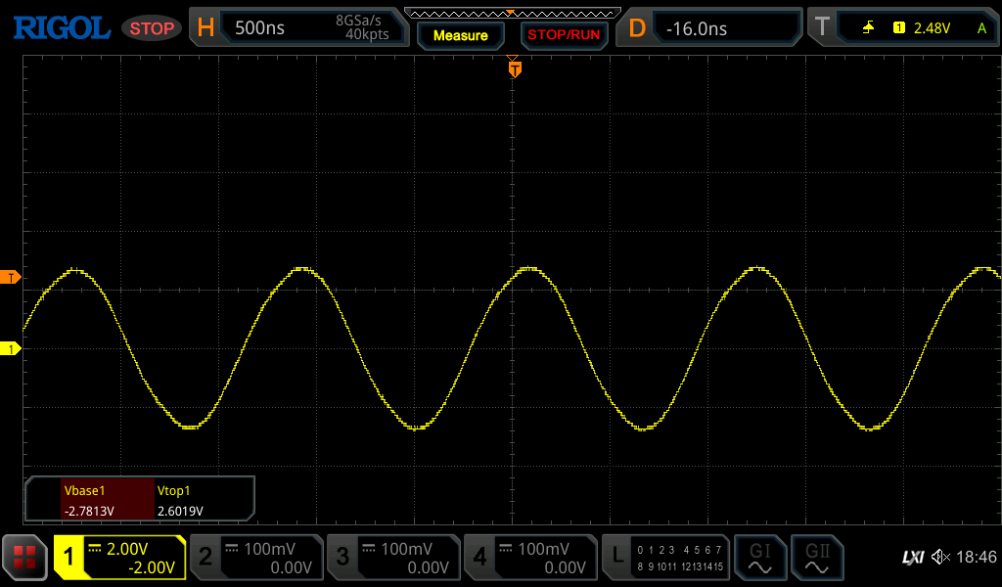

ADC1_IN

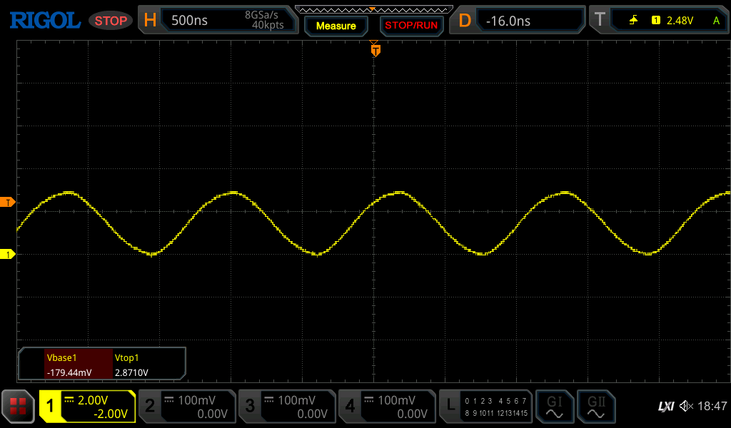

Input attenuation enabled (AFE_GAIN2_Pin = 1)

TP705

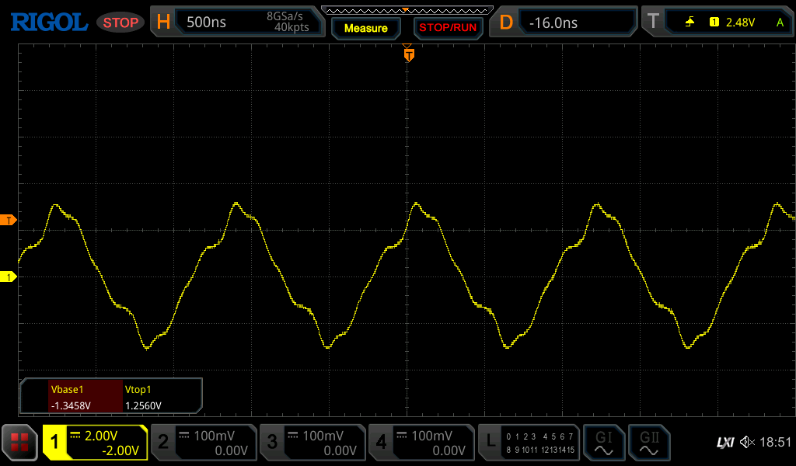

TP704

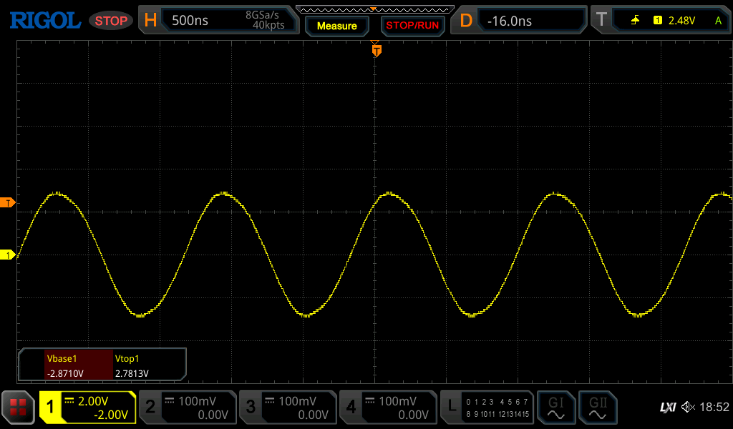

ADC1_IN

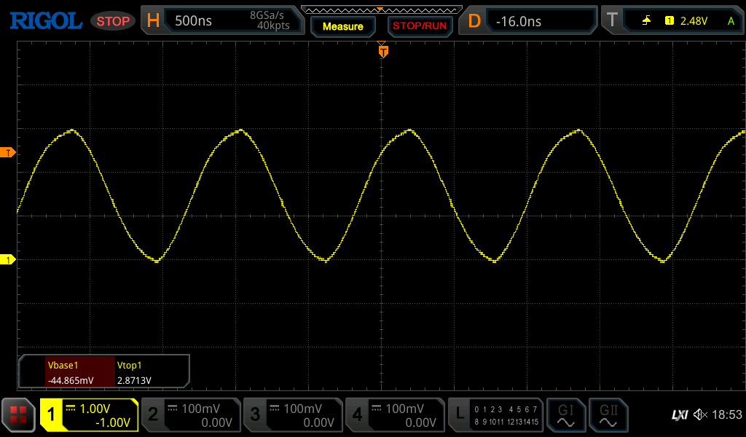  
  
  
60V (59.8V)

Transducer (questioable probe attenuation 20x or 10x ???)

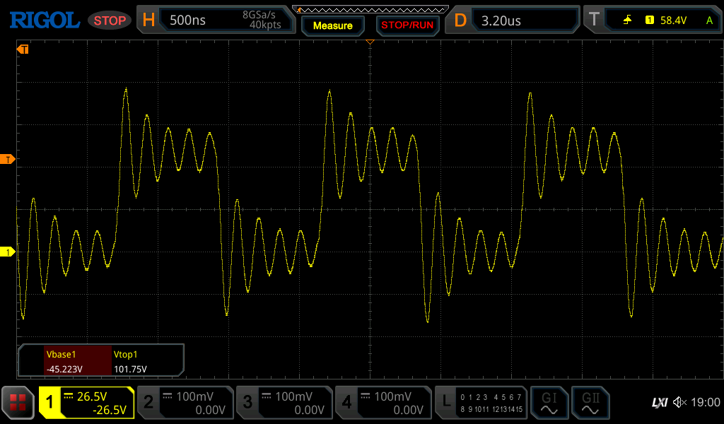

TP701  
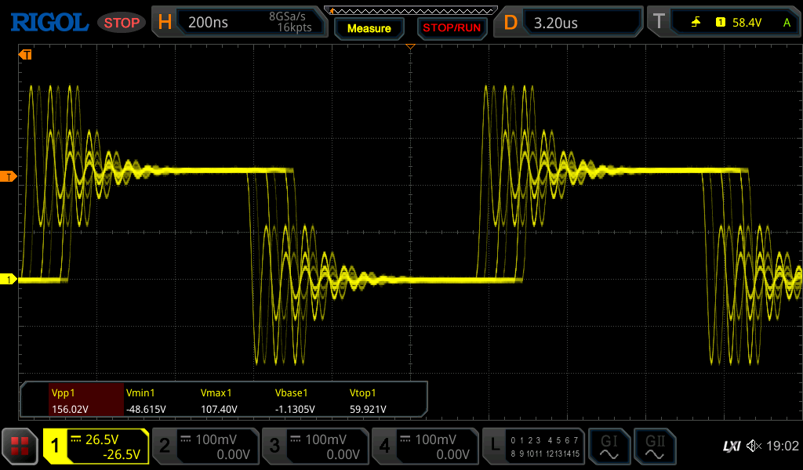

TP705

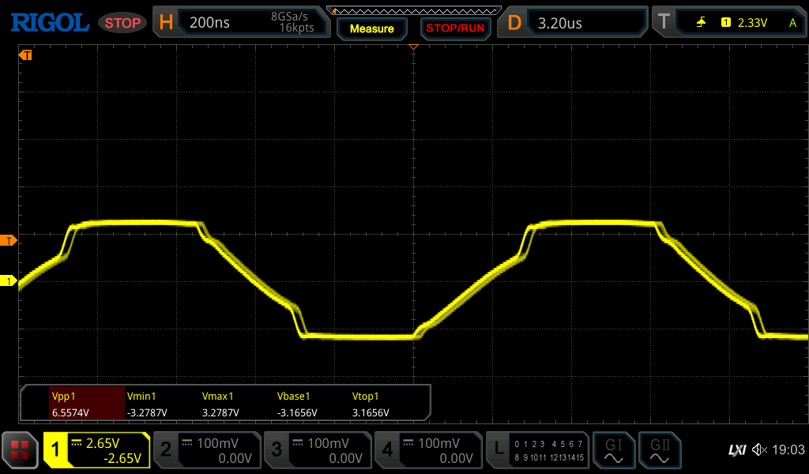

TP704

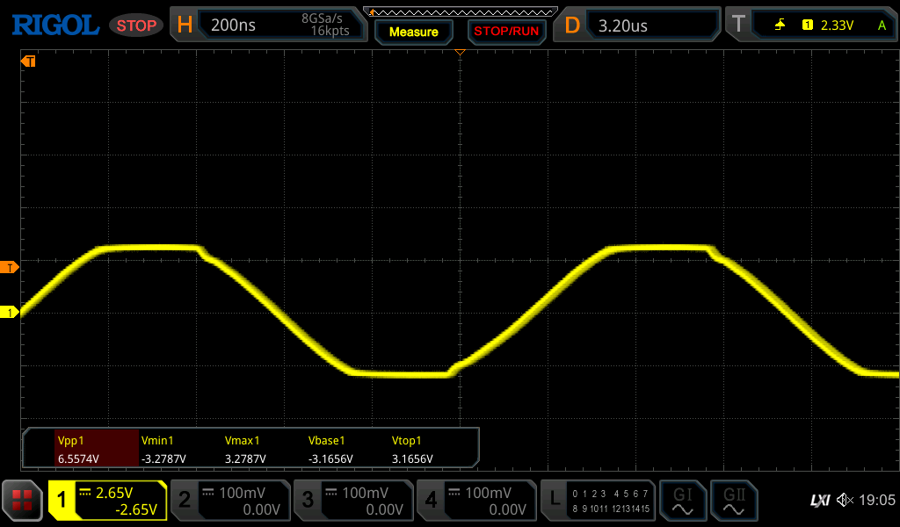  
  
ADC1_IN

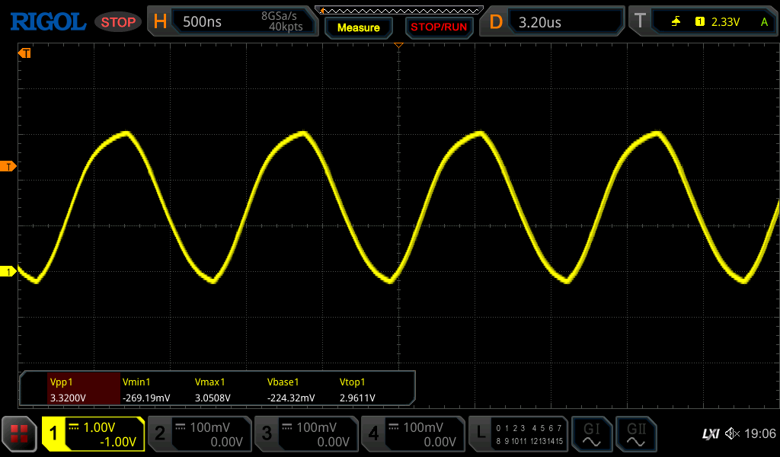  
  
DC Supply: 15V, Ipeak (visible) ~176mA