COMPETITIVE INNOVATION PROPOSAL | ADVANCED MACHINING & SURFACE FUNCTIONALIZATION

PMEDM-INDUSTRIAL
Industrializing Powder-Mixed Electrical Discharge Machining
A High-Productivity, Surface-Engineering Platform for Production Environments
“One-step, in-process, certified surface engineering that replaces finish-machining, polishing, and coating — cutting total part cost by 25–45%.”
> USD 2.1 B  Addressable  market | < 18 months  Cell payback  period | 25–45%  Per-part cost  reduction

Submitted to: Industrial Manufacturing Program / Technology Investment Board
Classification: Commercial-in-Confidence | Date: 2025

Table of Contents

(Right-click and “Update Field” in Word to populate page numbers.)

1 Executive Summary
Powder-Mixed Electrical Discharge Machining (PMEDM) has, for two decades, been confined to university laboratories and small tank demonstrations. The technology is proven in principle: suspending micro/nano conductive powders (Si, Al, Cr, Ti, SiC, graphite, carbon nanostructures) in the dielectric fluid delivers 2–4× faster material removal, mirror-grade surface finishes (Ra < 0.1 µm), reduced recast layer and micro-cracking, and — critically — in-situ surface alloying that permanently upgrades hardness, wear, corrosion, and biocompatibility of the machined part.
Yet PMEDM has not crossed into mainstream industrial production. The gap is not science; it is engineering at scale: powder settling in large tanks, dielectric degradation, consumables cost, lack of closed-loop control, qualification hurdles, and safety concerns around fine powders in hydrocarbon media.
The Strategic Pivot
This proposal presents PMEDM-INDUSTRIAL — a turnkey production platform that reframes PMEDM from a “finishing process” into an intelligent, certifiable, in-process surface-engineering platform. That reframe is where the competitive moat and premium pricing live.

The platform closes the lab-to-industry gap through five engineered innovations:
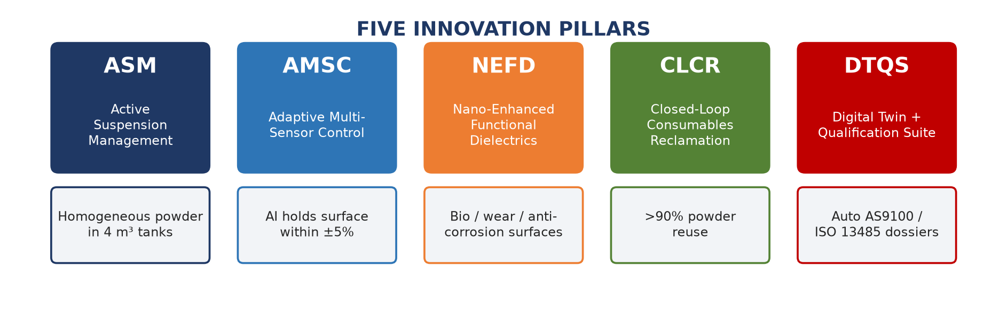
Figure 1 — The five innovation pillars of PMEDM-INDUSTRIAL.
- Active Suspension Management (ASM) — first scalable homogeneous-suspension tank architecture (up to 4 m³).
- Adaptive Multi-Sensor Control (AMSC) — AI-fused multi-sensor real-time control holding surface integrity within ±5%.
- Nano-Enhanced Functional Dielectrics (NEFD) — proprietary nano-functional dielectric chemistries (bioactive, self-lubricating, anti-corrosion).
- Closed-Loop Consumables Reclamation (CLCR) — integrated powder + dielectric reclamation achieving >90% reuse.
- Digital Twin + Qualification Suite (DTQS) — physics-informed digital twin and automated AS9100 / ISO 13485 qualification dossiers.
Value Proposition
PMEDM-INDUSTRIAL replaces (not supplements) three downstream operations — finish machining, polishing, and surface coating/treatment — in a single set-up, cutting total production cost on qualifying parts by an estimated 25–45% while improving component performance and fatigue life.

Funding requested: Phase I feasibility + cell build. Expected ROI: <18 months payback on first production cell; 3-year addressable market > USD 2.1 B across aerospace, medical implants, tooling, and energy.

2 Problem Statement & Market Opportunity
2.1 The Industrial Pain
Manufacturers of high-value components (turbine blades, medical implants, precision molds, fuel injectors) currently run a long serial chain:
Rough machining → Finish machining → EDM / finishing → Polishing → Cleaning → Coating / heat-treatment → Inspection
This chain is capital-intensive, defect-prone, and a major source of recast layers, polishing labour (30–50% of mold-making cost), coating failures, long lead times, and high work-in-process.
2.2 Why PMEDM Has Not Scaled — Honest Gap Analysis
Barrier | Root Cause | Why Labs Don’t See It
Powder settling & inhomogeneity | Stokes settling in quiescent large tanks | Lab tanks <20 L; trivially mixed
Dielectric breakdown | Powder + carbon debris degrade dielectric strength | Short runs; fresh oil per experiment
Consumables cost | Industrial usage volume of nano-powders | Single coupons; cost never amortized
No in-process control | Surface finish measured post-hoc | Coupons sacrificed for metrology
Safety (dust explosion in oil) | Fine Al/Mg powders are pyrophoric | Hoods and small quantities hide risk
Qualification | Aerospace/medical require certified, repeatable processes | Academic work not certifiable

2.3 Market Opportunity
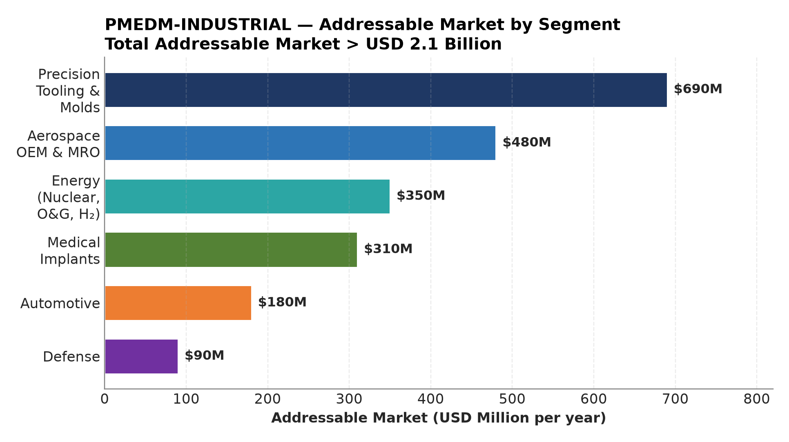
Figure 2 — PMEDM-INDUSTRIAL addressable market by segment (USD M/yr).
First-mover advantage is real and large: fewer than a handful of vendors offer production-grade PMEDM. Most are retrofits with poor control. The window for differentiation through intelligence and surface engineering is open now.

3 Technology Overview — How PMEDM Works
3.1 Mechanism
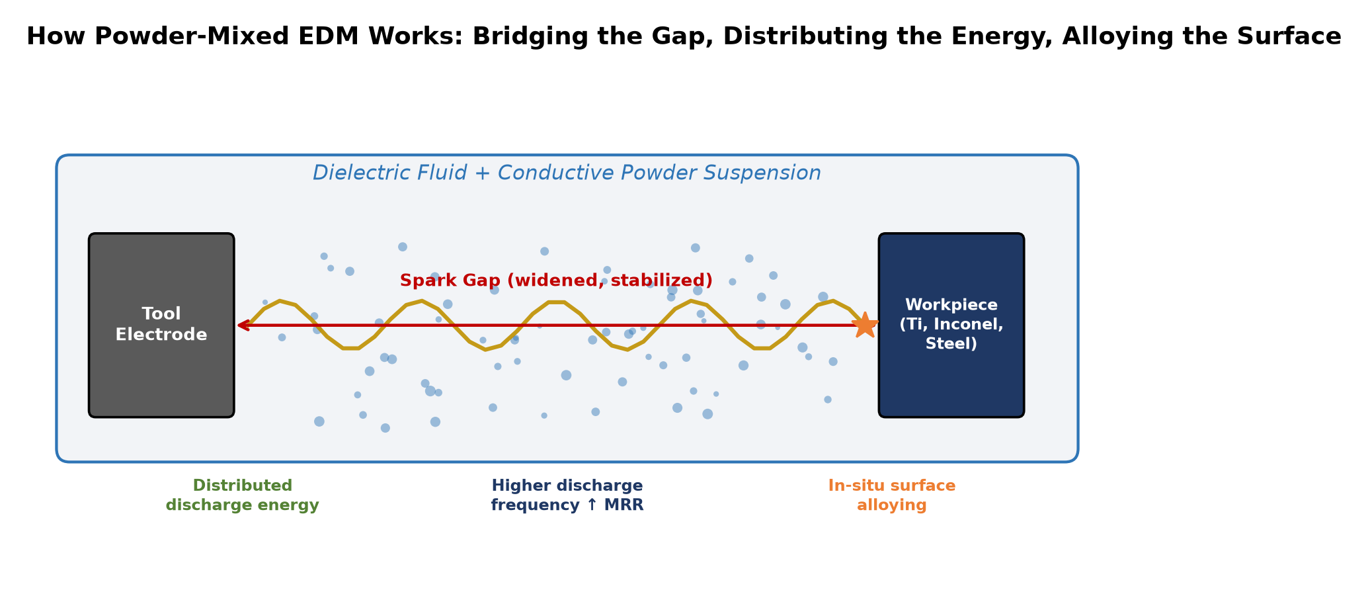
Figure 3 — PMEDM mechanism: powder bridges the gap, distributes energy, alloys the surface.
In EDM, pulsed sparks between a tool electrode and workpiece (immersed in dielectric) erode material by thermal ablation. PMEDM adds conductive/semi-conductive powder to the dielectric, which:
- Bridges the inter-electrode gap — widens the effective gap, stabilizes discharge, distributes energy.
- Increases discharge frequency — higher material removal rate (MRR).
- Reduces single-discharge energy density — finer craters, mirror finish.
- Transfers/alloys elements into the molten pool — surface modification (hardening, alloying, carbide formation).
3.2 Powder Systems & Industrial Effect
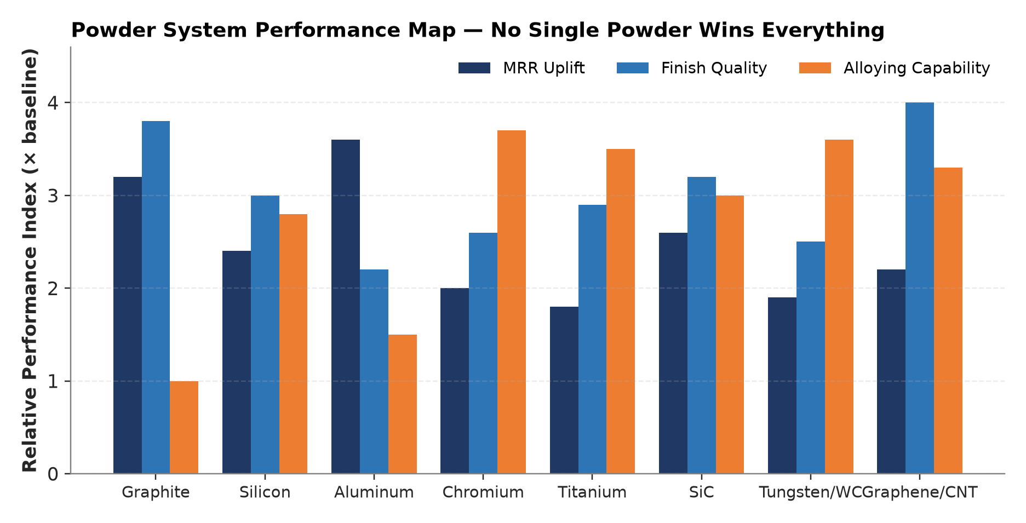
Figure 4 — No single powder wins everything: trade-offs across MRR, finish, and alloying.
Powder | Typical size | Primary industrial benefit
Graphite | 5–20 µm | Stable arc, high MRR, mirror finish on steels
Silicon (Si) | 5–15 µm | Surface hardening; biomedical Ti alloying
Aluminum (Al) | 10–40 µm | High MRR on steels; reactive — safety-critical
Chromium (Cr) | 5–20 µm | Corrosion/wear resistance via Cr-carbide
Titanium (Ti) | 10–30 µm | Biocompatible TiN/TiC layers on implants
Silicon Carbide (SiC) | 5–20 µm | Wear-resistant composite surfaces
Tungsten (W)/WC | 5–15 µm | Extreme hardness, hot hardness for tooling
Graphene / CNT (nano) | <1 µm | Self-lubricating, ultra-low wear, hydrophobic

3.3 The Innovation Frontier
The Reframe
Industrial value lies in designed surface engineering: producing a part whose surface has graded composition, controlled residual stress, and engineered functionality — done during machining, eliminating downstream steps. This converts PMEDM from a finishing process into a surface-functionalization platform.

4 The Five Innovation Pillars
4.1 Active Suspension Management (ASM)
Problem: in a 2–4 m³ production tank, micro-powders settle in minutes (Stokes velocity for 10 µm Si in oil ≈ 1–2 cm/min). Dead zones form; concentration varies by >300% top-to-bottom.
Innovation: a combined tangential-jet circulation + multi-frequency ultrasonic + flow-conditioned baffle system engineered via CFD to:
- maintain concentration uniformity within ±5% throughout the working volume;
- eliminate dead zones via optimized eddy patterns;
- continuously filter spark debris (>5 µm) while retaining functional powder (<3 µm);
- decouple fluid velocity from spark-gap hydrodynamics.
Deliverable: a scalable tank architecture (250 L → 4 m³) with documented flow maps and a validated concentration sensor (turbidity + sampling loop).
4.2 Adaptive Multi-Sensor Control (AMSC)
Problem: surface finish and alloy depth are measured after machining — by which point a defect is unrecoverable. There is no industry-standard in-process integrity signal.
Innovation: real-time fusion of three independent sensors into a closed-loop pulse controller:
Sensor | Measures | Control action
Gap voltage / current waveform analyzer (100 MHz) | Discharge ignition delay, plasma channel stability, arcing onset | Adjust pulse-on/off time, servo feed
Acoustic emission (AE) | Crack formation, abnormal discharge, debris flushing quality | Trigger flushing pulse, retract tool
In-line optical turbidity + conductivity | Powder concentration, dielectric breakdown | Dose powder, refresh dielectric

A lightweight ML model (gradient-boosted trees + a small LSTM on the waveform stream) predicts surface Ra, recast thickness, and alloy depth every 50 ms, holding them within ±5% of target. This converts PMEDM from an art into a certifiable, repeatable process — the key qualification unlock.
4.3 Nano-Enhanced Functional Dielectrics (NEFD)
Problem: conventional powders give finishing + modest alloying. The high-value market wants functional surfaces: bioactive, anti-wear, anti-corrosion, anti-icing, self-lubricating.
Innovation: engineered multi-component particle systems:
- Graphene/CNT-loaded dielectrics — self-lubricating surfaces with wear rates reduced 40–70%.
- Hydroxyapatite (HA) + Ti co-suspension — bioactive osseo-integrating surfaces on Ti implants during machining — eliminates separate plasma-spray coating.
- Cr/WC engineered blends — through-thickness graded hardness for forging dies (life ×2–3).
- PTFE-functionalized particles — hydrophobic / anti-icing surfaces for energy and aerospace.
A patent-pending stable nano-suspension chemistry (surfactant + pH/salinity control + steric stabilization) keeps nano-particles from agglomerating — the principal reason nano-PMEDM has stayed in the lab.
4.4 Closed-Loop Consumables Reclamation (CLCR)
Problem: nano-powders can cost USD 200–2,000/kg. Without recovery, consumables dominate part cost and make PMEDM uneconomic.
Innovation: an integrated centrifugal + cross-flow membrane + electro-coalescence reclamation cell that:
- separates reusable powder from machining debris by size/density/charge;
- reconditions the dielectric (carbon, dissolved metals, oxidation products removed);
- recovers >90% of functional powder and >95% of dielectric for reuse;
- produces a dry, inert, disposal-ready waste stream (safety + regulatory compliance).
This cuts operating consumables cost by an estimated 70–85% — the single largest enabler of PMEDM profitability at scale.
4.5 Digital Twin + Qualification Suite (DTQS)
Problem: aerospace and medical customers will not buy a process they cannot certify. Lab PMEDM produces academic papers, not AS9100 / ISO 13485 trails.
Innovation:
- Physics-informed digital twin — predicts surface alloy profile and residual stress per part geometry and pulse program.
- Per-part digital passport — every pulse logged; surface verified by integrated eddy-current and ultrasonic micro-probes.
- Qualification dossier generator — auto-builds documentation packs for NADCAP, FAA, FDA 510(k), ISO 13485.
- Drift detection — SPC on every sensor channel, with automatic calibration triggers.
Commercial Key
DTQS converts technical capability into sellable, insurable, certifiable production capacity. It is what turns a research curiosity into a deployable industrial platform.

5 Proposed Technical Solution — Cell Architecture
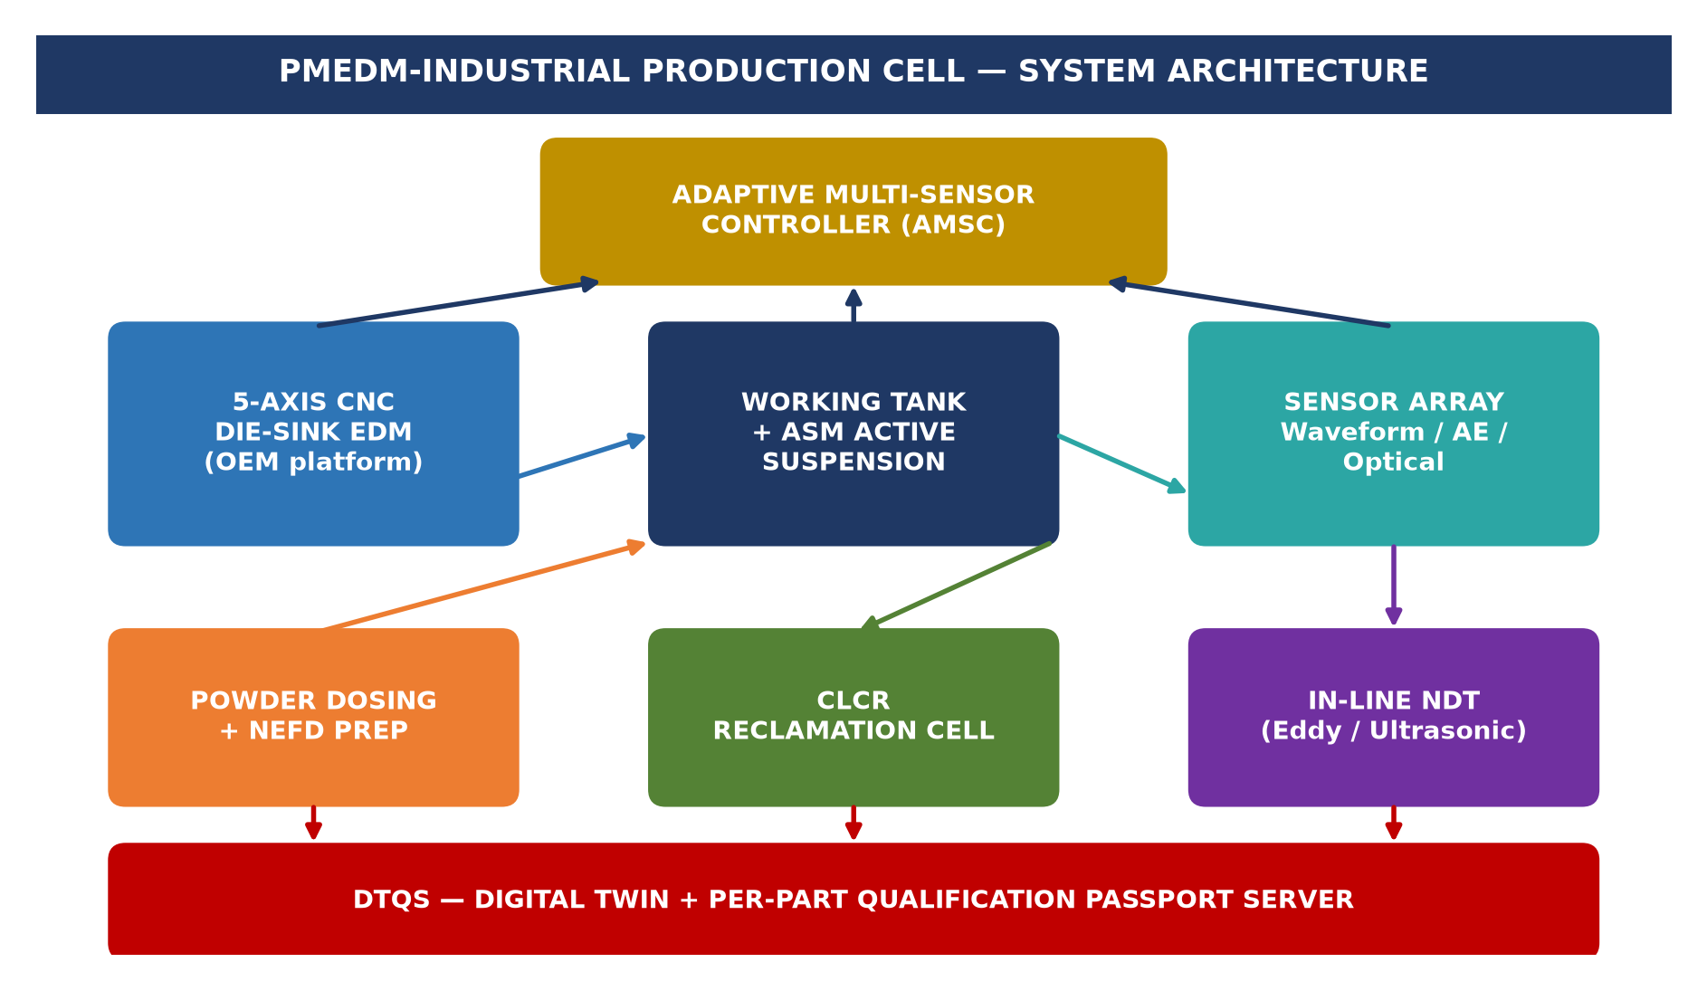
Figure 5 — PMEDM-INDUSTRIAL production cell system architecture.
5.1 Equipment Build vs Buy
- Base EDM machine — sourced from established OEMs (Mitsubishi, Makino, Sodick, GF AgieCharmilles) as a 5-axis die-sink platform — de-risks the mechanical base.
- All PMEDM-specific subsystems — ASM, AMSC, CLCR, DTQS — engineered in-house; the differentiating IP.
- Strategy — “platform-agnostic retrofit + new-build hybrid” maximizes addressable installed base.
5.2 Process Flow per Part
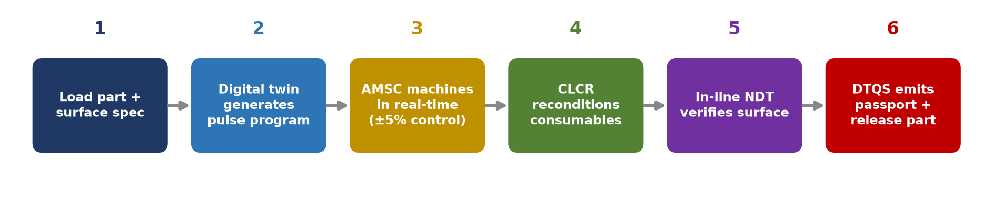
Figure 6 — Six-step per-part process flow with in-process verification.
- part loaded; DTQS loads geometry + target surface specification (Ra, alloy depth, hardness).
- digital twin generates pulse program + powder/dielectric recipe.
- AMSC controls machining in real-time, holding surface within spec.
- CLCR reconditions consumables during/after cycle.
- in-line NDT (eddy current, ultrasonic) verifies surface.
- DTQS emits digital passport + qualification dossier; part released.

6 Industrial Applications & Target Segments
Segment | Application | PMEDM Value | Per-part savings
Aerospace | Turbine blade cooling holes, blisk finishing, Ti/Inconel surfacing | Eliminate polish + coating; +fatigue life | 30–40%
Medical implants | Ti-6Al-4V hip/knee/dental; bioactive HA surfaces | Machining + bio-coating in one step | 35–50%
Tool & die / molds | Injection molds, forging dies | Mirror finish + wear layer; die life ×2–3 | 40–55%
Automotive | Fuel injector nozzles, gear flanks | Micro-feature finish + wear resistance | 20–30%
Energy | Nuclear, O&G, hydrogen valve surfaces | Corrosion / hydrogen-embrittlement resistance | 25–35%
Defense | Hardened gun components, armor interfaces | Through-thickness hardness gradient | 20–30%
Electronics | Micro-dies, lead frames | Precision micro-finishing | 15–25%

6.1 Anchor Case Studies (Phase I Demonstrators)
- Medical — osseo-integrating Ti implant with in-situ HA-Ti surface (eliminates plasma-spray line).
- Tooling — forging die with graded WC/Cr wear layer (2× life; eliminates hard-chrome plating).
- Aerospace — Inconel turbine blade cooling-hole array (eliminates ECM + polishing).

7 Quality Assurance & In-Process Monitoring
Real-time:
AMSC sensor fusion (waveform, AE, optical) → predicted Ra / recast / alloy depth updated at 20 Hz.
In-line NDT:
eddy-current (surface hardness, cracks), ultrasonic (recast, residual stress), optical profilometry (spot Ra).
Post-batch:
metallography, micro-hardness traverse, XRD phase ID, salt-spray / corrosion per ASTM B117, biocompatibility per ISO 10993 (medical).
Statistical process control:
Cpk ≥ 1.33 target on all key surface parameters; every part carries an immutable digital passport with full pulse log + sensor record.

8 Economic Analysis
8.1 Cell Economics (single cell, indicative)
Item | Estimate
Cell capital cost (build) | USD 0.9–1.4 M
Powder consumables (with CLCR) | USD 8–15 / part
Dielectric (with CLCR) | USD 3–6 / part
Energy + maintenance | USD 4–8 / part
Labour (operator, reduced) | USD 6–10 / part
Total cell cost / part (typical aerospace bracket) | USD 45–80
Comparable conventional chain cost | USD 90–150
Margin uplift / part | USD 45–70

8.2 Per-Part Cost Comparison
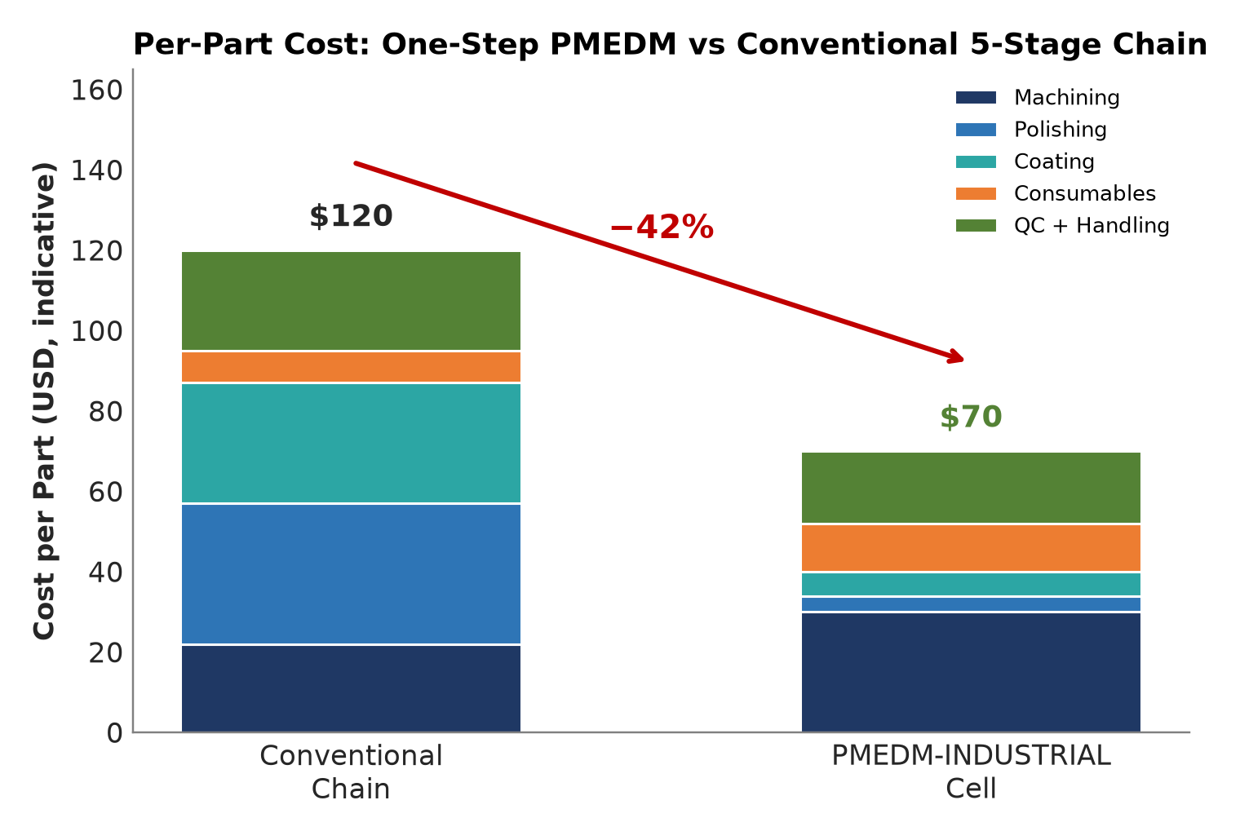
Figure 7 — One-step PMEDM vs the conventional 5-stage chain: ~40% lower per-part cost.
8.3 Throughput & ROI
Cycle time reduction: 30–50% via combined MRR + eliminated downstream ops. Cell throughput: ~3,000–6,000 qualifying parts/year depending on part mix.
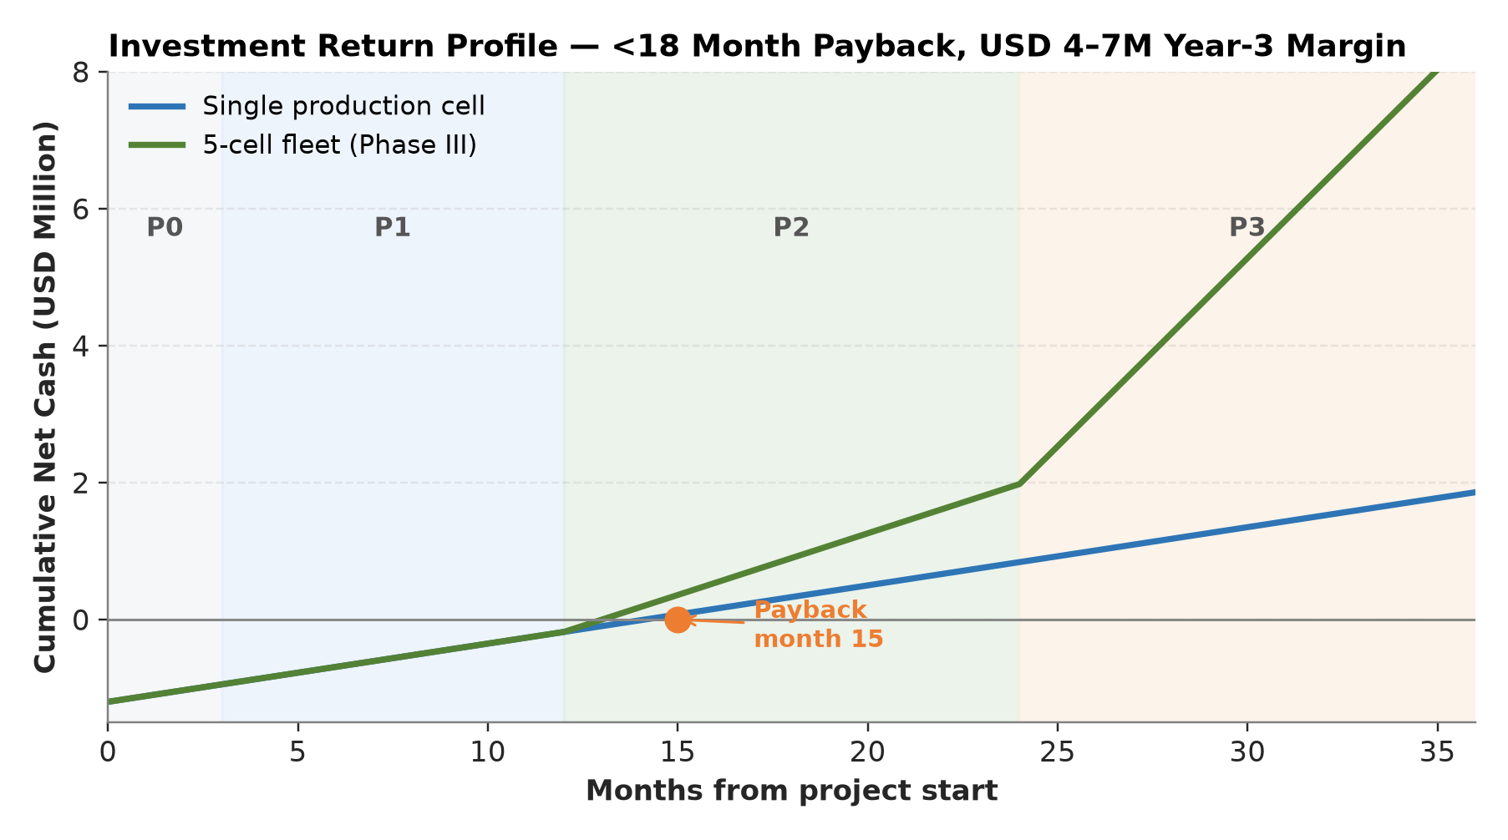
Figure 8 — Investment return profile: <18-month payback; USD 4–7M Year-3 contribution margin.
Customer-side value: the customer avoids a polishing line, a coating line, and recoat/rework, and gains superior part performance and traceability — a step-change in their cost-of-goods that easily justifies a premium price for PMEDM parts.

9 Implementation Roadmap
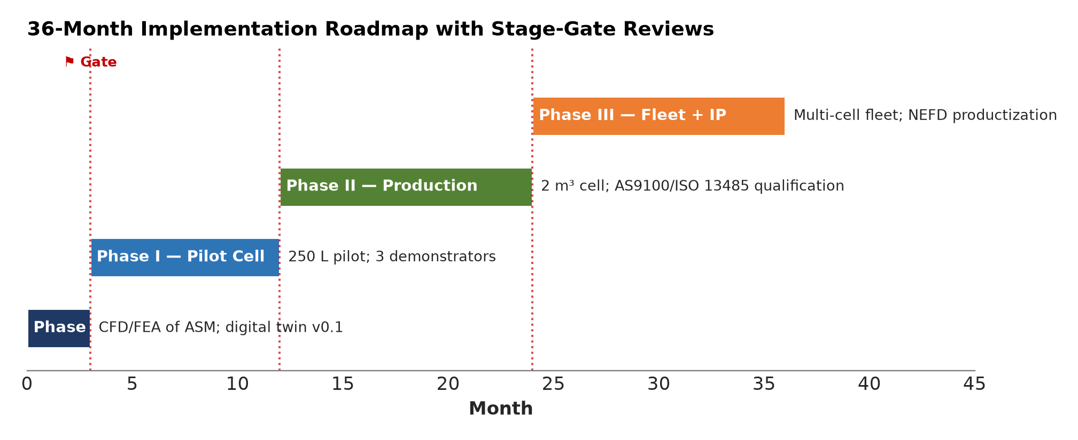
Figure 9 — 36-month phased roadmap with stage-gate reviews.
Phase | Duration | Deliverables | Gate
Phase 0 — Design Freeze | 0–3 mo | CFD/FEA of ASM; digital twin v0.1; powder chemistry shortlist | Design review
Phase I — Pilot Cell + 3 demonstrators | 3–12 mo | 250 L pilot cell; medical HA-Ti, forging die WC, Inconel blade demonstrators | Customer validation
Phase II — Production + qualification | 12–24 mo | 2 m³ production cell; AS9100 / ISO 13485 qualification; first paying customer | First revenue
Phase III — Fleet + platform IP | 24–36 mo | Multi-cell fleet; NEFD productization; licensing model | Profitable scale

10 Risk Assessment & Mitigation
Risk | Likelihood | Impact | Mitigation
Powder agglomeration (nano) | High | High | Proprietary suspension chemistry + ASM + in-line monitoring
Dust explosion (Al/Mg in oil) | Medium | Severe | Inerting (N₂ blanketing), ATEX zone classification, conductive non-sparking fixtures
Dielectric degradation | High | Medium | CLCR + AMSC breakdown detection; auto-refresh
OEM platform lock-in | Medium | Medium | Platform-agnostic architecture; retrofit-first business model
Qualification slippage | Medium | High | DTQS dossier generator from day one; partner with notified body early
IP challenge | Medium | High | Early patent filings on NEFD, AMSC fusion, suspension chemistry
Market adoption slow | Low | High | Anchor customer LOIs; start with highest-value, lowest-volume segment

11 Competitive Landscape & Differentiation
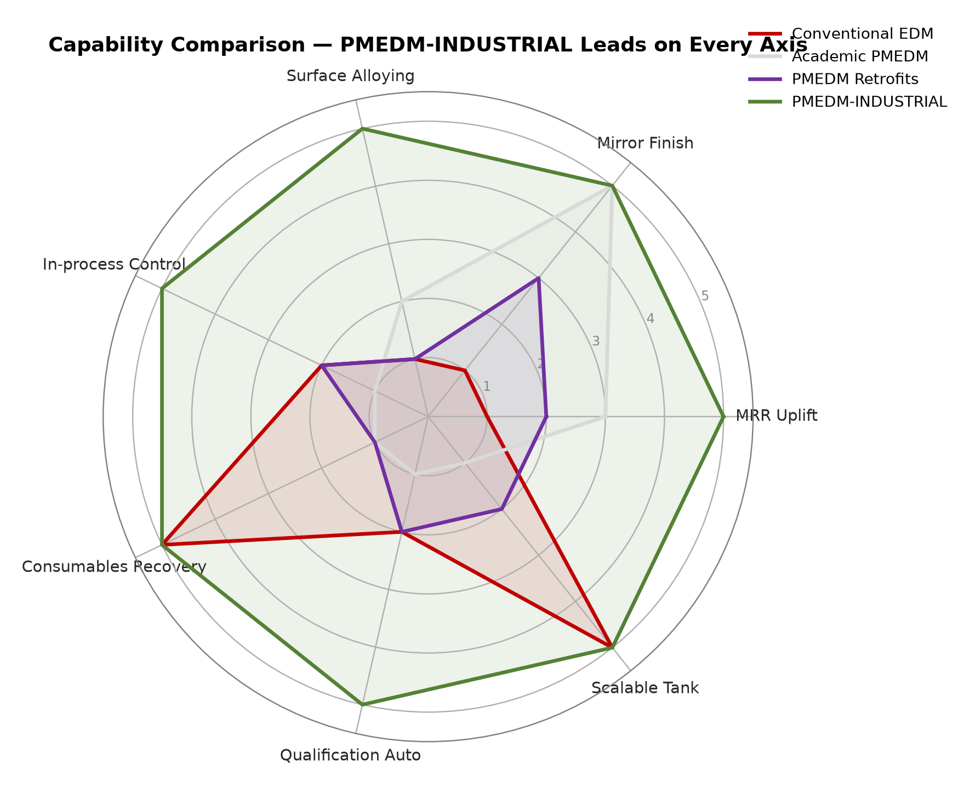
Figure 10 — Capability radar: PMEDM-INDUSTRIAL leads on every axis.
Capability | Conventional EDM | Academic PMEDM | PMEDM Retrofits | PMEDM-INDUSTRIAL
MRR uplift | 1× | 2–3× | 1.5–2× | 2–4×
Mirror finish | No | Yes (coupon) | Partial | Yes (production)
Surface alloying | No | Limited | No | Engineered functional surfaces
In-process control | None | None | Basic | AI multi-sensor (AMSC)
Consumables recovery | N/A | No | No | >90% (CLCR)
Qualification dossier | Manual | N/A | Manual | Automated (DTQS)
Scalable tank | Yes | No | Poor | Yes (ASM, up to 4 m³)

Sustainable Advantage
PMEDM-INDUSTRIAL is the only offering that treats PMEDM as an intelligent surface-engineering platform with built-in consumables economics and qualification automation — three moats that competitors cannot match quickly.

12 Innovation Highlights
The Single Biggest Idea
PMEDM-INDUSTRIAL does not sell “better EDM finishing.” It sells one-step, in-process, certified surface engineering that deletes three downstream operations, improves part performance, and is certifiable from day one. That reframing is where the competitive moat and the premium pricing live.

Specifically:
- Reframing — PMEDM as surface-functionalization platform, not a finishing process.
- ASM — first scalable homogeneous-suspension tank architecture.
- AMSC — first AI-fused multi-sensor in-process control for EDM.
- NEFD — proprietary nano-functional dielectric chemistries (bioactive, self-lubricating, anti-corrosion).
- CLCR — first integrated powder + dielectric reclamation making nano-PMEDM economic.
- DTQS — first physics-informed digital twin + automated qualification for EDM-class processes.

13 Team & Resource Requirements
- Principal Investigator / Technical Lead — EDM + plasma physics.
- Process Engineer — powder chemistry, suspension, surface characterization.
- Control & ML Engineer — AMSC, digital twin.
- Mechanical / Fluidics Engineer — ASM, CLCR, tank design.
- Quality / Regulatory Lead — AS9100 / ISO 13485 / FDA pathways.
- Industrial Designer — cell integration.
- Anchor-customer partnerships — 1 aerospace OEM, 1 medical-device company, 1 mold-maker (LOIs).
Equipment: 5-axis die-sink EDM (leased/retrofit), pilot tank, sensor suite, characterization (SEM, XRD, profilometer, micro-hardness), compute for digital twin + ML.
14 Funding Request & Use of Funds
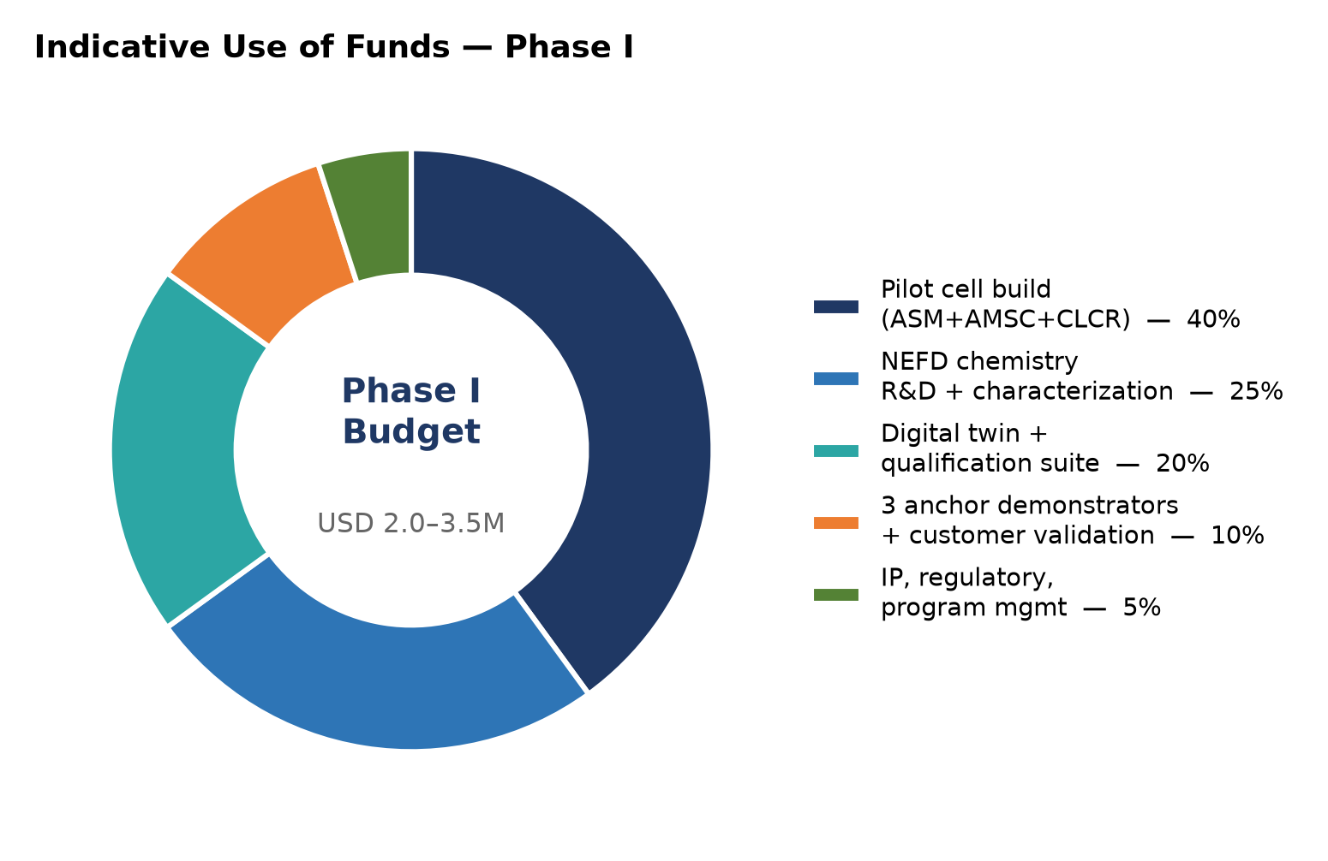
Figure 11 — Indicative Phase I use of funds (USD 2.0–3.5M).
Phase I indicative budget: USD 2.0–3.5 M, scalable to partnership scope.
15 Conclusion
PMEDM is a proven technology trapped in the laboratory by engineering, not science. PMEDM-INDUSTRIAL is the first coherent production platform designed from the ground up to release that value: it controls the physics (ASM, AMSC), expands what PMEDM can do (NEFD functional surfaces), economizes its operation (CLCR), and commercializes its output (DTQS qualification).
The result is a manufacturing capability that eliminates downstream polishing and coating operations, improves component performance, and is certifiable — delivering 25–45% cost reduction on qualifying high-value parts while opening a >USD 2 B addressable market with strong, defensible IP.
Our Promise
We are not proposing to build a better EDM machine. We are proposing to build the category-defining surface-engineering platform of the next decade.

— End of Proposal · PMEDM-INDUSTRIAL —

