**LAST NAME , FIRST NAME**

CS 4520/6520 Spring 2020

**Homework #4**

**Problem 1.** *MST – Prim’s and Kruskal’s algorithms*

* draw minimum spanning tree (MST) in BOLD BLUE using either Kruskal’s or Prim’s algorithm. Copy that blue edge I draw as many times as needed and twist it as necessary to put on top the edges which should be added to MST (alternatively, you can use WORD features if you know them, to change edge properties in-place).
* How many edges are in MST? _____   
  What is the length of MST? (total sum of weights of edges in MST)______
* What are the neighbors in the MST of   
  the node *a*___________ and the node *f*__________
* What are first six edges that Kruskal’s algorithm adds to MST:

______ , ______ , ______ , ______ , ______ , ______ .

* What are first six edges that Prim’s algorithm adds to MST:

______ , ______ , ______ , ______ , ______ , ______ .

* By what minimum amount the weight of edge (a,g) should be decreased so that

this edge will be added into MST? At least by ___ Out of MST will go the edge: ____

* By what minimum amount the weight of edge (a,d) should be increased to push

this edge out of MST? At least by ___ Inside MST will go the edge: ____

14

12

13

15

12

14

16

a

e

f

g

b

d

c

19

**Problem 2.** *Gale-Shapley algorithm*

Find best stable marriages, running Gale-Shapley algorithm twice - for men side, and women side (who does proposals first).

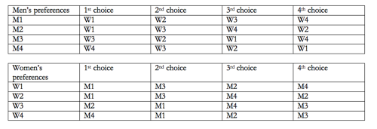

Answer:

For men:

M1 to W _ ; M2 to W _ ; M3 to W _ ; M4 to W _ ;

For women:

W1 to M _ ; W2 to M _ ; W3 to M _ ; W4 to M _ ;

**Problem 3.** *Dijkstra algorithm*

Run Dijkstra algorithm on this graph and find all shortest paths from Atlanta to all other cities.

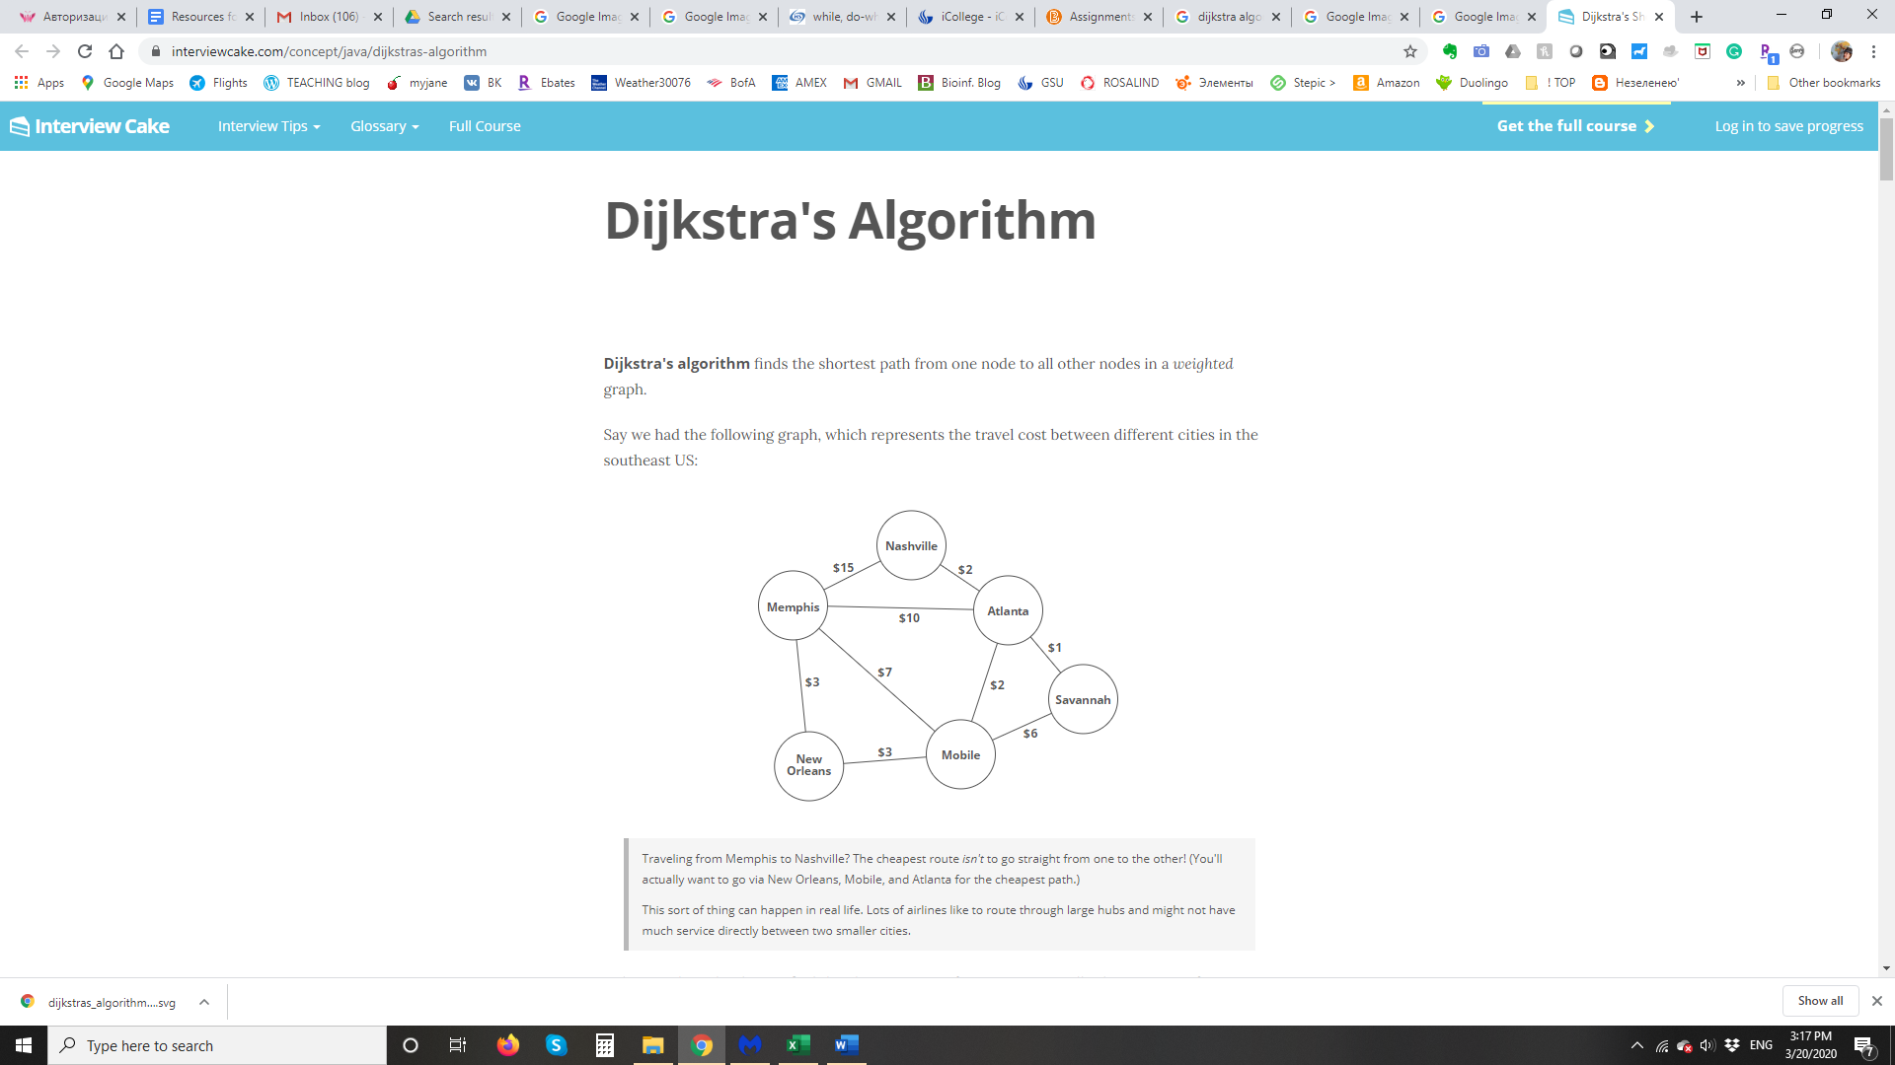

**Problem 4.** *Floyd-Warhall algorithm*

Run Floyd-Warhall algorithm on this graph. Mark all value changes (from previous matrix) in blue color, e.g. **5**.

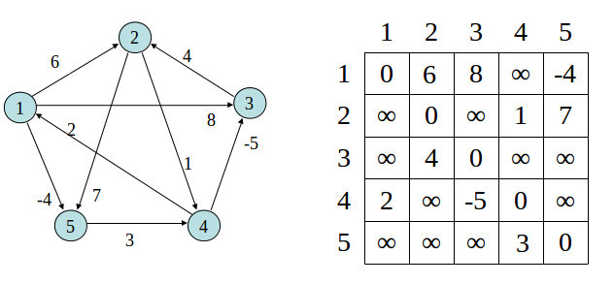

M_0 (cross-out first row and column)

|  |  |  |  |  |
| --- | --- | --- | --- | --- |
| **∞** |  |  |  |  |
|  | **∞** |  |  |  |
|  |  | **∞** |  |  |
|  |  |  | **∞** |  |
|  |  |  |  | **∞** |

M_1 (“result” of the previous matrix, cross-out second row and column, and so on)

|  |  |  |  |  |
| --- | --- | --- | --- | --- |
| **∞** |  |  |  |  |
|  | **∞** |  |  |  |
|  |  | **∞** |  |  |
|  |  |  | **∞** |  |
|  |  |  |  | **∞** |

M_2

|  |  |  |  |  |
| --- | --- | --- | --- | --- |
| **∞** |  |  |  |  |
|  | **∞** |  |  |  |
|  |  | **∞** |  |  |
|  |  |  | **∞** |  |
|  |  |  |  | **∞** |

M_3

|  |  |  |  |  |
| --- | --- | --- | --- | --- |
| **∞** |  |  |  |  |
|  | **∞** |  |  |  |
|  |  | **∞** |  |  |
|  |  |  | **∞** |  |
|  |  |  |  | **∞** |

M_4

|  |  |  |  |  |
| --- | --- | --- | --- | --- |
| **∞** |  |  |  |  |
|  | **∞** |  |  |  |
|  |  | **∞** |  |  |
|  |  |  | **∞** |  |
|  |  |  |  | **∞** |

M_5

|  |  |  |  |  |
| --- | --- | --- | --- | --- |
| **∞** |  |  |  |  |
|  | **∞** |  |  |  |
|  |  | **∞** |  |  |
|  |  |  | **∞** |  |
|  |  |  |  | **∞** |

*Critical thinking part and application of Floyd-Warhall algorithm.*

Consider given graph as a representation of a small community with 5 towns, and weights on edges are costs to travel (abstract yourself a bit about negative costs – it means that you’re profiting).

Now imagine you are on executive board at this community and in charge of spending federal money to build a hospital in the area. Where would you build it and why?

Try to come up with two ideas. Is one of them better than the other, what are pros and cons for each?