**HOMEWORK #5**

PROBLEM 1.

Use Ford-Fulkerson algorithm to find maximum st-flow and minimum st-cut in the netword shown below. Show every step, including residual flow (you drawing arrows by hand is Ok, although using word drawing capacities is even more appreciated)

Current flow in the netwrok is zero, capacities are given as weights on arcs.

(I recommend this video to refresh: <https://www.youtube.com/watch?v=hmIrJCGPPG4>)

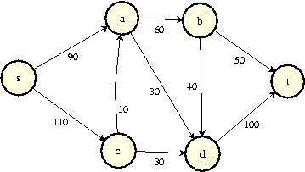

120, I don’t see any one got this wrong, so I skip the process 😊

PROBLEM 2.

Do 3 Bin packing algorithms (see slides #8).

You can assume you have infinite supply of bins (minibuses if we think as of packing data) of size 7.

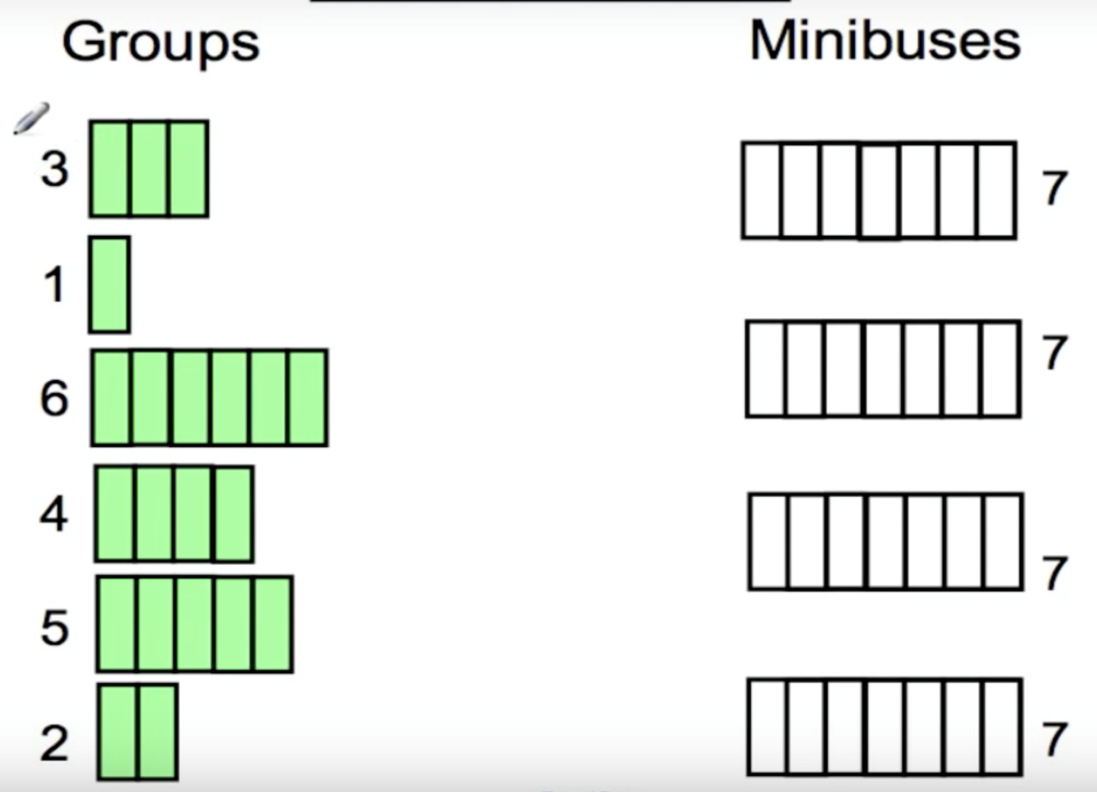

Next fit: [3,1][6][4][5,2]

First fit:[3,1,2][6][4][5]

First fit with sorting: [6,1][5,2][4,3]

PROBLEM 3.

Find Hamiltonian cycle in the following graph.

1. Use 2MST algorithm
2. Use Christofides algorithm

(It is Ok to reuse MST of course, for the same step #1 in both algorithms. Then they become looking different.)

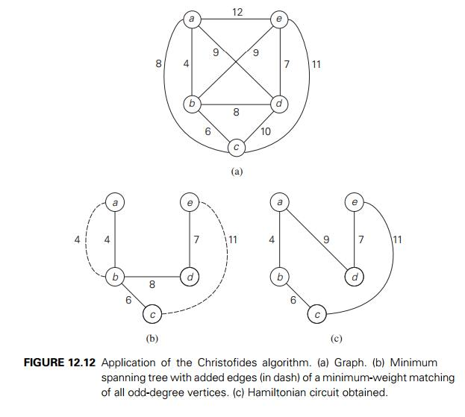

MST is (a,b)(b,d)(e,d) (b,c)

a)2MST can be abcbdedba

Shortcut can be (c,d), (e,a)

Ans: a,b,c,d,e,a

b)vertices with odd degree of MST are a,b,c,e

add cheapest edges to MST to create an Eulerian cycle: (a,b) (e,c)

Eulerian cycle is : abcedba

Find short cut (d,a)

Ans: a,b,c,e,d,a