***DNS FILTERED RESULTS***

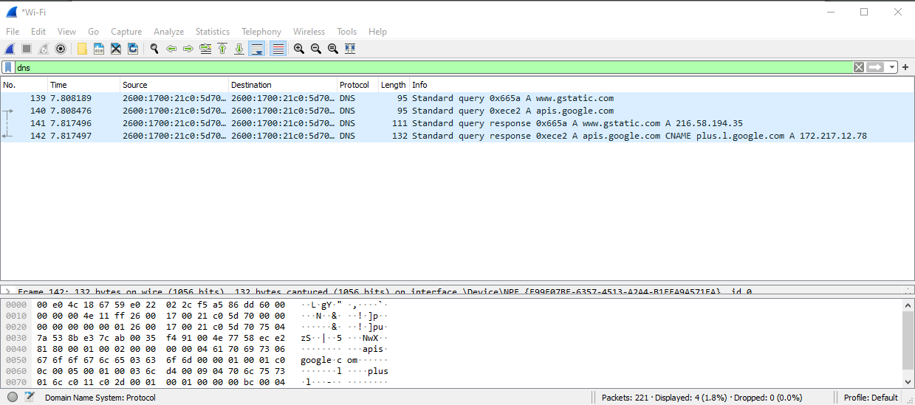

***PART 3 STEP 2***

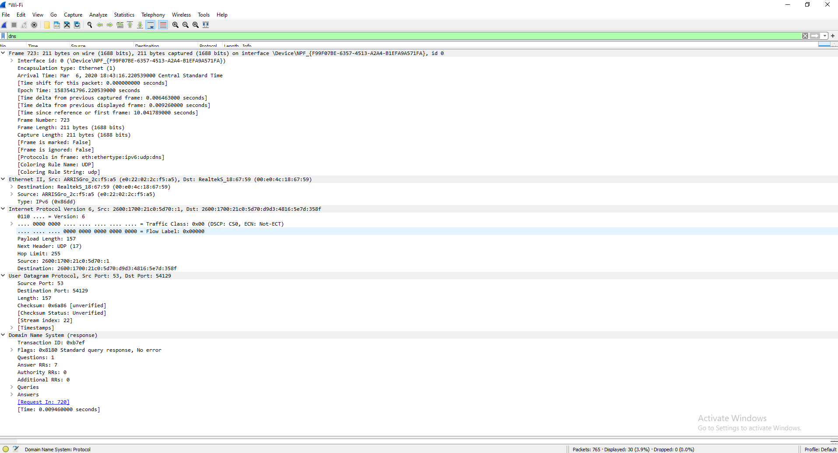

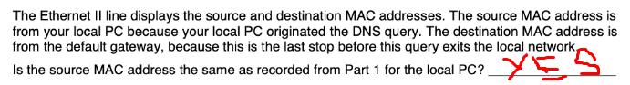

|  |  |  |
| --- | --- | --- |
| **Device** | **IP Address** | **MAC Address** |
| Local PC | 192.168.1.73 | e0:22:02:2c:f5:a5 |
| Default Gateway | 192.168.1.254 | 00:e0:4c:18:67:59 |

|  |  |
| --- | --- |
| **IP address** | **Answers will vary. 192.168.1.146** |
| MAC address | e0:22:02:2c:f5:a5 |
| Default gateway IP address | 192.168.1.254 |
| DNS server IP address | 192.168.1.254 |

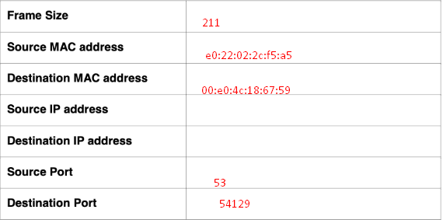

**Source IP : 2600.1700.21c0:5d70d9d3:3816:537d**

**Destination IP: 2600:1700:21c0:5d70::1**

Is the source IP address the same as the local PC IP address you recorded in Part 1? _____________ Yes

Is the destination IP address the same as the default gateway noted in Part 1? _____________

Yes, if the default gateway is also performing DNS.kal

***ACTIVE DNS_SPOOF PLUGIN***

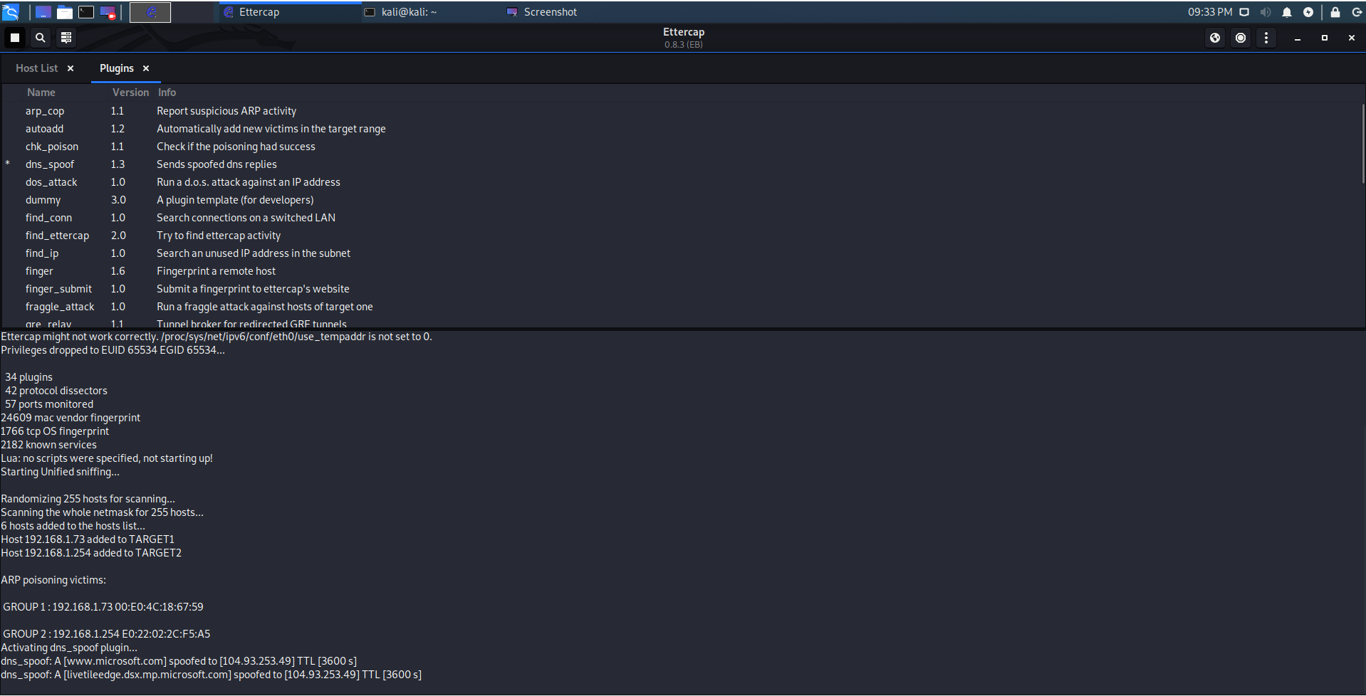

***SUCCESSFUL SPOOF***

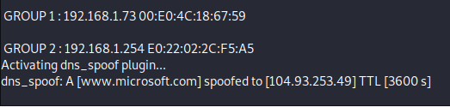

***EDITED ETTER.DNS***

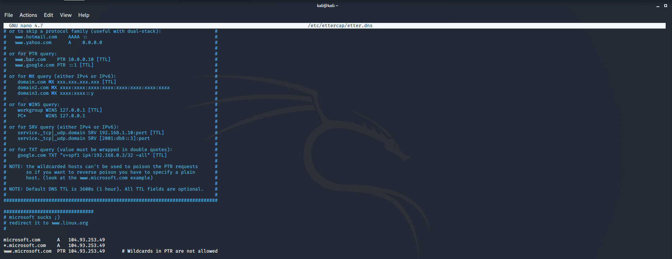

***PARAGRAPH SUMMARY***

So imagine you've got a massive phone book with everyone's names and phone numbers in.

If you think you might need a particular persons number often (say, your friend 'Bob'), you might write a copy of Bobs number down on a sticky note instead of going and taking the time to find their number in the phone book each time. It saves you time and effort. This is your 'cache'.

Now imagine that your evil house mate comes along and replaces that sticky note with a different one with the same name but a different phone number. Next time you go to call Bob, you don't bother with the book and just look at the sticky note that you thought you had. Only its been tampered with, and thus you end up calling someone else. And that person you call pretends to be Bob.

Now without realising it you could be telling someone else something you only originally intended to tell Bob.