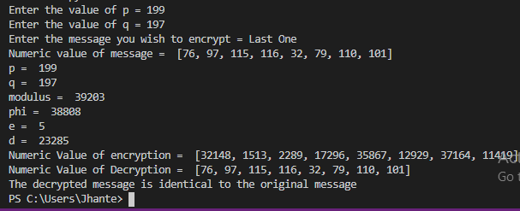
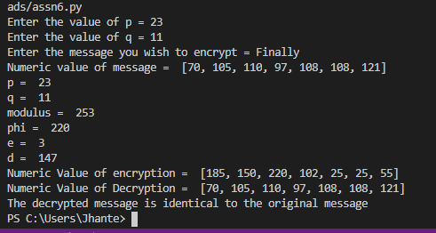
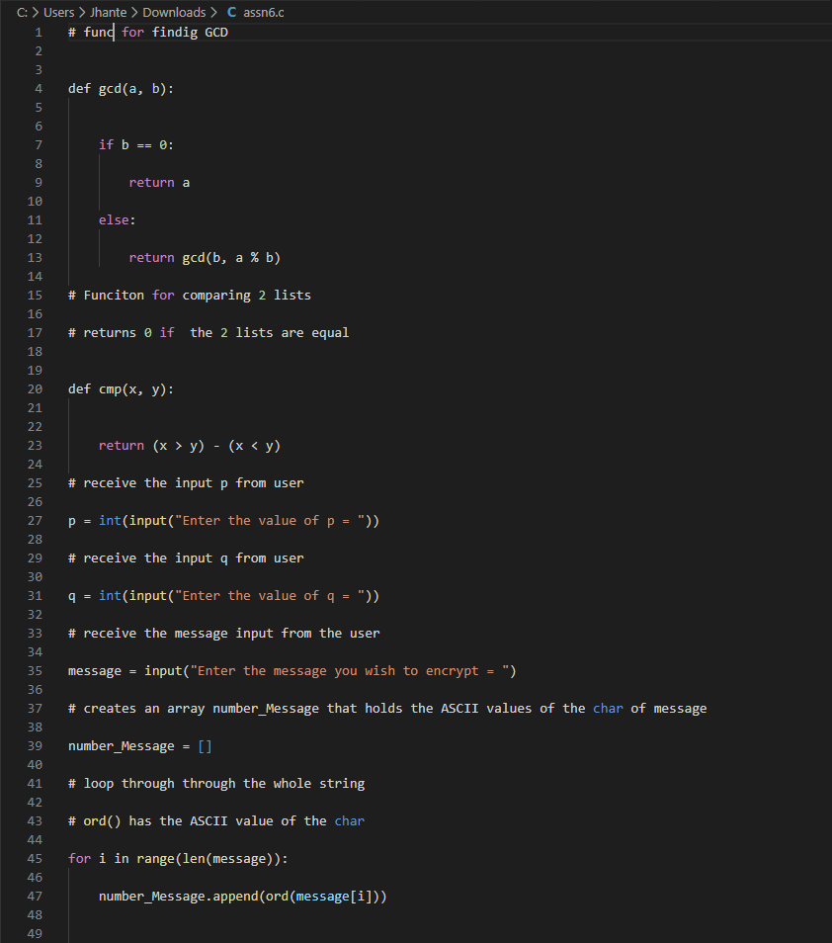
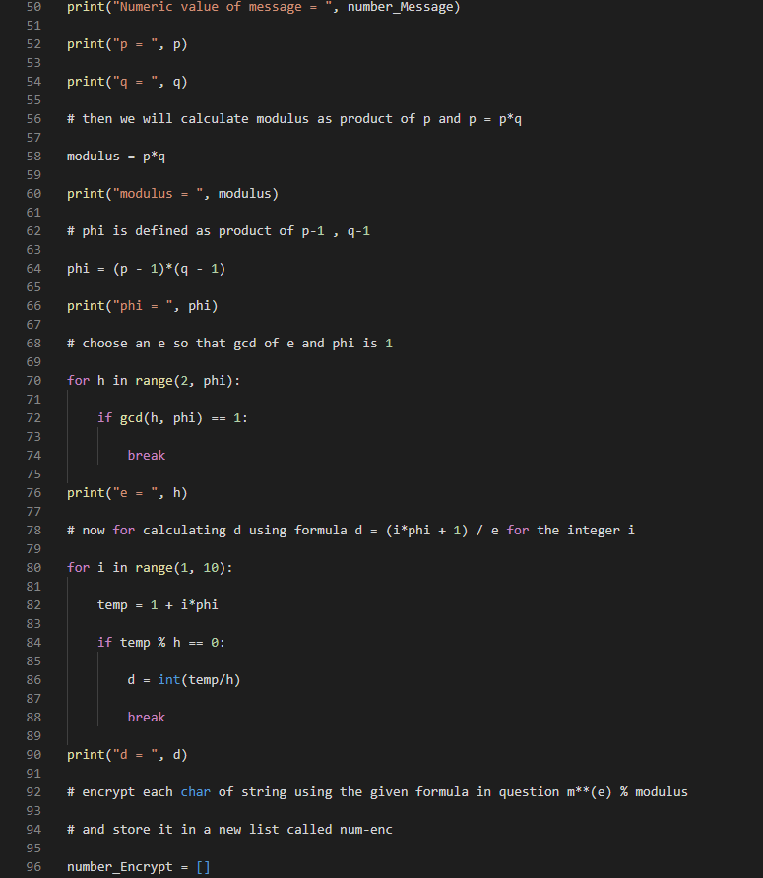
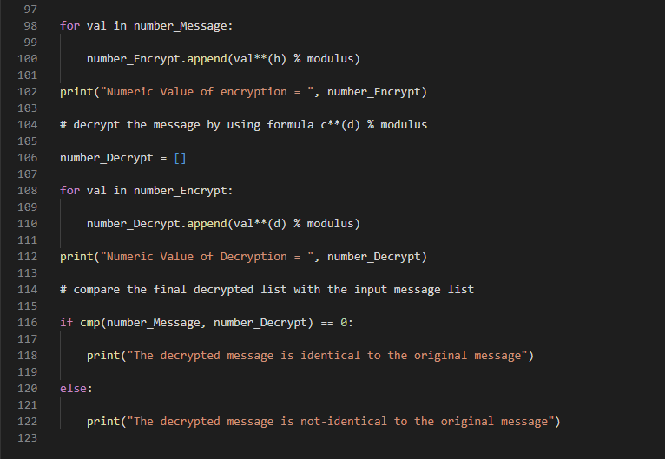
In short, I created a function for comparing the 2 lists that returns 0 if 2 of the lists are equal. I created an option to p and q from the user as user input. Next, I created an array that would hold the ASCII values from the characters of the mess and then loop through the whole string. Afterwards I calculated the modulus as a product of the p*q. I made sure that phi was defined as a product of p-1 * q-1 and chose an e so that the GCD of e & phi is 1. Then I used a for loop to calculate d using the formula d = (i*phi+1)/e. After that I encrypted each character of the string using said formula then stored them in a list. Following that was a decryption and then a comparison of the final list with the input message list.

