ENIGMA Viewer User Guide

(<http://enigma-viewer.org/>)

# Acknowledgement

This program is a collaborated work from the following organizations:

IVCL, University of Maryland, Baltimore County

University of Maryland, School of Medicine

ENIGMA Consortium

# Table of Contents

1. Acknowledgement 2

2. Table of Contents 3

3. Program Overview 4

4. Spatial View 6

1. Add/Remove an ROI to the view 6

2. Interactions 6

5. Chart View 7

1. Bar chart representation. 8

2. Add/Remove an ROI to the spatial view 8

3. Interactions 8

4. Other functions 10

6. Plot View 11

7. Control Panel 12

1. Spatial view controls 12

2. Chart view controls 13

3. Camera control 15

4. Data 15

# Program Overview

The ENIGMA viewer is a web-based program that can be executed on most modern browsers. It is recommended to use the latest version of Chrome for best compatibility.

The program interface is shown in Figure 1. It contains three major views. From left to right, these views are plot view, spatial view and chart view.

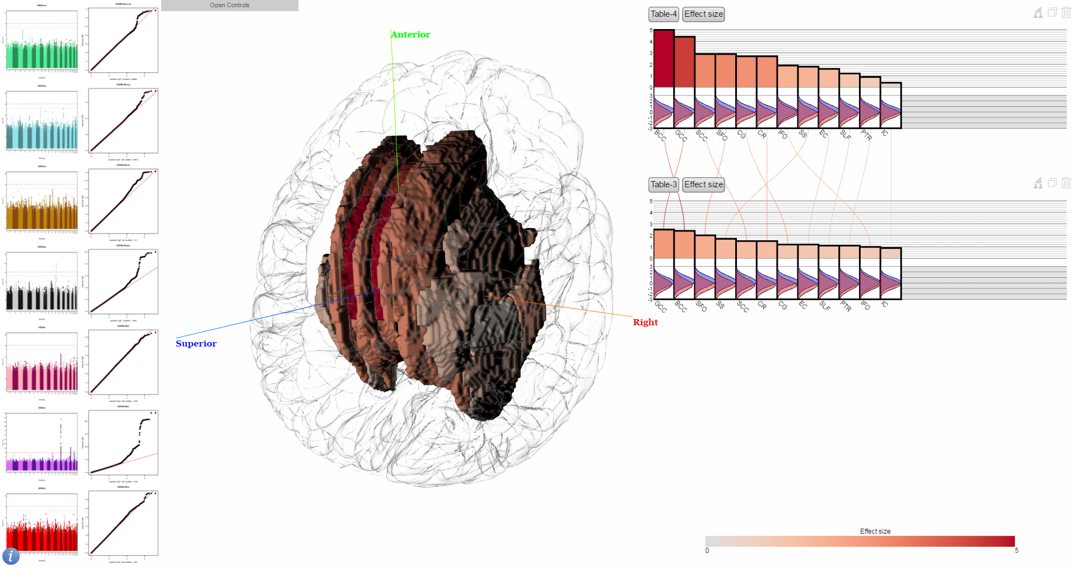

Figure Program Overview.

The plot view on the left displays images of Manhattan and QQ plots of several subcortical brain regions. Clicking on these images will make the corresponding brain regions shown in the spatial view.

The spatial view in the middle displays brain regions of interest (ROIs), including both cortical and subcortical regions. The cortical regions are displayed as transparent meshes while the subcortical regions are solid meshes. The 3D model can be rotated and scaled. Clicking on a mesh will remove it from the spatial view. Hovering over a mesh will display the related information on the tooltip.

The chart view on the right displays the statistics, namely effect size and p values of the corresponding ROIs. If population data is available, the FA value distribution will be drawn as Gaussian curves. The bars can be moved and scaled horizontally together by dragging and scrolling. Clicking on each of the bars will toggle the display of the ROI meshes in the spatial view. Hovering over a bar will display the related information on the tooltip. The legend of the color encoding is shown on the bottom of this view.

# Spatial View

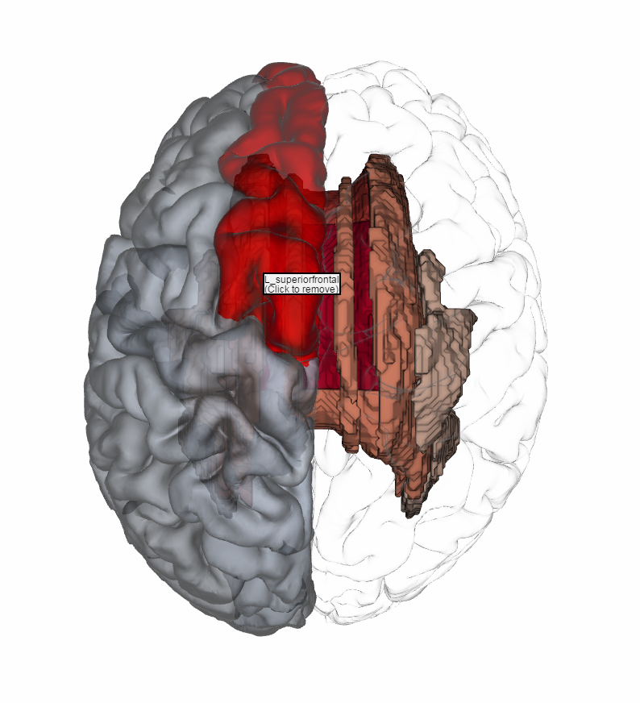

Figure Spatial view.

## Add/Remove an ROI to the view

Spatial view displays both cortical and subcortical ROIs showing as meshes displayed in a 3D glass brain model. The meshes are added to the spatial view by clicking a bar representing the corresponding ROI in the chart view. The ROIs are colored based on the bar color. To remove a mesh, simply click on the mesh in the spatial view.

## Interactions

Rotate. To view the 3D model from different angles, simply drag using the mouse left button.

Zoom. By scrolling using the mouse wheel, the model will be put closer to or farther away from the viewer.

Hover. Hovering the mouse cursor over an ROI mesh in the spatial view will display the information about the ROI at the cursor location.

# Chart View

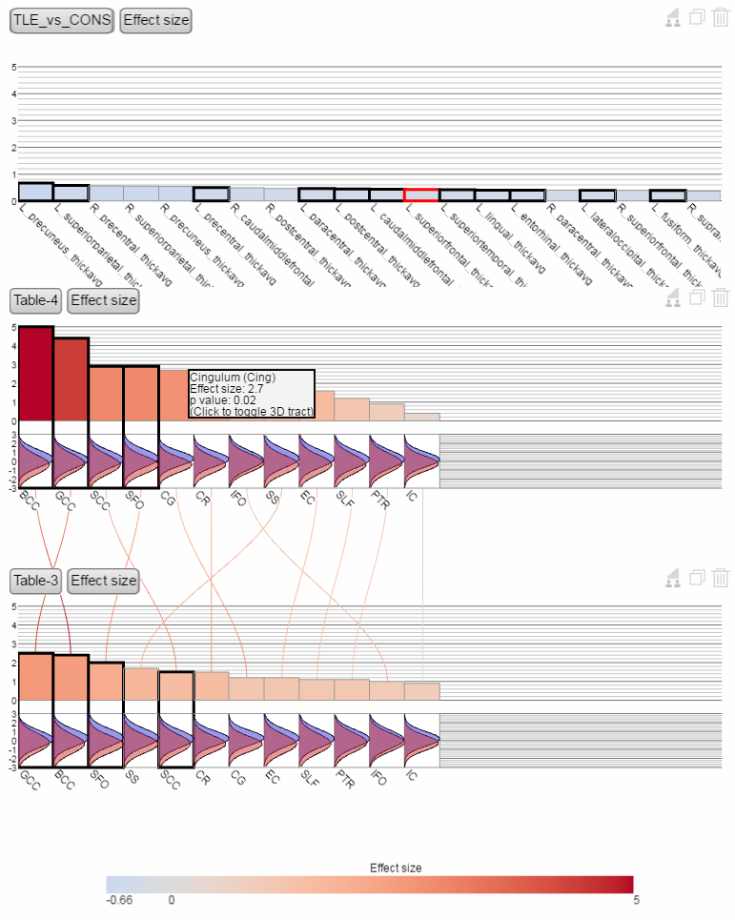

Figure Chart view.

Chart view displays the statistics from each study as bar chart. The legend of the color encoding is displayed at the bottom.

## Bar chart representation.

The chart representation uses both height and color to represent the statistics. Colors are always globally normalized, i.e. the same color always represents the same statistical values across bar charts. Bar height, by default is also globally normalized but can be changed to locally normalized so that the highest bar always occupies the entire vertical space within a chart.

## Add/Remove an ROI to the spatial view

Clicking on a bar chart representing one ROI will add the mesh representation into the spatial view. Those with meshes displayed in the spatial view will have a thick black bounding boxes highlight the bars. The ROI that are currently hovered by mouse cursor in the spatial view has red bounding box instead as shown in Figure 4.

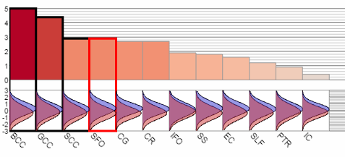

Figure Highlighted bars.

## Interactions

Translate. In case there are too many bars to be displayed and there is not enough horizontal space to show them all at once, these bars can be dragged to move along the horizontal direction. To do this, dragging the chart in the blank space (do not click on the bars) and move the mouse along the x axis.

Zoom. By scrolling using the mouse wheel, the width of the bars can be scaled accordingly.

Hover. Hover the mouse cursor over a bar will display the related ROI information on the tooltip.

Drag. Pressing on the most top left button, which displays the name of the dataset like thisand drag will move the chart as a whole. The chart can be dropped to other location to arrange the location of different bar charts. It can also be dropped to the spatial view which result in all the ROIs in the chart being added to the spatial view. Multiple charts can be added to the spatial view, as shown in Figure 5

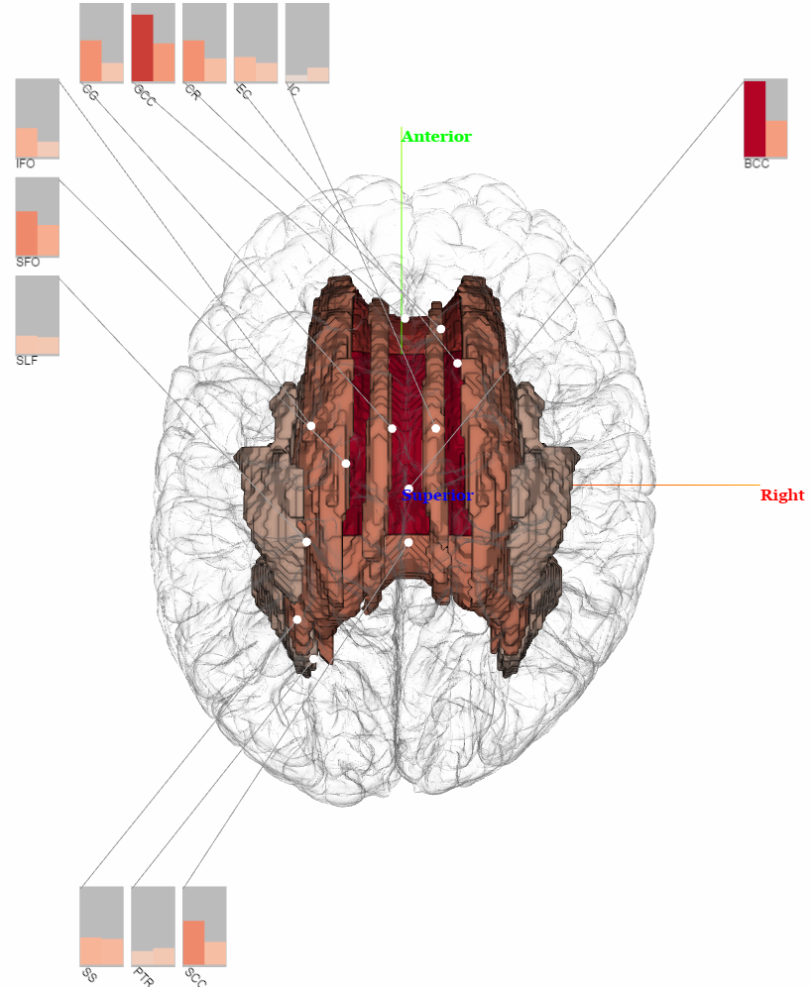

Figure Charts in spatial view.

Switch statistics. Press the button on the right to the most top left button, which displays the name of statistics, such as , will switch to next available statistics. Currently there are two statistics available in the visualization: effect size and p value. Clicking on the button will switch between the statistics and change the bar chart display accordingly, as shown in Figure 6.

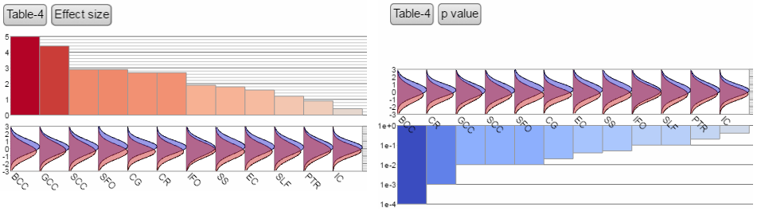

Figure Switch statistics.

## Other functions

As shown in Figure 3, there are several smaller buttons on the top right corner of each chart. These buttons are for toggling ROIs, copying chart and deleting a chart.

Toggle ROI button  is used to temporarily dismiss several ROI bars by making them smaller, as shown in Figure 7. By clicking this button, all selected ROI bars in the chart will be come much narrower and their labels will be hidden. Those that are already dismissed will become normal if they are selected where clicking the toggle ROI button.

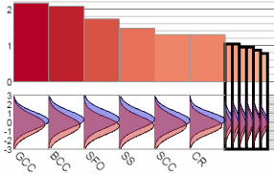

Figure ROI bar dismissal.

Copy and delete buttons  are used to make a copy of the current chart and delete the current chart. Copying the chart is useful if you want different statistics to be displayed for the same dataset.

# Plot View

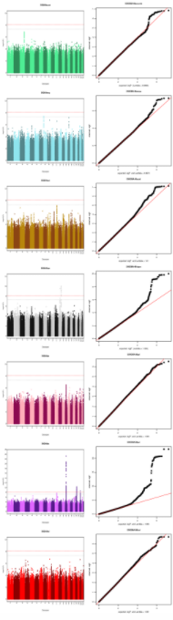Plot view displays the Manhattan plots (left) and QQ plots (right) of several subcortical regions.

Figure 8 Plot view.

Click on one of the plot will display the corresponding subcortical region in the spatial view. The region will have the same color as the one used in the Manhattan plot.

# Control Panel

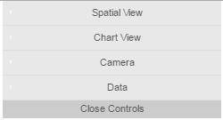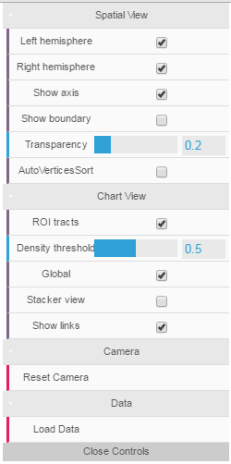

Figure Control Panel.

By default, the control panel is a small gray box located on the top left corner of the spatial view as in Figure 9 left. When clicking, it will expand to show its option categories as Figure 9 middle, each category can be expaneded. A fully expanded control panel is shown in Figure 9 right.

There are four major categories, controls for spatial view, chart view, spatial view camera and loading data.

## Spatial view controls

Left hemisphere/Right hemisphere: toggle the display of left/right hemisphere of the glass brain model.

Show axis: toggle the display of the axes showing anterior, superior and right directions.

Show boundary: toggle the display of boundary lines when a cortical mesh is added to the spatial view.

Transparency: adjust the transparency of the glass brain and the cortical meshes.

## Chart view controls

ROI tracts: toggle the generation and display of subcortical fiber tracts that pass through the subcortical ROI when a subcortical ROI is added to the spatial view. For example, when the ROI BCC is selected while the ROI tracts checkbox is checked, a transparency mesh is added to the spatial view with the BCC mesh as shown in Figure 10. See the density threshold below for description on the transparent tract mesh generation.

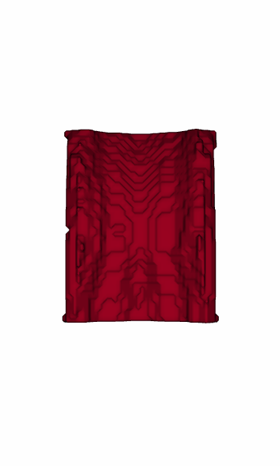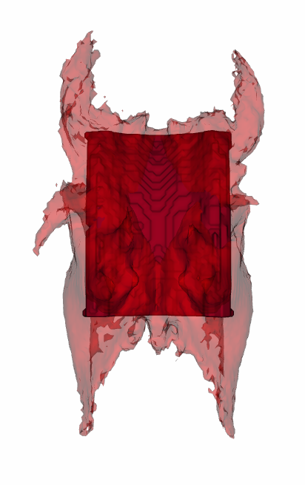

Figure ROI tracts.

Density threshold: the tract mesh from one subcortical ROI is generated from a density field for each ROI. The density field describes on each voxel the percentage of subject that has fiber passing through the selected ROI. The density threshold slider bar adjusts the threshold based on which an iso-contour is generated as the tract mesh. Note the value from this bar only affects the mesh being generated afterwards. Previously generated tract meshes will not be adjusted to newer density threshold because mesh generation on the density field is an expensive operation for the web application. To adjust this parameter on a previously generated tract mesh, click the old mesh to remove it and click the ROI bar again to let the program regenerate a new tract mesh based on the new threshold.

Global: toggle whether or not the bar heights are normalized globally or locally.

Stacker view: merge all chart views into a single stacker view where all effect size values belong to the same ROI are stacked together, as shown in Figure 11.

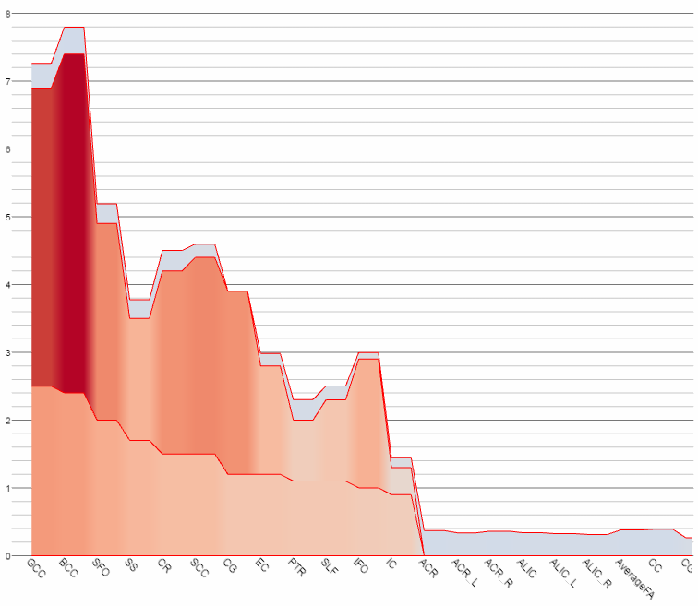

Figure Stack view.

Show links: toggle whether or not the links that connect the same ROIs across adjacent chart views are displayed, as shown in Figure 12. The link from an ROI bar is colored according to the color of its connected bars.

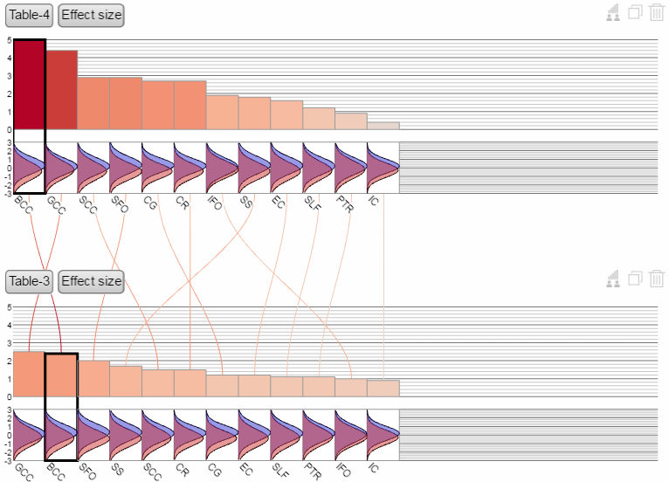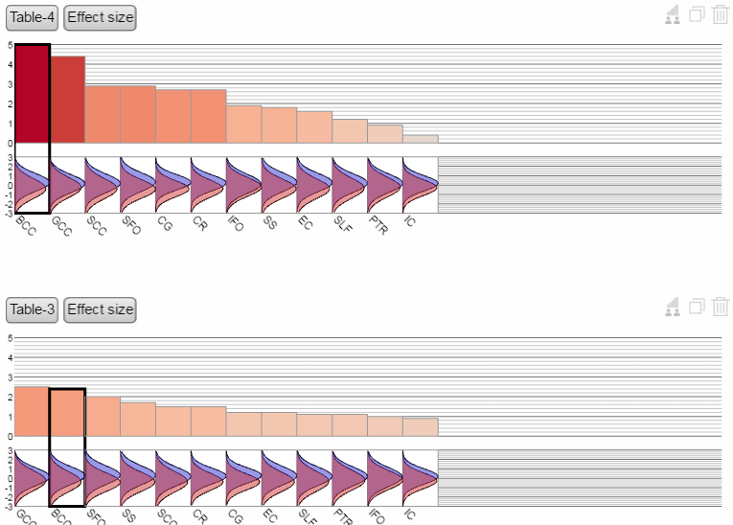

Figure Show links.

## Camera control

Reset camera: this will reset the camera to the default viewing angle.

## Data

Load data: upload a CSV file to add a new chart to the visualization. The data format is as follows:

Table Data format-subcortical

|  |  |  |  |  |  |
| --- | --- | --- | --- | --- | --- |
| roi | ACR | ACR_L | ACR_R | ALIC | ALIC_L |
| meta_d | -0.37086 | -0.33769 | -0.36108 | -0.33922 | -0.3255 |
| meta_pval | 6.72E-09 | 1.33E-07 | 9.14E-09 | 4.66E-08 | 3.82E-07 |

The table shown above are the content being read from the program. The content that triggers data input are the first column which must be named “roi”, “meta_d” and “meta_pval”, which refer to the ROI name row, effect size row and p value row respectively. The ROI row contains ROI names. For subcortical regions, the names must be included in the JHU/ENIGMA white matter template look up table.

Table Data format-cortical

|  |  |  |  |
| --- | --- | --- | --- |
| roi | L_precuneus_thickavg | L_superiorparietal_thickavg | R_precentral_thickavg |
| meta_d | -0.66762 | -0.57735 | -0.56487 |
| meta_pval | 8.66E-07 | 1.45E-04 | 1.17E-16 |

The above table shows the same table for cortical regions. The only difference is the format of names. Since the white matter template does not contain cortical regions. The names are currently in the above format.

Note the CSV file can contain other rows but only rows that begins with the aforementioned three names (“roi”, “meta_d” and “meta_pval”) will be read.