GPU writeup.
The purpose of this experiment was to determine whether GPUS were a viable option when it came to speeding up oasis. We used the calculation of Pi to determine this.
The Pi calculation was using Monte Carlo sampling. We placed random coordinates in a unit square and calculated the ratio between the number falling within a circle of radius 1, and those outside of the circle.

Just in case extra clarification is needed;
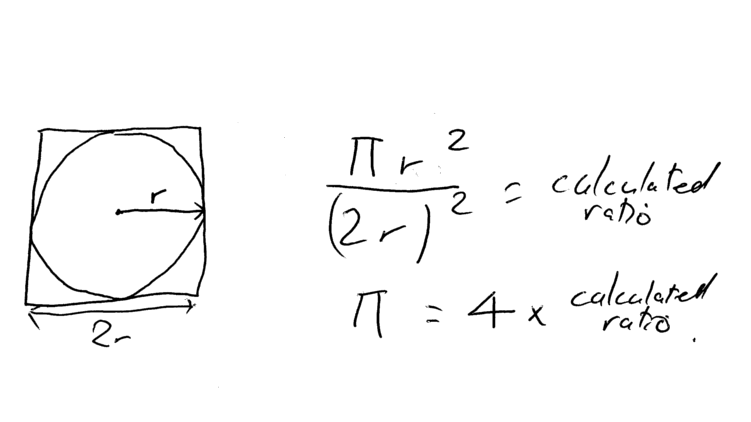
Program type | Time taken (secs) | Accuracy
Single core | 22.752820 | Approximately within 0.0003
20 cores | 1.809902 | Approximately within 0.0003
GPU | 0.865830 | Approximately within 0.0003

Specs:
Dual Xeon x5660 12 physical, 24 logical cores
16GB dual channel 500 mhz ram
Nvidia geforce gtx 660.

The random number algorithm is roughly¹ the same, both are Mersenne twisters for the CPU and GPU. The CPU version is 64 bit, GPU is 32.

It should be noted that the GPU is relatively low end compared to the CPUs.
I would expect an enterprise card to perform much better.
Multiple GPUs can also be used, adding this. Will also try to increase performance with single.

The main bottleneck in using the GPU is PCIe interface, transferring lots of data over the bus will take a while, particularly in my computer, as I am on PCIe 2.0 x8. In longer workflows than this, The GPU should be far more efficient.
As a finale note, There are very many implementations online where people have proved the GPUs to be far more efficient than I have. This may be for several reasons:
- My GPUs are cheap and slow
- my cuda implementation may be sub standard.
- Discrepancies in the number of samples made.

Reference:
http://docs.nvidia.com/cuda/#axzz3ihWNglZK.

