QUANTITATIVE METHODS AND MODELLING

Edi Graovac

**05.06.2025.**

# INTRODUCTION

The primary goal of this task is to analyze the heart weight of cats, with a special emphasis on comparisons between sexes. We are interested in determining whether there is a relationship between heart weight and cat sex, that is, whether male cats have a larger heart weight than female cats.

For this analysis, we will use a dataset called "cats.csv", which contains 60 measurements of different cats. The dataset contains the data shown in the *Table 1*.

|  |  |  |
| --- | --- | --- |
| Variable | Variable type | Description |
| sex | Nominal categorical variable (char) | indicates the sex of the cat  "F" for female cats  "M" for male cats |
| bwt | continuous numerical (float) | the cat's body weight, expressed in kilograms. |
| hwt | continuous numerical (float) | weight of a cat's hearth, expressed in grams |

Table Variables in the dataset

Analysis of this dataset includes information on:

* Descriptive analysis of variables - mean, five number summary, range, interquartile range, and standard deviation
* Visualize the distribution of heart weight
* Test if heart weight is normally distributed both graphically and through hypothesis testing, separately for male and female cats
* 95% confidence interval for the mean and standard deviation of heart weight, separately for male and female cats.
* Test if the variances of heart weight between male and female are equal
* Test if the means of heart weight between male and female are equal
* 95% confidence interval for the difference in the means of heart weight between male and female cats.

# DATA PRESENTATION

This section presents a comprehensive descriptive analysis of the dataset used to explore differences in heart weights between male and female cats. The study includes detailed statistics presented through tables and graphs, providing insights into key distributions and central tendencies within the data.

The following analysis breaks down the heart weights by sex, offering a comparison of central tendency and variability.

|  |  |  |  |  |  |  |  |  |  |
| --- | --- | --- | --- | --- | --- | --- | --- | --- | --- |
| Sex | Mean | Min | Q1 | Median | Q3 | Max | Range | IQR | STD |
| Male | 11.36 | 8.1 | 10.4 | 11.5 | 12.25 | 13.4 | 5.3 | 1.85 | 1.29 |
| Female | 8.9 | 5.2 | 7.95 | 9.2 | 10.0 | 10.9 | 5.7 | 2.05 | 1.37 |

Table Descriptive statistics of main variables

The data from the *Table 2* shows that male cats have an average weight of around 11.36 g with a standard deviation of 1.29. While for females we can see that their average weight can be slightly lower than that of males and is 8.8 g, followed by a higher standard deviation of 1.37. According to the standard deviation values ​​of both sexes, we can notice that all our data are close to the mean.

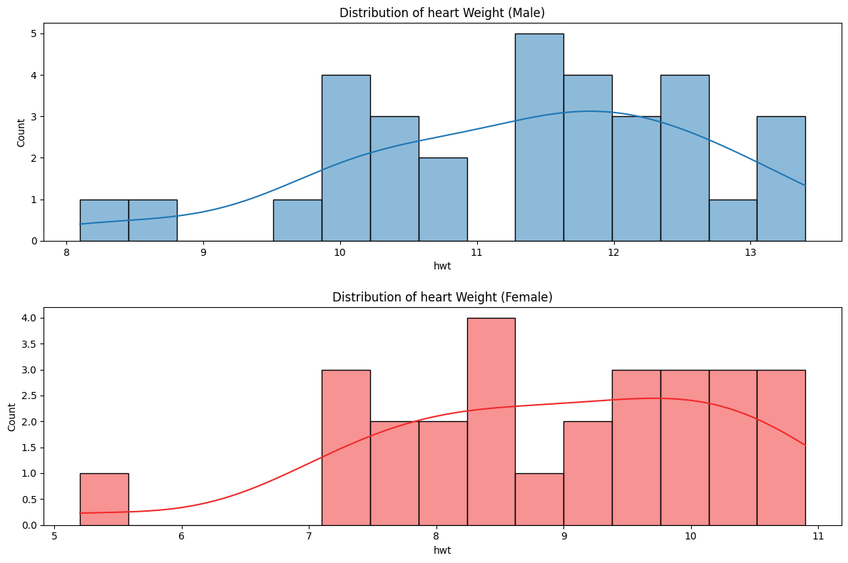

Figure Distribution of heart weight per sex

The graphs shown in *Figure 1* confirm the conclusions about heart weights of male and female cats. In the upper blue graph, the male heart weights show a bell-shaped distribution, indicating a normal distribution with most values ​​around 11.36 g. The data in the lower red graph have the same shape with values ​​primarily concentrated around the average of 8.9 g. This symmetrical pattern supports our statistical analysis of moderate variability, confirmed by the calculated mean.

# ANALYSIS RESULT

To gain a deeper understanding of the distribution of heart weights in male and female cats, a Shapiro-Wilk test was performed. The results showed that the heart weights of males and females were normally distributed, with p-values ​​of 0.3631 and 0.1657, respectively. Both values ​​exceed the significance level of 0.05, confirming a normal distribution for both groups.

The average heart weight for male cats is 11.36 grams (±1.29 grams), with a standard deviation confidence interval of [1.05, 1.74] grams. Female cats have a mean heart weight of 8.9 grams (±1.37 grams), with a confidence interval of [1.09, 1.91] grams.

An F-test was performed to compare the mean heart weights between the two groups. The results indicated no significant difference in variances, as the F-statistic was 0.8785 with a p-value of 0.6379.

After that, an independent samples t-test assuming equal variances showed a significant difference in mean heart weights between male and female cats, with a t-statistic of -6.8908 and a p-value of 0.000.

The 95% confidence interval for the difference in means is 2.46 grams, with a range of [1.735, 3.124] grams, confirming that male cats have a significantly higher average heart weight than female cats.

# SUMMARY

During the preparation of this paper, various statistical analyses and methodologies were used to understand the differences in heart weight between male and female cats. Analyzing a data set of 60 cats, this analysis aimed to detect a significant association between heart weight and gender.

The data were carefully examined through descriptive statistics, providing insight into the central tendencies and variability for each gender. Histograms visually confirmed the findings, with male and female cats showing a normal distribution, as confirmed by the Shapiro-Wilk test with p-values ​​greater than 0.05.

Male cats showed a higher mean heart weight of 11.36 grams, compared to 8.9 grams in females. Confidence intervals for the standard deviation confirmed these findings, as did the F-test, which showed no significant differences in variance. However, an independent samples t-test confirmed a significant difference in mean heart weight, confirming that male cats have a higher mean heart weight.

This comprehensive analysis highlights the importance of gender as a factor in heart weight differences among cats, providing valuable insights for veterinary studies and animal physiological research.