Coaching Touchpoints Benchmark Analysis
Date: February 4, 2026
Author: Data Analytics
Status: Draft
Updated: February 5, 2026 (corrected join to include all drivers)

Goal
Determine what a "healthy" level of coaching touchpoints looks like by comparing distributions across pre-assigned driver risk categories and comparing customers with ARR < 100k vs ARR ≥ 100k.

Definitions
Term | Definition
Coaching touchpoints | Count of distinct coachable_item_uuid where share_type IN (1, 2) — Self-Review OR Manager-Led Coaching. Excludes training.
Weekly period | Jan 26 – Feb 1, 2026
Monthly period | Jan 1 – Jan 31, 2026
Driver risk category | From product_analytics.driver_risk_classification as of Feb 1, 2026 (LOW, MEDIUM, HIGH)
ARR segment | Derived from account_arr_segment in datamodel_core.dim_organizations: ARR < 100k or ARR >= 100k

Data Sources
Source | Purpose
coachingdb_shards.coaching_sessions | Coaching session metadata
coachingdb_shards.coachable_item | Individual coaching items per session
coachingdb_shards.coachable_item_share | Share type (1=Self-Review, 2=Manager-Led)
product_analytics.driver_risk_classification | Driver risk category (LOW/MEDIUM/HIGH)
datamodel_core.dim_organizations | Account ARR segment

Summary Results

Population Overview
Metric | Count | %
Total drivers with risk classification | 733,163 | 100%
Drivers with any coaching (monthly) | 44,674 | 6.1%
Drivers with zero coaching | 688,489 | 93.9%

% of Drivers Receiving Any Coaching by Risk Level & ARR Segment
ARR Segment | Risk Level | Total Drivers | Drivers Coached | % Coached
ARR < 100k | LOW | 25,564 | 299 | 1.2%
ARR < 100k | MEDIUM | 64,351 | 2,070 | 3.2%
ARR < 100k | HIGH | 179,372 | 13,032 | 7.3%
ARR >= 100k | LOW | 53,009 | 454 | 0.9%
ARR >= 100k | MEDIUM | 136,290 | 3,933 | 2.9%
ARR >= 100k | HIGH | 274,577 | 24,886 | 9.1%

Monthly Touchpoints (All Drivers, Including Zeros)
ARR Segment | Risk Level | N Drivers | p50 | p99 | Mean
ARR < 100k | LOW | 25,564 | 0 | 1 | 0.06
ARR < 100k | MEDIUM | 64,351 | 0 | 3 | 0.17
ARR < 100k | HIGH | 179,372 | 0 | 15 | 0.68
ARR >= 100k | LOW | 53,009 | 0 | 0 | 0.02
ARR >= 100k | MEDIUM | 136,290 | 0 | 2 | 0.12
ARR >= 100k | HIGH | 274,577 | 0 | 13 | 0.72

Visualizations
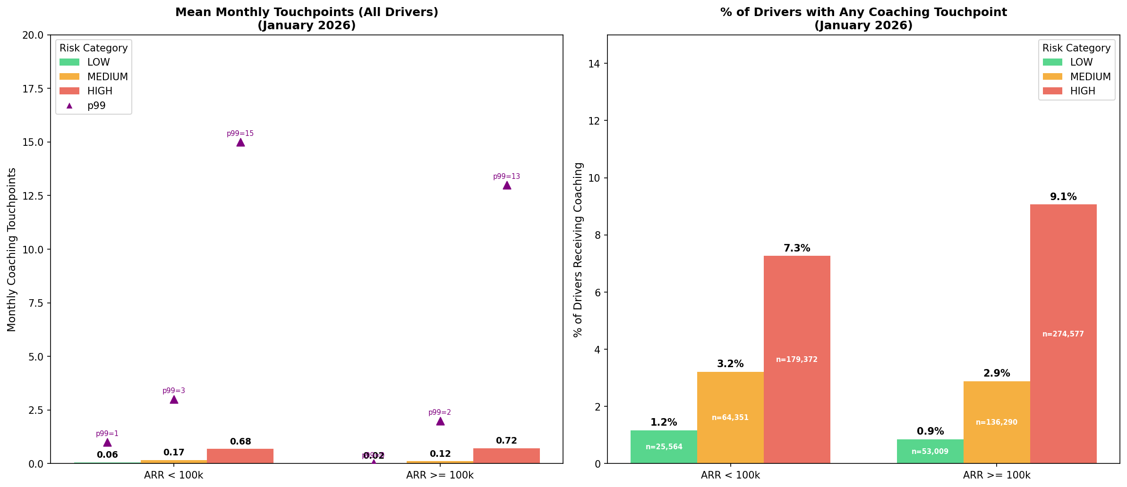
Left chart: Mean monthly touchpoints for all drivers by risk level and ARR segment, with p99 markers.
Right chart: Percentage of drivers receiving any coaching touchpoint by risk level within each ARR segment.

Key Takeaways

1. Most Drivers Receive No Coaching
• 93.9% of drivers had zero coaching touchpoints in January 2026
• Only 6.1% received any coaching (self-review or manager-led)
• This is consistent across both ARR segments

2. Coaching is Risk-Aligned
• HIGH-risk drivers are most likely to receive coaching:
- ARR < 100k: 7.3% of HIGH vs 1.2% of LOW
- ARR >= 100k: 9.1% of HIGH vs 0.9% of LOW
• HIGH-risk drivers receive 6-10x higher coaching rates than LOW-risk drivers

3. Larger Customers (ARR >= 100k) Coach Slightly More
• HIGH-risk coaching rate: 9.1% (ARR >= 100k) vs 7.3% (ARR < 100k)
• This may reflect more mature safety programs at larger organizations

4. When Drivers Are Coached, Volume is Similar
• Among coached drivers, mean monthly touchpoints are similar across ARR segments
• HIGH-risk coached drivers: ~7-9 touchpoints/month on average

Benchmarks
Based on this analysis, here are suggested coaching benchmarks:
Metric | Current State | Suggested Benchmark
% of HIGH-risk drivers coached | 7-9% | Target 15-20%
Monthly touchpoints for coached HIGH-risk | 7-9 mean | Maintain or increase
% of LOW-risk drivers coached | ~1% | Acceptable (focus on HIGH)

SQL Query
WITH coaching_touchpoints AS (
SELECT
cs.org_id,
ci.driver_id,
COUNT(DISTINCT CASE
WHEN ci.date BETWEEN '2026-01-26' AND '2026-02-01'
THEN ci.uuid
END) AS touchpoints_weekly,
COUNT(DISTINCT CASE
WHEN ci.date BETWEEN '2026-01-01' AND '2026-01-31'
THEN ci.uuid
END) AS touchpoints_monthly
FROM coachingdb_shards.coaching_sessions cs
JOIN coachingdb_shards.coachable_item ci
ON cs.uuid = ci.coaching_session_uuid
JOIN coachingdb_shards.coachable_item_share cis
ON ci.uuid = cis.coachable_item_uuid
WHERE cis.share_type IN (1, 2) -- Self-Review or Manager-Led
AND ci.date BETWEEN '2026-01-01' AND '2026-02-01'
AND ci.driver_id IS NOT NULL
AND ci.driver_id != 0
GROUP BY cs.org_id, ci.driver_id
),
risk_classification AS (
SELECT org_id, driver_id, classification AS driver_risk_category
FROM product_analytics.driver_risk_classification
WHERE date = '2026-02-01'
),
org_arr AS (
SELECT
org_id,
CASE
WHEN account_arr_segment IN ('100k - 500K', '500K - 1M', '1M+')
THEN 'ARR >= 100k'
ELSE 'ARR < 100k'
END AS org_arr_segment
FROM datamodel_core.dim_organizations
WHERE date = '2026-02-01'
AND is_paid_customer = TRUE
)
SELECT
rc.driver_id,
rc.org_id,
rc.driver_risk_category,
COALESCE(ct.touchpoints_weekly, 0) AS touchpoints_weekly,
COALESCE(ct.touchpoints_monthly, 0) AS touchpoints_monthly,
oa.org_arr_segment
FROM risk_classification rc
LEFT JOIN coaching_touchpoints ct
ON rc.org_id = ct.org_id AND rc.driver_id = ct.driver_id
LEFT JOIN org_arr oa
ON rc.org_id = oa.org_id
WHERE oa.org_arr_segment IS NOT NULL

Note: The key change from the initial analysis is using risk_classification LEFT JOIN coaching_touchpoints instead of the reverse. This ensures ALL drivers with a risk classification are included, not just those who received coaching.

Files
File | Description
coaching_analysis_data.csv | Driver-level data (733,163 rows)
coaching_analysis_charts.png | Visualization charts
coaching_touchpoints_benchmark_analysis.md | Markdown document

Appendix: Coaching Touchpoint Definitions
From safety_constants.py:
share_type | Coaching Type | Description
1 | Self-Review (Self-Coaching) | Driver reviews the safety event on their own via the app
2 | Manager-Led Coaching | A coach/manager reviews the event with the driver

Note: Training (product_type = 3 from formsdb) is tracked separately and is NOT included in coaching touchpoints.

