MODELING TECHNIQUES

Spatial Process GLMM Specification and Priors
The response variable y(s_{i}) was the number of vegetation plots that contain the species of interest within the i^{th} 10km grid cell at location s_{i}. Given the total number of vegetation plots within the grid cell, N(s_{i}), we assumed y(s_{i}) followed a binomial distribution. For the i^{th} location, the distribution of y(s_{i}) was taken to be:
π(y(s_{i} ) | η(s_{i} )) ~ Binomial(N(s_{i}), p(η(s_{i}))),
where p(η(s_{i})) = exp(η(s_{i}))/(1 + exp(η(s_{i}))) is the probability of species presence,
and η(s_{i}) = x(s_{i})’β + w(s_{i}),
where x(s_{i}) is a vector comprising an intercept and location-specific climate covariates, β is a vector of regression coefficients, and w(s_{i}) is the spatial random effect.

The output of our models is an estimate of the probability of occurrence, p(η(s_{i})), for individual samples within a grid cell, which is equivalent to predicted prevalence; we will use these two terms interchangeably throughout this manuscript. The random effect, w(s), was specified as a Gaussian process with a mean of zero with a covariance function between locations s_{i} and s_{j} defined as:
C(s_{i},s_{j})= σ² ρ(s_{i} ,s_{j} ; φ),
where σ² defines the magnitude of correlation,
ρ( · ; φ) is an exponential correlation function, and
φ is the spatial decay parameter.

Prior distributions on the remaining parameters complete the hierarchical model. The vector of regression effects β was assigned an uninformative multivariate Gaussian prior, while the latent variance component σ² was assigned an uninformative inverse gamma prior with shape and scale parameters of 2 and 1 respectively. The spatial decay parameter, φ, was assigned a uniform prior with support between effective ranges (the range at which the magnitude of correlation decays to 5% of its maximum value) of 20 and 600km, based on the average nearest neighbor distance between knots and half the span of the study area respectively. Point locations for the spatial process were defined as the centroid of the plot locations within a given grid cell. We also fit the corresponding GLMs with η(s_{i}) = x(s_{i})’β.

Fitting of Models
Models were fit within a Bayesian framework using an adaptive Metropolis within Gibbs sampler (Roberts and Rosenthal, 2009). Computations were performed in R (2.10.1; R Development Core Team, 2011) using the spGLM routine in the spBayes package (Finley et al, 2007). All covariates were standardized prior to modeling to avoid collinearity with the intercept and thus speed model convergence. Quadratic functions of each covariate were included to allow for non-linear responses. GLM models were also fit within the Bayesian framework to facilitate comparison between methods.
In the fitting of GLMMs, we ran 3 independent chains in parallel to convergence using an iterative approach. Individual chains were initiated using randomized starting values. An initial set of 25000 iterations was assessed for convergence over the last 50% of iterations using two criteria. First, we used the Multivariate Potential Scale Reduction Factor (MPSRF) diagnostic of Brooks and Gelman (1998) to assess mixing of the three chains (Brooks and Gelman, 1998). MPSRF values close to one indicate good mixing of the chains. We used a upper threshold of 1.3 to determine convergence. Trace plots indicated that in some cases, the spatial process parameters followed a trend despite good mixing of the chains as indicated by the MSPRF statistic. To check for such trends, we fit linear mixed effects models to each of the spatial process parameters, with slope and intercept as fixed effects and slope by chain as a random effect. The chains were thinned to every 50th observation to reduce autocorrelation. If MSPRF or either trend test (α=0.05) indicated a lack of convergence, we resumed the chains for an additional 10000 iterations and repeated the tests for convergence using the last 50% of amended chains. This process was repeated until convergence was achieved, requiring a total of 35000 to 75000 iterations. Upon convergence, samples were extracted from the last 50% of each chain and were systematically thinned to a total of 3000 samples for further analysis.

Spatial Predictive Process GLMs
The space varying intercept term, i.e., a spatial random effect, in the GLMM captures residual spatial dependence and is modeled using a zero centered spatial Gaussian process, see, e.g., Diggle and Ribeiro Jr. (2007). This random effect follows a multivariate normal distribution, with a n-by-n variance-covariance matrix that represents the spatial covariance among the locations where species occurrence was recorded. Estimation of the model’s parameters requires that the inverse and determinant of this n-by-n be evaluated within each MCMC iteration. The computational expense of these inversions is proportional to n³, making it difficult to fit such models to large datasets (> 1000 observations) using current computational technology. The spatial predictive process model introduced by Banerjee et al. (2008) provides an approximation to the “parent process” or the process estimated over the n observed locations. Following the notation in Banerjee et al. (2008), the spatial random effect, w(s), where s is the geographic coordinates of an observation, is modeled over a reduced set of locations, referred to as knots. Instead of inverting the n-by-n spatial variance-covariance matrix, the inversion is performed on a smaller matrix representing the spatial association among the knots, saving computationally expense. Then the value of w(s) at the n observed locations is predicted using an optimal estimator. The original predictive process specified in Banerjee et al. (2008) induces a bias in the variance parameter estimates. A modified predictive process, that adjusts for this bias was specified by Finley et al. (2009) and used in our current analysis.

For the current analysis, the predictive process was based on 300 knot locations, selected using k-means clustering on the historic data locations. Such knot designs have been shown to produce results comparable to other, more sophisticated, designs, see, e.g., Guhaniyogi et al. (2011). Here, the most critical element of the knot design is that the domain is adequately covered and the distance between knots is sufficiently short to allow the spatial random effects decay parameter to be estimated. For our design, the median distance from each historic data point to the nearest knot location was 7.5 km and the median nearest-neighbor distance between knots was 17.0 km. The estimated spatial decay parameter had an median effective spatial range of 160 km, which suggests the chosen knot intensity was sufficient.

Assessment of Residual Autocorrelation
To assess spatial dependency we used Moran’s I test on deviance residuals in 12 discrete distance classes . The classes used, in km, were: 0-15; 15-30; 30-45; 45-60; 60-75; 75-90; 90-120; 120-150; 150-200; 200-250; 250-300; and 300-600. Global significance was assessed using the minimum p-value of these tests after adjustment for multiple comparisons using the method of Holm (1979). Range of significant autocorrelation was estimated as the upper limit of the furthest significant bin for which all lesser bins were also significant. Magnitude of autocorrelation was measured using the value of the Moran’s I statistic in the first distance class, which included only adjacent grid cells.

GLMM Predictions
Predictions over the entire study area were made using the spPredict function in the spBayes library, which combines posterior fixed effects and kriging interpolations of the random intercept. We used historic climate data to make predictions in the historic period, and modern climate data to make projections to the modern period. Modern projections were made using models fit to the historic data, and the spatial random intercept from this fit was included in these projections. Projections were made by pooling 1000 posterior observations from each chain. Median values from pooled projections were used for accuracy assessment, and quantiles were used for assessment of prediction variability.

REFERENCES
Banerjee, S., Gelfand, A. E., Finley, A. O., & Sang, H. (2008). Gaussian predictive process models for large spatial data sets. Journal of the Royal Statistical Society. Series B, Statistical methodology, 70, 825-848.
Brooks, S. P., & Gelman, A. (1998). General Methods for Monitoring Convergence of Iterative Simulations. Journal of Computational and Graphical Statistics, 7, 434.
Diggle, P.J. and Ribeiro Jr., P.J. (2007) Model-based Geostatistics. Springer, NY.
Finley, A. O., Sang, H., Banerjee, S., & Gelfand, A. E. (2009). Improving the performance of predictive process modeling for large datasets. Computational statistics & data analysis, 53, 2873-2884.
Guhaniyogi, R., A.O. Finley, S. Banerjee, A.E. Gelfand. (2011) Adaptive Gaussian predictive process models for large spatial datasets. Environmetrics, 22:997–1007.
Holm, S. (1979). A simple sequentially rejective multiple test procedure. Scandinavian Journal of Statistics, 6, 65–70.
R Development Core Team. (2011). R: A language and environment for statistical computing. R Foundation for Statistical Computing, Vienna, Austria.
Roberts, G. O., & Rosenthal, J. S. (2009). Examples of adaptive MCMC. Journal of Computational and Graphical Statistics, 18(2), 349–367.

Figure S1a: Parameter estimate posteriors for Salvia mellifera. Spatial GLMM posteriors are shown as solid green lines while those from the conventional GLM are shown as dashed blue lines.

Figure S1b: Range size estimates in square kilometers for the modern period by method. Red dashed line is 1:1.

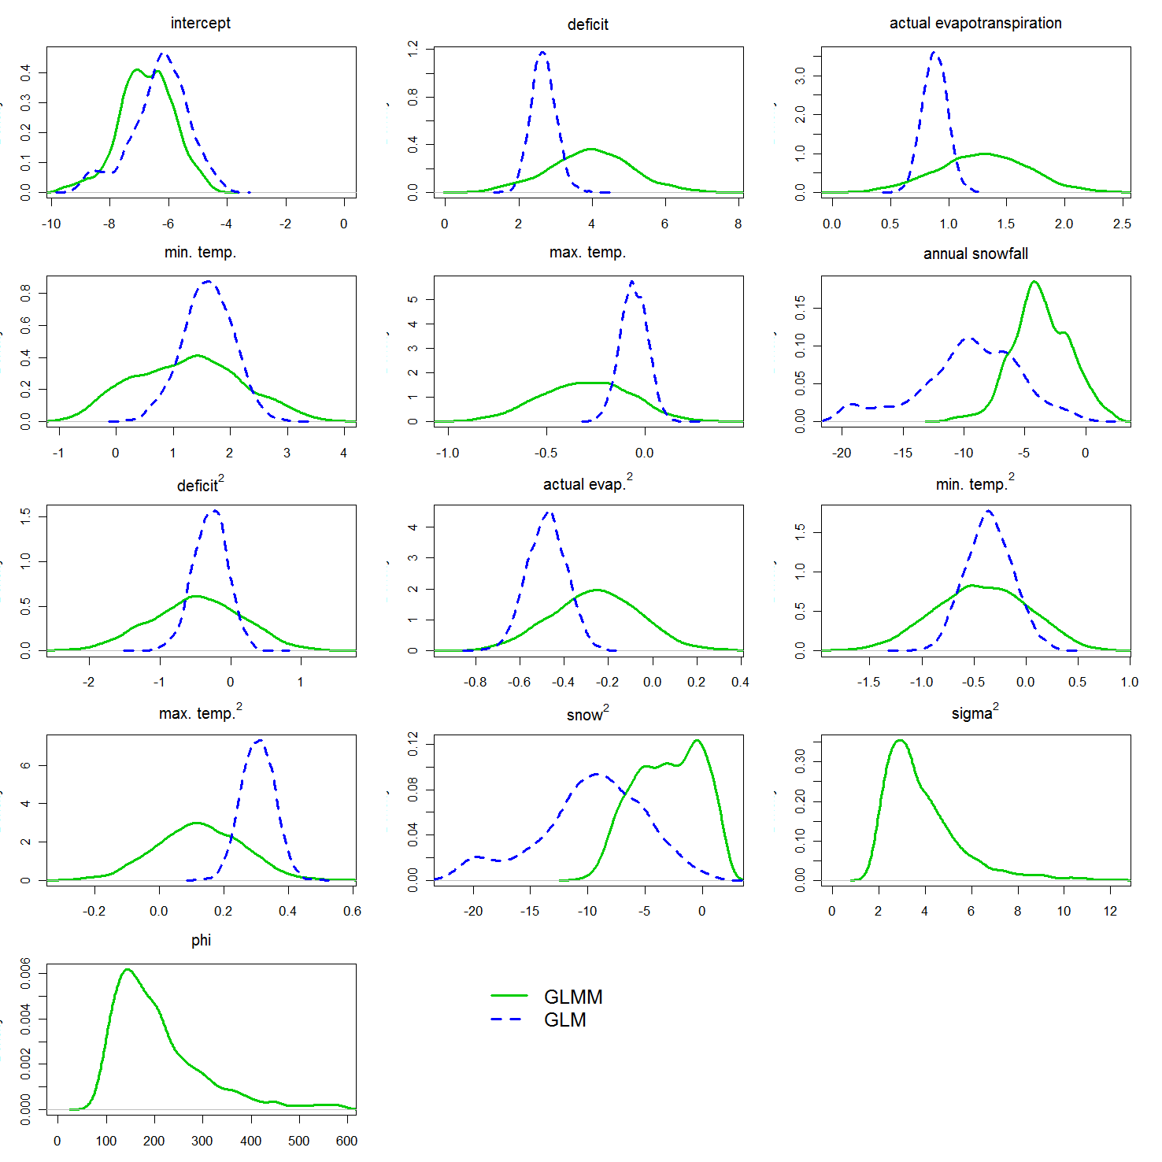
Figure S1a.

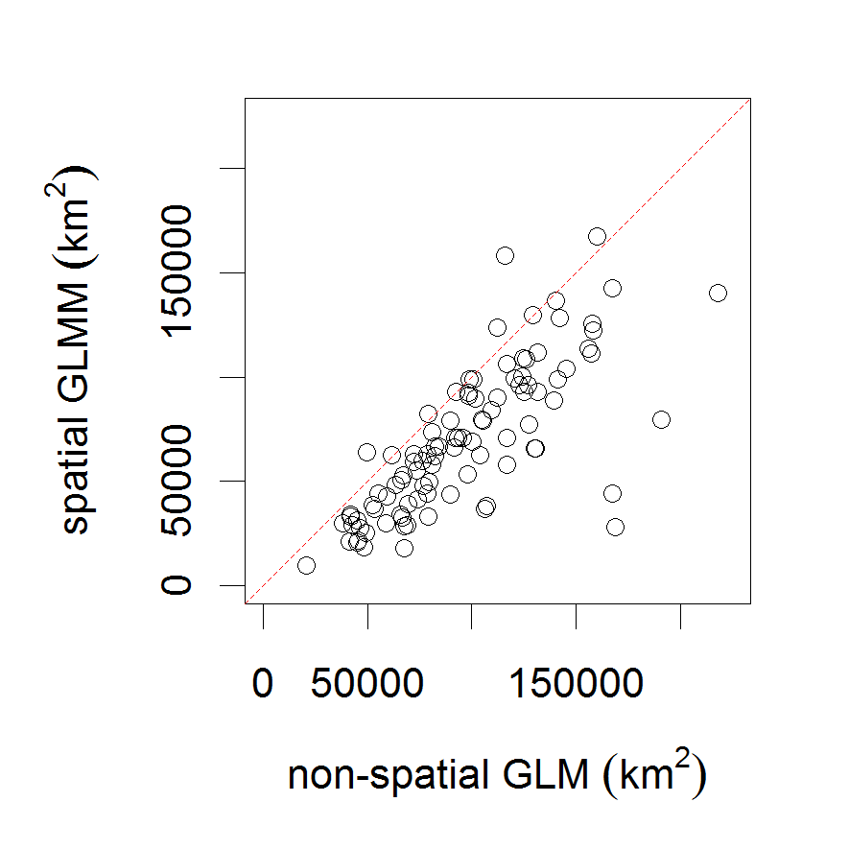
Figure S1b.

