GIST4302/5302: Instructions to Moving to On-line

(Mac Version)

Guofeng Cao

This document describes the steps to move the class, lectures and labs, to on-line. For the lecture, we will primarily use Blackboard and Microsoft Team as the backup in case the Blackboard system was overwhelmed. For the lab, additional steps will be required to access TTU server using your computers at home. The remainder of this document describes the details .

# 1. Lectures

Lectures will be live stream during the scheduled class time, 12:30pm-1:30pm on Tuesday and Thursday, and the recorded video should be available after the lectures complete.

## Blackboard

Blackboard is the easiest option without needing extra software. The following is the link to access the live stream during scheduled class time:

<https://us.bbcollab.com/guest/bf4809aecaee4a3e9e5757f7ebb6436e>

## Microsoft Team

As mentioned, we will go with this option as a backup in case the Blackboard is overwhelmed by the load. The setup with Microsoft Team is also straightforward. Copy and paste the following link into your browser (Google Chrome recommended on both Windows and Mac), and it might ask you to install Microsoft Team software.

<https://teams.microsoft.com/l/team/19%3aacc451c2de9b47afa2acb85c6716ebf9%40thread.tacv2/conversations?groupId=34a51520-8323-400a-9d6a-572cefdf3e3c&tenantId=178a51bf-8b20-49ff-b655-56245d5c173c>

# 2. Lab

**Chanmi will live stream her lab instructions during lab hours as I do for the lectures.**

Compared with lectures, moving labs to on-line takes extra steps. VPN is essential to allow the accesses to TTU resources from home. I recommend you having it setup first. After that, you can access the TTU servers including the lab materials on Techshare from home as you normally do on campus. The following gives the setup instructions.

For Mac users, as you might know that ArcMap is not available on Mac. Several possible ways are available to access ArcMap. Among them, remote desktop is probably the most convenient option. You will be assigned an IP address of computers in the Remote Sensing lab (Holden Hall 221) that you can remotely access through remote desktop. See the following for the remote desktop instructions.

If you are computer savvy, you can install Windows on Mac using Parallel or Bootcamp and then install ArcMap. Please let me know if you are up to this option.

## VPN

VPN stands for Virtual Private Network. It is required to access most of the TTU computation resources using off-campus computers. A TTU VPN connection authenticates your TTU credentials as an approved user who is allowed permission to access the TTU network. The setup of VPN on your own computer is straightforward; a software named GlobalProtect is basically what is needed. The TTU IT Help Central has a detail instruction on how to setup:

<https://www.askit.ttu.edu/portal/app/portlets/results/viewsolution.jsp?guest=0&solutionid=181128172423631&hypermediatext=null>

After the VPN is setup, you can access the lab materials on Techshare (\\techshare.ttu.edu\depts\geosciences\gistcourses\gist4302) by the following steps:

1. In the top menu of the Finder: Go -> Connect to Server

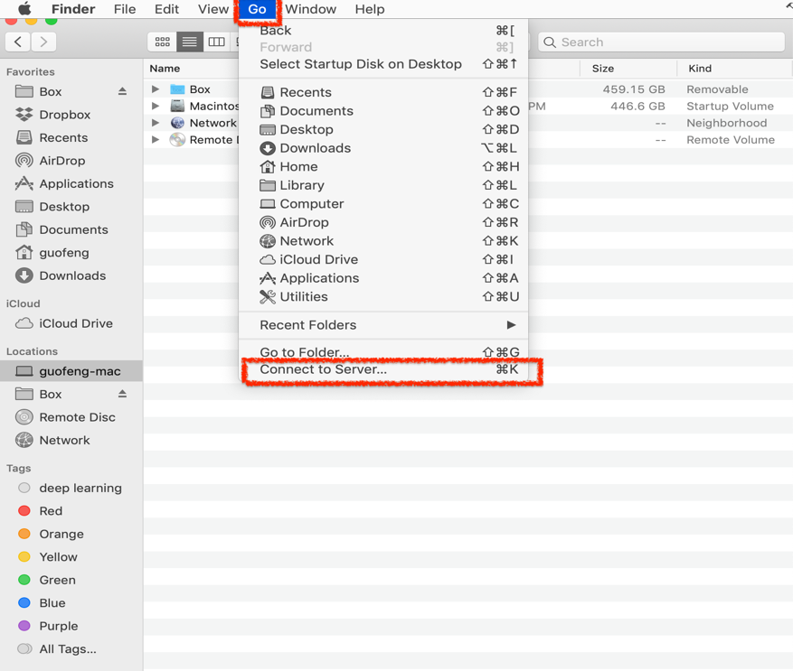

2. The following will pop up and put the address of the folder and then Connect: smb://techshare.ttu.edu/depts/geosciences/gistcourses/gist4302

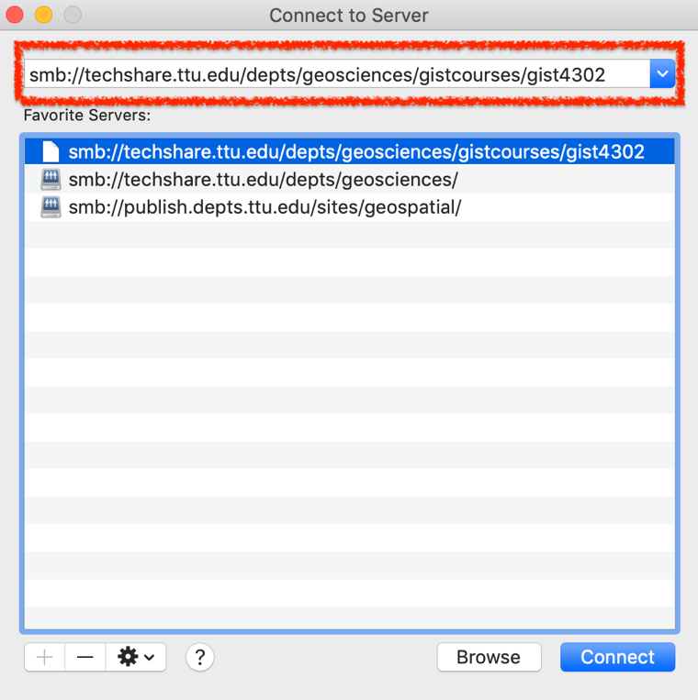

1. It will ask your TTU credentials:

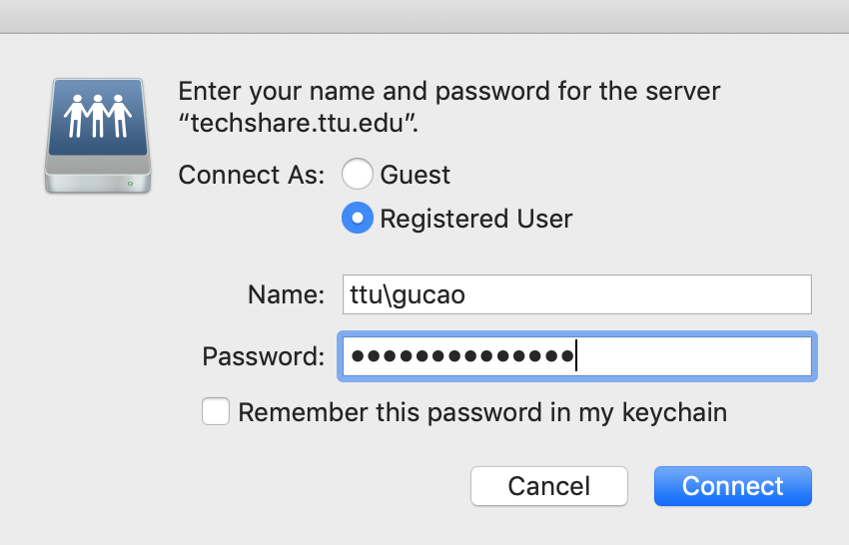

1. Then the lab folders should appear in your Finder:

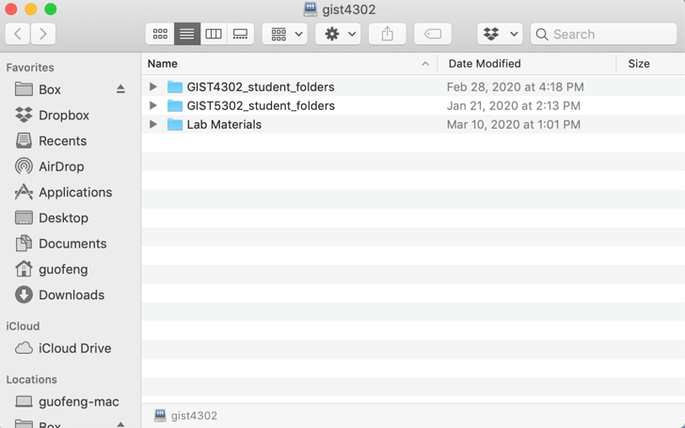

## Remote desktop

To use remote desktop, you basically need a software called Microsoft Remote Desktop that is available on App Store. Here is an instruction on how to install the software:

https://www.askit.ttu.edu/portal/app/portlets/results/viewsolution.jsp?guest=0&solutionid=131018105434182&hypermediatext=null

Once you have Microsoft Remote Desktop installed, you can use it by following the instruction. **Note, VPN is required for the remote desktop works.** **In the 3rd step of the following instruction, please change the PC name as the IP Address you are assigned to**:

https://www.askit.ttu.edu/portal/app/portlets/results/viewsolution.jsp?guest=0&solutionid=131018105253488&hypermediatext=null