GIST4302/5302: Instructions to Moving to On-line

(Mac Version, Tentative)

Guofeng Cao and Chanmi Lee

This document describes the steps to move the class, lectures, and labs to on-line. For the lecture, we will primarily use Blackboard, but also Microsoft Teams as the backup in case the Blackboard system is overwhelmed. For the lab, additional steps will be required to access TTU server using your computer at home. The remainder of this document describes the details .

# 1. Lectures

Lectures will be live stream during the scheduled class time, 12:30pm-1:30pm on Tuesday and Thursday, and the recorded video should be available after the lectures complete.

## Blackboard

Blackboard is the easiest option without needing extra software. The following is the link to access the live stream during scheduled class time:

<https://us.bbcollab.com/guest/bf4809aecaee4a3e9e5757f7ebb6436e>

## Microsoft Team

As mentioned, we will go with this option as a backup in case the Blackboard is overwhelmed by the load. To setup Microsoft Teams, copy and paste the following link into your browser (Google Chrome is recommended on both Windows and Mac), and it might ask you to install Microsoft Teams software.

<https://teams.microsoft.com/l/team/19%3aacc451c2de9b47afa2acb85c6716ebf9%40thread.tacv2/conversations?groupId=34a51520-8323-400a-9d6a-572cefdf3e3c&tenantId=178a51bf-8b20-49ff-b655-56245d5c173c>

# 2. Lab

**Chanmi will live stream her lab instructions during lab hours as I do for the lectures.**

Compared with lectures, moving labs to on-line takes extra steps. VPN is essential to allow access to TTU resources from your home. I recommend you to setup VPN first (instructions to setup VPN is below). After that, you can access the TTU server including the lab materials folder on Techshare from home as you normally do on campus. To map a network drive to the class server, use the link \\techshare.ttu.edu\depts\geosciences\gistcourses\gist4302 like you did in the first lab class.

For Mac users, as you might know that ArcMap is not available on Mac. Several possible options are available to access ArcMap. Among them, remote desktop is probably the most convenient one. You already have an IP address of computers in the Remote Sensing lab (Holden Hall 221) that you can access through remote desktop (your IP address is also in the same excel file sent from Dr. Cao on March 25). See the following for the remote desktop instructions.

If you are computer savvy, you can install Windows on Mac using Parallel or Bootcamp and then install ArcMap. Please email Dr. Cao if you are up to this option.

## VPN

VPN stands for Virtual Private Network. It is required to access most of the TTU computation resources using off-campus computers. A TTU VPN connection authenticates your TTU credentials as an approved user who is allowed permission to access the TTU network. The setup of VPN on your own computer needs a software named GlobalProtect. The TTU IT Help Central has detailed instructions on how to setup:

<https://www.askit.ttu.edu/portal/app/portlets/results/viewsolution.jsp?guest=0&solutionid=181128172423631&hypermediatext=null>

After the VPN is setup, you can access the lab materials on Techshare (\\techshare.ttu.edu\depts\geosciences\gistcourses\gist4302) by the following steps:

1. In the top menu of the Finder: Go -> Connect to Server

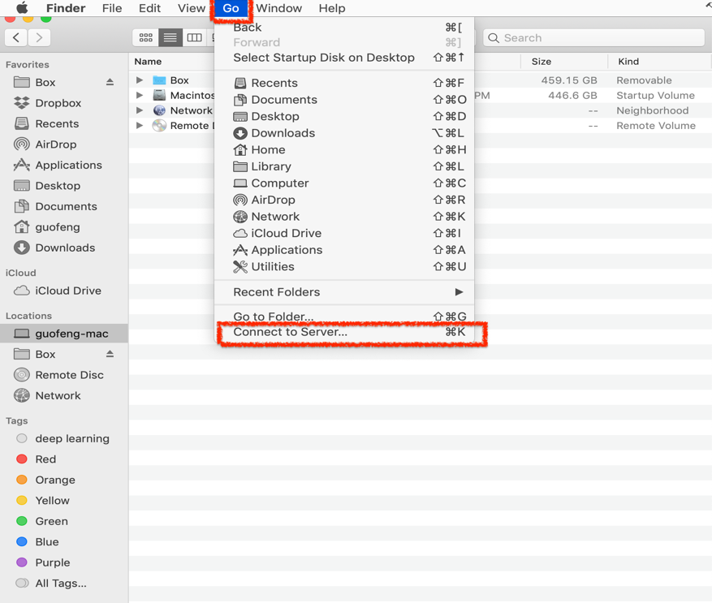

2. The following will pop up and put the address of the folder and then Connect: smb://techshare.ttu.edu/depts/geosciences/gistcourses/gist4302

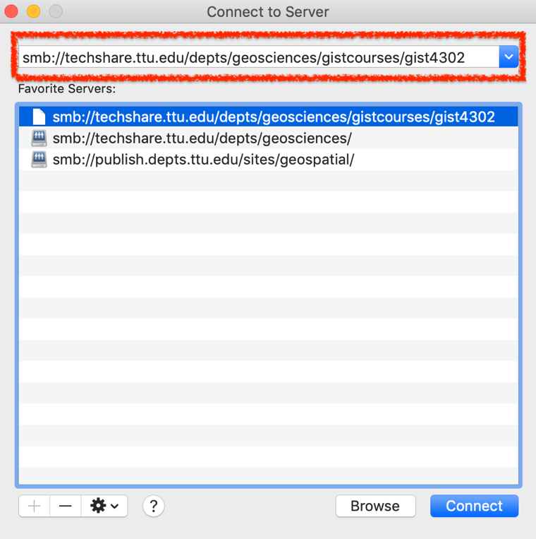

1. It will ask your TTU credentials:

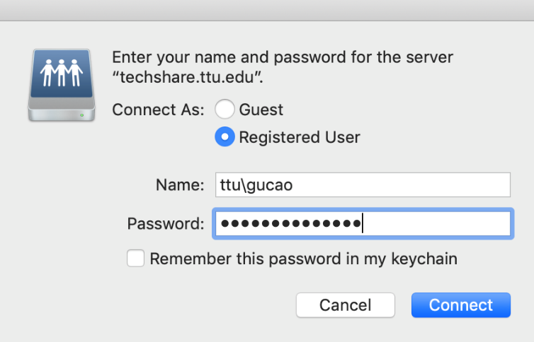

1. Then the lab folders should appear in your Finder:

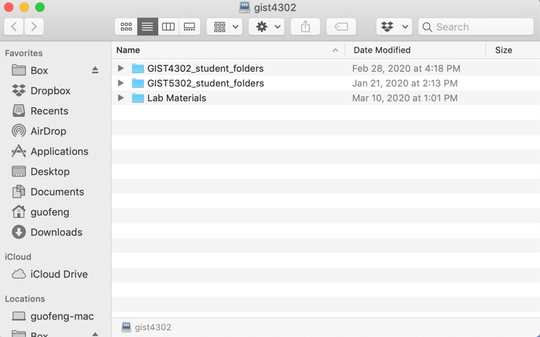

## Remote desktop

To use remote desktop, you basically need a software called Microsoft Remote Desktop that is available on the App Store. Here is the instruction on how to install the software:

https://www.askit.ttu.edu/portal/app/portlets/results/viewsolution.jsp?guest=0&solutionid=131018105434182&hypermediatext=null

Once you have Microsoft Remote Desktop installed, you can use it by following the instruction. **Note, VPN is required for the remote desktop works.** **In the 3rd step of the following instruction, please use the IP address (computer name) you are assigned to.** This IP address has the format like ‘rs20.geog.ttu.edu.’

https://www.askit.ttu.edu/portal/app/portlets/results/viewsolution.jsp?guest=0&solutionid=131018105253488&hypermediatext=null