Act Report of WeRateDogs Dataset

In this report, I am going to investigate the tweet archive of Twitter user @dog_rates from February 2015 to August 2017 and a table of image predictions alongside each tweet ID of the tweet archive. Twitter user @dog_rates, also known as WeRateDogs, is a Twitter account that rates people's dogs with a humorous comment about the dog.

After finishing all necessary wrangling jobs, I get two more friendly dataframs. I have the following interesting discovers:

1. **WeRateDogs’ most favourite rating score is from 10/10 to 12/10**

By analysing all rating score of the dataset, there are 3 rating score show out the most times. They are 12/10 490 times, 10/10 436 times and 11/10 418 times. These 3 rating scores take about 64.3% of total number.

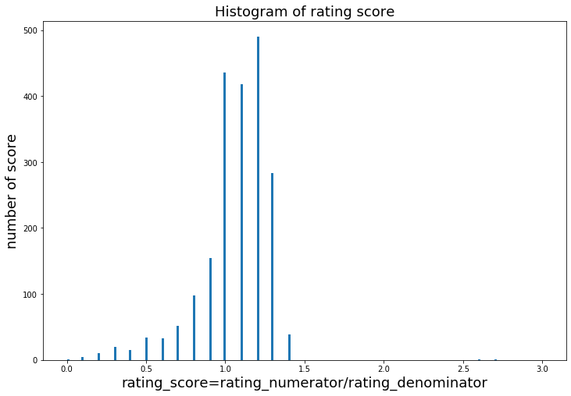

I can also find from the above Histogram of rating score, exclude very few outliers, all rating score are around 10/10 to 14/10.

1. **The most favorited tweet is about a doggo standing and walking in water with two back legs**

More than 50% of the tweets are favorited less than 4000 times. Around 75% of the tweets are favorited less than 11000 times.

The most favorited tweet has a 158903 favourite-count, this tweet is about a dog swimming and standing in a swimming pool (https://t.co/7wE9LTEXC4).

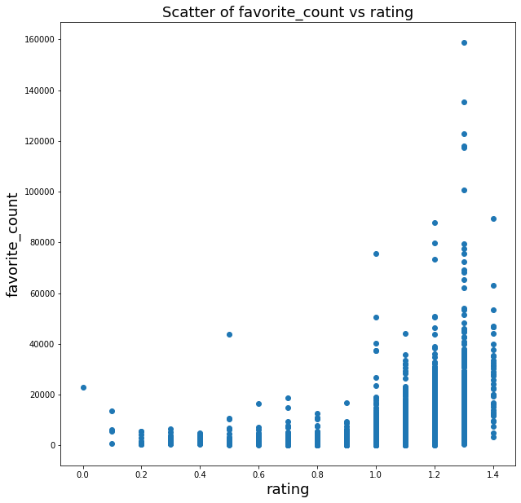

By combine the rating score value and favourite_count value together, I can find the tweet with higher rating score will be more likely to be favorited.

1. **People could be more likely to favourite and retweet large dogs**

By combining dog breeds prediction with retweet_counts and favourite_counts, I find cardingan, English springer, Eskimo dog, French bulldog, Great pyrenes, Labrador retriever, Lakeland retriever, Samoyed, cocker spaniel, golden retriever, standard poodle and whippet have the most favourite count and retweet count.

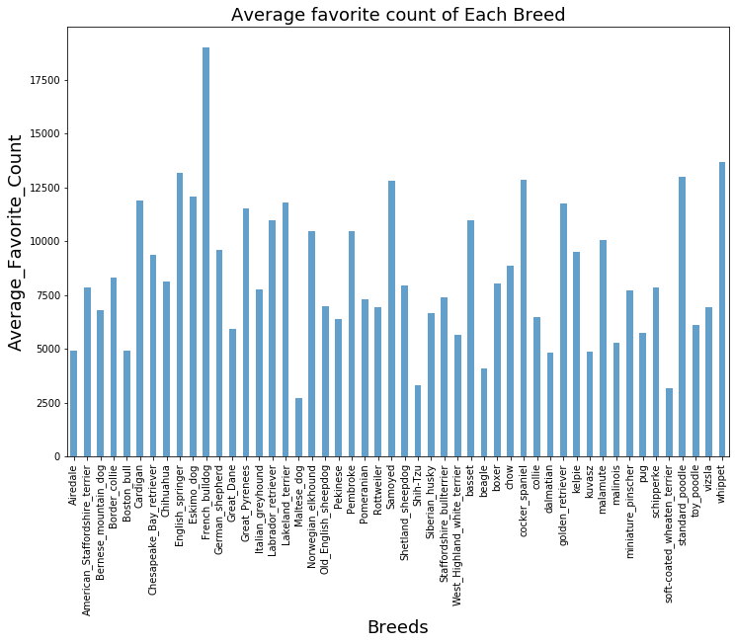

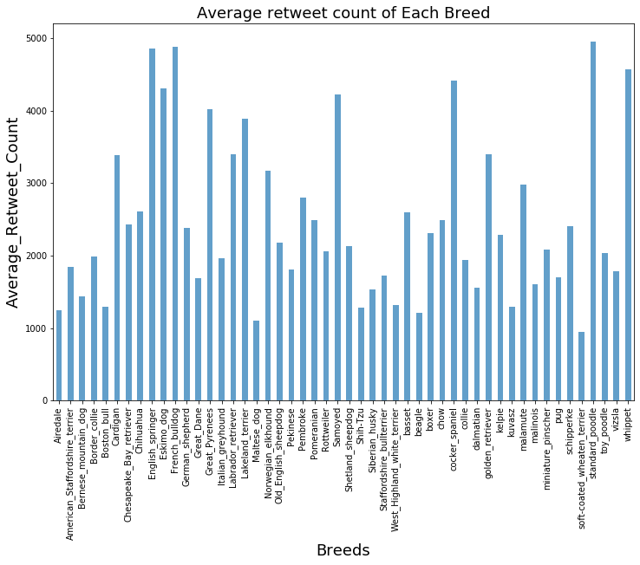

After I searched some basic information about these 12 breeds. I find cardingan, English springer, great pyrenes, Labrador retriever, Samoyed, cocker spaniel, golden retriever, standard poodle and whippet are all large dogs. Maybe it shows people are more likely to favourite and retweet dogs of large body size.