PROJECT REPORT
Belraetha Ltd Sales and Customer Behavior Analysis

Prepared from the SQL queries and result screenshots supplied
Orders Dataset Analysis Using Microsoft SQL Server
Presented By: EDIGBE ONOME
Table analysed: dbo.ORDERS
Analysis environment: Microsoft SQL Server Management Studio

1. Project Overview
This project analyses the dbo.ORDERS table in the Belraetha Ltd database using Microsoft SQL Server. The purpose is to examine sales and profit performance, compare regions and product categories, understand customer-segment purchasing patterns, and identify high-value transactions and profitable product sub-categories. The SQL queries aggregate and filter transactional records to turn order-level data into information that can support commercial and operational decisions.

2. Business Objectives
The analysis was designed to address the following business questions:
- What are the overall sales and profit generated by the orders in the table?
- Which sales region contributes the greatest sales value?
- How do the main product categories compare in sales and profit?
- Which customer segment has the highest average sales per order record?
- How many orders have sales greater than $1,000, and what do these high-value transactions indicate?
- Which product sub-categories generate the highest total profit?
- Which categories and sub-categories may require closer management attention?

3. Dataset Description
The dataset is stored in the dbo.ORDERS table within the Belraetha Ltd SQL Server database. The first-10-records query was used to inspect the table structure and sample transactions. The visible fields include order and shipping dates, shipping mode, customer identifier and name, customer segment, country, city, state, postal code, and sales region. The result grid also indicates product-related fields and measures used by the analysis, including category, sub-category, sales, and profit. The table therefore combines order, customer, geographic, shipping, product, and financial information.
The screenshots do not show a complete schema listing or a total row count for the full table. Accordingly, this report does not assume a precise dataset size or a complete list of column data types.

4. Tools Used
- Microsoft SQL Server 17.0 — database platform used to store and query the Orders table.
- SQL Server Management Studio (SSMS) — interface used to write and execute SQL statements and inspect result grids.
- Transact-SQL (T-SQL) — used for SELECT, SUM, AVG, WHERE, GROUP BY, ORDER BY, and HAVING operations.
- Microsoft Excel — not evidenced in the supplied screenshots; it may be used optionally for independent validation or presentation.

5. Data Cleaning and Preparation
The supplied evidence confirms an initial data-structure review: SELECT TOP 10 * FROM ORDERS was executed successfully, and sample rows were inspected. The query outputs also show that the relevant date, text, geographic, sales, and profit fields could be used in the subsequent aggregations and filters.
No screenshots or scripts were supplied showing explicit removal of duplicates, treatment of NULL values, standardisation of inconsistent labels, correction of data types, or outlier handling. These steps are therefore not claimed as completed. Before using the results for production decisions, the dataset should be checked for duplicate order lines, missing customer/product values, invalid dates, non-numeric sales or profit values, and inconsistent category, region, or shipping-mode labels. The date range and row count should also be documented.

6. SQL Analysis: Key Findings
The following findings are taken directly from the visible SQL result grids or the observations recorded in the query comments.

6.1 Overall sales and profit
The aggregate query returned total sales of $22,972,011.07 and total profit of $2,863,997.79. This indicates an overall positive profit result. The implied aggregate profit-to-sales ratio is approximately 12.47% (total profit divided by total sales); this is a descriptive ratio for the supplied totals, not a net margin measure unless all relevant costs are included in the Profit field.

6.2 Sales by region
Region | Total sales (USD) | Rank
West | $725,457.93 | 1
East | $678,781.36 | 2
Central | $501,239.88 | 3
South | $391,721.90 | 4
The West region generated the highest sales, followed by the East. The South recorded the lowest sales among the four regions shown. The West result is about 85% higher than the South result, indicating a meaningful geographic performance gap.

6.3 Sales and profit by product category
Category | Total sales (USD) | Total profit (USD)
Technology | $836,154.10 | $145,455.66
Office Supplies | $719,046.99 | $122,490.88
Furniture | $741,999.81 | $18,451.25
Technology led both sales and profit among the three categories. Office Supplies generated the lowest sales but still delivered substantial profit. Furniture produced sales close to Office Supplies but much lower profit. Based on these category figures, Furniture's profit-to-sales ratio is approximately 2.49%, compared with about 17.40% for Technology and 17.04% for Office Supplies. This makes Furniture the clearest category-level profitability concern.

6.4 Average sales by customer segment
Customer segment | Average sales per order row (USD)
Home Office | $240.97
Corporate | $233.82
Consumer | $223.73
Home Office had the highest average sales per order record, followed by Corporate and Consumer. The difference is modest, so the result suggests an opportunity to tailor offers by segment rather than assuming one segment is dramatically more valuable. This metric is an average sales value per row, not necessarily average customer lifetime value or average order value if an order can contain multiple rows.

6.5 High-value orders
The filter WHERE SALES > 1000 returned 468 records. The visible sample includes Consumer, Corporate, and Home Office transactions and orders shipped using different shipping modes. Some customers, including Becky Martin and Dianna Wilson, appear more than once in the displayed high-value results. This points to repeat high-value purchasing, although customer-level totals and repeat-purchase frequency would need a dedicated grouped query to confirm the extent.

6.6 Most profitable sub-categories
Sub-category | Total profit (USD)
Copiers | $55,617.90
Phones | $44,516.25
Accessories | $41,936.78
Paper | $34,053.34
Binders | $30,221.64
Copiers ranked first in total profit, followed by Phones and Accessories. These five sub-categories represent strong contributors within the results shown and are candidates for focused merchandising and stock availability.

6.7 Category profit threshold
A HAVING SUM(PROFIT) > 10000 query returned all three categories: Technology (approximately $145,455.66), Office Supplies (approximately $122,490.88), and Furniture (approximately $18,451.25). The filter confirms that each category exceeded the selected $10,000 threshold, but it does not change the relative finding that Furniture's profit contribution was substantially weaker.

7. Business Insights
- Overall performance is profitable in aggregate. The reported totals show positive profit of approximately $2.86 million on sales of approximately $22.97 million. Management can use this as a baseline, while validating the source data and the meaning of the Profit measure.
- Regional sales are uneven. The West and East are the strongest markets in the result set, while the South is the weakest. This may reflect differences in customer demand, market coverage, product mix, or sales execution; the current queries do not identify the cause.
- Technology is the strongest category in both revenue and profit. It should be protected through reliable inventory, competitive pricing, and continued customer support.
- Furniture requires a profitability review. Its sales are substantial, but its profit is low relative to those sales. Discounting, procurement costs, fulfilment costs, returns, or product mix may be reducing profitability; these drivers should be tested before changing the range or pricing.
- Home Office customers have the highest average sales per order row, but the segment differences are relatively small. Segment-specific campaigns may improve relevance, but should be evaluated using conversion and repeat-purchase measures.
- The 468 sales records above $1,000 indicate a meaningful high-value transaction group. Repeated customer names in the sample suggest that customer-level targeting may be worthwhile, subject to confirmation with customer-level aggregation.
- Copiers, Phones, and Accessories are the leading sub-categories by total profit in the top-five result. Their contribution makes them useful candidates for availability planning and targeted cross-selling.

8. Recommendations
- Investigate Furniture profitability first. Furniture generated approximately $742,000 in sales but only about $18,451 in profit, a category profit-to-sales ratio of roughly 2.49%. Review discount levels, supplier costs, delivery/handling costs, returns, and profit by Furniture sub-category. Test corrective actions before making broad pricing changes.
- Protect and grow Technology. Technology produced the highest category sales (about $836,154) and profit (about $145,456). Maintain stock availability for strong Technology sub-categories, monitor stock-outs, and test targeted bundles or complementary offers.
- Replicate effective practices from stronger regions. West sales were approximately $725,458 compared with about $391,722 in the South. Compare product mix, customer segment mix, order value, discounting, and sales coverage between these regions. Use the strongest practices from West/East as test hypotheses for improving South performance.
- Develop a high-value customer programme. The SQL filter identified 468 records with sales above $1,000, and repeated customer names appeared in the sample. Create a customer-level analysis of total spend, number of orders, and time between purchases, then consider account management or loyalty offers for verified repeat high-value customers.
- Use sub-category profitability in merchandising and inventory decisions. Copiers ($55,617.90), Phones ($44,516.25), and Accessories ($41,936.78) were the three most profitable sub-categories in the top-five output. Monitor their stock availability and test relevant cross-sell bundles, while tracking margin rather than sales alone.
- Validate and extend the analysis before operational rollout. The screenshots do not document formal null, duplicate, or data-type checks. Run data-quality checks and add analysis of monthly trends, discounts, shipping costs, order counts, and profit by region/segment/sub-category. This will help explain why performance differs, not just where it differs.

Conclusion
The SQL analysis shows positive aggregate profitability, with Technology leading category performance, the West leading regional sales, and Home Office showing the highest average sales per order row. The most important issue for further investigation is Furniture's comparatively low profit despite substantial sales. The strongest sub-category profit contributors are Copiers, Phones, and Accessories. These findings provide a practical starting point for improving product mix, regional execution, customer targeting, and margin management. The recommendations should be refined after the underlying data-quality checks and additional driver analysis are completed.

Appendix A. SQL Evidence Screenshots
The screenshots below are included as supporting evidence of the queries executed and the results reviewed. They are reproduced from the images supplied with the project request.
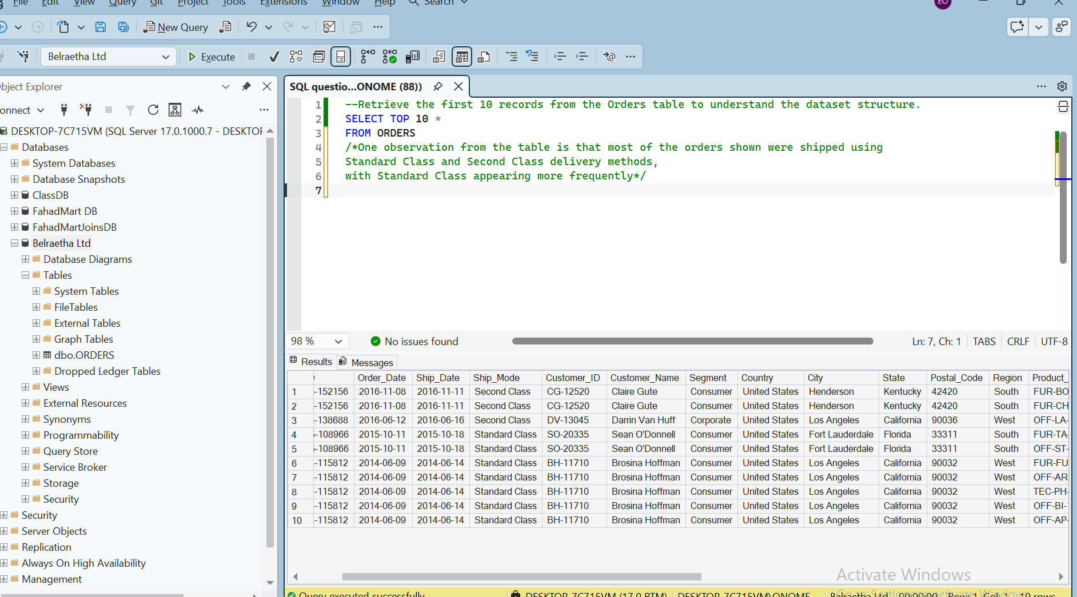
Figure A1. Initial inspection of the first 10 records from the ORDERS table; sample fields and shipping modes are visible.
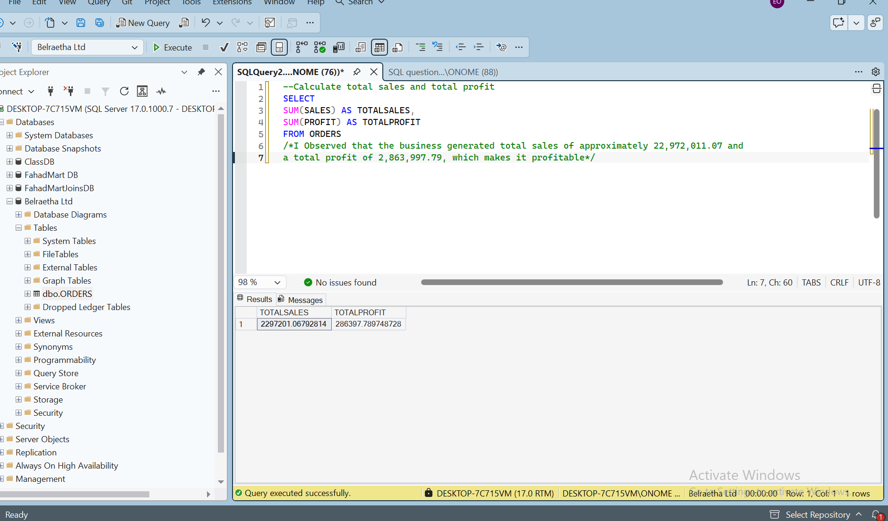
Figure A2. Aggregate total sales and total profit query result.

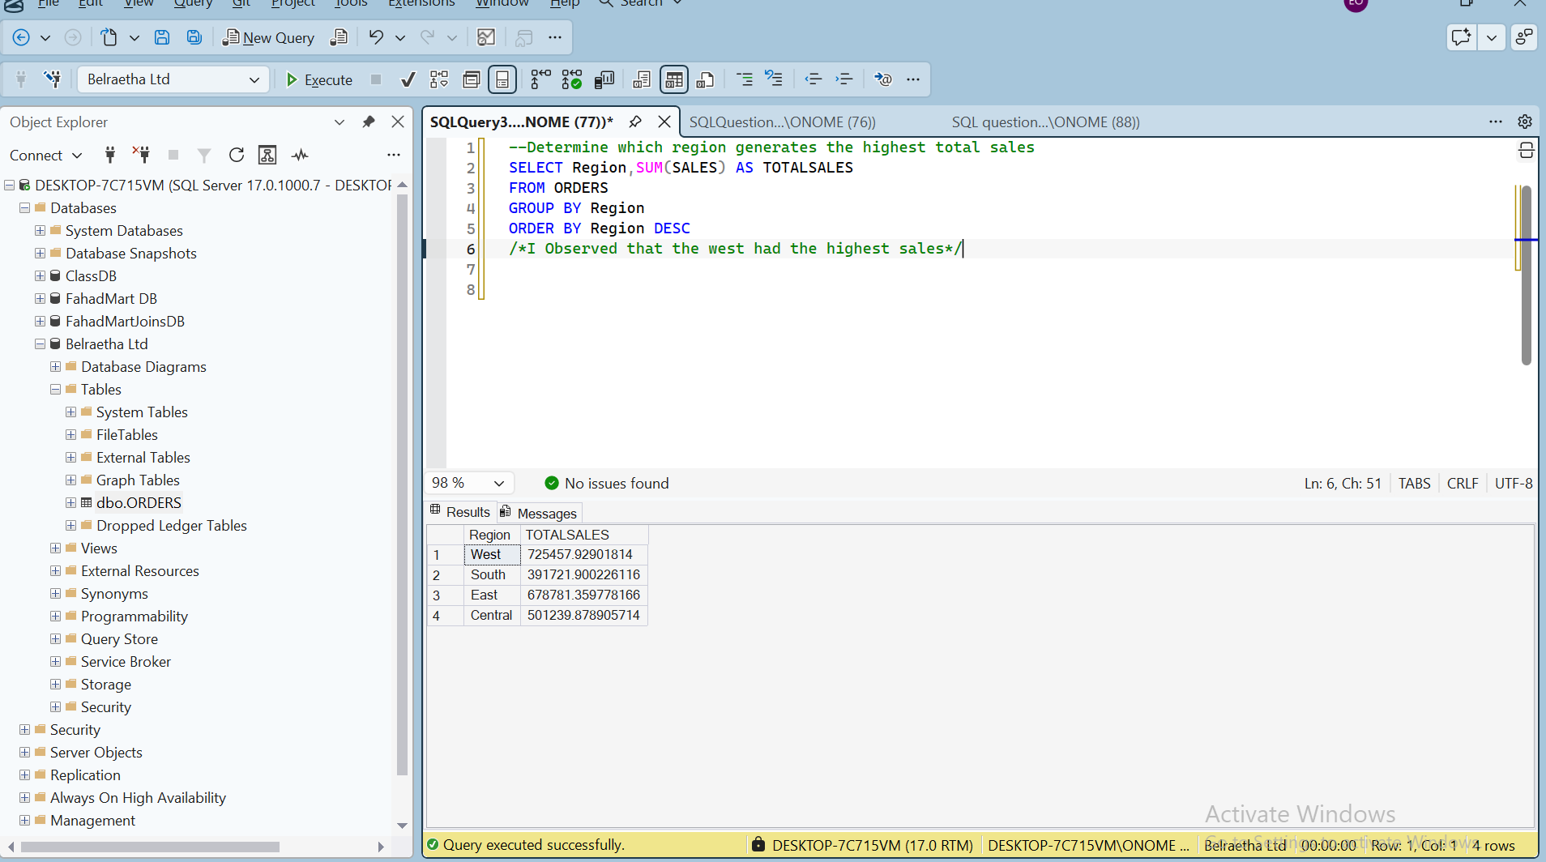
Figure A3. Total sales by region; West ranks first in the displayed output.
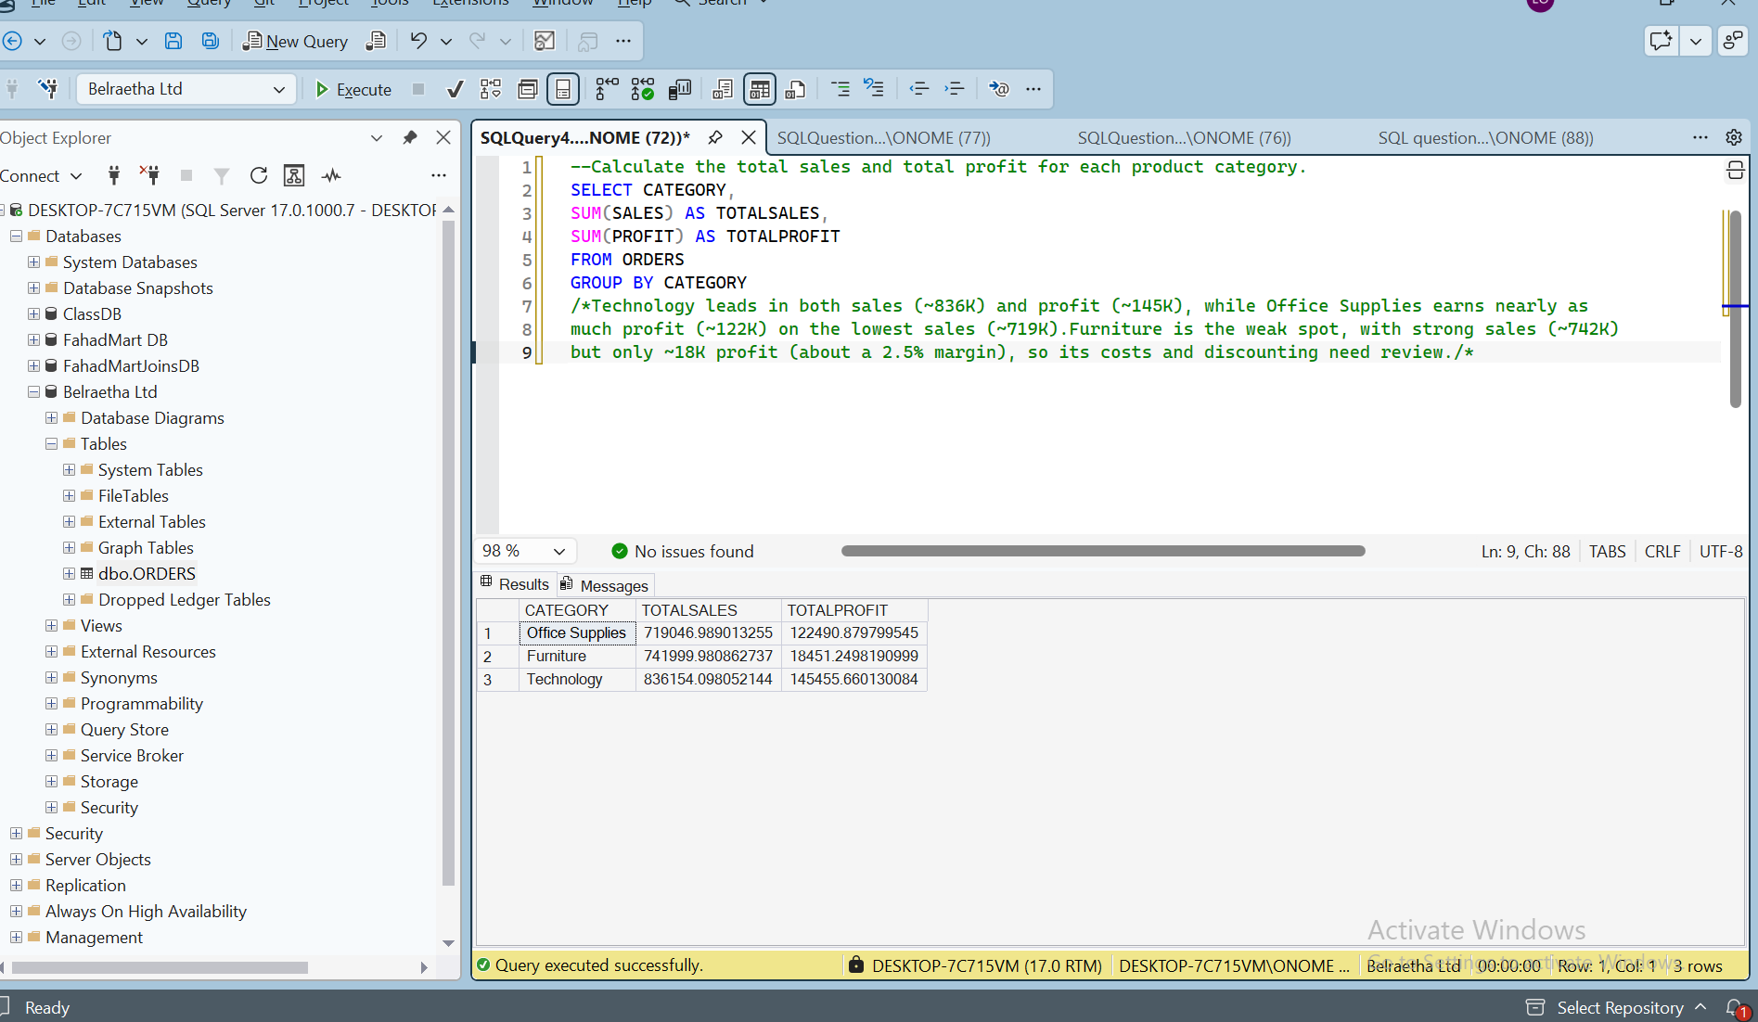
Figure A4. Sales and profit by product category.

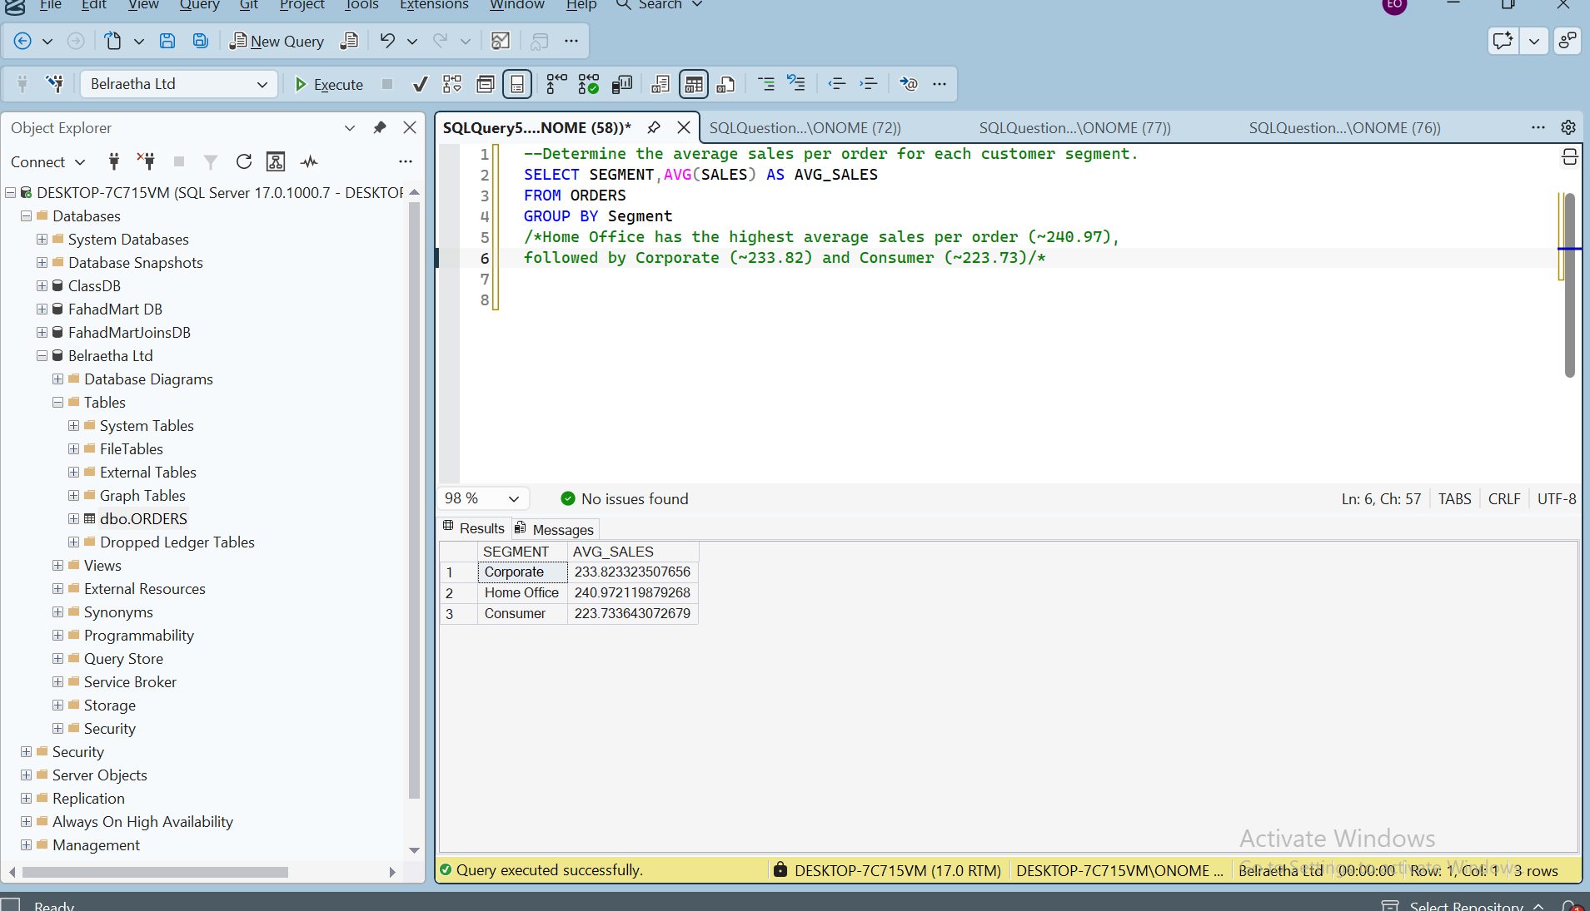
Figure A5. Average sales by customer segment.
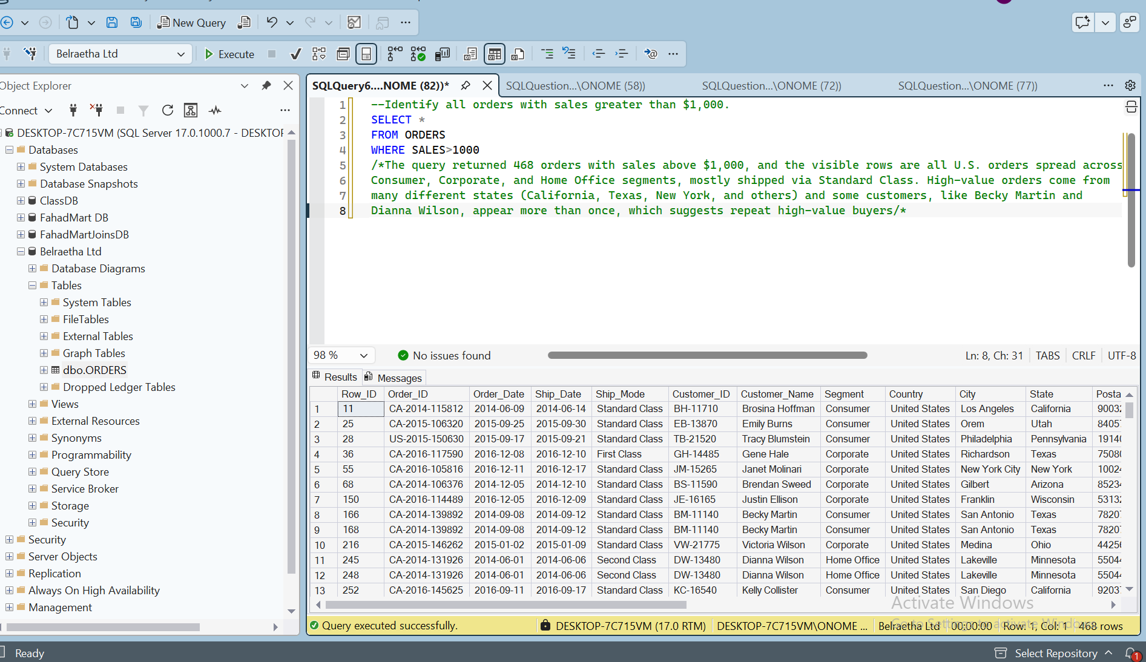
Figure A6. Records with sales greater than $1,000; the result grid reports 468 rows.

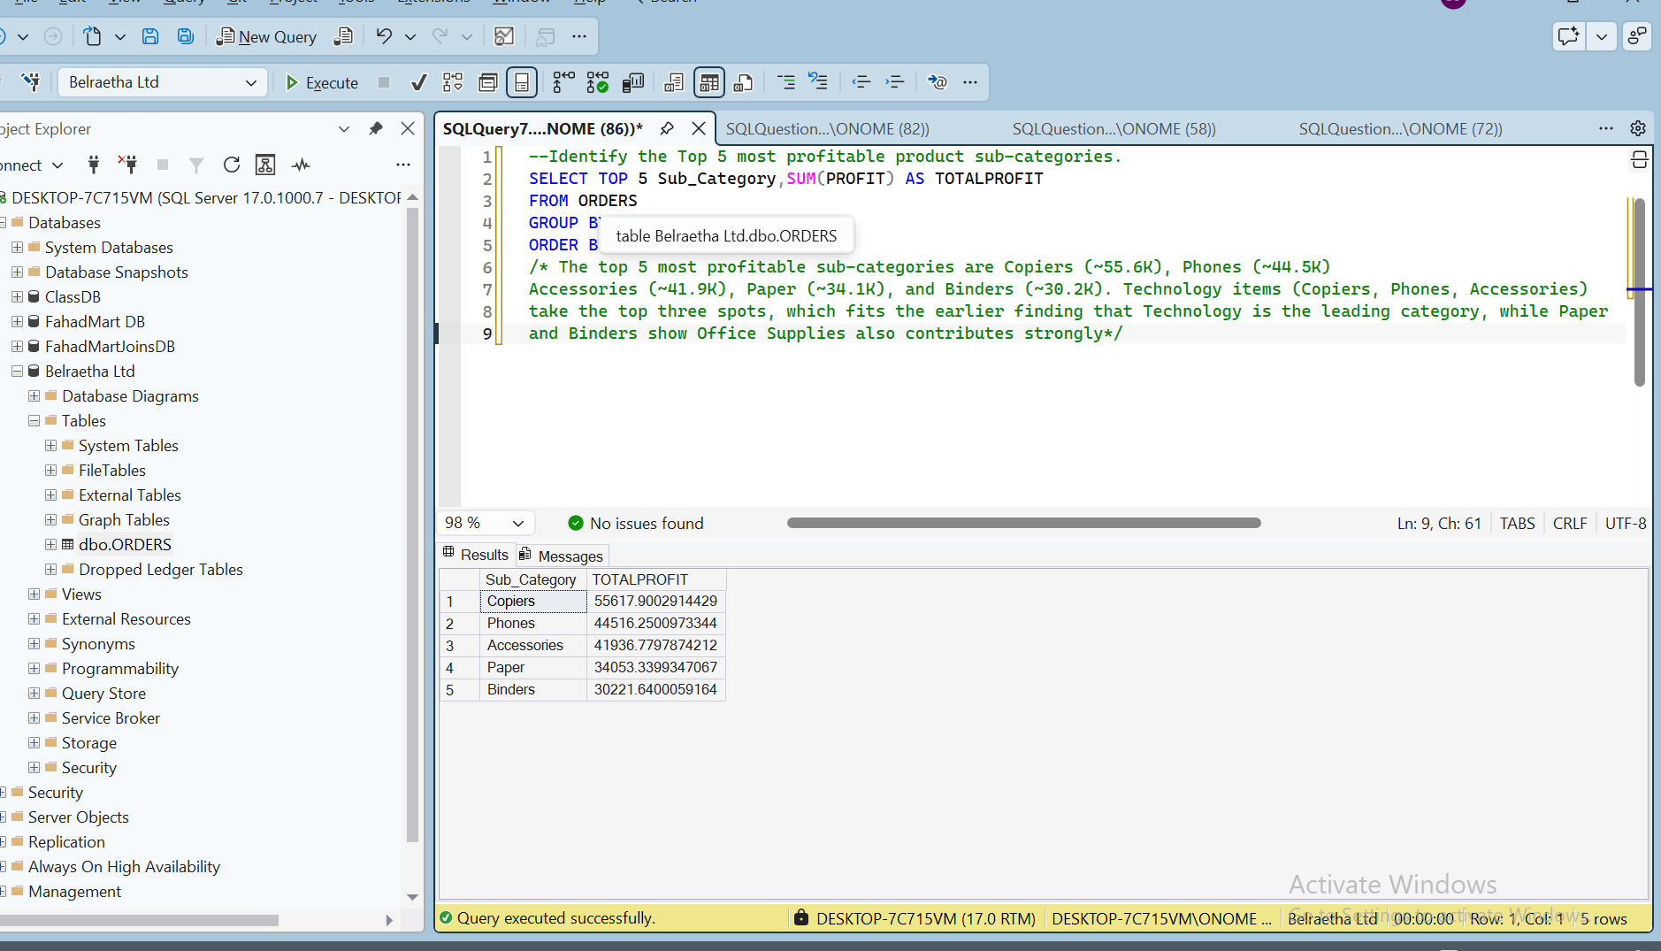
Figure A7. Top five most profitable product sub-categories.
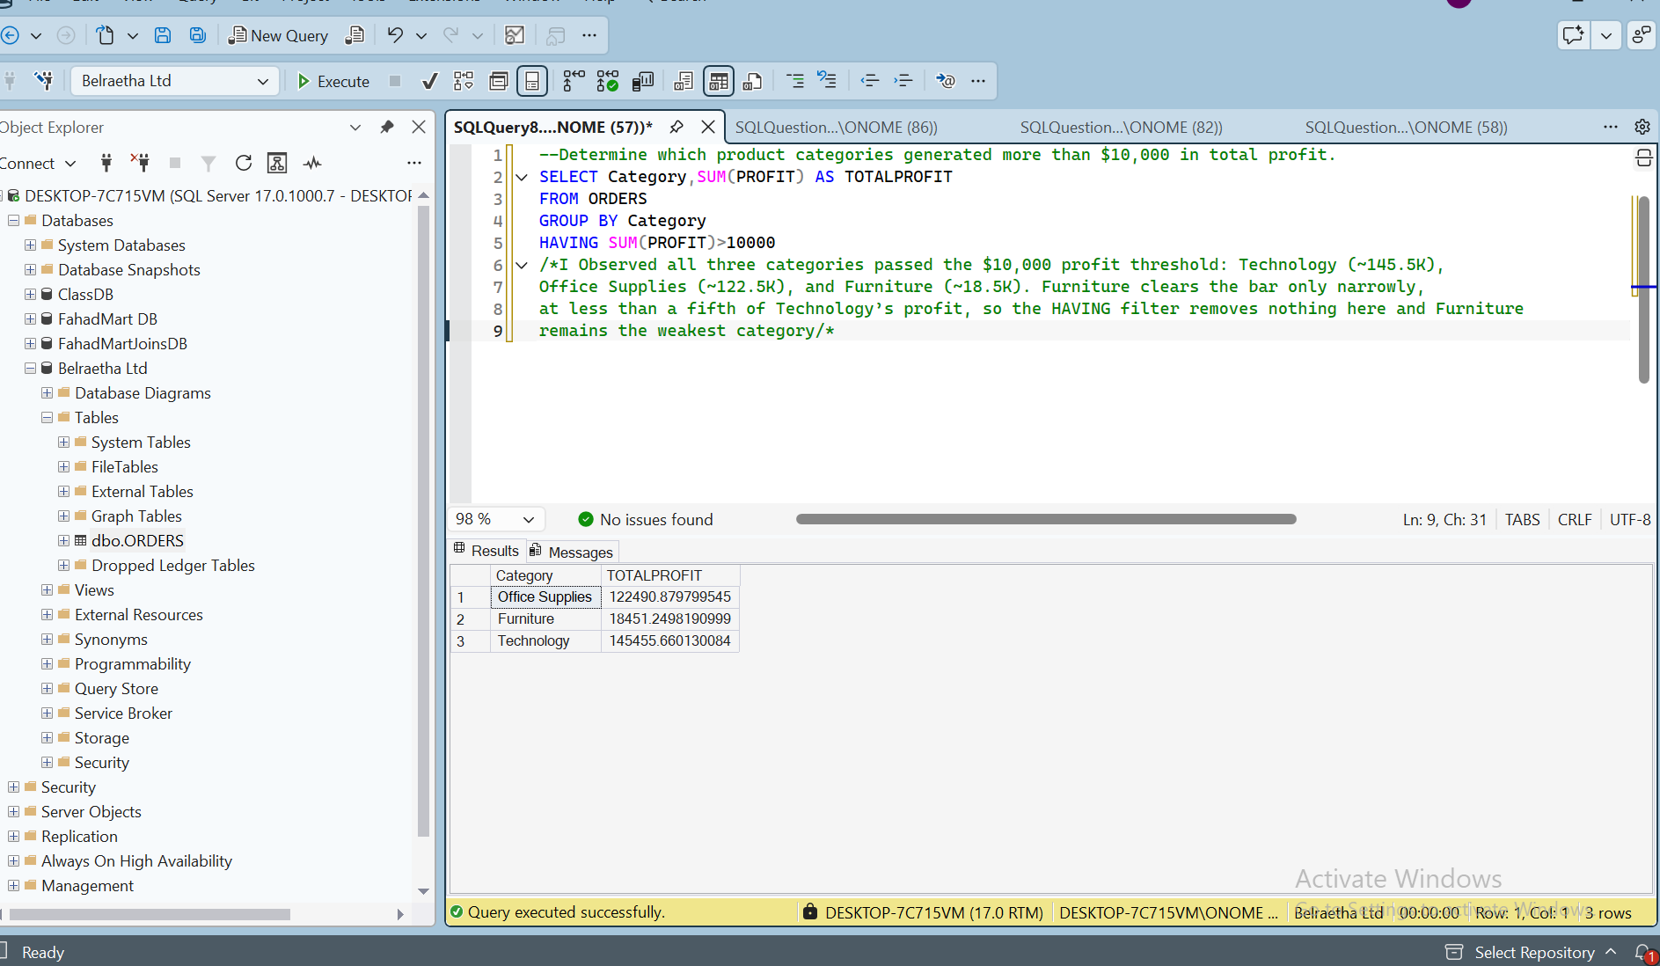
Figure A8. Categories with total profit greater than $10,000.

