THE SCALING ON THE X-AXIS REPORT

BY: EDISON LAMAR, RAFAEL GARCÍA, MIGUEL HERRANZ

DATE: 11/03/2019

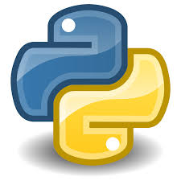

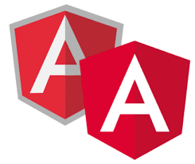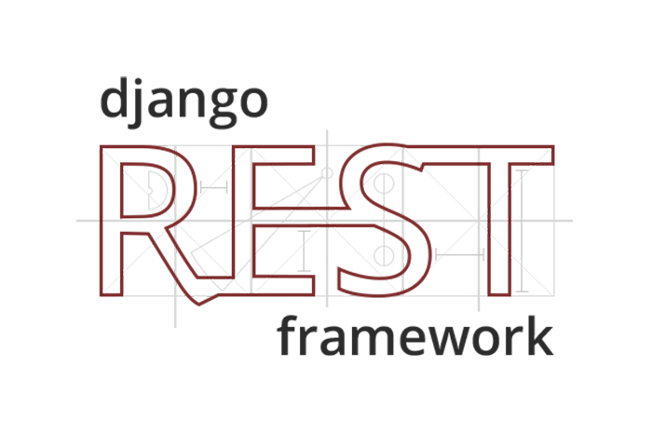

This report serves as auxiliary documentation to fully understand the work done in this compulsory assignment.

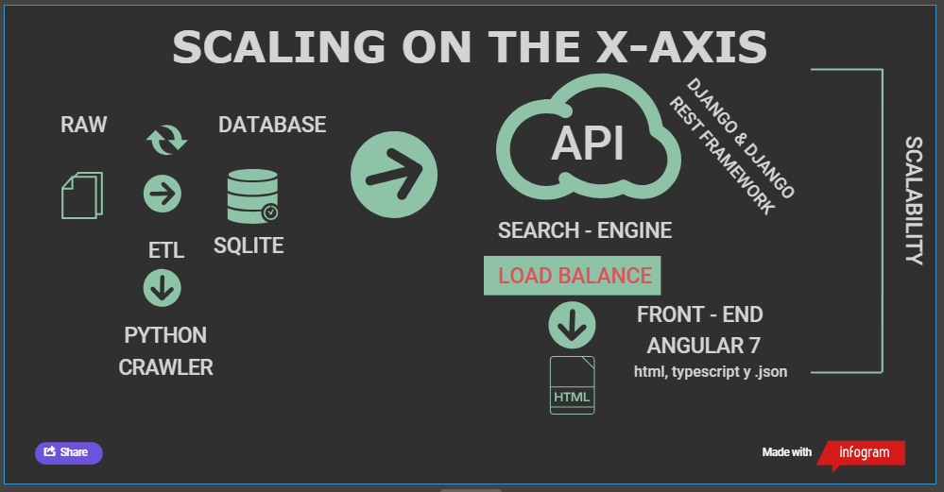Well, we will start by making a brief introduction to what is going to be seen next, in broad strokes we can divide the work done in 4 parts, which will be clearly denoted. To see it more clearly, we will add a picture with the project´s design architecture:

1. Back – End

The objective of this Compulsory Assignment is to organize in an efficient way the search of files.

* 1. Indexation

The files are extracted and their words (determined by blank spaces) are cut through the ETL process performed by Crawler.

|  |  |  |
| --- | --- | --- |
| Def handle(self, *args, **options): | | |
|  | # r=root, d=directories, f = files |
|  | for r, d, f in os.walk(PATH): |
|  | for file in f: |
|  | file_path = self.get_file_path(r, file) |
|  | self.open_file(file_path) |

* 1. Api Rest:

We use an Api with Django and Django Rest Framework to allow a Load Balance in the project, in addition to that our ETL process is programmed in Python, and django is an open source web application framework written in Python. The development environment of the Api has been Visual Studio Code.

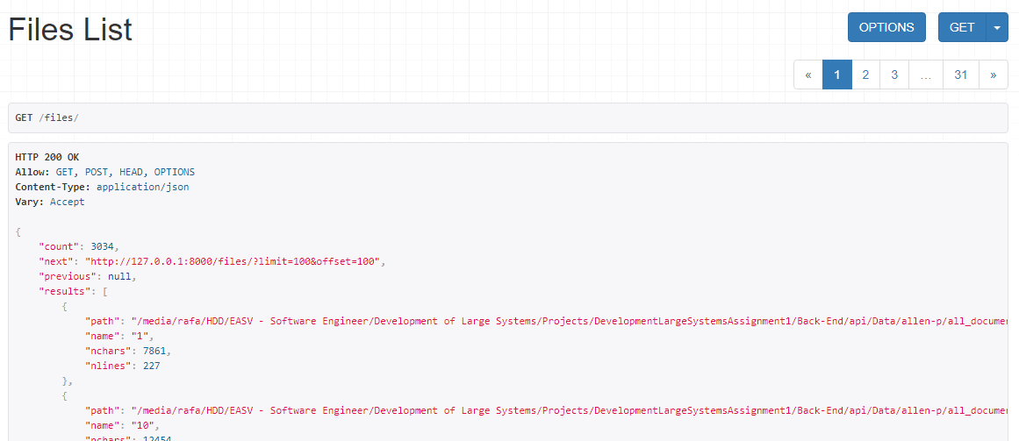

1. Front – End:

The development of the Interface has been carried out in Angular 7 with the WebStorm development environment, and has two modules, one common and another containing the search engine.

Finally, it is important to highlight the importance of the scalability that makes up the entire structure of the project. This application right now is designed to be 100% scalable, and in fact the next step would be this one.

You can see the rest in our Github repository in: <https://github.com/edijavi/DLS-Assignment1>