**Overview**

The objective is to find out what factors are correlated with the voting for the 2020 Presidential Candidates: Joe Biden and Donald Trump.

**Data**

The data provided is survey information. It contains 8280 observations and 59 variables. It also contains a data dictionary which is shown in table 1. The data is primarily categorical data with the exception of Age. There are missing variables in 51 of the 59 variables.

|  |  |
| --- | --- |
| **caseid** | **Case identifier** |
| weight_pre | Full sample pre-election weight |
| weight_post | Full sample post-election weight |
| sampvar | Full sample variance unit |
| varstrat | Full sample variance stratum |
| interest_politics | How often does R pay attention to politics and elections? |
| interest_campaigns | How interested in following campaigns? |
| state_reg | Voter registration state |
| party_reg | Party of registration |
| primary_voter | Did R vote in a Presidential primary or caucus? |
| pol_spectrum | Where does R place themselves on seven-point liberal-conservative scale? |
| party_id | Party identification |
| party_salience | How important is R's party identity? |
| gov_trust | How often does R trust government in Washington to do what is right? |
| gov_interests | Is government run by a few big interests or for the benefit of all? |
| gov_waste | Does the government waste much tax monthly? |
| gov_corrup | How much of the government is corrupt? |
| people_trusted | How often can people be trusted |
| gov_responsive | How much do elections make the government pay attention? |
| better_economy | Which party would do a better job of handling the nation's economy? |
| better_health | Which party would do a better job of handling health care? |
| better_immigratino | Which party would do a better job of handling immigration? |
| better_taxes | Which party would do a better job of handling taxes? |
| better_environment | Which party would do a better of handling the environment? |
| better_covid | Which party would do a better job of handling COVID-19? |
| fav_deathpen | Do you favor or oppose the death penalty? |
| stayhome | The country would be better off if we just stayed home |
| trust_media | How much do you trust the news media |
| corr_trump | How have government corruption levels changed since Trump was elected? |
| fav_impeach | How much did you support the House impeachment of the President? |
| fav_senacquittal | How much did you support the Senate's decision to acquit President Trump? |
| covid_gov | How would you characterize the federal government's response to COVID-19 |
| covid_reopen | Is America opening too quickly or too slowly in response to COVID-19? |
| inc_gap | How much larger is the income gap today? |
| gov_climate | Show the government do more about rising temperatures? |
| samesex | Should businesses be required to provide services to same sex couples? |
| transgender | What are your feelings on transgender bathroom use? |
| lgbtlaw | Do you favor laws that protect LBGT against job discrimination |
| birthright | Do you favor ending birthright citizenship |
| deportkids | Should children brought illegally be sent back or allowed to stay? |
| wall | Do you support building a wall on the border with Mexico? |
| russianinterfere | How likely was it that Russia will interfere with the upcoming election? |
| religion | Major religious group |
| age | Respondent's age in years |
| marital | Marital Status |
| education | Educational Attainment |
| spouse_edu | Spouse's educational attainment |
| armedforces | Did R participate in US armed forces? |
| labor | Labor force status |
| union | Is anyone in HH part of a labor union |
| ethnicity | R's self-identified ethnicity |
| children | How many children aged 0 - 17 in household |
| income | Total household income |
| health | Health of R |
| getcovid | Did anyone in the household get COVID? |
| satisfied | How satisfied is R with life? |
| vote | Did R vote for President in 2020? |
| whovoted | For whom did R vote? |
| region | Census region |

**Table 1: Data Dictionary**

**Approach**

The analysis approach would be

* Review the data dictionary to get more context and select key variables
* Apply different techniques (visualization, statistical modeling) to the data in order to achieve the objective
* Generate insights

The analysis was done using R and RStudio.

**Analysis**

Multiple attributes were looked using the data dictionary. After the review it was narrowed down to 9 variables. These are:

* Ethnicity
* Income
* Education
* Marital status
* Religion
* Political Spectrum
* Party registration
* Age
* Whovoted

Univariate plots will be used to get a better understanding of these variables.

Looking at the whovoted variable it looks like Biden got slightly more votes than Trump.

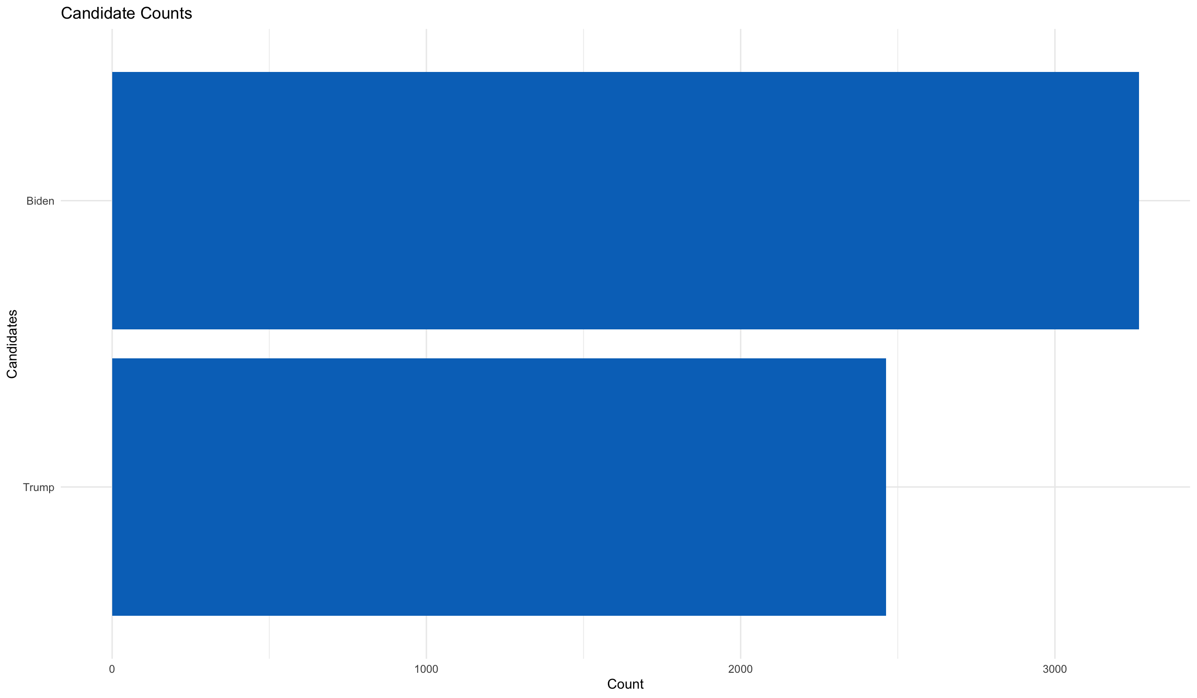

**Figure 1: Whovoted plot**

Age skews towards an older demographic. 40+ and above.

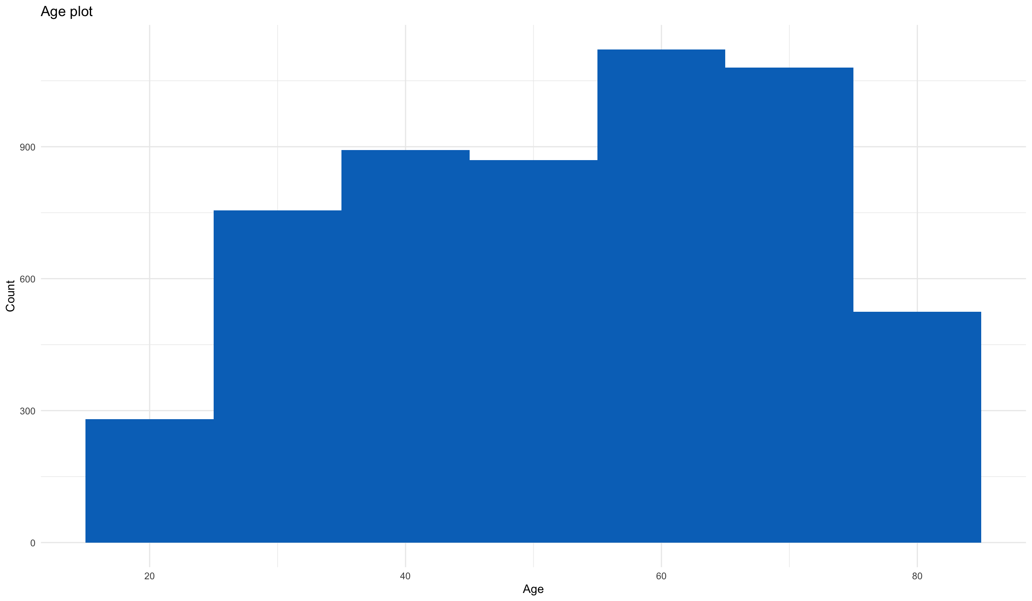

**Figure 2: Age plot**

There are a lot of non-religious people voting. Variations of the Christian faith are the majority in the data.

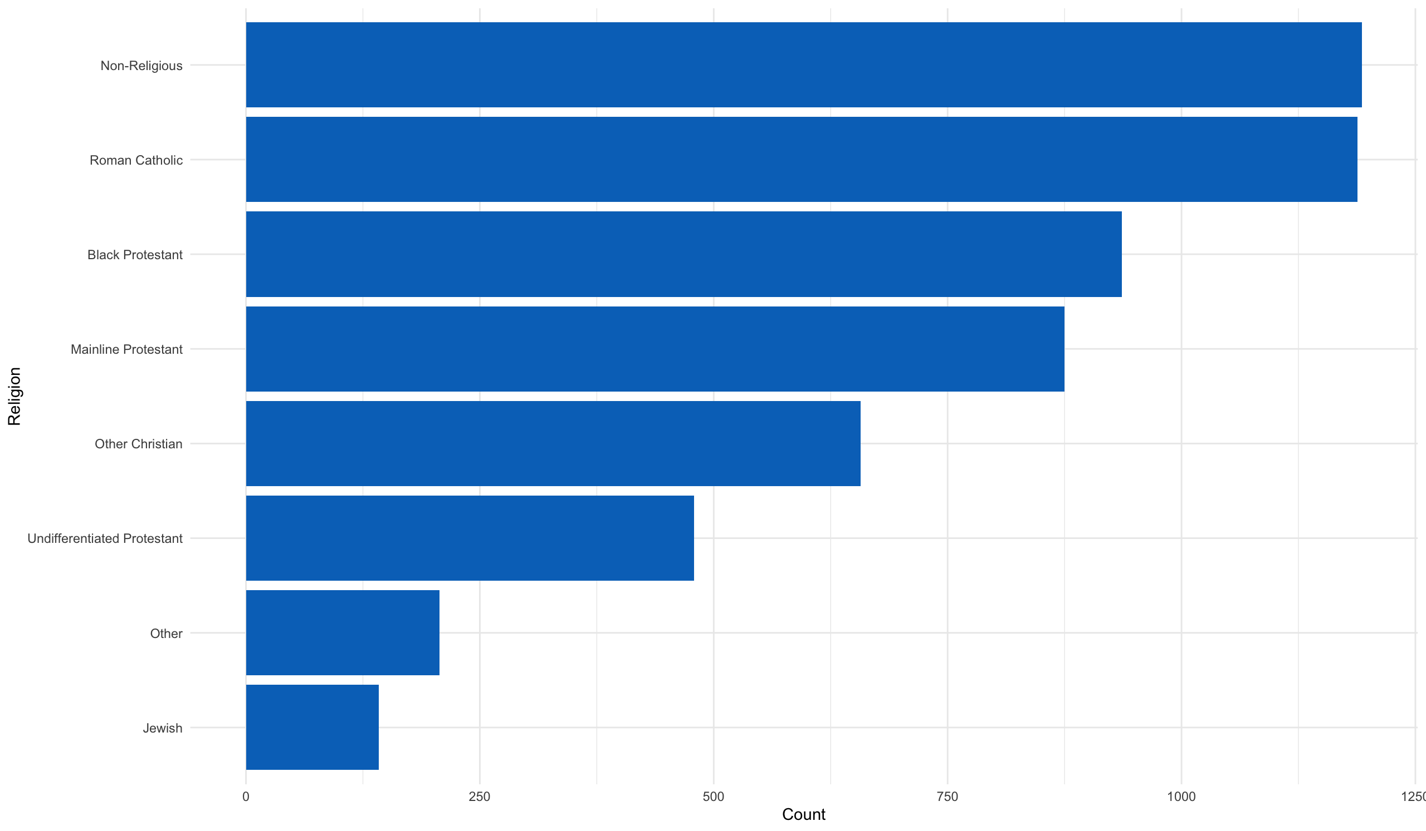

**Figure 3: Religion plot**

The income distribution is skewed towards high income earners. Although there were quite a number of people that were earning less than $10000.

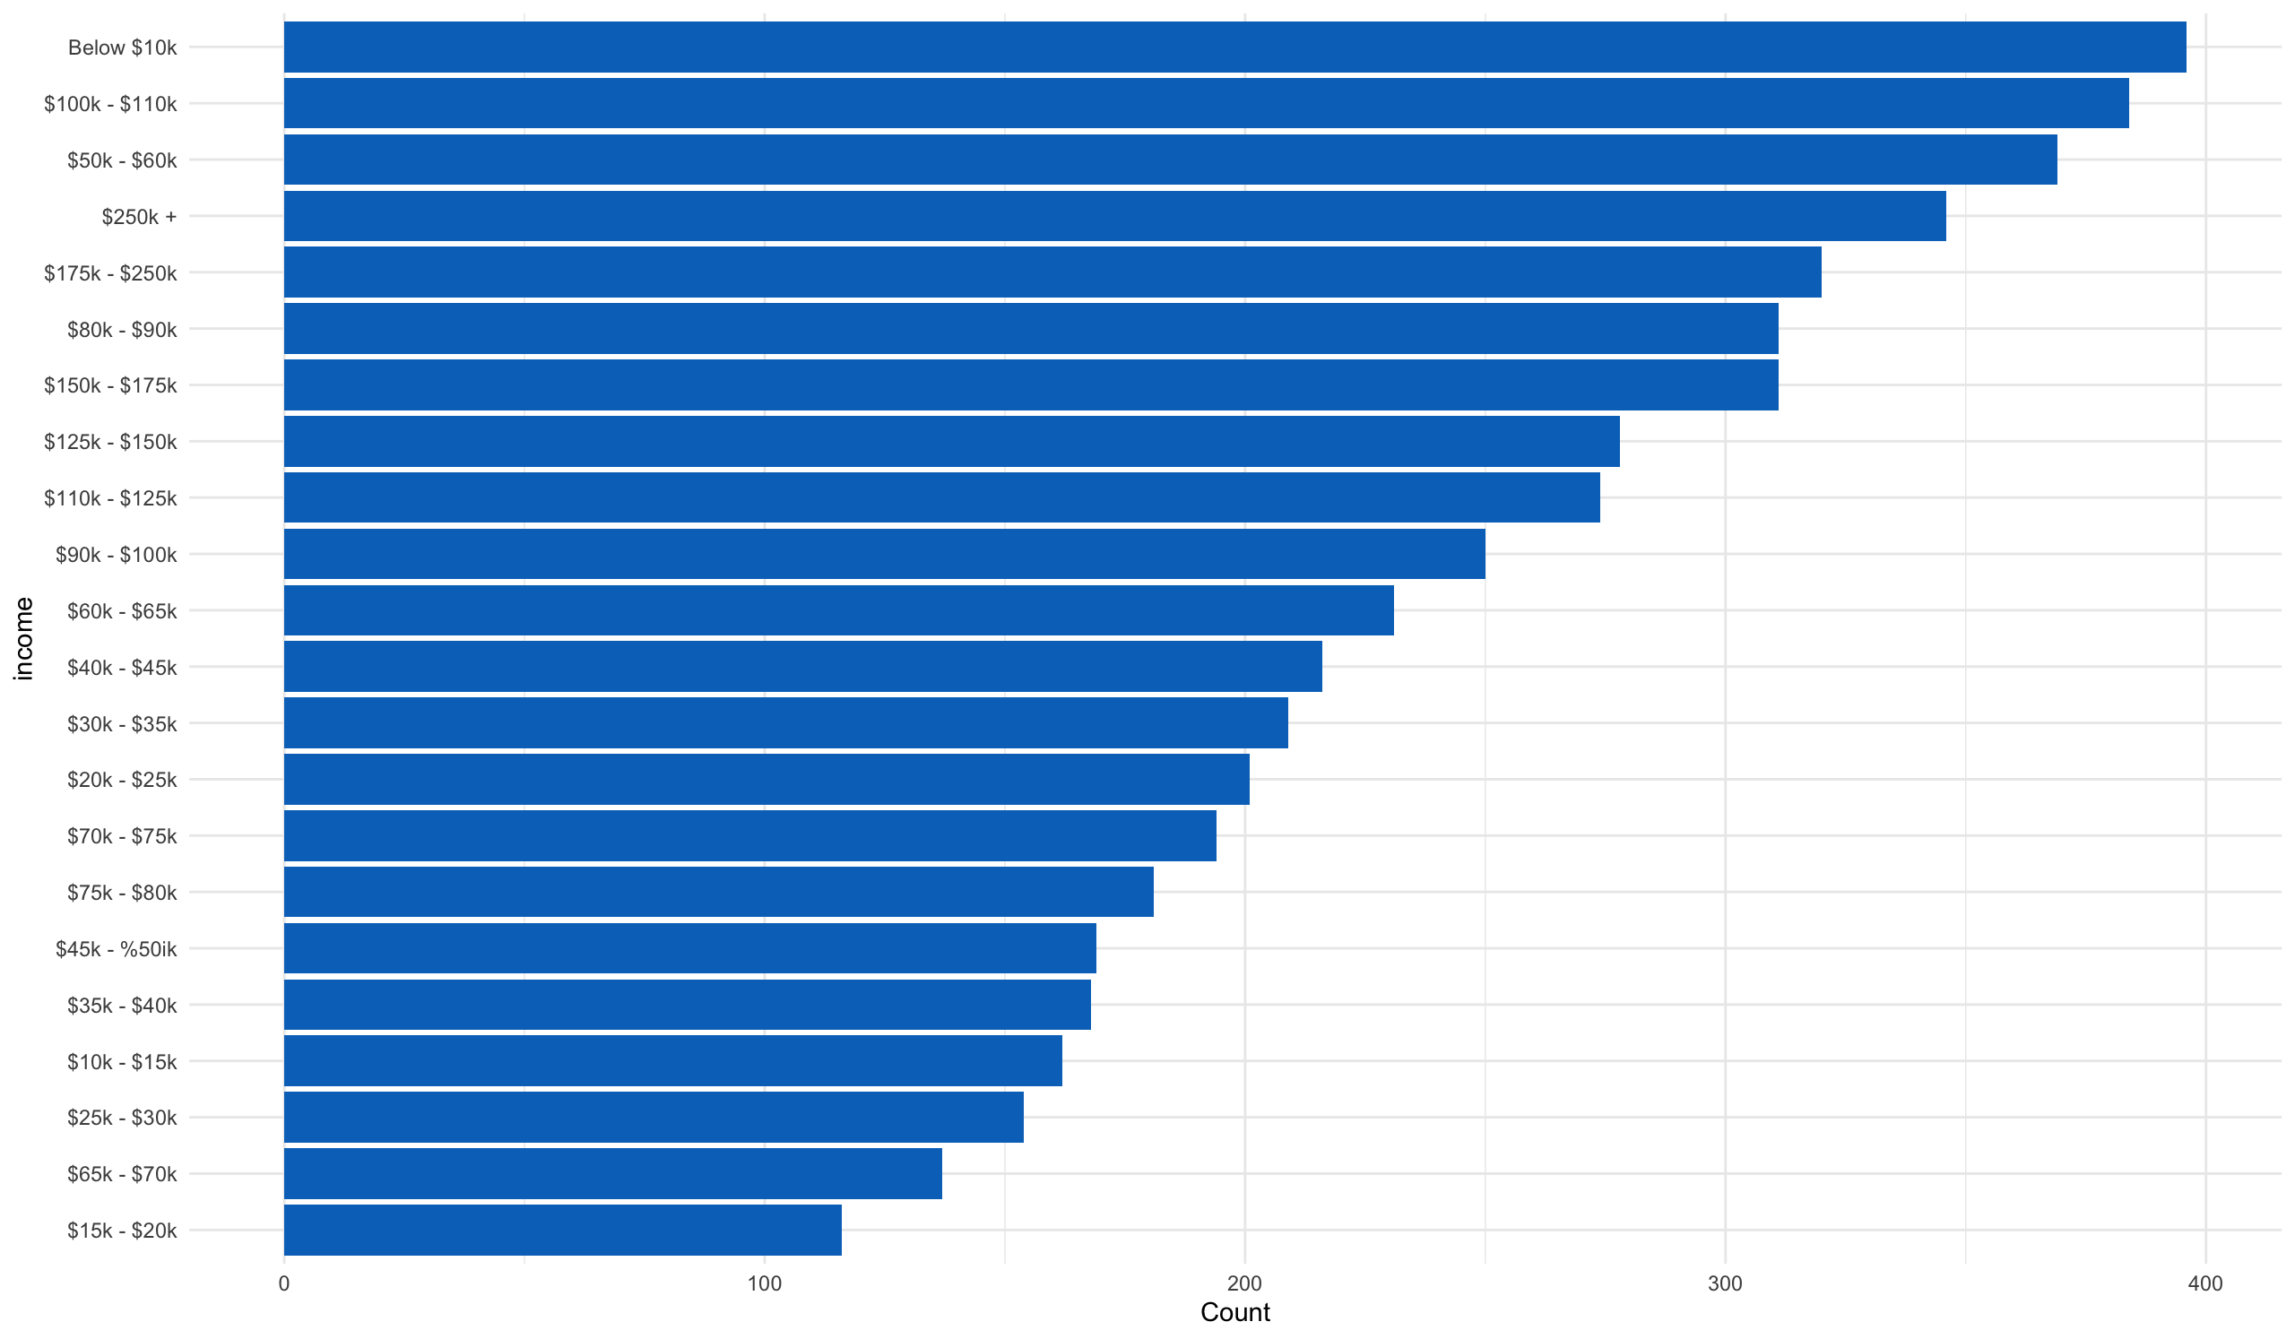

**Figure 4: Income plot**

The majority of the voting base was White Non-Hispanic. The black and Hispanic ethnic groups were a close second and third.

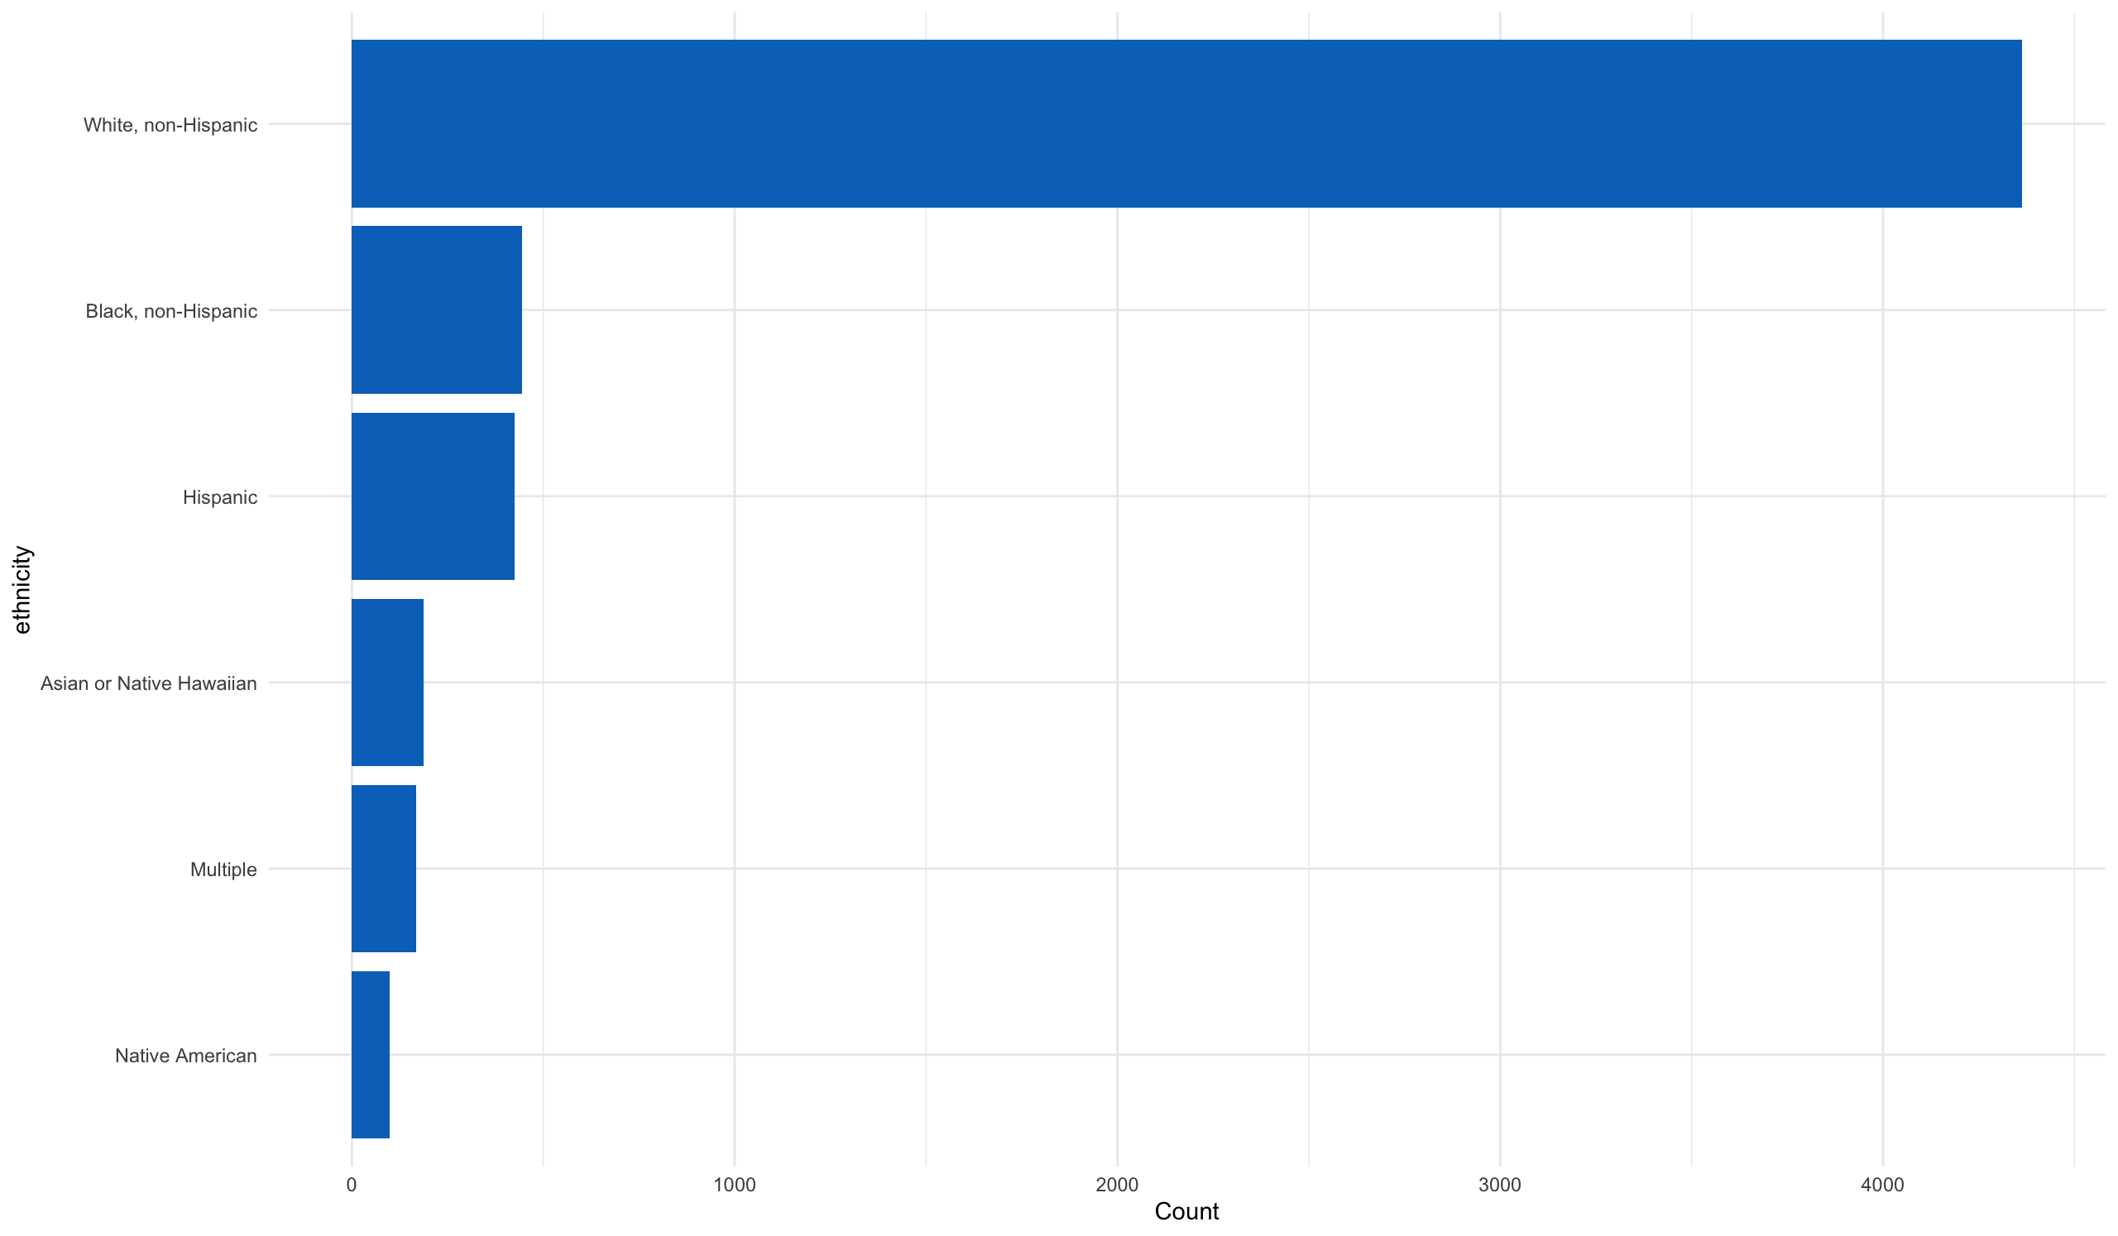

**Figure 5: Ethnicity plot**

**There seems to be a good mix between those with high school degrees and post graduate education.**

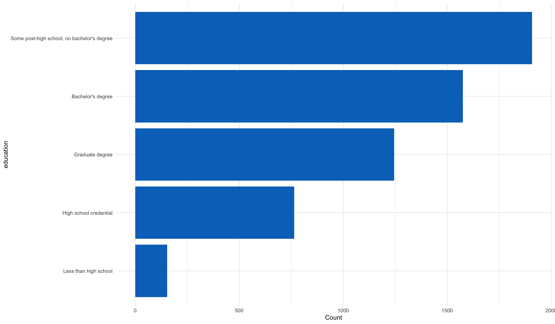

**Figure 6: Education plot**

Party registration is primarily democratic and republic. Although there are quite a number in the other category.

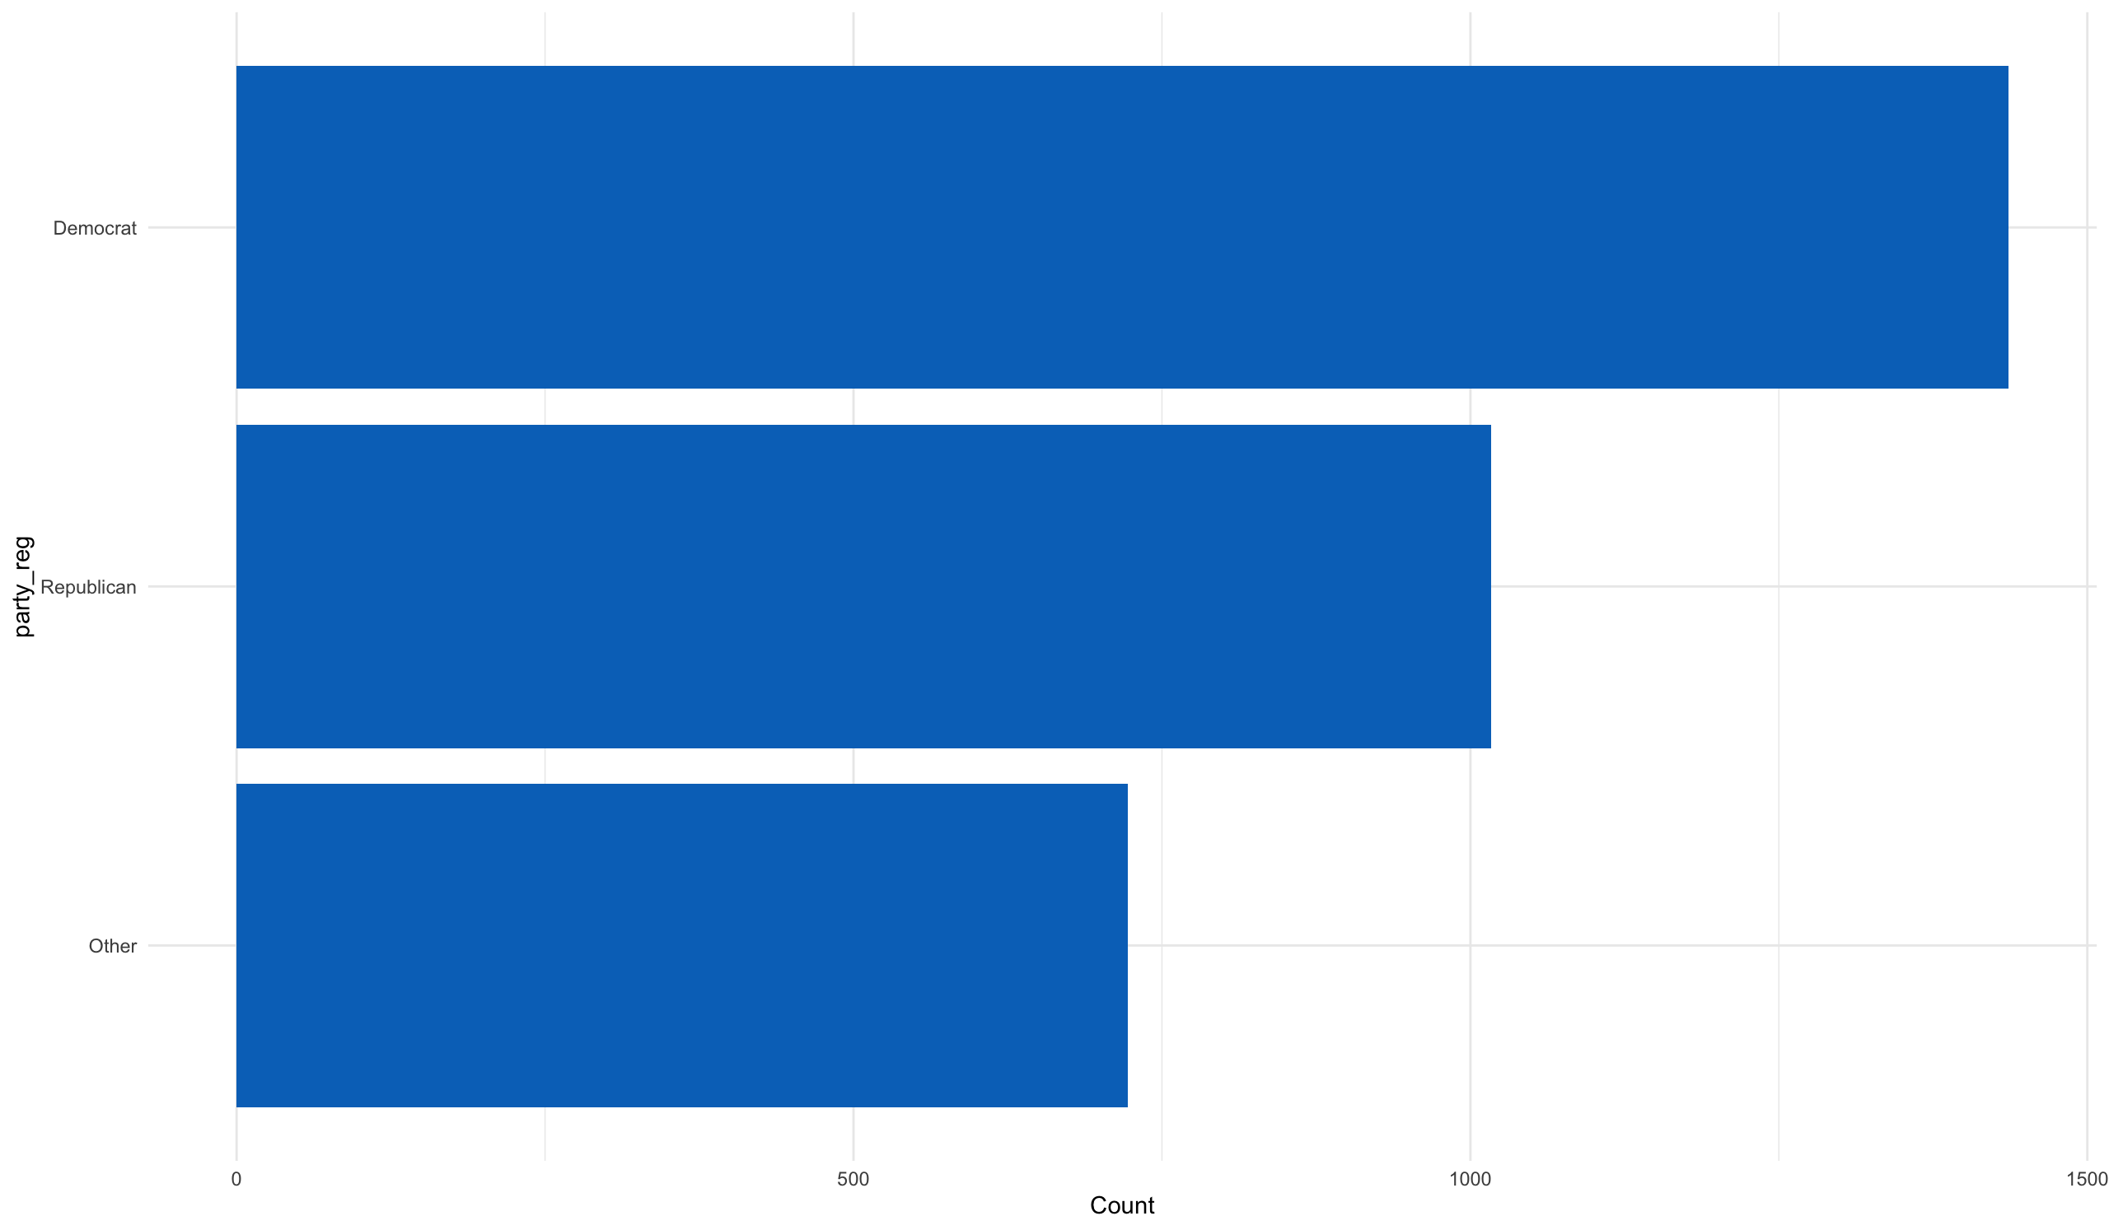

**Figure 7: Party registration plot**

There are a lot of moderates and conservatives. The extreme ends of the political spectrums are small.

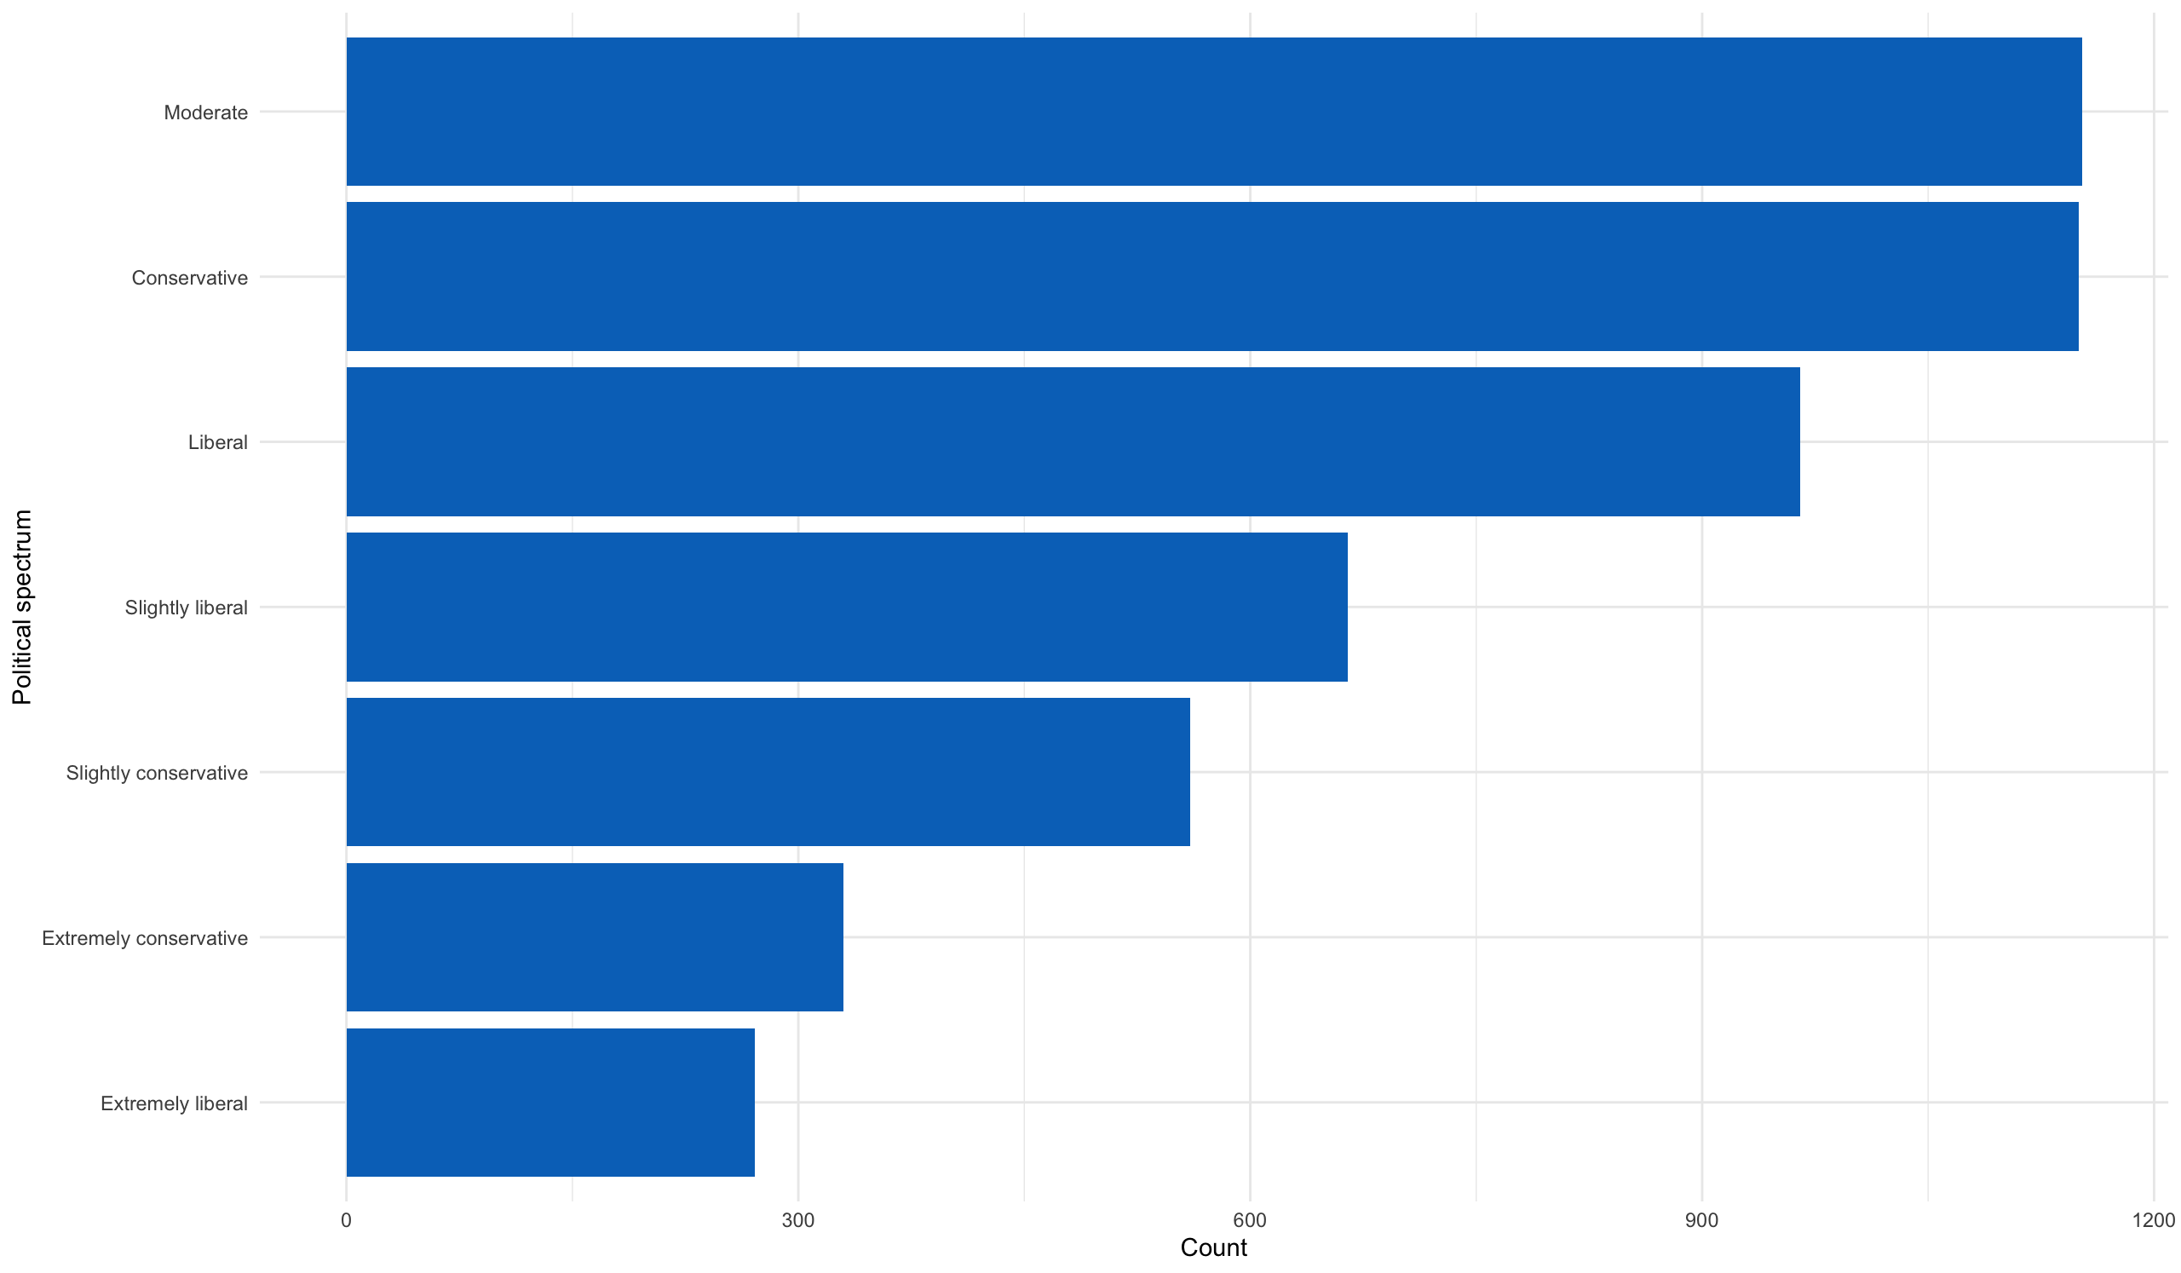

**Figure 8: Political spectrum plot**

The largest base is those that are married. Never married mostly correlates to younger people. Surprising to see a lot of divorced people.

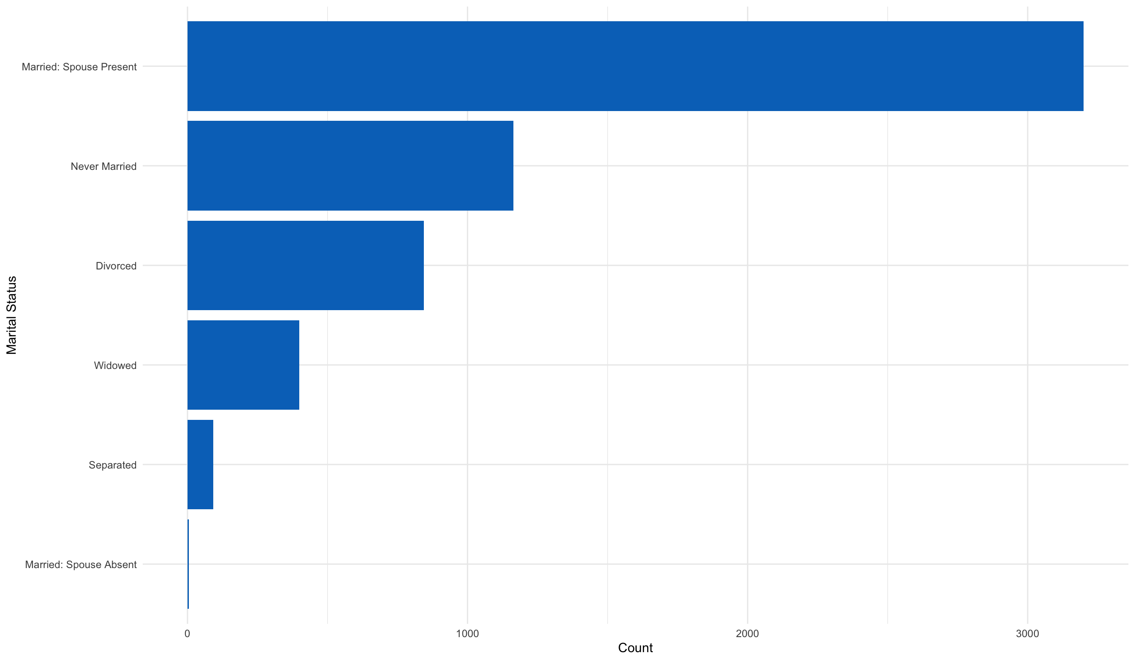

**Figure 9: Martial status plot**

The data points are mainly categorical with the exception of Age. Therefore, to see if there is correlation between the different variables and whovoted the chi-square test will be applied. The null hypothesis of the Chi-Square test is that no relationship exists on the categorical variables. It would also use 95% confidence. All p-values are less than 0.05 hence we can conclude that the variables are not independent of each other and that there is a statistical relationship between the categorical variables.

Bivariate visualization plots will be created to compared the different variables with the whovoted variable to see how the different attributes impact both Trump and Biden.

Both candidates voters that skewed older. Although a lot more younger people came out to vote for Biden.

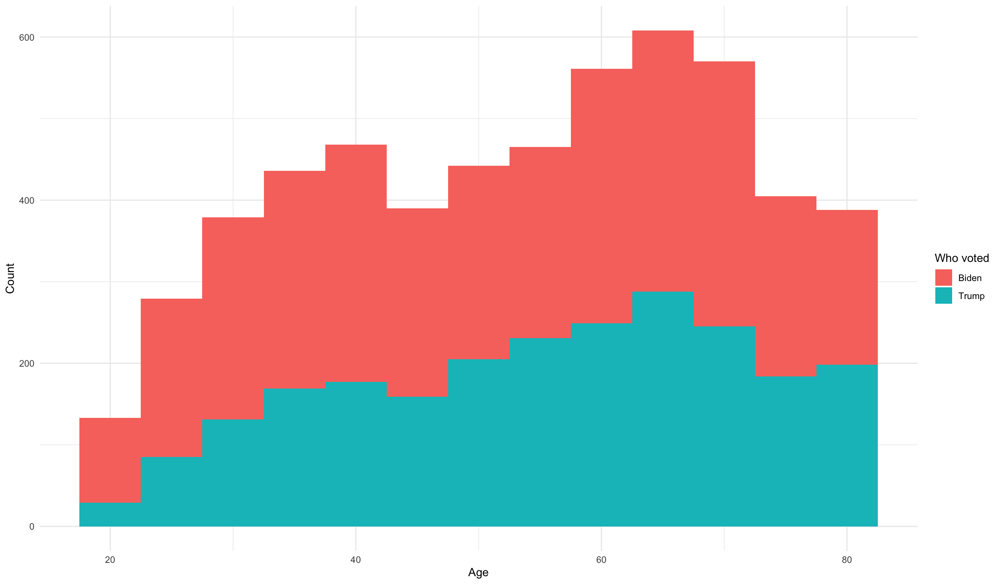

**Figure 10: Age plot**

Both Biden and Trump have a solid base across the Christian faith. Although Biden had a massive boost from those that are Non-religious especially.

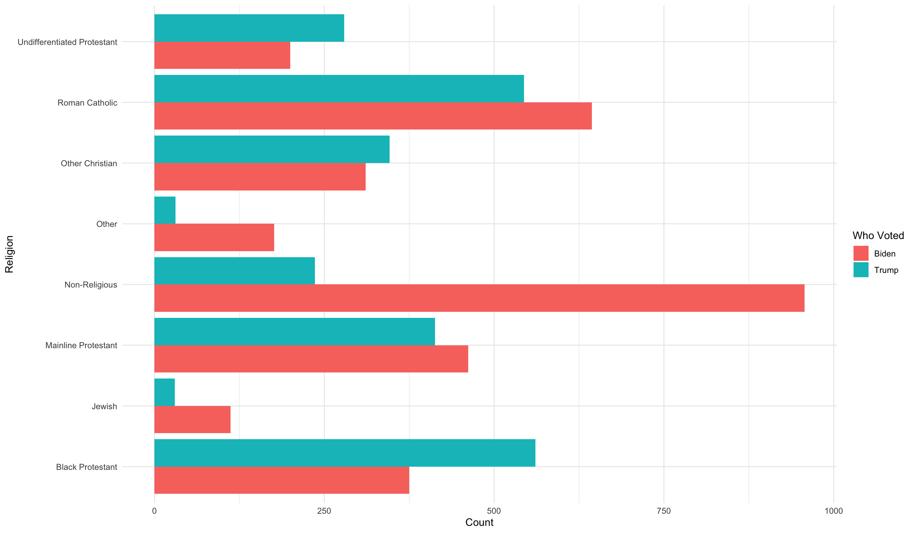

**Figure 11: Religion plot**

Across all incomes people preferred Biden to Trump but the gap narrows for earnings less than 100,000 and below.

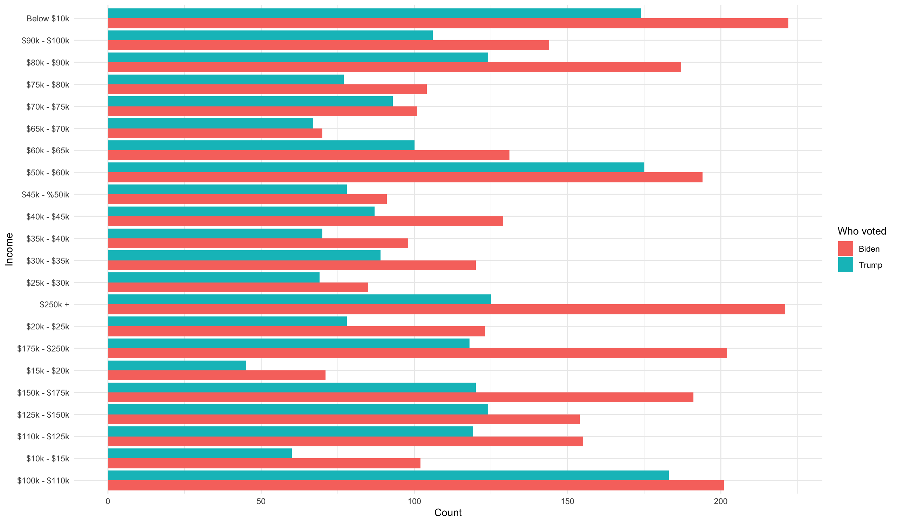

**Figure 12: Income plot**

Both candidates got had candidates that were predominantly White. Looks like it was close to an even split among White and Native American.

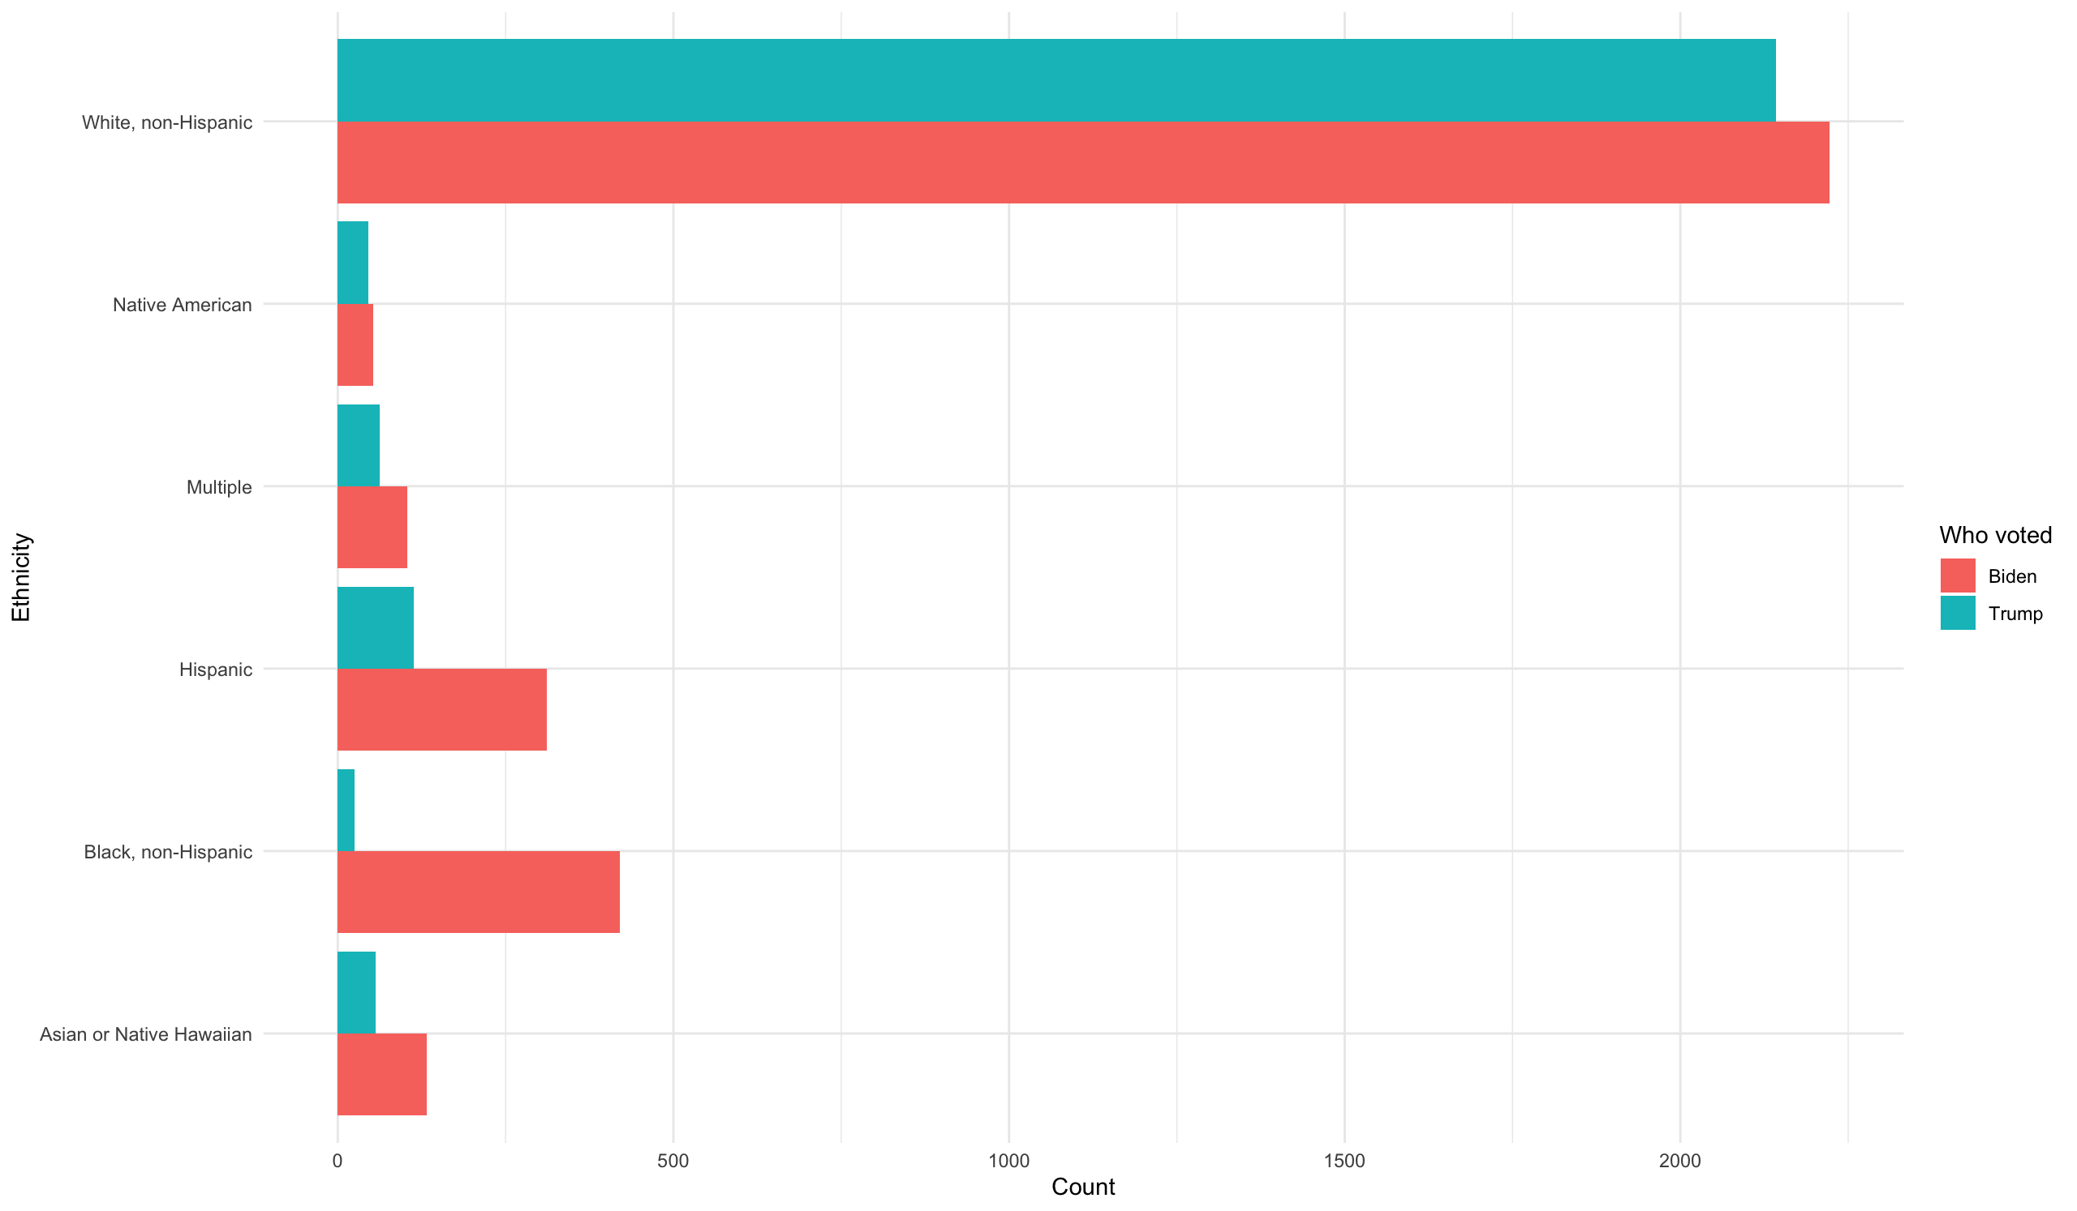

**Figure 13: Ethnicity plot**

Trump had a higher share of candidates with less than a bachelors degree. Biden took the voters with post-secondary education.

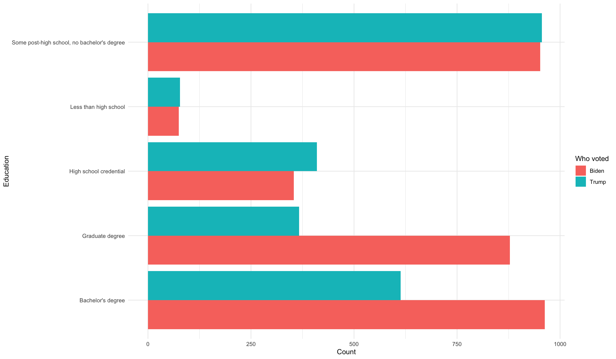

**Figure 14: Education plot**

Majority of Democratic and Republican voters voted for their party. Those in the other category mostly went with Biden.

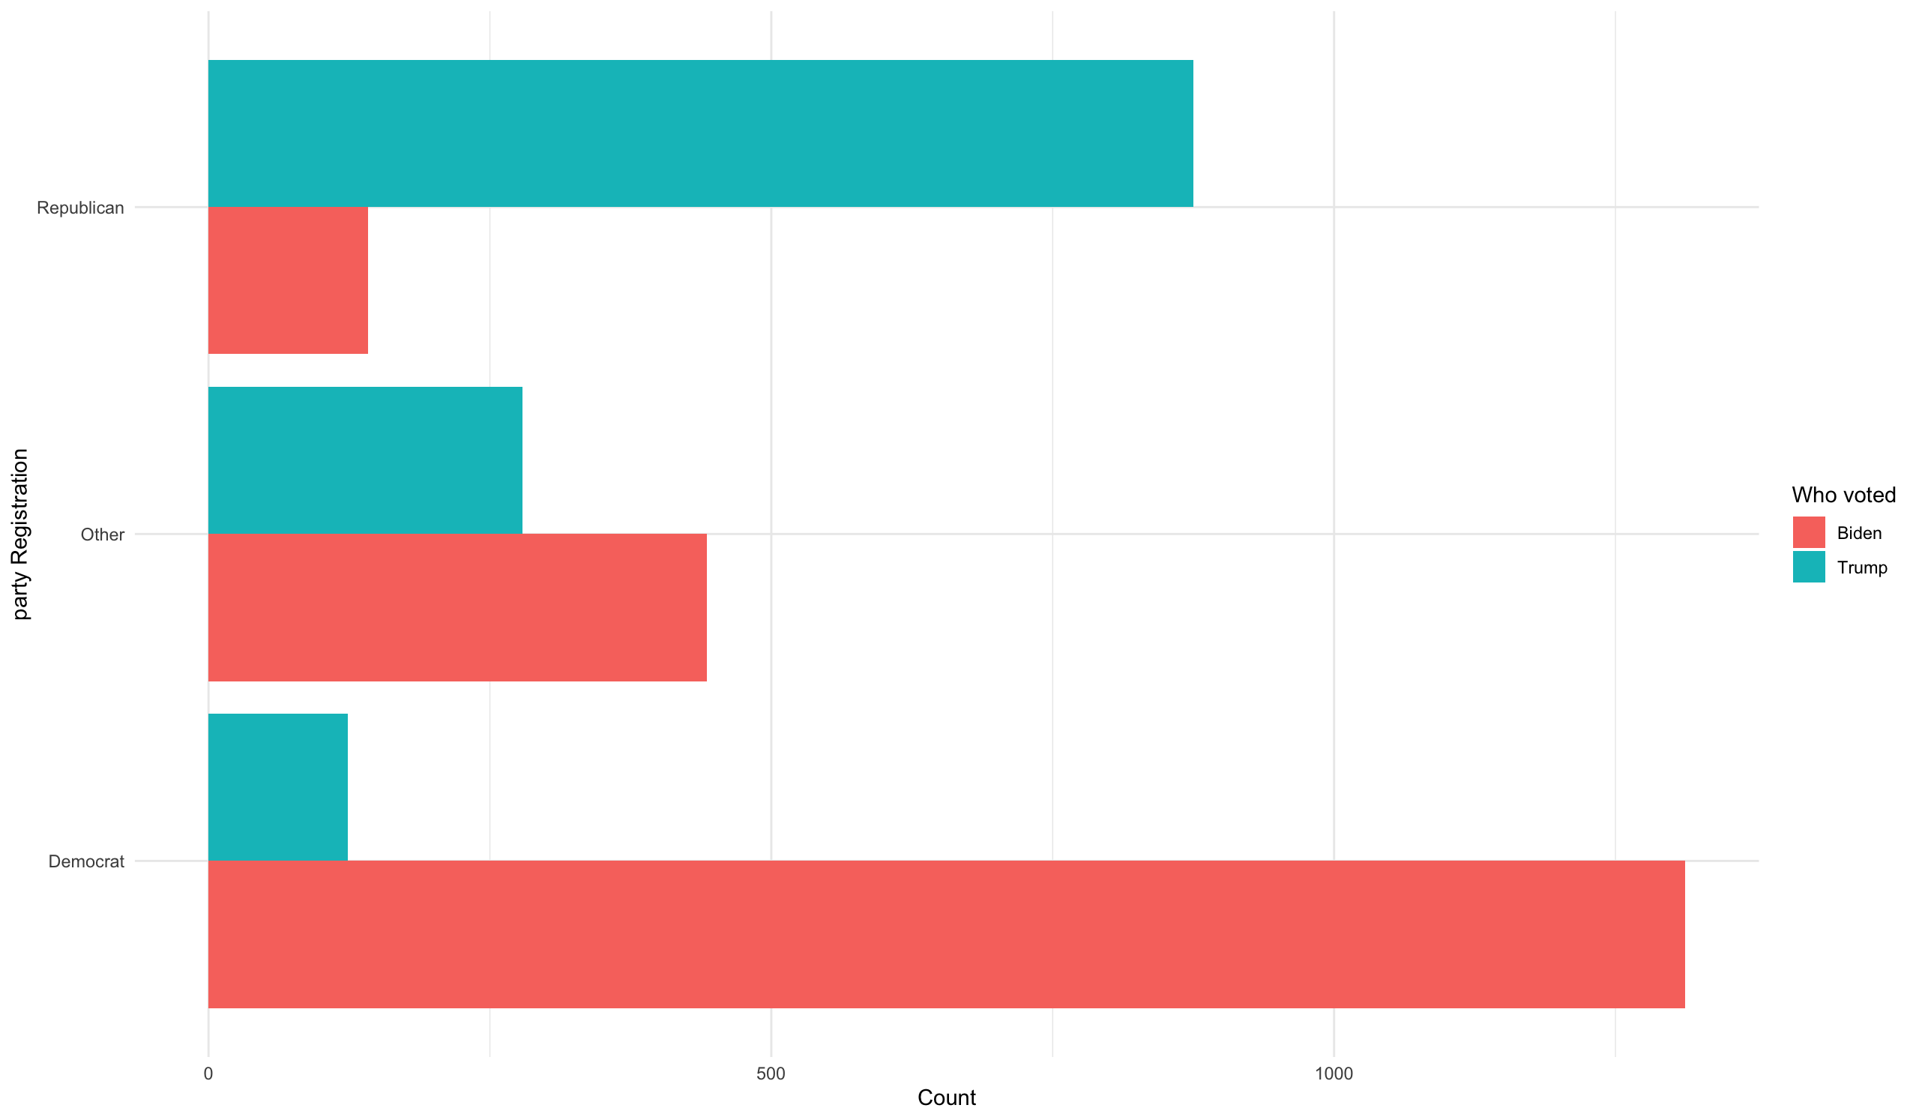

**Figure 15: Party registration plot**

Liberal voters voted for Biden and conservative voters voted for Trump.

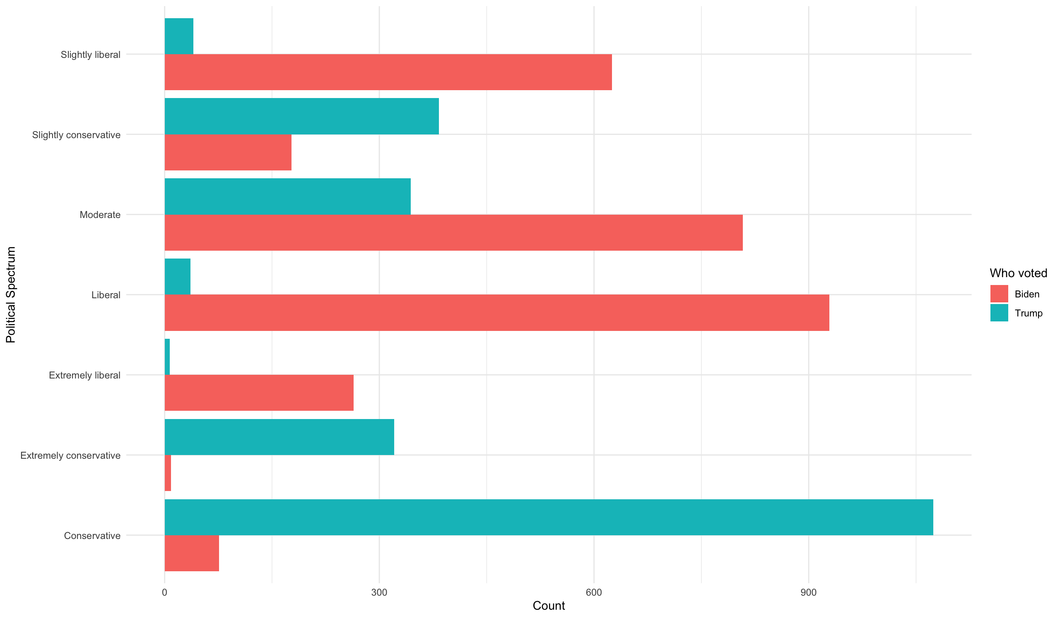

**Figure 16: Political spectrum plot**

People across all martial statuses voted for more for Biden than Trump although the Widowed and Married: Spouse Present groups were quite close.

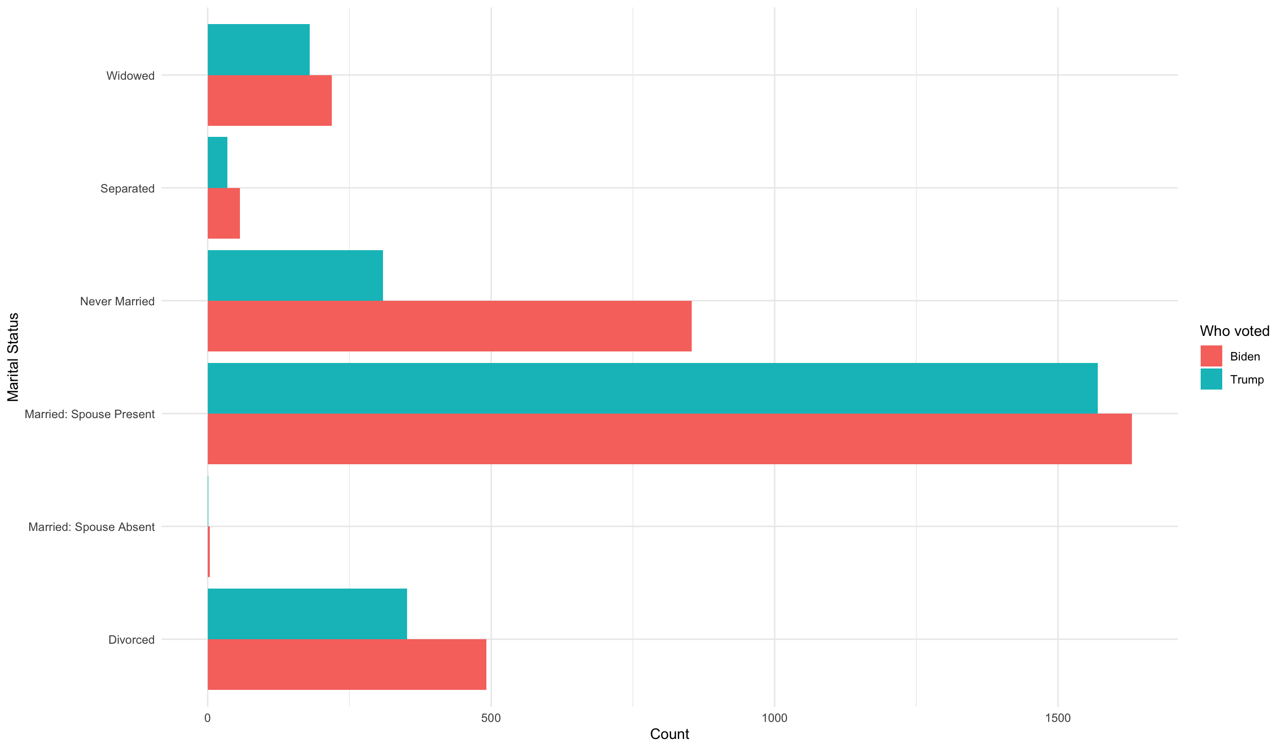

**Figure 17: Martial status plot**

**Insights**

Based on the analysis it shows that a Trump voter profile is:

* White
* Older (50+)
* Married
* Is conservative and votes conservative
* Most likely has a high school degree
* Christian
* Low to middle income earner

A typical Biden voter profile is:

* White
* Older (50+)
* Married
* Is democrat and votes democrat
* Most likely has a post-secondary degree
* Either Non-Religious or affiliated with a Christian denomination
* Middle to high income earner