FPP3: Chapter 7 The forecaster’s toolbox
# Load GEFCom2014 data
# (6 columns: YYYYMMDD, HH, zonal price, system load~demand, zonal load~demand, day-of-the-week)
d <- read.table("GEFCOM.txt")
# Select one hour for analysis ...
hour <- 9
p <- d[seq(hour, dim(d)[1], by = 24), 3]
x <- d[seq(hour, dim(d)[1], by = 24), 4]
end <- length(p) # variable to make the code similar to Matlab
# ... or take the daily average (uncomment)
# p <- apply(matrix(d[, 3], ncol = 24, byrow = TRUE), 1, mean)
# x <- apply(matrix(d[, 4], ncol = 24, byrow = TRUE), 1, mean)

# Last day of the calibration period
Tc <- 360 # "T" should not be a variable name in R

Estimations for a single hour (or the daily mean)
# AR(1) - estimation
pcal <- p[1:Tc]
y <- pcal[8:Tc] # for day d, d-1, ...
X <- cbind(1, pcal[7:(Tc - 1)])
X_fut <- cbind(1, p[Tc:(end - 1)])
# Regression, i.e., estimate betas
beta <- lm(y ~ X + 0)$coefficients # add "+ 0" if there is an explicit constant (intercept) in X
# Make prediction
pf <- numeric(length(p))
pf[(Tc + 1):end] <- X_fut %*% beta

# Sparse AR(7), i.e., lags 1,2,7 - estimation
pcal <- p[1:Tc]
y <- pcal[8:Tc] # for day d, d-1, ...
X <- cbind(1, pcal[7:(Tc - 1)], pcal[6:(Tc - 2)], pcal[1:(Tc - 7)])
X_fut <- cbind(1, p[Tc:(end - 1)], p[(Tc - 1):(end - 2)], p[(Tc - 6):(end - 7)])
# Regression, i.e., estimate betas
beta <- lm(y ~ X + 0)$coefficients
# Make prediction
pf7 <- numeric(length(p))
pf7[(Tc + 1):end] <- X_fut %*% beta

# Sparse ARX(7), i.e., lags 1,2,7 + X - estimation
pcal <- p[1:Tc]
xcal <- x[1:Tc]
y <- pcal[8:Tc] # for day d, d-1, ...
X <- cbind(1, pcal[7:(Tc - 1)], pcal[6:(Tc - 2)], pcal[1:(Tc - 7)], xcal[8:Tc])
X_fut <- cbind(1, p[Tc:(end - 1)], p[(Tc - 1):(end - 2)], p[(Tc - 6):(end - 7)], x[(Tc + 1):end])
# Regression, i.e., estimate betas
beta <- lm(y ~ X + 0)$coefficients
# Make prediction
pf7x <- numeric(length(p))
pf7x[(Tc + 1):end] <- X_fut %*% beta

Compare MAE and RMSE for the three AR-type and naive forecasts
# Day-of-the-week
dow <- d[seq(1, dim(d)[1], by = 24), 6]

# Naive method - point forecasts
npf17 <- numeric(length(p))
for (j in 8:length(p))
if (dow[j] < 2) {
npf17[j] <- p[j-7]
} else if (dow[j] > 5) {
npf17[j] <- p[j-7]
} else {
npf17[j] <- p[j-1]
}

# Naive (always d-7)
npf7 <- numeric(length(p))
npf7[8:end] <- p[1:(end-7)];
# Naive (always d-1)
npf1 <- numeric(length(p))
npf1[8:end] <- p[7:(end-1)];

nresults <- matrix(ncol = 3, nrow = 2, dimnames = list(c("MAE", "RMSE"), c("Naive", "Naive168", "Naive24")))
nresults[1, ] <- c(mean(abs(p[(Tc + 1):end] - npf17[(Tc + 1):end])),
mean(abs(p[(Tc + 1):end] - npf7[(Tc + 1):end])),
mean(abs(p[(Tc + 1):end] - npf1[(Tc + 1):end])))
nresults[2, ] <- c(sqrt(mean((p[(Tc + 1):end] - npf17[(Tc + 1):end])^2)),
sqrt(mean((p[(Tc + 1):end] - npf7[(Tc + 1):end])^2)),
sqrt(mean((p[(Tc + 1):end] - npf1[(Tc + 1):end])^2)))
print(nresults)
## Naive Naive168 Naive24
## MAE 6.779751 11.51856 7.437742
## RMSE 13.326458 24.55668 12.853891
results <- matrix(ncol = 3, nrow = 2, dimnames = list(c("MAE", "RMSE"), c("AR(1)", "AR(7)", "ARX(7)")))
results[1, ] <- c(mean(abs(p[(Tc + 1):end] - pf[(Tc + 1):end])),
mean(abs(p[(Tc + 1):end] - pf7[(Tc + 1):end])),
mean(abs(p[(Tc + 1):end] - pf7x[(Tc + 1):end])))
results[2, ] <- c(sqrt(mean((p[(Tc + 1):end] - pf[(Tc + 1):end])^2)),
sqrt(mean((p[(Tc + 1):end] - pf7[(Tc + 1):end])^2)),
sqrt(mean((p[(Tc + 1):end] - pf7x[(Tc + 1):end])^2)))
print(results)
## AR(1) AR(7) ARX(7)
## MAE 7.807249 7.029046 6.788227
## RMSE 12.646187 12.519813 12.123744

FPP3: Chapter 5 The forecaster’s toolbox

Initialize the FPP3 library
library(fpp3)
## -- Attaching packages -------------------------------------------- fpp3 0.4.0 --
## v tibble 3.1.6 v tsibble 1.1.1
## v dplyr 1.0.8 v tsibbledata 0.4.0
## v tidyr 1.2.0 v feasts 0.2.2
## v lubridate 1.8.0 v fable 0.3.1
## v ggplot2 3.3.5
## -- Conflicts ------------------------------------------------- fpp3_conflicts --
## x lubridate::date() masks base::date()
## x dplyr::filter() masks stats::filter()
## x tsibble::intersect() masks base::intersect()
## x tsibble::interval() masks lubridate::interval()
## x dplyr::lag() masks stats::lag()
## x tsibble::setdiff() masks base::setdiff()
## x tsibble::union() masks base::union()

5.1 A tidy forecasting workflow

#1 Load, transform
# Load GDP data and compute GDP per capita
gdppc <- global_economy %>%
mutate(GDP_per_capita = GDP / Population)

gdppc

Country  <fct> | Code  <fct> | Year  <dbl> | GDP  <dbl> | Growth  <dbl> | CPI  <dbl> | Imports  <dbl>
Afghanistan | AFG | 1960 | 5.377778e+08 | NA | NA | 7.02479337
Afghanistan | AFG | 1961 | 5.488889e+08 | NA | NA | 8.09716630
Afghanistan | AFG | 1962 | 5.466667e+08 | NA | NA | 9.34959331
Afghanistan | AFG | 1963 | 7.511112e+08 | NA | NA | 16.86391033
Afghanistan | AFG | 1964 | 8.000000e+08 | NA | NA | 18.05555539
Afghanistan | AFG | 1965 | 1.006667e+09 | NA | NA | 21.41280348
Afghanistan | AFG | 1966 | 1.400000e+09 | NA | NA | 18.57142854
Afghanistan | AFG | 1967 | 1.673333e+09 | NA | NA | 14.20982704
Afghanistan | AFG | 1968 | 1.373333e+09 | NA | NA | 15.21035643
Afghanistan | AFG | 1969 | 1.408889e+09 | NA | NA | 14.98422725
Next
123456
...
1000
Previous
1-10 of 10,000 rows | 1-7 of 10 columns
# write.csv(gdppc,"gdppc.csv", row.names = FALSE)

#2 Plot the data (visualize)
# Plot the data (visualize)
gdppc %>%
filter(Country == "Sweden") %>%
autoplot(GDP_per_capita) +
labs(y = "$US", title = "GDP per capita for Sweden")
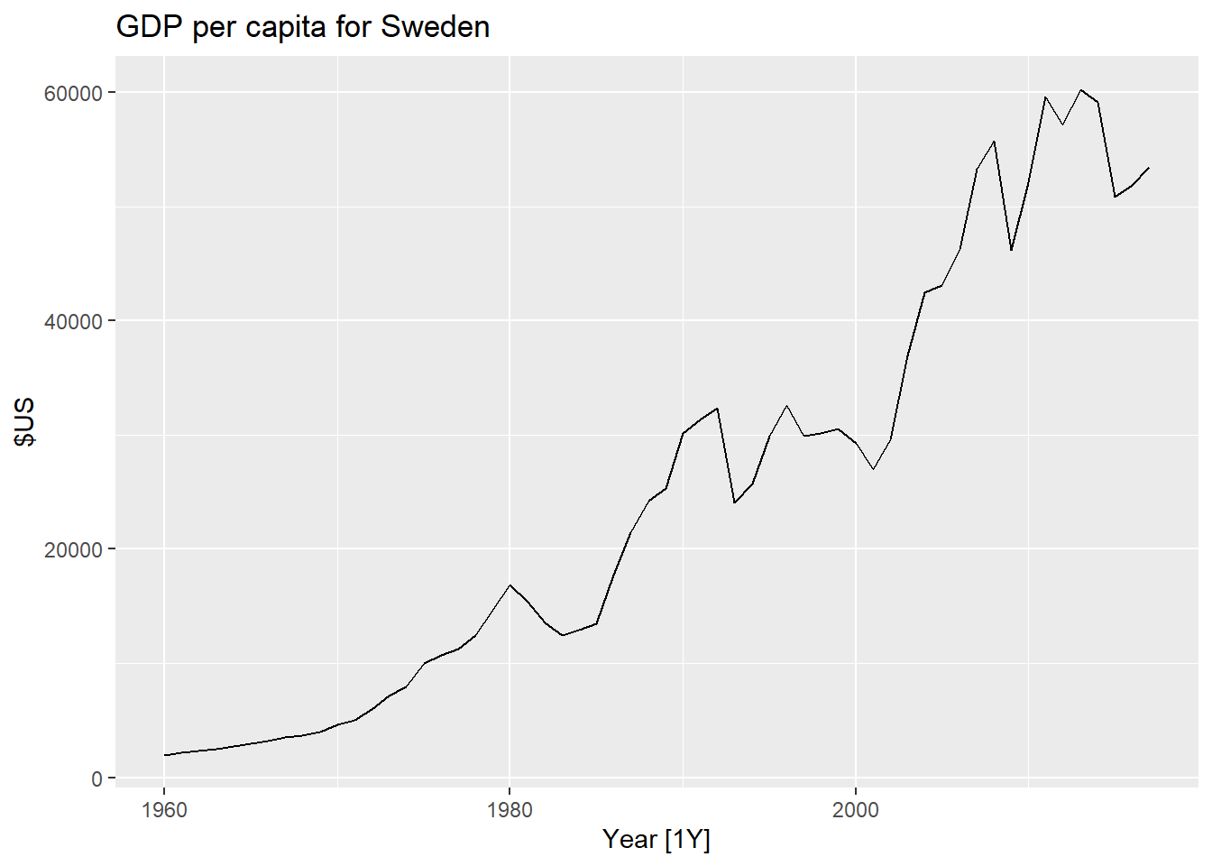
# Plot the data (visualize) for Poland
gdppc %>%
filter(Country == "Poland") %>%
autoplot(GDP_per_capita) +
labs(y = "$US", title = "GDP per capita for Poland")
## Warning: Removed 30 row(s) containing missing values (geom_path).
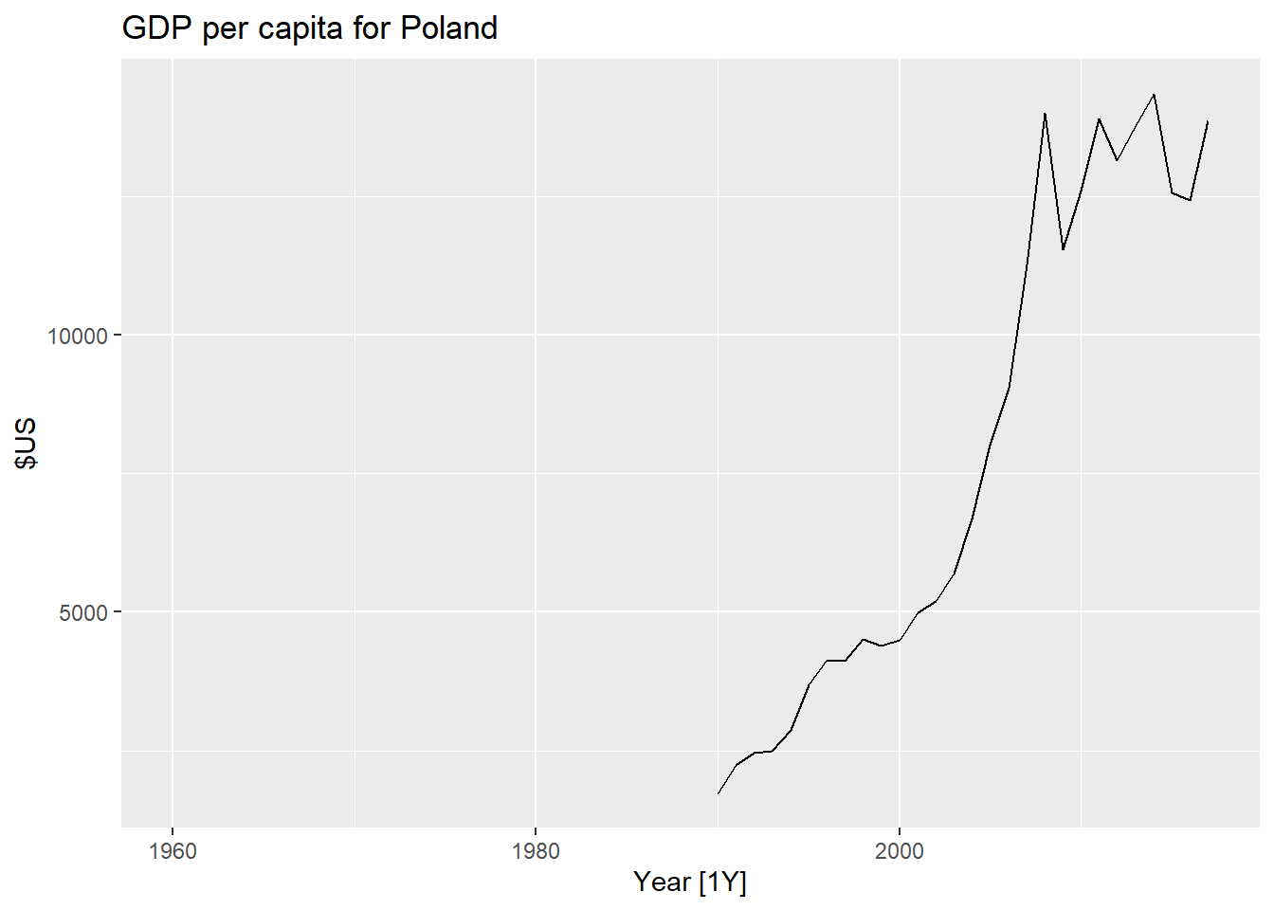

#3-4 Specify and train (estimate) a Time Series Linear (regression) Model
fit <- gdppc %>%
model(trend_model = TSLM(GDP_per_capita ~ trend()))
## Warning: 7 errors (1 unique) encountered for trend_model
## [7] 0 (non-NA) cases
fit

Country  <fct> | trend_model  <lst_mdl>
Afghanistan | <lst_mdl>
Albania | <lst_mdl>
Algeria | <lst_mdl>
American Samoa | <lst_mdl>
Andorra | <lst_mdl>
Angola | <lst_mdl>
Antigua and Barbuda | <lst_mdl>
Arab World | <lst_mdl>
Argentina | <lst_mdl>
Armenia | <lst_mdl>
Next
123456
...
27
Previous
1-10 of 263 rows

#6 Produce and visualize the forecasts
fit %>%
forecast(h = "5 years") %>%
filter(Country == "Sweden") %>%
autoplot(gdppc) +
labs(y = "$US", title = "GDP per capita for Sweden")
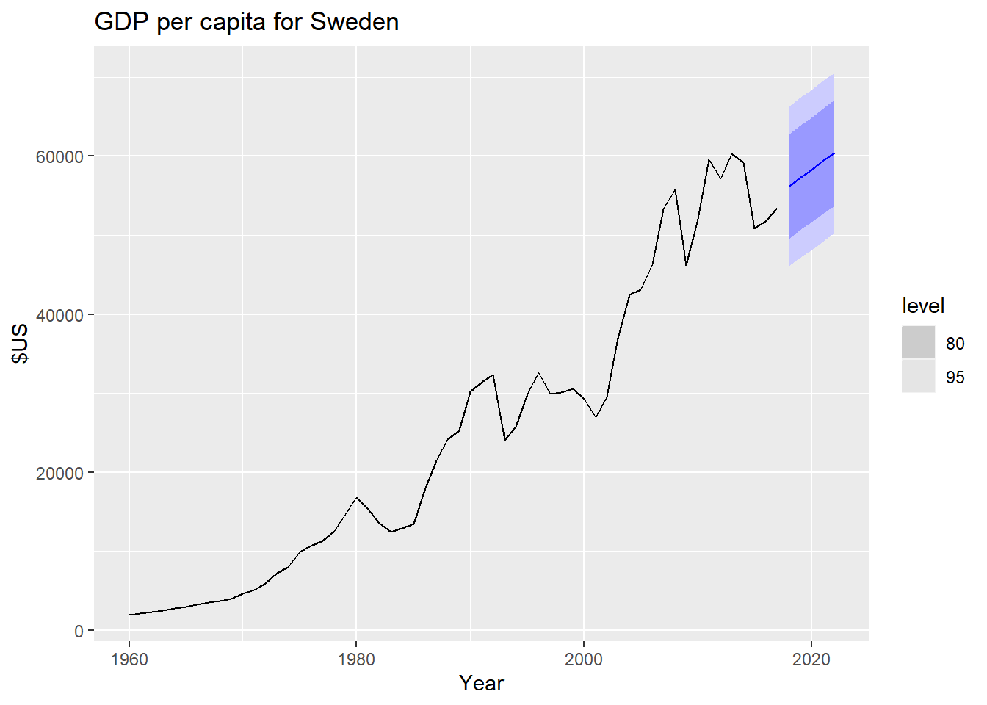

5.2 Simple forecasting methods
# Set training data from 1992 to 2006
train <- aus_production %>%
filter_index("1992 Q1" ~ "2006 Q4")
# Fit the models
beer_fit <- train %>%
model(
Mean = MEAN(Beer),
`Naïve` = NAIVE(Beer),
`Seasonal naïve` = SNAIVE(Beer)
)
# Generate forecasts for 14 quarters
beer_fc <- beer_fit %>% forecast(h = 14)
# Plot forecasts against actual values
beer_fc %>%
autoplot(train, level = NULL) +
autolayer(
filter_index(aus_production, "2007 Q1" ~ .),
colour = "black"
) +
labs(
y = "Megalitres",
title = "Forecasts for quarterly beer production"
) +
guides(colour = guide_legend(title = "Forecast"))
## Plot variable not specified, automatically selected `.vars = Beer`
