**SQL Challenge**

**Overall Approach**

Review all 8 tables to get an understanding of what their values are and how they are interconnected based on the (primary keys).

**Question 1**

What is the price of each bag of “Chais”?

**Approach and Solution:**

Look at the Products table since it contains product information. The query used is shown below.

SELECT [Price] as [ChaisPrice] FROM [Products]

Where [ProductName] = "Chais"

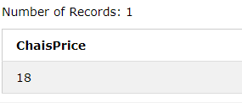

**Question 2**

How many suppliers are there in each country

**Approach and Solution**

Look at the supplier table for supplier information. The query the get this information is shown below.

SELECT Count([SupplierName]) as [Supplier_Count], [Country] FROM [Suppliers]

group by [Country]

Order by Country ASC

**Note**: There is an issue with Sweden in the Country column. One has a length of 6, the other has a length of 7. So I updated the suppliers table to fix the issue using the query below. Occurred when using google chrome.

UPDATE [Suppliers]

SET [Country] = "Sweden"

WHERE [Country] like "Swe%"

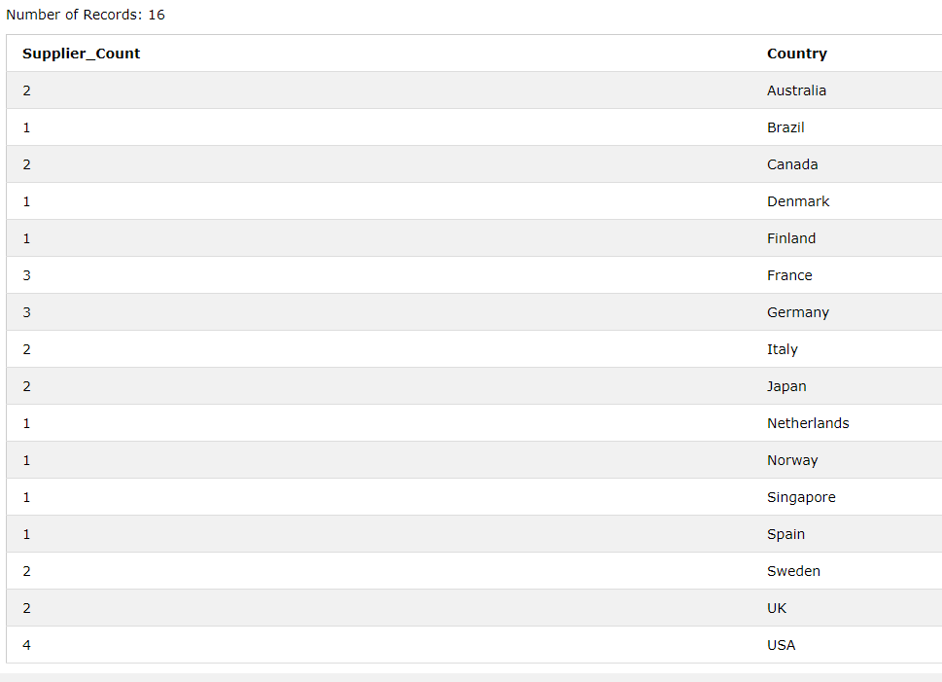

**Question 3**

What’s the average quantity of items in an order when the employee involved is Margaret Peacock?

**Approach and Solution**

Looked at the employees, order and order details table in order to design the query needed. The query to answer the question is shown below.

SELECT ROUND(AVG(OD.Quantity)) as [Average_Quantity] FROM [OrderDetails] OD, [Orders] O

where OD.OrderID = O.OrderID

and O.EmployeeID = (SELECT [EmployeeID] FROM [Employees] WHERE [FirstName] = "Margaret" and [LastName] = "Peacock")

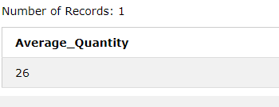

**Question 4**

What are the top 3 categories by most products sold?

**Approach and Solution**

I looked at the categories, order details and products tables to design the query. The query to generate the output is shown below.

SELECT c.CategoryName, sum(o.Quantity) as Quantity FROM [OrderDetails] o, [Products] p, [Categories] c

where p.ProductID = o.ProductID

and c.CategoryID = p.CategoryID

group by c.CategoryName

Order by 2 DESC

limit 3

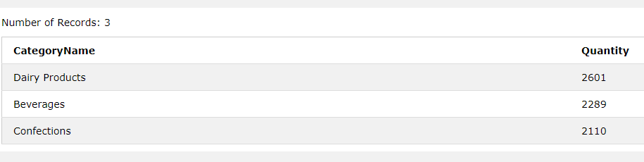

**Question 5**

What’s the average order value of orders being shipped to Germany?

**Approach and Solution**

I looked at the orders, order details, product and customer tables to design the query. The query to answer the given question is shown below.

Select Round(AVG(p.Price * od.Quantity),2) as [Average_Order_Value]

From [Orders] o, [OrderDetails] od, [Products] p, [Customers] c

where

od.ProductID = p.ProductID

and od.OrderID = o.OrderID

and c.Country = "Germany"

