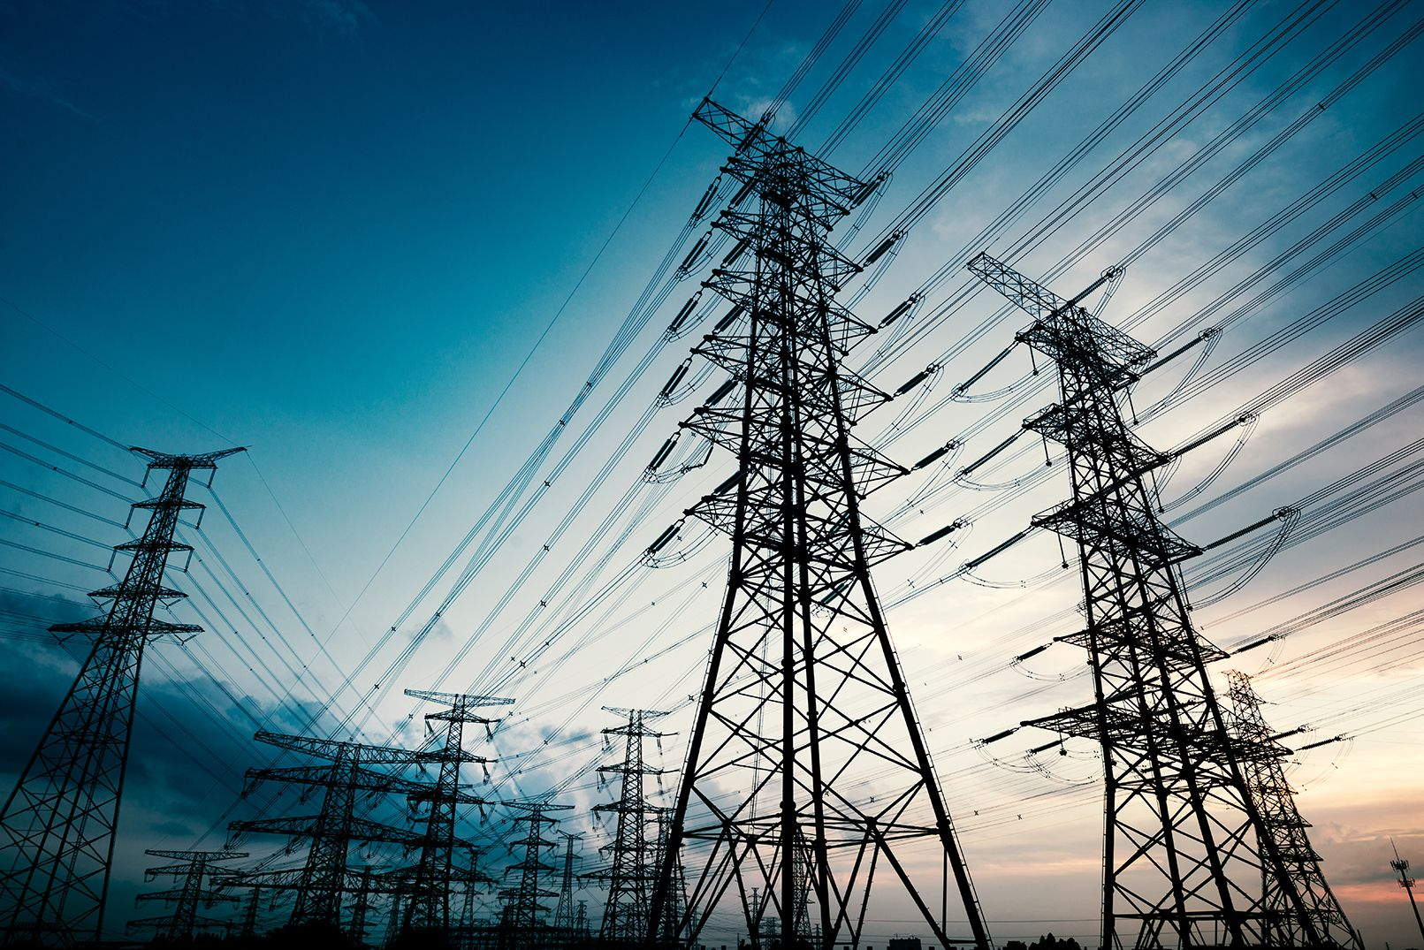

Project Proposal

# MISO Outage management System

***Summary***

*Scheduled events like routine maintenance and unscheduled events usually caused by severe weather events or aging infrastructures makes is paramount for System Operators to have a robust outage management and coordination process.*

**Overview**

MISO (Mid-continent Independent System Operator) is an independent, not-for-profit, member-based organization that delivers safe, cost-effective electric power across 15 U.S. states and the Canadian province of Manitoba. A major service they provide is the coordination of scheduled and unscheduled outages of electricity generation and transmission assets. These assets are controlled by various stakeholders and must occasionally be taken offline for maintenance and repair. The current process for scheduling outages and coordinating with different stakeholders is cumbersome.

**Objective**

The goal is to develop a new system that would assist MISO in meeting these criteria:

- Increase the certainty around outages

- Minimize dependence on MISO staff

- Driver greater predictability and accuracy

- Simplify the outage coordination process

- Simplify the overall process

**Assumptions**

* Proposed solution can be integrated into current MISO operations

**Solution Requirements**

The design needed to solve this challenge will have to meet the following criteria:

- Allows resource down time while protecting system integrity by ensuring a minimum quality of available resources

- Balances overall system integrity with fairness to individual resource owners in allowing for routine maintenance

- Integrates the request, analysis, and scheduling functions while allowing visibility of availability to requestors

**Solution Design**

Based on the requirements and objectives highlighted an outage management system (OMS) integrated with operational processes should be able to tackle the problem. An OMS can be defined as any type of software or computing device that assists in locating, analyzing, and fixing an outage on the energy grid. OMS can operate within the context of individual utilities; they are often able to coordinate with many different sources of data in order to get an accurate image of the grid in real-time. Some OMSs usually have a suite of diverse cross-domain models and multi-disciplinary software applications to holistically and scientifically consider both non-power and power system factors. These include but is not limited to:

* Geographical Information System (GIS)
* Customer Information System (CIS)
* Automated Metering Infrastructure (AMI)
* Mobile Workforce Management Systems (MWM)
* Supervisory Control and Data Acquisition Systems (SCADA)
* Outage Risk Prediction for transmission assets, based on their vulnerabilities to extreme weather condition
* Real Time Unplanned Outage Detection and Real Time Decision Support for optimal planning and prediction of the impact of plans on the state of the grid
* Real Time Automated Closed Loop Control for execution of the plans to reliably operate the grid during Emergency
* Transmission Outage & Restoration Planner (TORP)
* Data analytics application
* Time Shutdown & Restoration Manager (RTSRM),
* Advanced Energy Management System (AEMS) application

For this challenge the solution would be called MOMSP. MOMSP stands for MISO Outage Management System and Processes. The solution would be an integrated set of applications that streamline work processes and improve communications between field and operations personnel. It will allow generation and transmission asset owners (and MISO) the ability to comprehensively manage all outages and their lifecycles, from planning and operations all the way through reporting to ISO scheduling entities, NERC and much more.

**MOMSP**

MOMSP will have the following capabilities

***Submitted proposals along with all relevant supporting data should include the information described in the Detailed Description of the Challenge. The solution may combine existing components, commercially available components, and/or novel Solver solutions. Ideas leveraged from other industries with similar problems are encouraged.***

1. ***A detailed block diagram/wireframe view of the proposed system with major components and information flow indicated***
2. ***Specific details of each component and how to implement the functionality of the component. This may include custom or commercial software, and in the case of custom software a detailed description of the algorithm and architecture is required***
3. ***Data, drawings etc. necessary to convey the full extent of the proposed solution.***

**Outage Management Process**

Key stakeholders for MOMS are ….

***c( Detailed narratives for different outage request scenarios beginning with a request from a participant. Narratives must describe the information flow between components, the decision process within relevant components, and the operation of each component utilized in the scenario. Scenarios must include:***

***- A simple outage request that can be approved automatically***

***- An outage request that requires a full outage study and is approved***

* ***An outage request that is denied***
* ***Data, drawings etc. necessary to convey the full extent of the proposed solution.***

***Detailed description of an approach to an outage coordination system that can meet the above Solution Requirements.***

**Solution Benefits**

***Rationale as to why the Solver believes that the proposed system will work. This rationale should address each of the Solution Requirements described in the Detailed Description and should be supported with any relevant examples and/or scenarios.***

- Allows resource down time while protecting system integrity by ensuring a minimum quality of available resources

- Balances overall system integrity with fairness to individual resource owners in allowing for routine maintenance

- Integrates the request, analysis, and scheduling functions while allowing visibility of availability to requestors

- An OMS can make a big difference for your local/national utility and for your own power usage. Using new meter technology like AMI, outages are now detected faster than ever. Combined with a good OMS software, many outages today are fixed without anyone even noticing they occurred.

- Though many outages are detected when a person loses power in their home and calls up their local utility, a reliable OMS can identify this information and provide a quicker response than waiting for you and your neighbor to dial in.

- This automated coordination and processing an OMS provides means more reliable power and faster resolution for issues to help keep your home running smoothly.