**Social Platform Diagrams**

**Conceptual Architecture Diagram:**

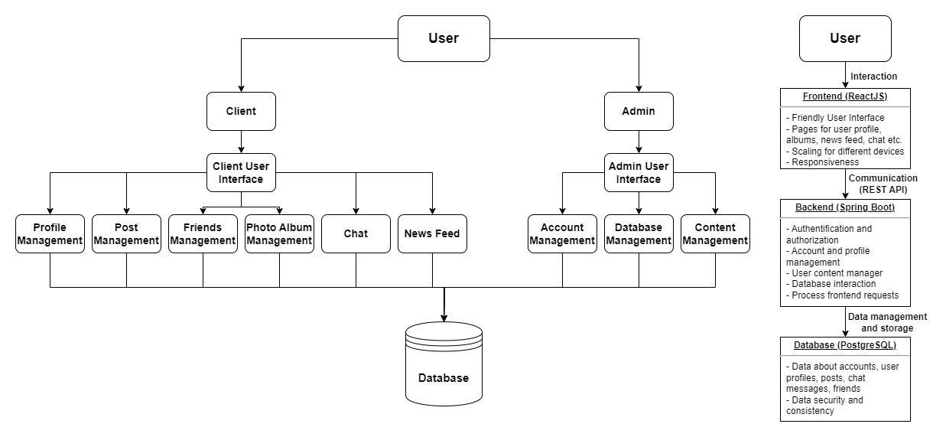

**Package Diagram:**

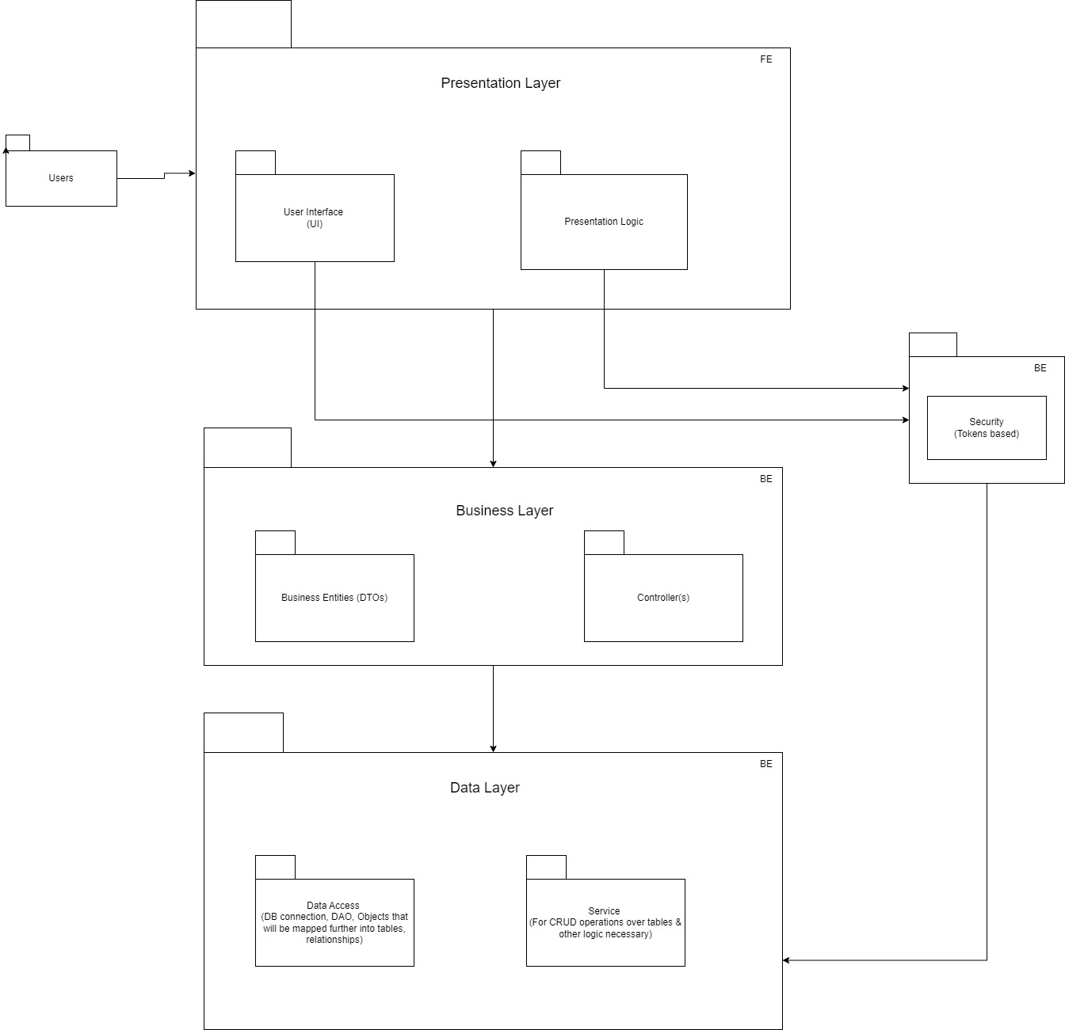

**Sequence Diagram:**

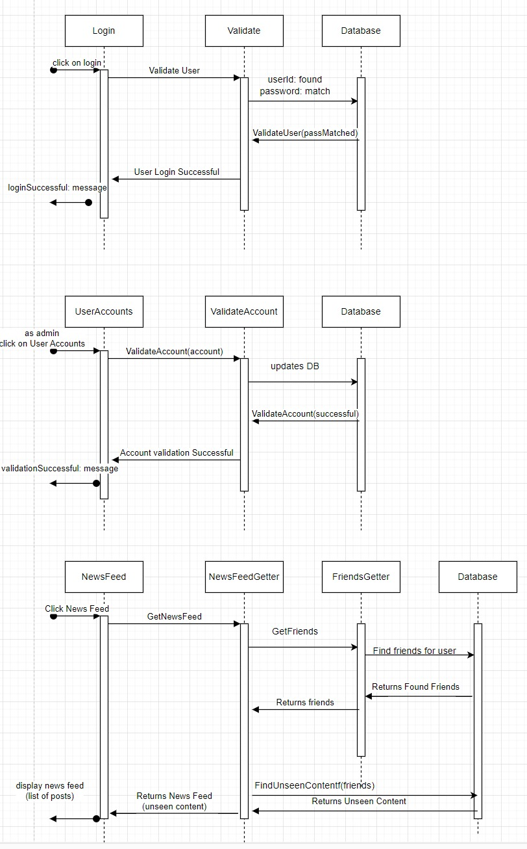

**Database Diagram:**

