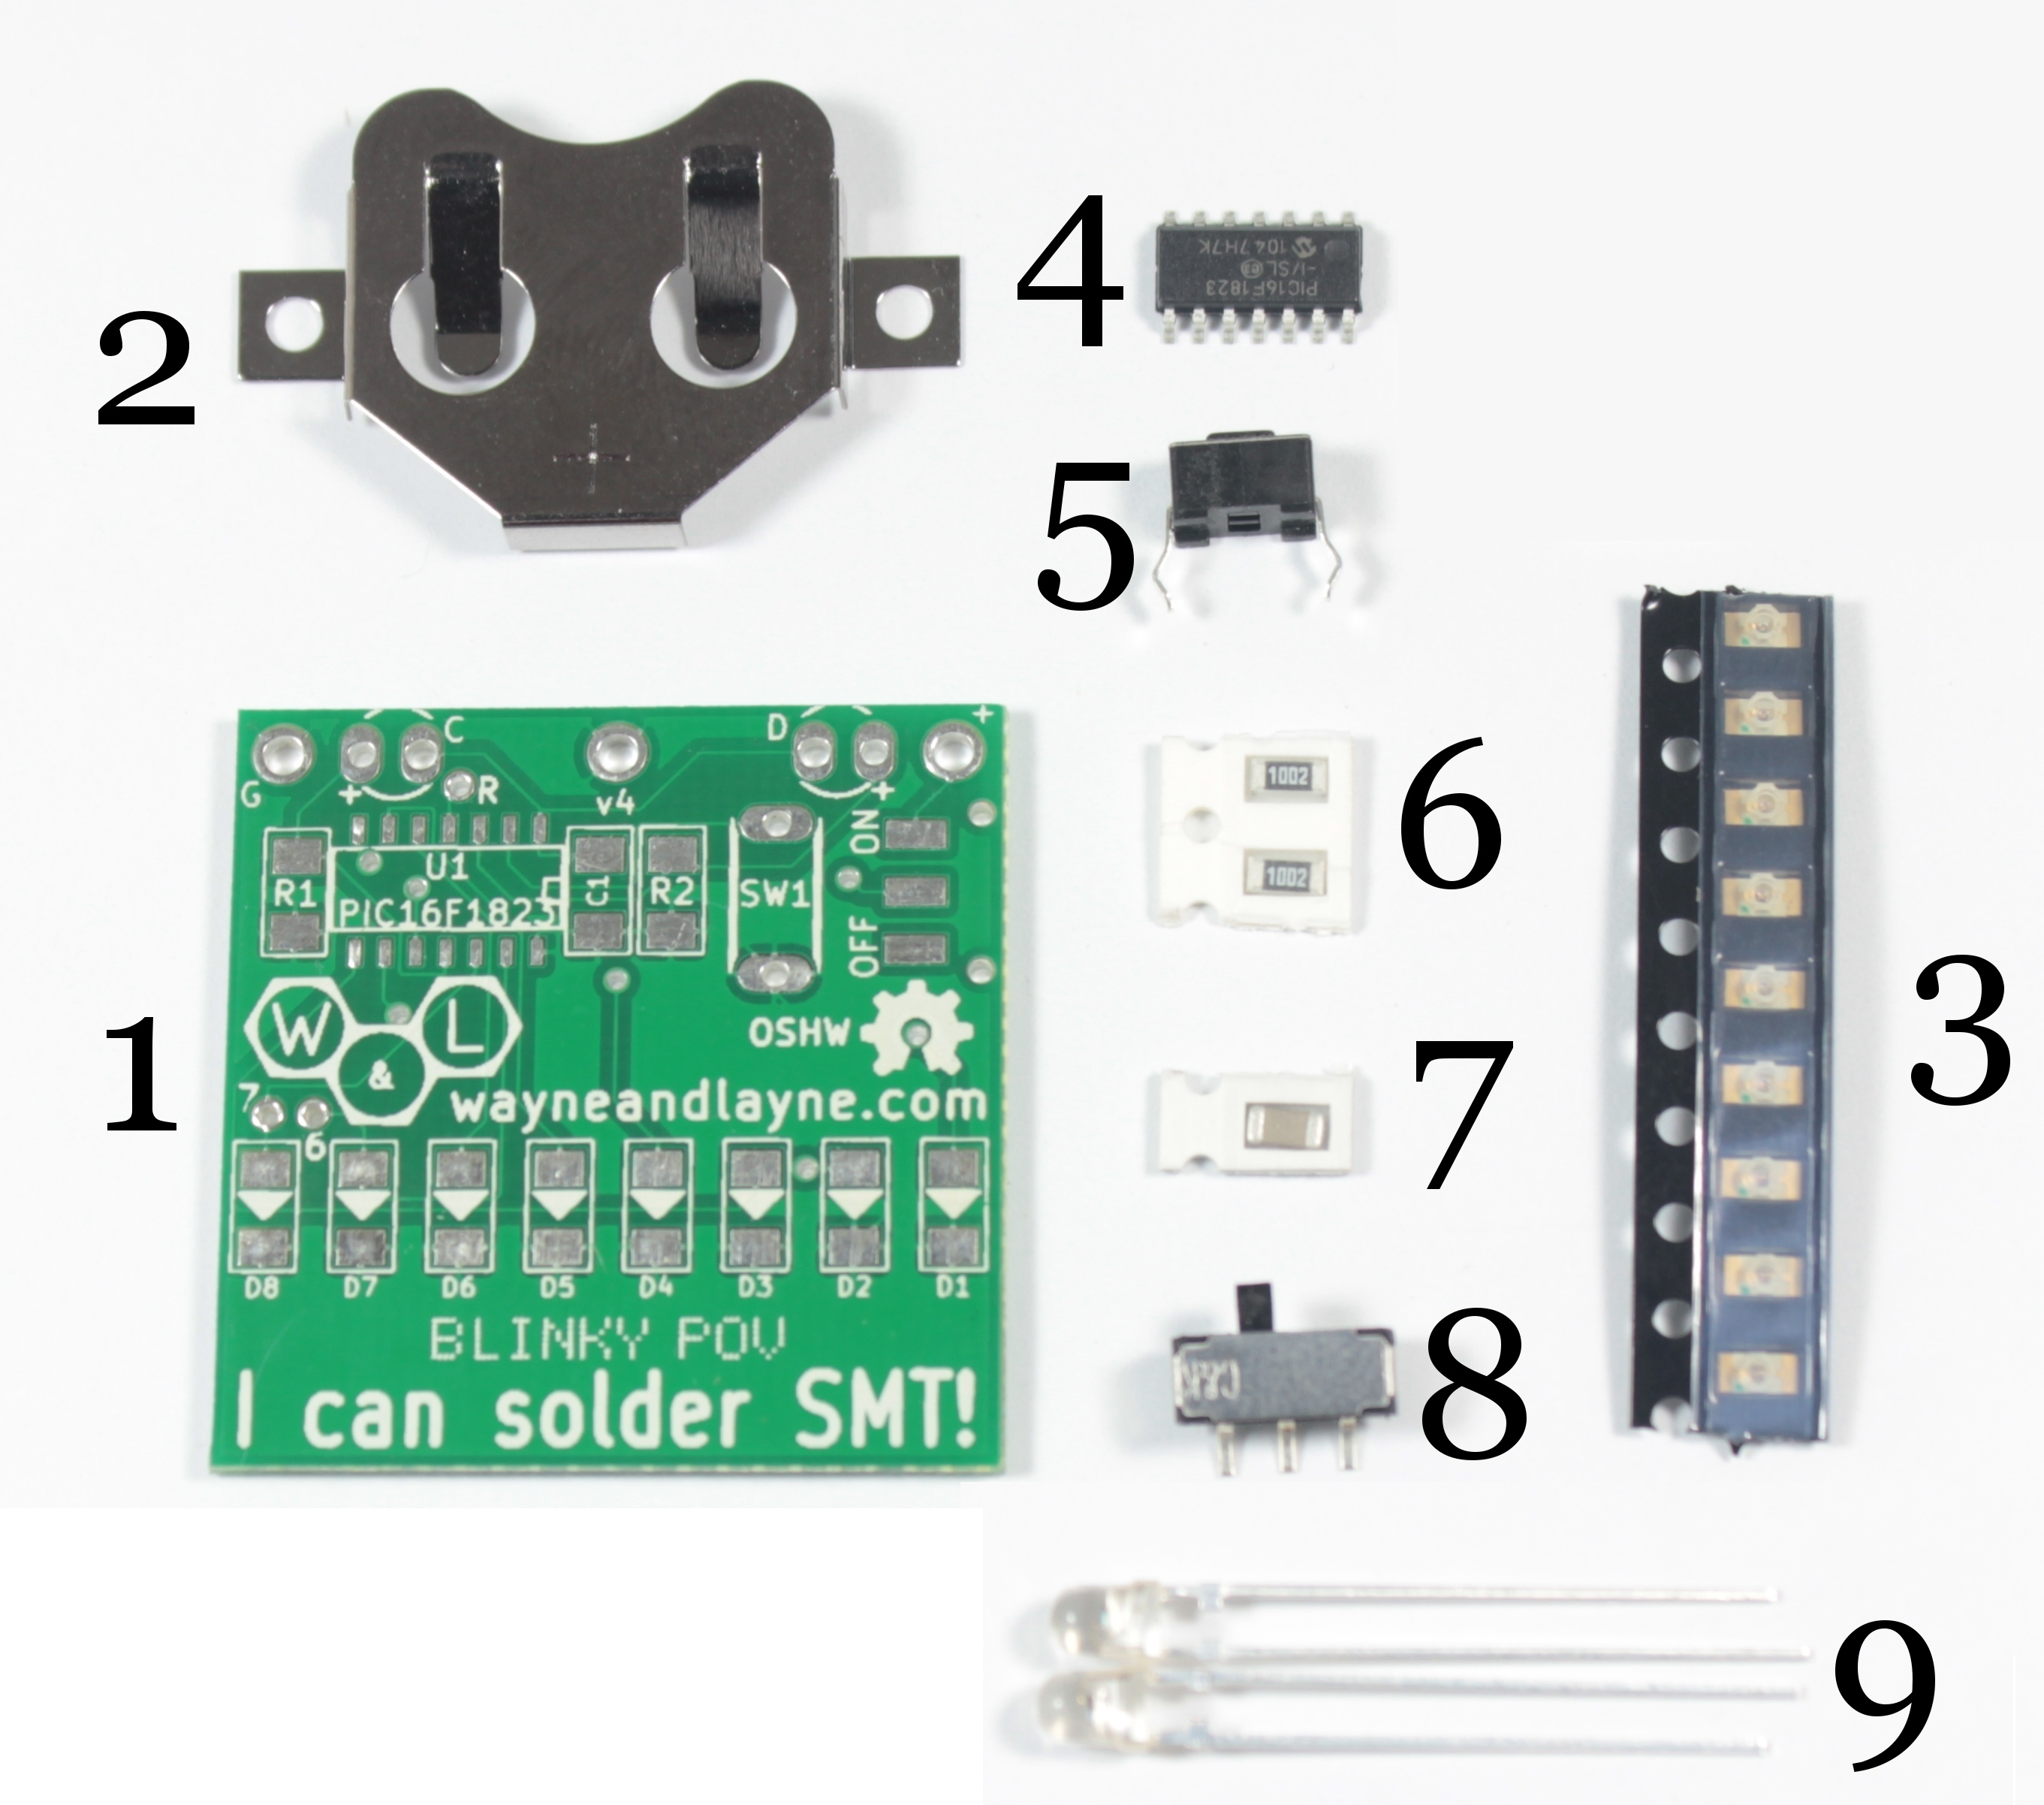
Start with Resistors and Capacitor, it doesn’t matter which way around these go.
- R1 & R2, the little black rectangles with “1002” written on the resistor (part 6 in diagram).
- C1 – Little brown rectangle, with no marking (part 7)

Next solder on the 8 Light Emitting Diodes
- D1 – D8. Little white rectangles in the black plastic strip (part 3). Make sure that the green dot is next to the sharp end of the triangle on the board.

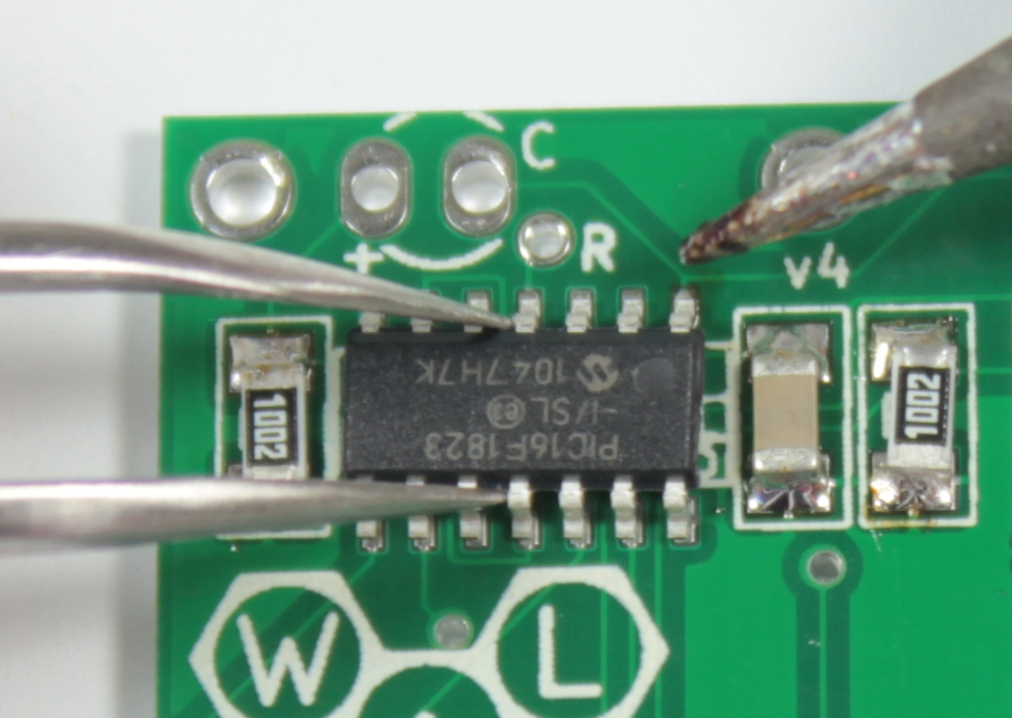
Then the micro-controller.
- U1 – Black chip with lots of legs (part 4). Ensure the dimple on the corner of the chip is next to the brown capacitor and v4 text on the board. The writing on the chip will also be “upside down” in relation to the rest of the board.
Check the legs are aligned with the pads on the board and solder a leg at two diagonal corners to hold the chip in place. Then solder the rest of the legs.
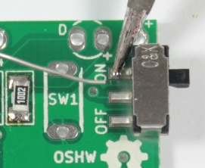
- Place the power switch (part 8) on the board and solder the three pins to the board.
- Push the push button (part 5) through the holes in the board next to SW1 it should make a positive click. Turn the board over and solder the pins into position.

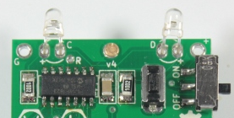
- Take the light detectors (part 9) and place them thorough the holes marked C and D. The longer lead should go through the hole marked + Bend the legs by 90 degrees as shown in the diagram to the right.
Turn over the board and solder the legs. Ensure you are wearing safety glasses then clip the legs, holding onto the end to stop them pinging across the room!

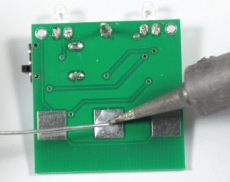
On the back of the board...
- To help the battery stay in place better, you should add some solder to the large middle pad. Not too much, but enough to form a tiny little pillow of solder across the whole pad.

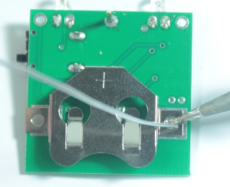
- Solder the battery clip (part 2) onto the two large pads.

- Check the solder joints look ok and there isn't extra solder between adjoining pins of the black chip. You can also ask a helper to check too.
- Slide a CR2032 battery into the battery holder, with the + sign facing upwards. Slide the power switch from “off” to “on”, turn the board over, and you should see the LEDs lighting up!
- Wave the kit quickly backwards and forwards, hopefully you should see a pattern.
- Use the online programmer http://www.wayneandlayne.com/blinky_programmer/ to display your own message or pattern.

