

wiki.ehlab.uk/
startrite_bandsaw
The Startrite 18-T-10 is a vertical bandsaw. It is currently fitted with a blade designed for cutting wood and soft metals.
Personal Protective Equipment
  Hearing protection must be worn when cutting metal. | 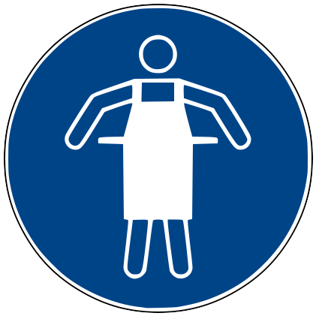  No loose clothing. Roll long sleeves to elbows. | 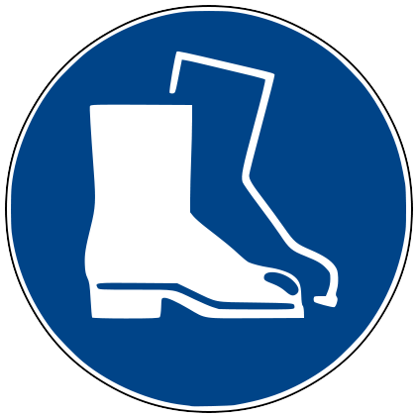  Sturdy Shoes must be worn.
  Eye protection must be worn. | Tie back long hair. | 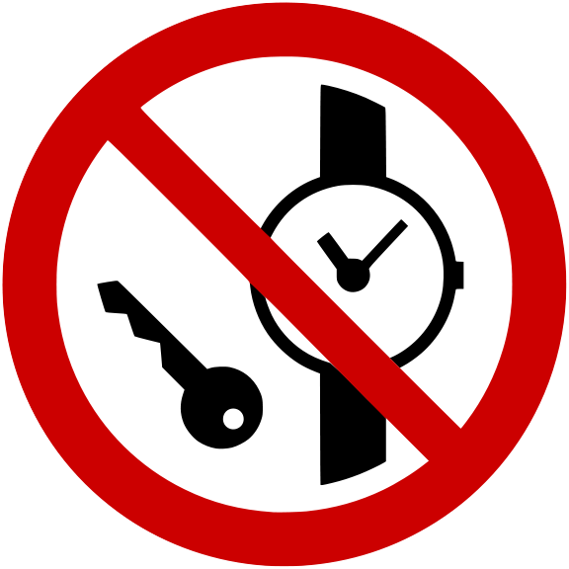  No watches or loose jewelery.
Before  - Ensure surrounding area cleared of obstacles.  - Check interior of machine for dust/obstruction.  - Alert other workshop users to keep clear.  - Ensure table cleared of objects.  - Ensure machine is set up correctly:  - Blade is aligned correctly.  - All adjustments tightened.  - Guard is locked in place and set as low as possible.  - Blade is sharp and there is no visible damage.  - Ensure machine can be spun manually by hand.  - Power off machine before checking this!  - Check Wiki for material settings.  During  - Keep your hands 3-4cm from the blade.  - Hold workpiece tight and push into the blade at a steady rate.  - Only cut pieces you can safely hold by yourself.  - Keep work in contact with the table at all times.  - Make sure the workpiece is supported – Use sacrificial scrap to support overhangs. | After  - Log out of the tool after use  - Clean the area around the machine and any dust created – leave the machine cleaner than you found it!  - Vacuum up any dust left inside the machine.
Don’t
- Do not use faulty equipment. Report faulty equipment to the Tool Maintainers’ mailing list: tools@edinburghacklab.com
- Do not freehand above the table surface! Elevated parts will be grabbed by the blade.
- Do not cut hard metals such as Hardened or Stainless steel. These will damage the blade.
- Do not force a workpiece into the blade – this will damage the blade or the machine. If the machine is not cutting effectively, stop and contact the maintainers.
- Do not leave the machine unattended.
- Do not allow another person to use the tool under your access token.
This card is designed as a quick reference for a properly trained user, and does not necessarily cover all possible hazards. It does not replace, and should be used in combination with, proper training and other reference material.

