

wiki.ehlab.uk/
beltsander
The combination belt and disc sander is used for shaping wooden and plastic parts.
Personal Protective Equipment
  Eye protection must be worn. | 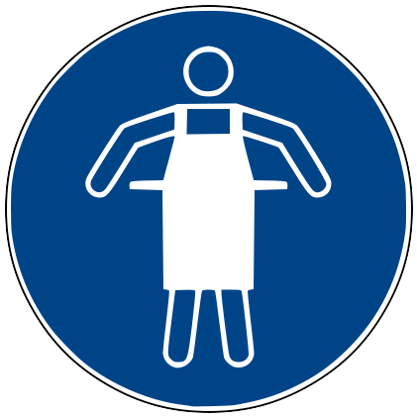  No loose clothing. Roll long sleeves up to elbows. | 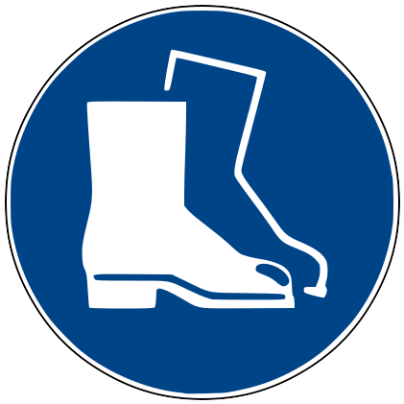  Sturdy Shoes must be worn.
  Hearing protection is strongly advised. | 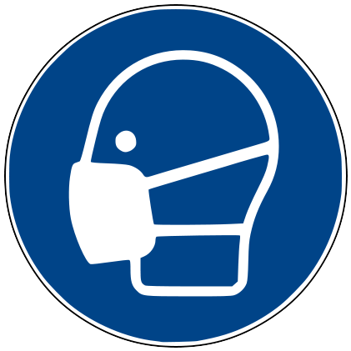  Wearing a mask or respirator is strongly advised. | 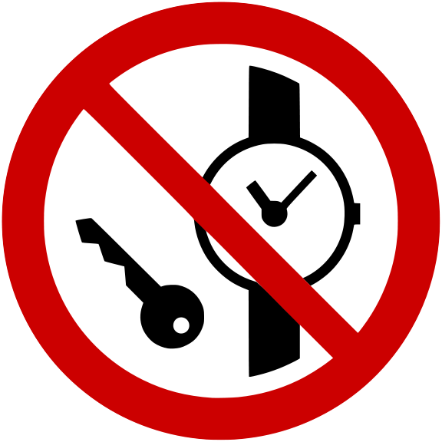  No watches or loose jewelery.
Before  - Ensure surrounding area cleared of obstacles.  - Alert other workshop users to keep clear.  - Ensure belt and table are cleared of objects.  - Ensure machine is set up correctly:  - Belt is aligned correctly.  - All adjustments tightened.  - No damage to belt/disc.  - Ensure machine can be turned manually by hand, and that the belt stays aligned when doing so.  - Power off machine before checking this!  - Ensure the dust extractor is running.  - If it does not start automatically, use the green button on the dust extractor to start it.  During  - Keep your hands 10cm from any moving parts.  - Take particular care around gap where the belt disappears into the machine.  - Hold workpiece tightly and gently press into the abrasive.  - Only sand pieces you can safely hold by yourself.  - When using the disk, only sand on the downward (right) hand side of the disk.  - When using the belt, stand so that the belt motion is away from yourself.  - Be aware that the workplace may get caught and drawn into the sander, or be flung across the room. | After  - Log out of the tool after use  - Clean the area around the machine and any dust created – leave the machine cleaner than you found it!  - Check if the band/disk is worn beyond it’s useful life: If so, replace it.
Don’t
- Do not use faulty equipment. Report faulty equipment to the Tool Maintainers’ mailing list: tools@edinburghacklab.com
- Do not sand parts that are too large or too small. If a part is impractical to hold by hand, or your hands are getting too close to the abrasive, Stop and sand the part by hand.
- Do not sand metal parts.
- Do not leave the machine running unattended.
- Do not allow another person to use the tool under your access token.
This card is designed as a quick reference for a properly trained user, and does not necessarily cover all possible hazards. It does not replace, and should be used in combination with, proper training and other reference material.

