Introduction

Sugars, are energy and structural molecules produced by plants as the result of photosynthesis reactions. Glucose is the key molecule in living systems. Plant foods are very important to animal life, especially us humans. The principal sugars are glucose and fructose. They are the simplest carbon-hydrogen-oxygen molecules, known as monosaccharides. Glucose is the fuel of all living things, supplying energy to all living cells, both plant and animal through respiration. Glucose production begins in plants with their complex photosynthesis reaction. Photons are the ultimate source of energy used by the chloroplasts to form glucose. Plants then use the glucose to fuel all their other synthetic processes. Therefore light is an essential factor in maintaining plants. The rate of growth and length of time a plant remains active is dependent on the amount of light it receives. Light intensity influences the manufacture of plant food, stem length, leaf color and flowering. Generally speaking, plants grown in low light tend to be spindly with light green leaves. A similar plant grown in very bright light tends to be shorter, better branches, and have larger, dark green leaves.

In my experiment, my objective is to observe the effect of light intensity on photosynthetic rate of plants. I am not looking at plants' height or number of leaves, etc, but instead I observe its sugar concentration in the phloem of the stems. In order to do this experiment, I needed to understand the concept of optical activity. Go to Optical Activity section for detail descriptions.

Laser

The laser, like any light source, is a device that converts energy to light. All use some form of input energy to excite atoms or molecules, which then emit light. In the case of the laser, the input or pump, energy can take many forms, the two most common being optical and electrical. Another laser may even be used as an optical pump.

In a conventional light source, each excited atom randomly emits a single photon according to a given statistical probability. This randomness causes radiation in all directions with a spread of wavelengths and no interrelationships among individual photons. This is called spontaneous emission.

Einstein predicted that excited atoms also could convert their stored energy into light by a process called stimulated emission. An excited atom first produces a photon by spontaneous emission. When this photon reaches another excited atom, the interaction prompts that atom to emit a second photon (figure 1). This process has two important characteristics. First it is multiplicative one photon becomes two. If these two photons interact with two other excited atoms. This will yield a total of four photons, and so forth. Most important, these two photons have identical property ñ energy, direction, phase and polarization.

The laser cavity is the heart of laser. The simplest cavity is defined by two mirrors ñ a total reflector, and a partial reflector whose reflectance can vary between 50 to 99 percent. Light bounces back and forth between these mirrors, gaining intensity with each pass through the gain medium. Because some of this light escapes the cavity, or oscillator, through the partial reflector (output coupler) a stable equilibrium condition is reached quickly. The output beam is the light that escapes through the output coupler.

In the ideal laser, all the photons in the output beam are identical. This imparts several unique properties: directionality, monochromaticity, coherence and brightness.

Monochromaticity: A Photon’s energy determines its wavelength through the relationship E = hc/(, where c is the speed of light, h is Planck’s constant, and ( is wavelength. If our ideal laser emits all photons with the same energy, and thus the same wavelength, it is said to be monochromatic. Many applications are dependent on monochromaticity. For example, in telecommunications, several lasers at different wavelengths transmit multiple streams of data down the same fiber without crosstalk.

Coherence: Besides being the same wavelength, the photons that make up a laser beam are all in phase.

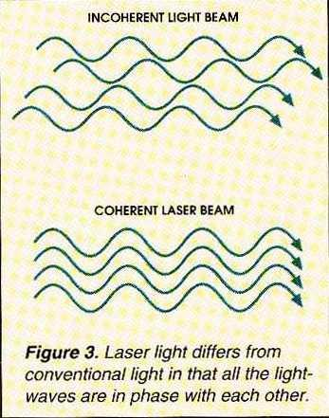

In the ideal case, the laser acts as one long, continuous, intense lightwave. This enables a host of applications that rely on interference of lightwaves. For example, the surface of precision lenses and mirrors is measured using laser interferometers. The coherent light beam acts as an ultrafine ruler, where the wavelength of light fulfills the dimensional role.

Directionality and brightness: The most obvious visible difference between lasers and conventional light sources is the laser light travels in the same direction as an intense beam. Brightness is defined as the amount of light leaving the source per unit surface area. Because a laser’s photons have identical vector properties, they act as if they are coming from the same point in space. The ideal laser thus acts as a true point source with extreme brightness. This combination of directionality and brightness has two consequences. The beam can be projected over great distances, and it can be focused to a very small spot. In the ideal case, the divergence of a collimated beam or the size of the focused spots are limited only by diffraction ñ an inescapable property of light. This is referred to as a diffraction-limited beam.

Optical Activity

Enatiomers and Optical Activity

Enantiomers of opposite configuration are said to be optically active. One enantiomer will rotate the light a set number of degrees to the right. This is called the dextrorotatory isomer or (+) isomer. The other enantiomer will rotate the plane polarized light the same number of set degrees in the opposite left direction. This isomer is said to be a levorotatory isomer or (-) isomer.

There is no relationship between a particular configuration and the direction of rotation. R-configured enantiomers may be dextrorotatory or levorotatory just as S-configured enantiomer may be either. However if the R-configured isomer is levorotatory then it is an assurity that the S-configured isomer will be dextrorotatory. For example, if one isomer is R-configured and rotates plane polarized light 10 degrees to the left then the S-configured isomer will rotate plane polarized light 10 degrees to the left.

The instrument used to measure light rotation is called a polarimeter. It consists of a monochromatic light source usually a Sodium D-Lamp that is capable of emitting a remarkable pure single wavelength of light which is bi-planar. A polarizer filters out one plane of this bi-planer light and allows only one plane to pass through the polarizer. This plane polarized light beam is then split into two beams and one beam is routed around the sample while the other split beam is passed through the sample. If any rotation occurs of the beam passing through the sample, then the intensity of the light passing through the sample will be different then the beam that was passed around the sample. This will appear to an observer looking though an eyepiece to have two semi-circular spots of light one brighter than the other. By rotating a calibrated analyzer so that the two half circles of light become the same intensity the boundary will disappear in the eyepiece and will appear as one bright circle of light. By reading the calibrated analyzer one can determine whether the sample rotated to the right or left and the precise number of degrees of rotation. This is called the "observed rotation". Usually the observed rotation must be converted to a "specific rotation" before it is reported.

Determining the Specific Rotation

The observed rotation is dependent upon the path length of the light passing through the sample compartment and is also dependent upon the number of molecules of the isomer. The observed rotation is converted to a specific rotation by using the following formula:

Specific Rotation = Observed Rotation / (conc,g/ml) (length of sample tube, decimeters)

Let's take an example: Suppose that the observed rotation of an optically active isomer produced an observed rotation of +13.00 degrees. The sample had a concentration of 1000g/liter and the length of the sample tube was 20 cm in length. What would be the reported specific rotation of this dextrorotatory isomer?

1.Convert the concentration to g/ml

1000g / liter X 1 liter / 1000 ml = 1.0 g/ml

2.Convert the length of the tube to decimeters knowing that 10 cm = 1 decimeter.

20 cm X 1 dm / 10 cm = 2 dm

3.Using the above formula plug in the observed rotation, the length and concentration.

Specific Rotation = +13.00 / (1.0 g/ml) (2 dm) = +6.50 degrees

Optical Isomers

This optical property of compounds that have asymmetric carbon atoms is what has prompted us to call these compounds optically active. The mirror images of these compounds are referred to as optical isomers. The reason that this is so important, however, is not because these particular compounds can rotate light. Instead, it has to do with the way that biological reactions take place. Biological reactions generally are catalyzed by enzymes and the enzymes are set up to specifically handle a particular orientation of atoms within a molecule. An enzyme that would be able to take D-glucose, and hydrolyze it, or oxidize it, or do something else to it would not be able to carry out that same reaction on the mirror image of D-glucose. That is because it wouldn't fit properly up against the enzyme as is necessary to carry out the reaction. As a consequence, different arrangements of the atoms in molecules, even just one or two of the OH's switched in position in the molecules shown above will make a biological difference. Therefore, it's very important to be very familiar with the orientations of the functional groups within a particular molecule.

Demonstrations

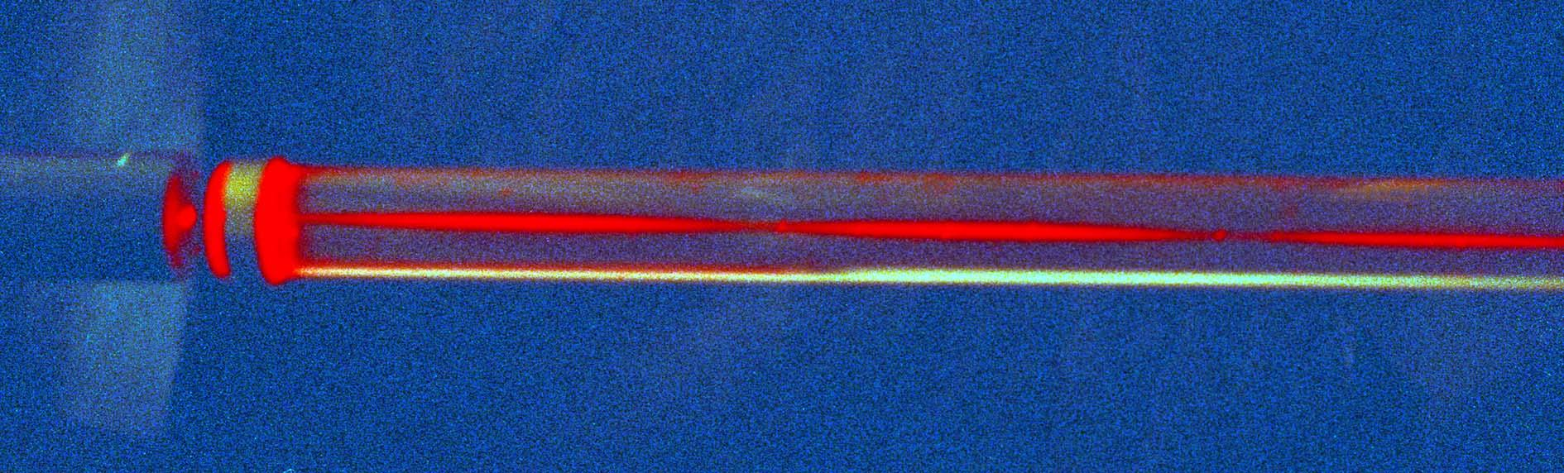

The image above shows the appearance of a plane polarized laser beam passing along the axis of a tube filled with corn syrup. The plane of vibration of the laser beam is horizontal when it enters the syrup and it rotates through 1800 in about 15 cm.

Polarimetry

Polarimetry is a sensitive, nondestructive technique for measuring the optical activity exhibited by inorganic and organic compounds. A compound is considered to be optically active if linearly polarized light is rotated when passing through it. The amount of optical rotation is determined by the molecular structure and concentration of chiral molecules in the substance. Each optically active substance has its own specific rotation as defined in Biots law:

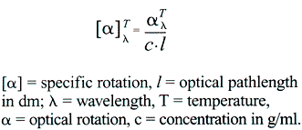

The polarimetric method is a simple and accurate means for determination and investigation of structure in macro, semi-micro and micro analysis of expensive and non-duplicable samples. Polarimetry is employed in quality control, process control and research in the pharmaceutical, chemical, essential oil, flavor and food industries. It is so well established that the United States Pharmacopoeia and the Food & Drug Administration include polarimetric specifications for numerous substances.

Pharmaceutical Industry

Determines product purity by measuring specific rotation and optical rotation of:

Amino acids Amino sugars Analgesics

Antibiotics Cocaine Codeine

Dextrose Diuretics Serums

Steroids Tranquilizers Vitamins

Flavor, Fragrance and Essential Oil Industry

Utilizes polarimetry for incoming raw materials inspection of:

Camphors Citric acid Glyceric acid

Gums Lavender oil Lemon oil

Orange oil Spearmint oil

Food Industry

Ensures product quality by measuring the concentration and purity of the following compounds in sugar based foods, cereals and syrups:

Carbohydrates Fructose Glucose

Lactose Levulose Maltose

Natural mono-saccharides Raffinose Sucrose

Various starches Xylose

Chemical Industry

Analyzes optical rotation as a means of identifying and characterizing:

Biopolymers Natural polymers Synthetic polymers