**Materials:**

|  |  |  |
| --- | --- | --- |
| 250 mL beaker (5) | Distilled Water | Scale |
| 2000 mL Beaker (3) | Glass Stirring Rod | Sink |
| Aprons | Gloves (surgical/rubber) | Tab Water |
| Autoclave | Graduated Cylinder | Thermometer |
| Bio-Hazardous Bag | Inoculation Loop | Toothpicks |
| Bleach | Hole- Punch | Transfer Pipettes |
| Bunsen Burner | Living Bacteria [staphylococcus epidermidis](http://staphylococcus.bsnpt.com/) | Trash Receptacle |
| Laboratory Sterilizer | Matches or Striker | Tweezers |
| Calculator | Metric Ruler | Wax Pencil |
| Chromatography Paper | Micro-scale spot plate (5) |  |
| Cup-Cake Paper | Nutrient Agar Plates (9) |  |

**[1]*Procedure:**  
1- Put on apron and surgical gloves. Sterilize all glassware with the C2250 Sybron/Barnstead Laboratory Sterilizer:

* Open door.
* Depress "Fill" button until water is one inch from the front of chamber.
* Load glassware into sterilizer.
* Set temperature to 270 ( F)
* Set vent control as required.
* Close and lock door.
* Turn cycle timer to 10 and then turn to desired time (3 minutes).
* When cycle is complete, open door slightly. (Prevent burns by opening door slightly to allow residual steam to dissipate.)
* Turn cycle timer to 10 then to desired drying time.

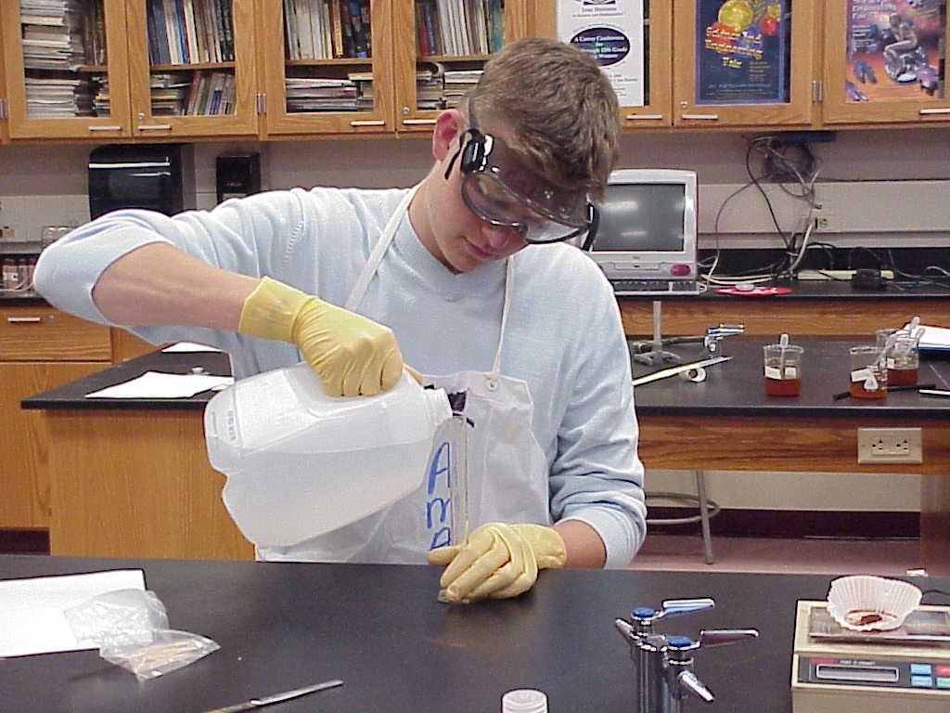 Prepare the Sterilizer Carefully

When cycle is complete, carefully open door. Unload glassware cautiously.

2- Label nine pairs of Carolina Agar Plates as follows:

* On the top Water (H2O); on the bottom sectioned in six parts alphabetically A-F (See Drawing A)
* (2) On the top .25%; on the bottom sectioned alphabetically A-F
* (2) On the top .50%; on the bottom sectioned alphabetically A-F
* (2) On the top .75%; on the bottom sectioned alphabetically A-F
* (2) On the top 1.0%; on the bottom sectioned alphabetically A-F

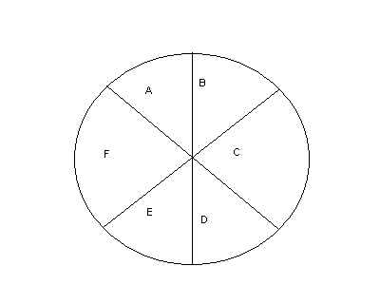Drawing A

3- Prepare Concentrations:

* Using (5) sterilized 250 ml beakers create 5 different solution concentrations.
* Mass .25, .5, .75, and 1 grams of Pure Grape Seed Extract provided by Activin with a scale. (Figure A)

Figure A

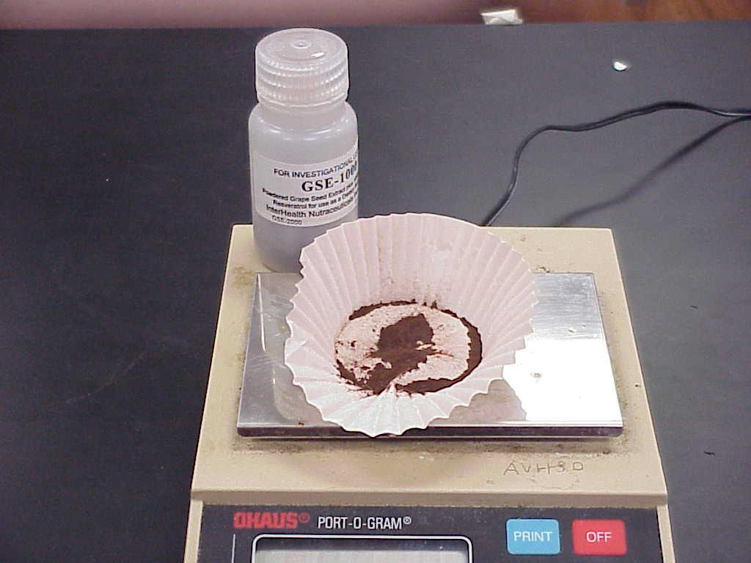

* Measure 99.75, 99.5, 99.25, and 99 ml of distilled water using a graduated cylinder.
* Using a stirring rod mix the .25 grams of GSE in a 250 ml beaker with the 99.75 ml of distilled water (solution 1); mix the .5 grams of GSE in another 250 ml beaker with the 99.5 ml of distilled water (solution 2); mix .75 grams of GSE in another 250 ml beaker with the 99.25 ml of distilled water (solution 3); mix the 1gram of GSE in another 250 ml beaker with the 99 ml of distilled water (solution 4); finally, measure 100 ml of water into the last 250 ml beaker (solution 5).
* Using a transfer pipette add five drops of (solution 1) to six wells of a micro-scale spot plate labeled alphabetically A-F. Label this micro-scale spot plate (concentration 1).
* Using a transfer pipette add five drops of (solution 2) to six wells of a micro-scale spot plate labeled alphabetically A-F. Label this micro-scale spot plate (concentration 2).
* Using a transfer pipette add five drops of (solution 3) to six wells of a micro-scale spot plate labeled alphabetically A-F. Label this micro-scale spot plate (concentration 3).
* Using a transfer pipette add five drops of (solution 4) to six wells of a micro-scale spot plate labeled alphabetically A-F. Label this micro-scale spot plate (concentration 4).
* Using a transfer pipette add five drops of (solution 5) to six wells of a micro-scale spot plate labeled alphabetically A-F. Label this micro-scale spot plate (concentration 5).

4- Prepare Chromatography Paper to view Zones of Inhibition:

* Punch out six discs of chromatography paper with the hole-punch.
* Place a disc in each of the wells and let soak for 15 to 20 minutes.

5- Prepare Bacteria while Chromatography Paper soaks:

* Read the details and safety instructions that came with the bacteria.
* Put an inoculation loop into the test tube containing [staphylococcus epidermidis](http://staphylococcus.bsnpt.com/) to obtain the bacteria. (Figure B)

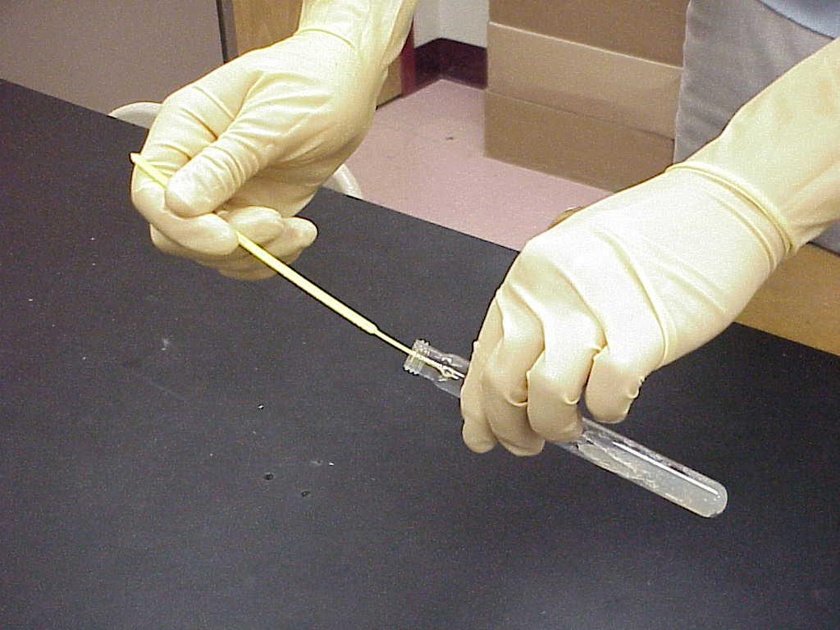 Figure B

* Establish a bacterial lawn with the streak-plate method:  
  A. Lift lid carefully to a 45( angle and lightly streak the cotton swab back and forth evenly across the entire surface of the petri dishes. Be sure to swab the bacteria to the edges of the dish. (Diagram 1)

B. Rotate the petri dishes 45deg and swab at right angles to the first swab. (Diagram 2)  
Diagram 1 Diagram 2

|  |  |
| --- | --- |
|  |  |

* Using tweezers, obtain a disc from well A of (concentration 1) and place it on the region of the petri dish labeled A of petri dish labeled .25%. Be sure that the disc is in full contact with the agar gel.
* Repeat for concentrations 1-5 and agar plates .25% – 1% and water.
* Disinfect the tweezers with Bunsen burner. Allow the tips of the tweezers to turn red at least two times. Then, let cool before further use. (Figure C)

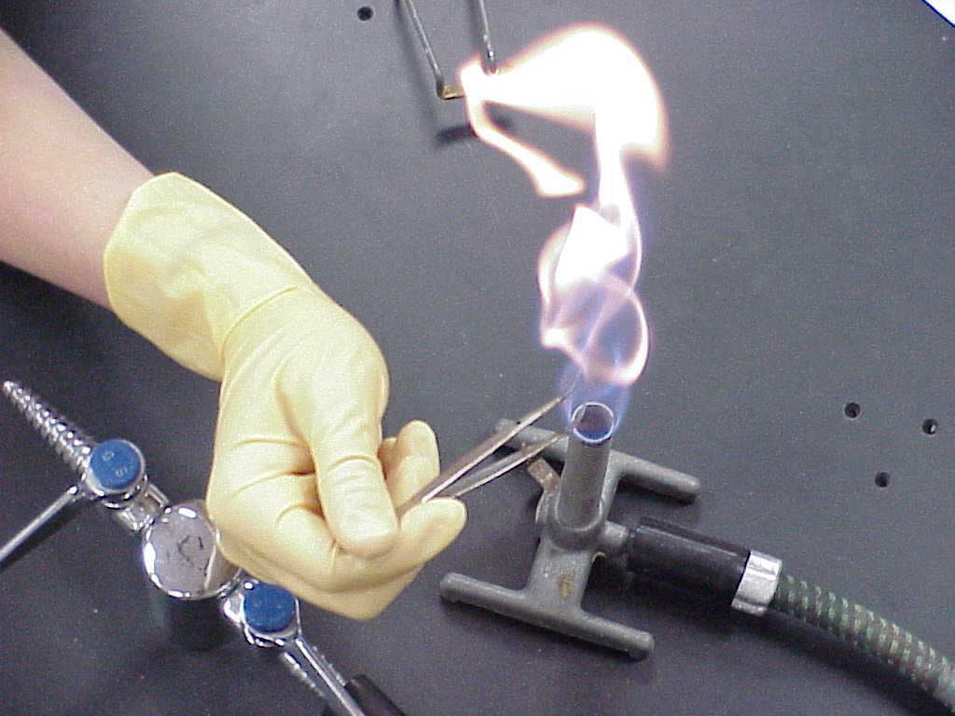

Figure C

* Invert the petri dishes and incubate in autoclave overnight at approximately 37C.
* Disinfect lab area again using the bleach solution. Discard it after use in the sink with plenty of water. (Figure D)

Figure D

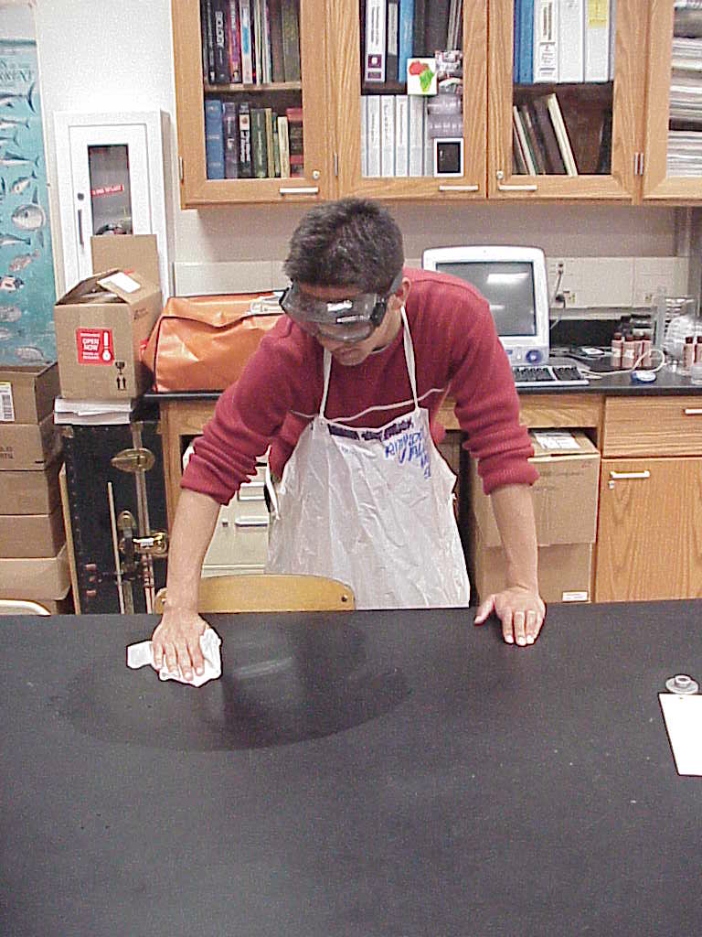

6- Upon Visual Confirmation of Bacteria Growth:

1. Put on apron and surgical gloves.
2. Disinfect lab area using 25% bleach solution.
3. Open autoclave and retrieve petri dishes.
4. Observe and measure the diameter of the zone of inhibition for each group (mm) to the nearest ½ a millimeter.
5. Record data in Table Raw Data.
6. Repeat Steps 1-5 for three consecutive days.

7- For Disposal of Hazardous Materials (Bacteria);

1. Increase the temperature of the autoclave to 100(C. Place the petri dishes in autoclave overnight.
2. The next day, pour 100% bleach into petri dishes and wait for the gel to disintegrate.
3. To the original test tube of Bacillus cereus, add 100% bleach until the tube is full. Close the cap tightly.
4. Discard petri dishes and test tube of Bacillus cereus in a bio-hazardous bag.

1. * The following procedure has been adopted from the successful procedure utilized by Christina Young and Elisa two former AP Biology students at Amador Valley High. To view their project. “Garlic: An Antibiotic Alternative?” Click Here