**Introduction:**

“In 1998, NASA satellite data showed that the Antarctic ozone hole was the largest on record, covering 27 million square kilometers; researchers in 1997 found that increased ultraviolet light coming from the hole damages the DNA of ice fish, an Antarctic fish lacking hemoglobin; ozone depletion earlier was shown to harm one-celled Antarctic marine plants.”

–“Antarctica” article.

The use of chlorofluorocarbons in industries such as refrigeration and air conditioning has lead to a rather unexpected, and now rather urgent problem: holes in the ozone layer.

The ozone layer, present in the stratosphere surrounding Earth, is solely responsible for blocking harmful ultraviolet radiation from reaching the surface of the planet in large amounts. In fact, ozone molecules are formed when UV rays strike an O2 molecule and split it, freeing an oxygen molecule, which then bonds with another O2 molecule, forming O3.

In a rather ironic way, these same UV rays hit chlorofluorocarbons (or CFC’s) and initiate a chain of chemical reactions that, under the right conditions, start the “catalytic ozone destruction cycles.” To put it bluntly, the use of CFC’s has resulted in huge ozone holes over both of the earth’s poles, as well as a thinning of the ozone over some populated areas such as Chile.

These “right conditions” that are necessary for the break down of ozone molecules include very low temperatures. In an experiment conducted by British meteorologists, drastically higher levels of carbon dioxide in the atmosphere would result in a cooling of the stratosphere, the same layer that houses the ozone layer. This cooling could result in widespread ice clouds, which would greatly speed up the reactions between CFC’s and ozone molecules. The result? Jerry Mahlman of the National Oceanic and Atmospheric Administration’s Geophysical Fluid Dynamics Lab in Princeton, New Jersey believes more people would be affected by the resulting ozone hole than are at this time.

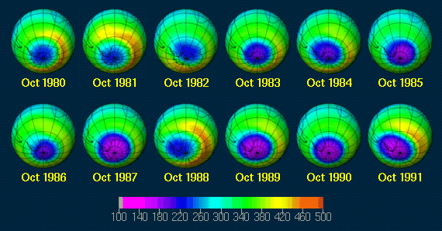

**http://www.atm.ch.cam.ac.uk/tour/**

The above image depicts the differing levels of ozone concentration over the Antarctic recorded every October over a number of years. Though the hole changes from year to year, there is an obvious worsening of the hole from 1980 to 1991. The picture of October 2001 is guaranteed to be worse than that of 1991.

The next issue to address is the problem caused by holes present in the protective layer surrounding our home. Basically, the ozone layer that previously blocked out harmful radiation from the sun, i.e. ultraviolet-B radiation, will increase drastically as the protective layer becomes thinner and thinner. As mentioned in the opening quote, an increase in ultraviolet levels have been shown damage both fish and one-celled animals living in the Antarctic. However, the damage caused by such a drastic increase in UV levels could be literally immeasurable. One article suggested a mere economic loss of trillions of dollars worldwide. Based on studies done around the globe by countless scientists, increased UV levels will most likely result in a vast increase in the number of cancer cases worldwide. In one article found on the website salon.com, (it was later misplaced by us) elementary school children living in Chile had to go to school covered completely (from head to toe) in clothing because of the extremely thin ozone layers present above that country. Though the indigenous skin pigment is much darker than found in Europe, for example, only ten minutes of exposure to the increased levels of ultraviolet radiation could result in terrible sunburn. The imminent danger of living in such an environment is that over time, skin remembers and builds up, if you will, damages from the sun. One good example of this is thymine dimers, in which a covalent bond forms between two adjacent thymines in a DNA strand. This prevents the replication of the DNA strand by forming a kink, and thus prevents repair of the damaged cells.

It is well documented that extended exposure to UV radiation causes cancer in humans. However, the effect on plants has yet to be thoroughly examined, as the most pressing subject has always been the effect on mobile life. In a report published by Michael Unsworth and William Hogsett, an experiment conducted by Teramura using soybeans, wheat and rice showed that “under any realistic scenario of increasing UV-B radiation, crop yields are unlikely to be altered to a significant extent.” However, a reputable scientist from the MadScience Network states that an increase in UV levels would significantly impair both the growth and the biodiversity of plants one earth. Plants already possessing darker pigmented leaves would have a definite advantage over those with lighter leaves because they survive better under such conditions, according to research at the USDA Agricultural Research Center in Beltsville, Maryland.

It was our goal to address a pressing environmental issue in our advanced placement biology experiment. After choosing the problem of increasing ultraviolet radiation as a result of the depletion if the ozone layer, reading reports such as the ones discussed above convinced us that little is known about the effect of higher levels of UV on crops that are essential for providing millions, if not billions of people, with food worldwide. By using crops similar to the ones Teramura used in his experiments, and by measuring both growth and success of our plants under a control (a plant light representing normal sun light), under a light of increased ultraviolet radiation (under a regular fluorescent light bulb), and under a light devoid of any UV rays (over a material meant to block any UV), we should be able to determine whether or not an increase in UV radiation would have an effect upon the food supply in the event of a world-wide thinning of the ozone layer.