Andy Heller

Defecation and the changes that variables bring

From the beginning of time people have sought to discover a method of suppressing discomfort of the digestive tract. In the Middle Ages people turned to their wise healers for remedies of the stomach. One such remedy was spiced and mulled wine at the end of a meal would encourage your digestive tract to work well. A common remedy for indigestion (abdominal pain, cramps, diarrhea, and vomiting) was Dill combined with other herbs and spices.

“But if a postem be of phlegm, after his blood-letting and his purging, make him a gargle of sap from a hazelnut tree, dill, poppy, either the water that bark from a nut or mulberry tree has been seeped in, or the juice of bittersweet, with dried honeysuckle leaves and aloe. “[1]

In modern society it is not uncommon for the common man (or woman) to be in possession of a cellular phone, beeper, or laptop computer. There is a Starbucks or other java hut (coffee house) in nearly every city in America. Depression is at an all-time high throughout the world, and more and more people are turning to illegal substances than ever before in the history of mankind. Times are changing and people are very quick to believe that science will be the solution to all of life’s problems. Science will be able the answer to any and every obstacle that is thrown in the path that we’re on known as life.

Money is the key that will be our savior and yet at the same time, destroyer. The old adage “The love of money is the root of all evil”[2] is not quite far off in that the search for wealth, power, and prestige is so abundant in today’s society as to make us forget other people and things. In modern society it is not uncommon to throw money at any and every situation, which might be made better or easier by way of money.

“Action and reaction are equal and opposite.”[3] Is a nice way of saying that everything that you do will have a consequence. This can manifest itself in many different ways, whether deciding to stay indoors and study for a test, or playing basketball with your friends and failing your examination the next day. By the same token the human body scenario works very well with the above mentioned. The human body is an extremely complex machine that is capable of mechanical mobility, self-preservation, and most importantly intelligence, or the ability to learn and prosper from life and memories.

Today many people are looking for a quick fix to their gastrointestinal troubles. My friend Jake and I took a trip to the local Walmart to discover just how many products there were for your intestinal tract that would give you a “quick fix” or similar results. The results were shocking to me, with over 150 products found intended for the digestive tract, 7 were products that did something that your body naturally could not. These products completely cleared your digestive system of all food and liquid. The reason that your body does not naturally produce these chemicals is that they are used for surgery, surgery in which it is necessary that one have absolutely nothing in the stomach, intestines, and other parts of the digestive tract. These surgeries are not found in nature, and therefore are not essential.

That means that about 140 products do something that your body can naturally do itself. Why is this important? The reason that this is important is that it tells drug manufacturers that people are very willing to purchase products that unnecessary offer a quick fix to many digestive problems. The purpose of this paper is not to chastise or verbally reprimand people who do take drugs to make them feel better, but to offer an alternative which is more natural.

The human body is capable of repairing itself without any conscious effort. Platelets in your blood create blockages in torn or ripped skin, muscle, and tissue so that precious blood is not lost. The same is true for the other parts of your body such as the digestive tract. The lining of your intestines contains bacteria that allows digestion to take place. The bacteria will break down food and other molecules that it finds and converts it to sugar that your body can absorb through the lining of the walls of the intestines.

Problems start to occur in your digestive tract when other bacteria disrupt the general nature of the bacteria already present in your intestines. In layman’s terms this means that bad bacteria is introduced into the body and changes the balance found between the good bacteria found in your body. After all, “It’s all about balance.”[4] A common example of an infection that takes place because of this type of behavior is that of a yeast infection. A yeast infection occurs when the balance that is held in place of the throat or sex organs is disrupted and the necessary conditions for yeast to mature are produced. This can lead to severe discomfort, but in the most part your body can naturally take care of the problem itself if given enough time.

Diarrhea is your body’s natural defense to foods that do not agree with you. The purpose of diarrhea is to purge your body of toxins, bacteria, and other organisms, which are not supposed to be part of your digestive tract. The same type of reaction is that of a fever, which is your body’s way of killing off the same types of conditions by lethally cooking them.

People feel that because they have a fever they need to take medicine to make their body feel better. All that is actually required to have the fever reduced is time and sleep. The immediate reaction is to run to the store and purchase a product, such as aspirin, which will make the fever go down. What you are doing in this case is treating the symptoms and not the problem.

Problems of the digestive tract are treated in much the same way in today’s society. Out of the 140 or so products mentioned earlier, they all treat the symptoms of problems, without actually treating the real problem. So what is the problem, right? The problem is that Americans are lazy. You’re probably thinking, “I just read through all of that to have you tell me something that I’ve known since I was old enough to eat at a fast food restaurant.”

Once somebody admits and understands that there is a problem they are more adept to dealing with the problem not to mention more willing. America needs to realize that there is not necessarily a reason that something happens, but that it should just be enough that something did happen. The ultimate responsibility of all people in modern society is that to make life changes that will ultimately benefit them in other ways than just their digestive tract. “One of the most striking changes I have seen is how much less exercise my patients get today compared with a couple of generations ago. As machine sand computer have made our daily lives easier, we humans no longer have to perform many physical tasks-like washing clothes with a scrub board or tilling the soil to grow food for dinner-chores that gave our ancestors a good workout.[5]

A change in lifestyle is what is ultimately necessary to allow for the kind of digestion that we would most like to have in our everyday lives. An example of the type of change, which refers to this, is reducing the intake of caffeine into your body that will decrease tension in your intestinal tract and in turn make your intestines less irritable.

Some other suggestions as to changing your diet include cutting back foods very high in fats such as milk and cheese, which will produce gas and bloating. Too much food high in acid such as lemons, oranges, tomatoes, and tomato sauce will increase the PH of your intestines to the point where they can become very irritated. This can cause your body to try and expel the food as quickly as possible resulting in diarrhea.

Recently, in Reader’s Digest there was an article based around the obesity that is common in Americans. The reason? “The problem is that getting fat is deeply ingrained in American culture.”[6] America is a country of immigrants, and while immigrants bring many rich traditions and many foods to eat Americans bastardize these left and right. A plate of Fettuccine Alfredo in Rome consists of a 11 oz. Portion with 825 calories, while in New York City it is served at 20 oz., and 1500 calories. Another example is the croissant. In a French bakery in Paris a 2 oz. Croissant contains 215 calories, while in New York City the portions are doubled. The problem is not in the food, but in the attitudes of the people buying the foods. Lifestyle changes are needed to make this country healthy again.

The need to understand what is happening to your body is so great that it seems almost irresponsible not to understand what is happening inside of your body. It is a necessity that people understand how interactions take place within their bodies if they expect to lead a healthy existence.

# Hypothesis

GI disorders cause stress as much as stress cause GI disorders.

If GI disorders cause stress as much as stress cause GI disorders, than some other factor is the ultimate cause of GI disorders.

# Survey

I decided that in order to test my prediction out that I would need to gain information via test subjects. The idea that would best take care of these needs were characteristics that were very consistent with either an interview with individual people, or a survey. The latter was the choice picked because individuals could fill out the survey at their leisure. Personal interviews would have been extremely time consuming and difficult to schedule. The other downside to the personal interviews is that it would have limited the region in which the interviews were collected.

The data was collected using a form via the World Wide Web and an asp script. All of the information was collected into a Microsoft Database file. The people submitting information were asked a series of questions that related to habits that could influence their digestive tract in both positive and negative aspects.

What is your age – This question can be used to either keep track of the age group that the individuals represent. This information can also be looked at if the person has developed a condition that they are aware of. It can indicate whether this was brought on because of puberty or not.

Any existing gastrointestinal conditions that you know of – If they did it would be useful to know this in comparing other people to those who already are diagnosed.

What is this existing condition? – This is useful in comparing this person to others.

How long has this condition been aware to you? – Depending on the amount of time that a person is being treated, their body may start to revert back to more normal behaviors. Ideally if they’re being treated in a fashion that will make their bodies act more normally, which in turn will make them feel better physically and about their mental health.

How often to you defecate? – This question is necessary in determining if there is a problem with the digestive tract. It can and should be used in conjunction with question regarding a person’s diet.

Is defecation difficult? – If defecation is difficult than steps need to be taken to make this less of an issue.

Is it difficult? – Though this question sounds very similar to the question regarding difficulty though it is different. This question is encouraging somebody think about his or her defecation habits. If moving your bowels is difficult this could be a sign of many serious problems and should be looked into at once. Remember, It is not normal to feel uncomfortable.

The girls section was the exact same types of questions, but with a few added on.

Is there a change in these conditions when you’re menstruating? – According to Doctor Gitnick, Chief of Digestive Disease at UCLA, out of the people with gastrointestinal disorders, 3/4ths of the woman claim to have changes to their digestive tract in response to their period.

Do you believe that you lead a stressful life? – This question is to see whether or not the person leads a stressful life. The question is obviously up to the interpretation of the individual taking the quiz, but there is no other way to measure stress over Internet.

How many hours of sleep do you get a night on average? – Perhaps sleep can affect how stressful a person’s life is, not to mention the activity of their GI tract.

How often do you eat fast food? – The reason for this question is that fast food is notorious for having a high fat percentage as well as full of calories. Large amounts of Calories are not necessarily a bad thing. The problem lies in the fact that people eat very quickly, which does not allow their stomachs time to properly adjust to the food that has entered. They have the sensation of being hungry, so they eat more. This only increases the amount of food in their stomach, which can contain fats and oils, which cannot only discomfort the digestive tract, but your heart, liver, and kidneys as well.

Do you exercise on a regular basis? – If a person is exercising, then they are doing something to burn fat and calories, which will encourage them to stick to a more planned eating regiment. Likewise are these people to be more conscientious of the foods in which they ingest, which can help deter digestive problems.

RAW DATA – The raw data is in an excel spreadsheet [defecation.xls](http://defecation.xls)

# Conclusion

After looking at the data collected, I came to a few conclusions. The first and foremost of these conclusions was that in order to have data with which to analyze, one would first need a large enough population size with which to work with.

Secondly, there are many different variables that can affect the data being collected. The first problem that is run into is the stigma attached to speaking about ones feces, digestive habits, and own body. In modern American society it is not spoken of in polite company. The problems occur however when it becomes difficult to speak to your doctor about conditions which effect the human body. This is very dangerous in that if you cannot speak to your doctor about problems in your own body, chances are that you cannot quite understand yourself what is happening. If this is the case, a serious condition or illness might be present, though overlooked.

People were very hesitant to actually take the survey because as many people informed me “That’s very personal information”. Out of at least 500 people that looked at the survey, only 103 actually took the time to fill out the information requested. This could however be directly proportional to the fact that the server that the survey was residing on crashed due to too much traffic during the first weekend of its existence.

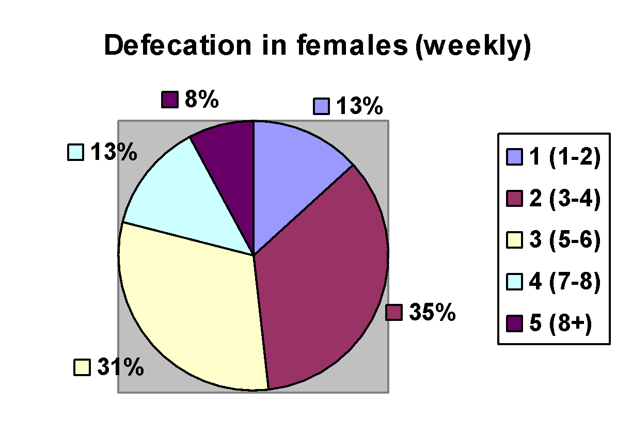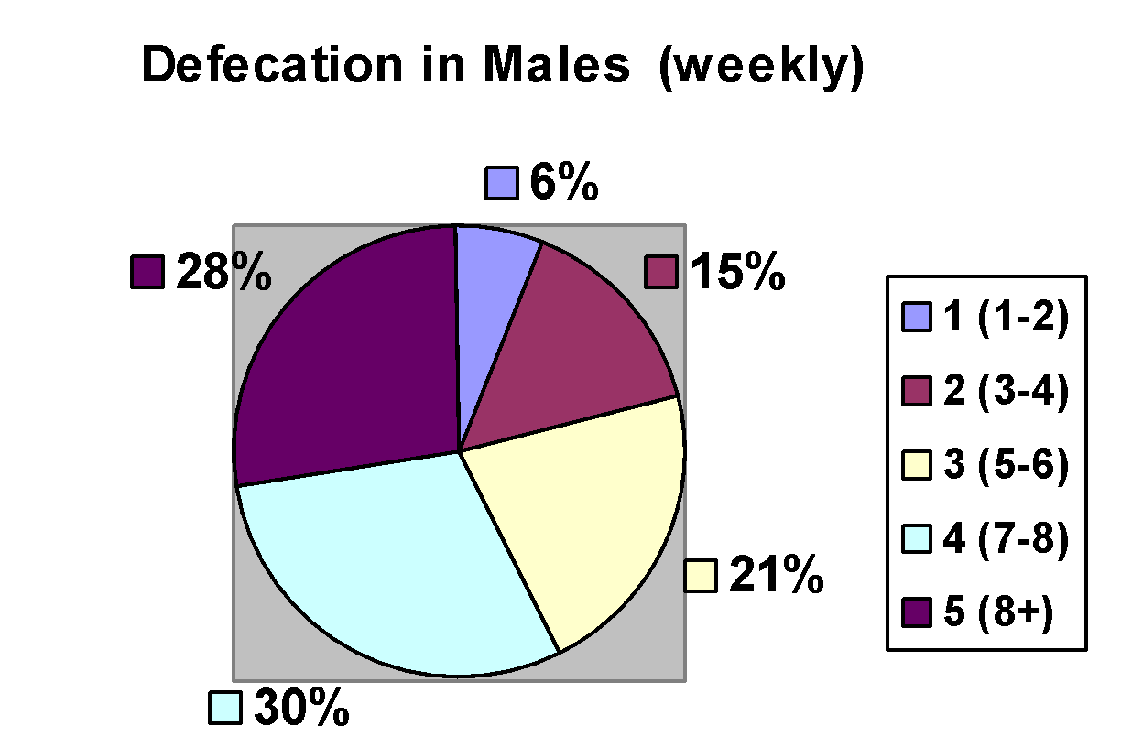

As the data shows, the males that took the survey seemed to defecate more frequently than the females who took the survey do. The males who defecate more than 8 times in a given week sleep an average of 7.3 hours a night and eating at fast food restaurants 1.92 times a week. The females on the other hand seemed to get 7.75 hours of sleep a night and eating an average of 2.75 times a week. These women also all experienced some sort of change in digestive habits while they were menstruating. Could fast food be the cause of digestive distress?

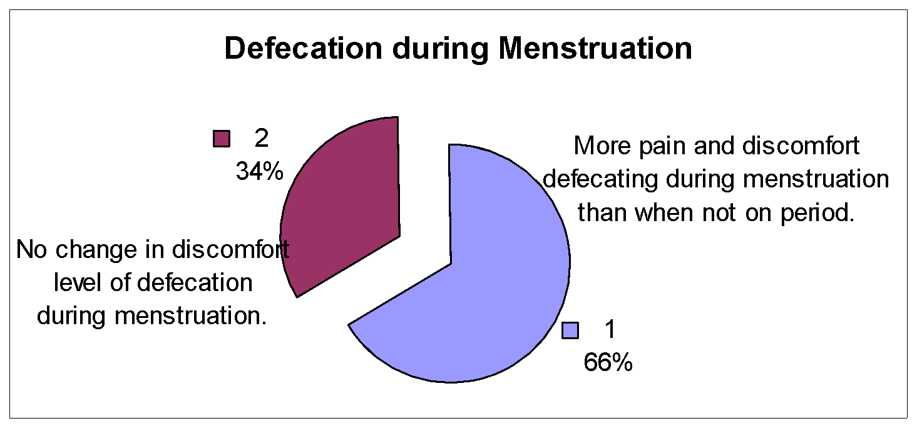

In all actuality I have to say that all of my efforts did not fail, but did not succeed either. The reason that I consider this survey neither a success or a failure is the reason that science is neither right nor wrong, it just is. Though I might not have collected the type of data that I would have really liked to, it has allowed other ideas to form in my head, which might be of use to other students, or even myself at a later date. The first conclusion that I drew was one that should be used with every experiment or survey that you ever do. Have a large enough sample size so that your data means something. The first problem that I ran into in this survey was the fact that not enough people took it. As I said earlier this could be attributed to the facts that the survey asked some very intimate questions in which many people are not willing to answer.

More questions need to be asked in order to gain a better understanding of how they interact with the rest of their community. Their weight and height can play a vital role in determining if they’re healthy or not as far as their digestive tract goes. Even the nationality of the individual can make a huge impact on their weight and food processing habits. An easy example of this to grasp is that of a Native American from Alaska compared to a native of a South American country. The probability of the Alaskan having a greater body weight is greater than the South American having a thicker layer of fat and muscle because of the climate and environment in which they lived and survived for generations.

Another idea that has a lot of merit would be asking the person taking the survey to keep a journal of what they eat on a daily basis. This should also include a reference to what time they ate, what time they defecated, and what time they went to sleep. By making a detailed journal of the life of their stomach these people can determine if there is a problem, and if there is make a change for the better.

To anyone reading this and thinking that you’d be interested in doing a study similar to mine, please contact me via telephone so it can be done better than mine. (925) 462-4365

# Bibliography

Danzi, J. Thomas. Free Yourself from Digestive Pain. New Jersey; Prestince-Hall 1984.

Gitnick, Gary. FREEDOM from DIGESTIVE DISTRESS. New York; THREE RIVERS PRESS 2000.

Janowitz, Hendry D. INDIGESTION Living Better with Upper Intestinal Problems from Heartburn to Ulcers and Gallstones. New York; OXFORD UNIVERSITY PRESS 1992.

Rosenthal, M. Sara. THE GASTROINESTINAL SOURCEBOOK. Los Angeles; LOWELL HOUSE 1997.

“The Big Fat Question If obesity is America’s new No.1 health problem, why aren’t doctors serving up a steady diet of help?” Reader’s Digest Apr. 2002: 140-145.

Wallace, Susan. “Commonly used medical plants”

2002 <http://www.skell.org/plants.htm>

# Journal

January 30th

Today I started putting together the survey for the project. I decided that questions such as “How often do you defecate?” and “How often do you sleep?” I’m not sure that many people are going to be very willing to actually fill it out.

February (throughout the month)

I’ve been trying to get Meier to set up the asp code on the survey for me, but he’s been putting it off. I’ve been looking up how to use asp code and I think that I can do it if I can just get onto a server that can support QSL databases. Okay, I finally got Meier to do something. We’re setting up the server today.

March 11th

We set up the server, and it looks like it’s going to work. I’ve been sending out invitations to many of my friend to take the survey, and I think that a bunch of them have done it. I also asked them to send out the survey to all of their friends.

March 12th

CRAP! The server had too many hits and it crashed last night. It crashed 7 people into the database, so all of those people who came later were not able to fill anything out.

March 14th

It turns out that Meier screwed something up when he was changing the asp code, so if anybody leaves anything blank then they get a redirection to a page that looks just like the one that they’re supposed to go to, but it says in little letters that there’s an error.

We fixed the problem. SCORE!

March 21st

I’m looking through all of the data, but it doesn’t look like there’s very much data collected. Tomorrow’s my birthday!

March 27th

As it turns out there was a misspelling in the asp code that kept the form from recording any information regarding exercise. I guess that’s one category that’s just not going to be on the data page.

April 5th

I’m through….I’m done!

1. Anglicus, Gilertus; Compendium of Medicine
2. Bible Timothy 6:10
3. Stein, Gertrude; Wars I have seen 1944
4. Eric Thiel
5. Gary Gitnick (p.8)
6. Reader’s Digest April 2002 P.142