**Procedure/ Survey**

Materials needed:

* Individuals to survey
* Well-developed survey
* Master-list of English classes
* Resources: books, journals, websites

Based on research we had collected previously, we developed questions that we felt would give us the necessary information to draw conclusions about the topic. We then obtained a master-list of English classes at Amador Valley High School and numbered them. Using a calculator, we randomly selected classes to survey. With the permission of those teachers, we came to the specific periods selected randomly, and surveyed those students. The teachers that we selected were:

* Bartholomew: 2nd and 7th period
* Damon: 6th period
* Heller: 5th period
* Robbins: 3rd and 7th period
* Searle: 5th period
* Souder: 2nd period

This is the survey that was distributed to 220 students in those English classes:

**AP Biology Research Survey**

**Ashley Blake & Heath Cady**

*Please fill out this survey completely and as honestly as possible. The responses are completely anonymous. Thank you.*

1) What is your gender? Female Male

2) What grade are you in? 9 10 11 12

3) What activities do you do weekly that would be considered exercise? Check all that apply.

Weight lifting Lacrosse

Track (running) Rugby

Soccer Biking

Basketball Power walking

Hiking other aerobic sports __________

4) On average, how often do you exercise aerobically? (hours per week)

2 or less 3-4 5-7 8 or more

5) On average, how many hours of sleep do you get per night?

3 or less 4-6 7-8 9 or more

6) On average, how would you rate your stress level on a scale of 1-10? 1= no stress,

10= extremely stressed. __________

7) Have you recently experienced any traumatic, stress-causing situation? (example: family death, pregnancy, divorce)

Yes No

8) When you are feeling stress, do you find yourself eating more or less than normal?

9) Is the food that you eat when you are stressed healthy? Yes No

10) What food group makes up the greatest portion of your diet? Circle one.

Fruits Vegetables Grains Meats Dairy Fats & Sweets

11) On average, how often do you eat food rich with zinc or zinc supplements? (foods with zinc include red & white meat, shellfish)

Once a week or less 2-3 times a week 4-5 times a week 6 or more

12) On average, how often in a week do you eat foods rich with iron or iron supplements?

(foods with iron include green leafy vegetables, red meat)

1 or less times 2-3 times 4-5 times 6 or more times

13) On a scale from 1-10, how would you rate your nutrition level/ eating habits? (1=unhealthy, 10=very healthy)

14) Do you take vitamin supplements regularly?

Yes No

15) Do you regularly intake of vitamin C? (example: oranges and orange juice)

Yes No

16) Do you normally take any medication that would affect your immune system’s efficiency? (example: steroids, hormones)

Yes No

17) Are you inflicted with any diseases that would affect your immune system?

Yes No

18) Do you or your parents have a history of chronic illness?(chronic=sick all of the time)

Yes No

19) On average, how often are you sick per year?

2 or less times 3-4 times 5-6 times 7 or more times

20) On average, how long does your sickness last?

2 days or less 3-7 days 8-14 days 15 days or more

We categorized the students based on how often they were sick per year, and how long their sickness lasted. After separating them into their categories, we compared their food and exercise habits, stress levels, and amount of sleep per night.

This graph compared the stress levels of those we classified as “well individuals” and “sick individuals”. We decided to take those who were sick the least amount of times, with the shortest duration of sickness, and labeled them the “well individuals”. We took the responses of those who were sick the most often and had a long duration sickness, and labeled them “sick individuals”. By comparing the opposites, we hoped to find that our data showed obvious differences between those who were “well” and those who were “sick”

Although our data was not a successful as we would have hoped it does show that there were higher stress levels among the “sick individuals”.

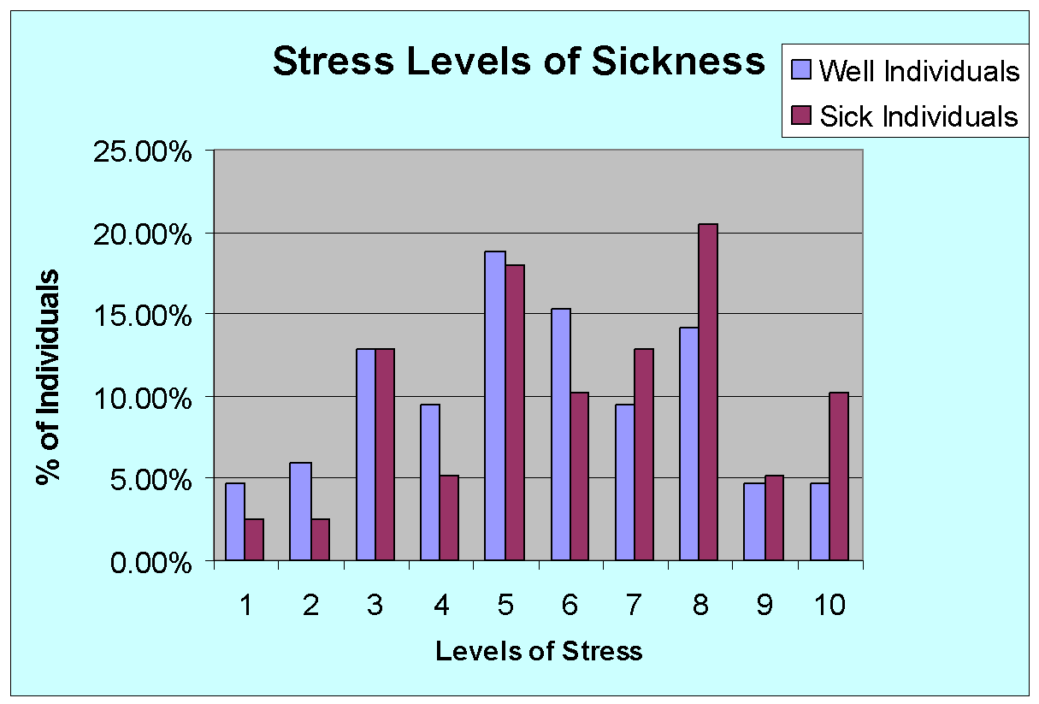

These charts represent average hours of sleep per night for “well individuals” and “sick individuals. From these charts, we can gather that sleep may not be a significant factor in our research.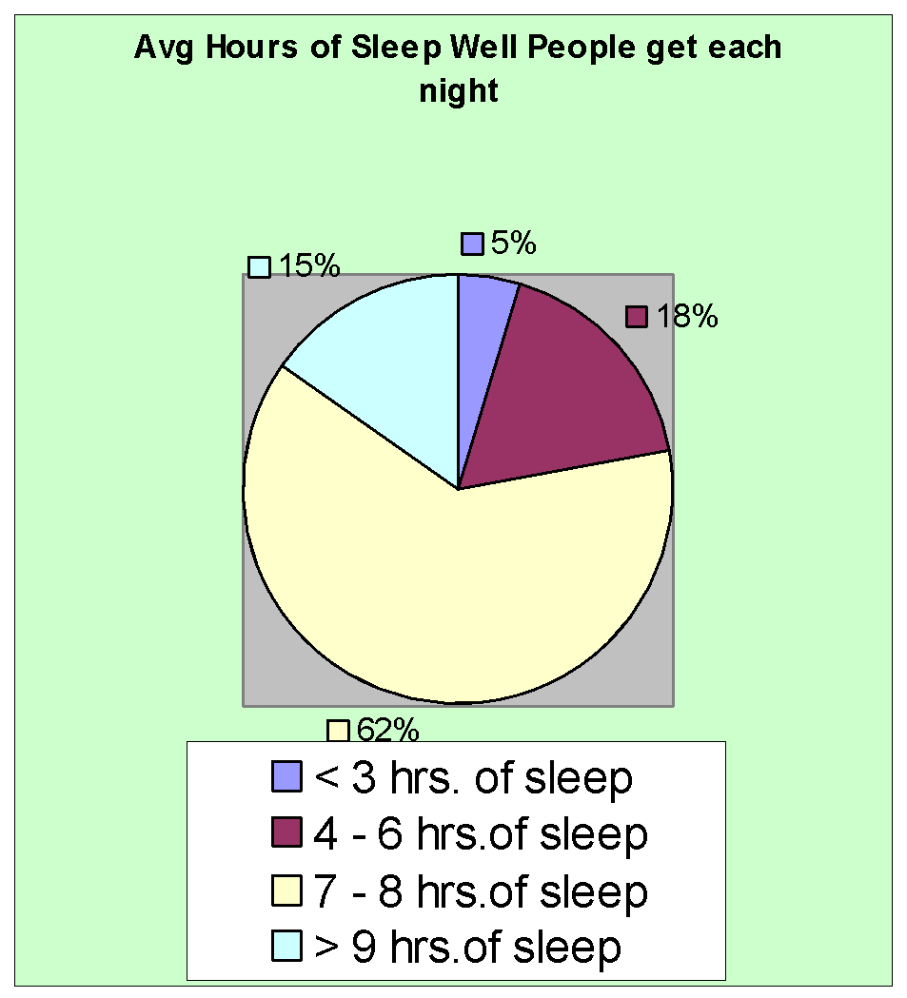

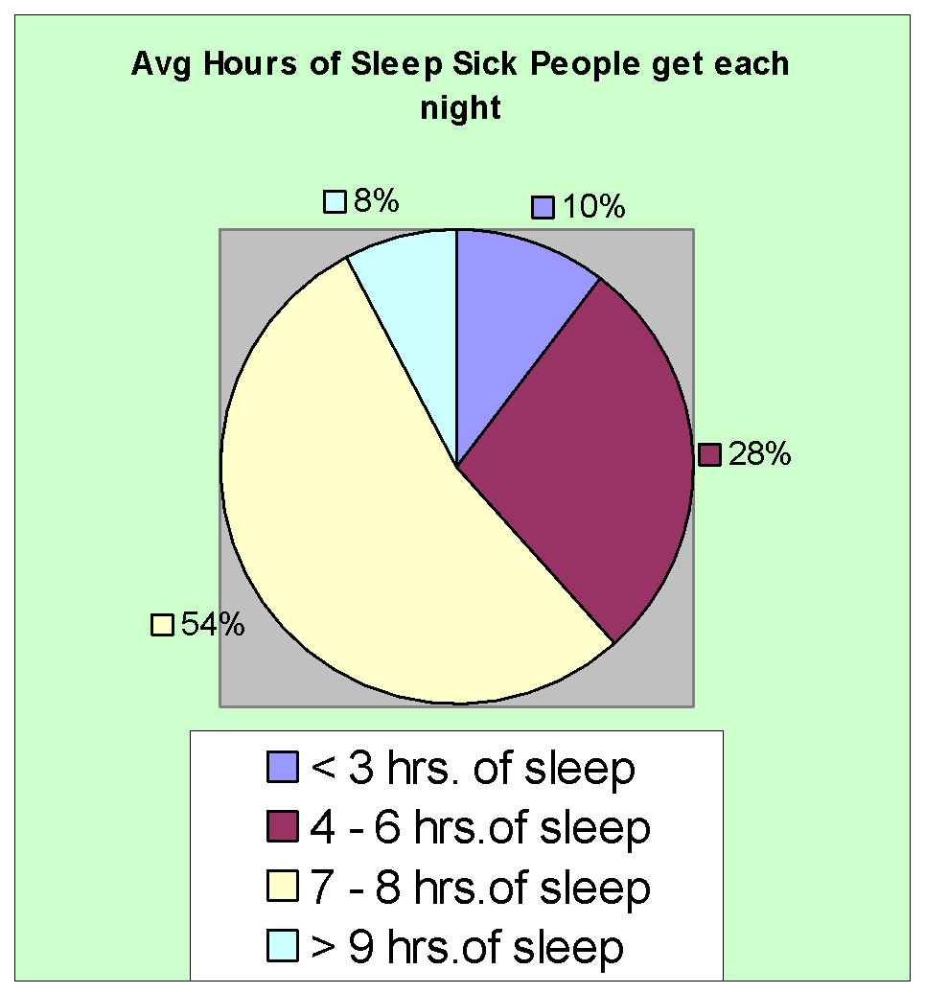

When comparing males and females, in relation to wellness, we can conclude that our data does not follow the normal trend.

“Women possibly have more efficient immune systems than men, and this fact may be responsible for their greater life expectancies.” (29) Our data showed that females had a higher percentage that were sick often, as well as having a higher duration of sickness.