Bibliography:

1. Nowak, Ronald M.; Australian Native Mice, Walker's Mammals of the World, Baltimore, 1991, p. 820
2. Corliss, William R.; [Science Frontiers #81, May-Jun 1992](http://www.science-frontiers.com/sf081/index.htm),
3. Sheldrake’s, Rupert; “Sheldrake online.” (Online). <http://www.sheldrake.org/>. 1995 – 2001
4. Sheldrake, Rupert, Seven Experiments That Could Change the World. Cambridge University Press, Great Britain, 1994.
5. Horn, Angela; “mouse@horns.” (Online). <http://www.horns.freeserve.co.uk/mouse.htm>
6. Campbell, Neil A.; Reece, Jane B.; Mitchell, Lawrence G.; Biology 5th edition; Illinois, Pearson Education, Inc. 1999-2000
7. (Online). About Mice, <http://www.petwebsite.com/about_mice.htm>. 1997
8. (Online). “the Skeptics Dictionary: Morphic Resonance,” <http://skepdic.com/morphicres.htm>
9. Excerpts from an interview with Sheldrake, Rupert. (Online). “What the hell is Morphic Resonance,” <http://www.geocities.com/Athens/Atlantis/3425/page133.htm>
10. Sheldrake, Rupert. The rebirth of a Nature: The greening of Science and God. New York: Bantam Books, 1991
11. Marks, David F.; Colwell, John. The Psychic Staring Effect: an artifact of pseudo randomization. (Online) <http://www.csicop.org/si/2000-09/staring.html>
12. Sheldrake, Rupert. (Online.) Morphic Resonance. <http://www.geocities.com/Athens/Atlantis/3425/page118.htm>. 18 Aug. 1999
13. Sheldrake, Rupert. Dogs that know when their owners are coming home. Three Rivers Press, New York, 1999
14. Sheldrake, Rupert. A New Science of Life. Park Street Press, Rochester Vermont, 1995.
15. Sheldrake, Rupert. The presence of the past. Harper Collins Publishers, Great Britain, 1988
16. Sheldrake, Rupert. [Part I: Mind, Memory, and Archetype Morphic Resonance and the Collective Unconscious.](http://www.sheldrake.org/articles/db.cgi?db=default&uid=default&ww=on&id=44&view_records=1) Psychological Perspectives 1987. (Online) <http://www.sheldrake.org/articles/db.cgi?db=default&uid=default&ww=on&id=44&view_records=1>
17. Sheldrake, Rupert. [Extended Mind, Power, & Prayer: Morphic Resonance and the Collective Unconscious Part III.](http://www.sheldrake.org/articles/db.cgi?db=default&uid=default&ww=on&id=43&view_records=1) Psychological Perspectives 1997. (Online) <http://www.sheldrake.org/articles/db.cgi?db=default&uid=default&ww=on&id=43&view_records=1>
18. Sheldrake, Rupert. [Society, Spirit & Ritual: Morphic Resonance and the Collective Unconscious.](http://www.sheldrake.org/articles/db.cgi?db=default&uid=default&ww=on&id=42&view_records=1) Psychological Perspectives 1987. (Online) <http://www.sheldrake.org/articles/db.cgi?db=default&uid=default&ww=on&id=42&view_records=1>
19. Sheldrake, Rupert. [An Experimental Test of the Hypothesis of Formative Causation](http://www.sheldrake.org/articles/db.cgi?db=default&uid=default&ww=on&id=26&view_records=1)   
    Rivista Di Biologia-Biology Forum 1992, V85, N3-4 Pages: 431-443. (Online) <http://www.sheldrake.org/articles/db.cgi?db=default&uid=default&ww=on&id=26&view_records=1>

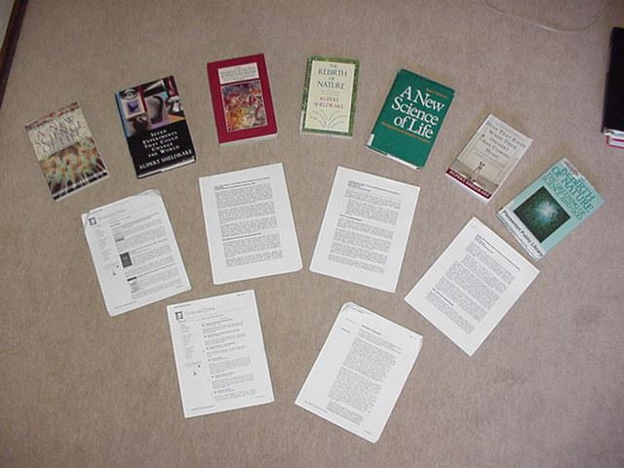

1. Henderson, Leah; Vedral, Vlatko. CQC Introductions: Quantum Entanglement. (Online) <http://www.qubit.org/intros/entang>.
2. Penrose, Roger. Shadows of the Mind. Vintage Random House, London, 1995.
3. Roger Penrose. The Emperor’s New Mind. Oxford University Press, New York, 1990
4. Thompson, Helen; Woodhead, Nichola. “Helen and Nichola’s Mouse Page.” (Online) <http://www.burleyms.freeserve.co.uk/animals/uk/helenmouse.html>
5. “Systematics of the Mus species group, the house mouse, and classical in bred strains.” (Online) <http://www.informatics.jax.org/silver/2.3.shtml>