Discussion:

By establishing a trend for the effects of Morphic resonance when operating in close proximity, I was able to compare the effects of Morphic resonance across large distances and note whether the trend was maintained or lost. This would indicate whether or not Morphic fields were influenced by space. Establishing a trend from the limited data available becomes a difficult task. In order to ensure the accuracy of our conclusions, some preliminary steps must be taken in organizing the data and understanding the implications of each element involved. So, restating the experiment in a more pragmatic sense would be helpful: the aim is to investigate whether the local influence of Morphic fields is commensurate to its non-local influence. If the mice in this experiment demonstrated influences of Morphic resonance (meaning, if their relative abilities to learn the maze in close proximity became increasingly greater) then testing the learning ability against non-local conditions should yield the same trend in the isolated mice’s learning ability. It is therefore necessary to vigorously control this experiment so as not to allow other factors to influence your interpretation of the mice’s learning ability. Such problems arose and the control variables established are numerous. Some important controlled variables were:

* A conditioned aversion must be present for the mice to yield accurate results. As in the chick experiment, the chicks rapidly learnt to refrain from pecking the yellow light emitting diode (LED) because of the negative association with its consequences, the same must be here. The mice must be kept hungry to the extent that they learn that the only way they will get food is to make it to the end of the maze. This will provide some incentive for the mouse and will ensure that your results are not merely haphazard running of the random playtime of rodent. They must grow averse to being hungry and learn that the solution to their physical duress lies in completing the maze. This aversion to hunger manifests it self in an aversion to not running the maze which yields results because the mouse wants to complete the maze, and because it works towards memorizing the maze and calling upon its collective memory to assist it in doing so, thus we are able to record meaningful results.
* The test subjects, used to carry out the experiment, must all be members of the same species. (Mus musculus) This is fundamental to the theory of formative causation – “…the influence of like upon like.”
* The gender of all test subjects must be the same. In this experiment it was chosen to be female because of the reason mentioned above, and other advantages of keeping females, which includes a less noticeable odor. However, a component of buying and keeping females is that they may fall pregnant. This I hoped would not be possible as long as all test-subjects were female. However, before I even acquired the rodents, one of the mice had already been impregnated whilst living in the pet store. This mouse was labeled mouse number seven and the results of experimentation on it must be stricken from consideration when deciding upon a conclusion because it will lead to inaccuracy. As we saw, several of the runs of mouse number seven were far below the norm and it took in excess of 10min to complete the maze on 10 different occasions. It was substantially different from other test subjects and therefore represents an aspect of the experiment outside the bounds of a control; therefore it is a threat to the accuracy of our data and a cause of inconclusive findings. Therefore it must be disregarded as evidence. It became evident half way through the 4 weeks of experimentation, that this mouse was in fact pregnant. This we can assume was detrimental to the mouse’s performance and physical abilities. As we saw by the data collected, the pregnancy is most likely to be the cause of the physical incompetence, and was the reason for the mouse’s long periods of motionlessness and seeming reticence. The abnormal data of mouse seven should be excised from consideration in our conclusions.
* Furthermore, the similar behavior of mouse number four provided somewhat of an enigma, because mouse number four did not turn out to be pregnant, yet it did manifest the same behavioral components as mouse seven. Mouse number four produced results that were even less consistent with the norm, than mouse seven. As the observations column, over trials 9, 10, and 11, points out, “A change in behavior is noticed when the mouse…appears sufficiently familiar with the surrounding environment that he is simply content to sit and do nothing anywhere he can. Removing him from the cup and getting him to enter the maze is a most difficult task. This apathy and indolence grows until he barely even runs out of the start portion of the maze. The mouse can no longer be cajoled into exiting the cup; I am forced to shake it in order to exact his exit into the maze. He runs from the shock of the shaking glass but then quickly resumes his position in dead end C. And remains still and motionless until the end of the 10min.” Faced with this dilemma I contacted a physiology teacher at Witwatersrand Technikon, South Africa her name was Myriam Lakmeeharan. She informed me that this was not an uncommon occurrence. She explained that this was simply the nature of some mice, she continued to say that scientists today usually test their mice before any experiments are conducted, to ensure that their entire test subject sample size consists only of mice that will run the maze, active mice; those which are “runners” are sleeted for the test subject sample group. She said that “non-runners” simply cannot be used in my data collection and for the purposes of testing Morphic resonance. Due to these recent developments I have no choice but to extricate mouse four’s data from consideration when coming to a conclusion. It appears to me that all other mice however did luckily manifest properties of being runners. The above two mice’s results (mice seven and four) can be removed without consideration of their effects on the experiment because neither of the mice, by the end of the 12 trials, showed any signs of having memorized the maze or having developed some knowledge of it’s configuration. Therefore, as individuals, their contribution to my data was zero and their effects by way of Morphic resonance on the other test subjects is the same. Therefore removing their data from my analysis will ensure greater accuracy of my conclusions.
* In addition, Morphic resonance works when a test organism learns something new and in doing so makes other organisms of the same species do so more readily. However the way I have defined the point at which they have officially memorized the maze is respective to the time they take to complete it. This is an incorrect relationship, but one which simply makes life easier for experimental purposes. This relationship is incorrect because according to the time recordings starting from trial 1 through12, it would suggest that the mouse knows the maze relatively well when he enters the first time (because he is agitated and completes the maze quickly), then the mouse begins to forget the configuration (calms down and runs the maze more slowly, learning all the corridors), and then memorizes it again, more completely (true memorization). But this is incorrect. The time taken to complete the maze on the first two trials, is always less than the third. This is not because the mouse already knows the maze and then forgets it slightly, as my definition of memorization (time taken to complete maze) may suggest, but can be better explicated in terms of an increased level of fear and agitation in the mouse due to the new surroundings. This fear, as in humans, leads to enhanced physical abilities and an increase in speed due to adrenaline production by the body. This enhanced physical state of agitation translates itself into a speedy run of the maze and a heightened awareness and increased perceptivity of the mouse’s senses. These combined states of astuteness and physical enhancement sway the data in a way that causes it to digress from the expected ‘decrease in time of completion of maze, as the number of trials gets greater’. This means that the dip at the beginning of the time/trial recordings is not due to relevant factors here, and should also be disregarded to ensure accuracy of results. Once the first two trials of each mouse’s data are removed, the remaining data shows the expected trend: as the mouse runs the maze more times, he completes it increasingly rapidly. An aspect of memory, self-resonance. The more we do something, the more wememorize it and the more rapidly we are able to do it again. Through repetition the knowledge of the maze configuration is committed to the collective unconscious memory. However, because this occurs in every mouse, and seems to be a controlled variable because of that, we have included it in the analysis, but we are mindful of it’s incorrectness and we avoid using it incalculations.
* The diet of the mice must be the same for all subjects and they must be treated equally in all respects. (Including you interactions with them.) Ensuring that their diet is the same, you can hope that their performances and the data you collect is due to the tested variable and not their respective diets.
* Testing must be carried out over a period of 4weeks. Keeping the time between each subsequent subjects section of testing, constant. This will ensure that no aspects of the temporal decay of Morphic Fields (which has not been investigated yet) has any influence on you results. This will ensure that the results obtained are truly from the tested variable and not the lack of control that may be present if testing times and periods were haphazard. This-two mouse to one-week ratio is consistent with the U.S. and S.A. experiments.

The variable being tested here is rather unorthodox: the strength of the Morphic field with regard to the knowledge of the maze configuration in the collective memory of the species Mus Musculus. As subsequent mice learn the maze and commit it to their collective memory, the strength of the Morphic fields will increase and cause the following mice to learn the same thing more easily. This varied strength of the Morphic field, is the dependent variable. And the independent variable is the time in which the mice are able to complete the maze, which was arbitrarily set at the outset of the experiment to be when the mouse completes the maze in less than 30seconds. This means that the mouse will always arbitrarily go until he reaches the 30second mark (independent variable) but how many trials he needs to do so, is to be determined (dependent variable.) An analysis of each mouse’s results follows:

Analysis –part 1, in the U.S.

Mouse 1:

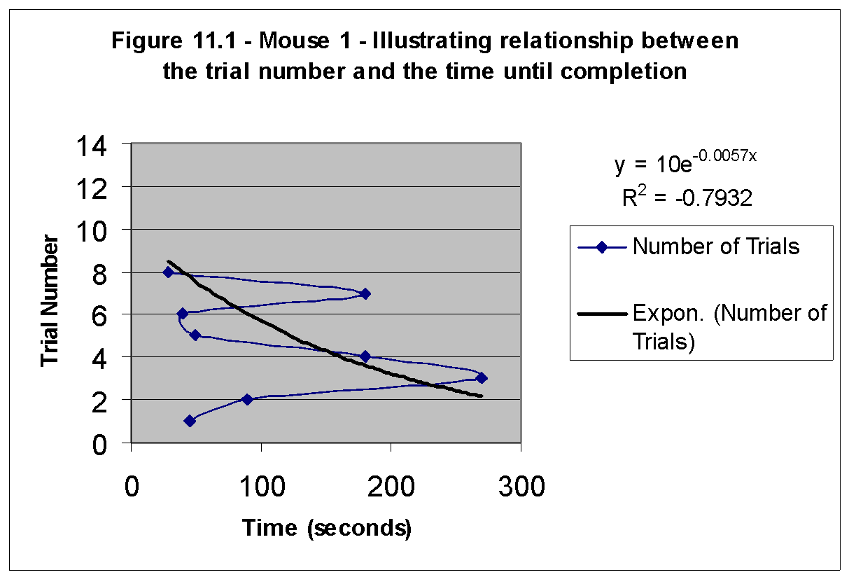

The method I used to graph this is slightly awkward at first, but it soon becomes evident that it is more clear when presented in this manner: with the time on the x-axis and the trial number on the y-axis, we can clearly see which trials lasted less that 30seconds (all points to the left of a line drawn vertically up from the 30second mark on the x-axis.). This is the independent variable here. It would seem as though the number of trials is the independent variable, but it is not because we have arbitrarily set the point where the goal is accomplished, relative to the time, (30seconds completion). Therefore the time goes on the x-axis and not the number of trials, as we might expect in other experiments. The number of trials depends on how quickly or how many trials the mouse needs to be able to complete the maze in under 30seconds. Therefore the number of trials is dependent upon when the goal (under 30 seconds) is accomplished, and is therefore determined by the testing factor here, which is the strength of the Morphic field, which would make the mouse able to learn the maze in fewer trials. The time will always run until 30seconds and therefore is independent of the number of trials or the testing factor. Therefore the dependent variable is the number of trials. The lower section of the graph containing, the first two trials indicates an increase in time taken to complete the maze, as we explained before, the first two trials of each mouse are considered immaterial because of the uncontrolled circumstances. Here let us begin analyzing the trend of the graph from trial three through trial eight. There is obviously a trend tending toward a decrease in time of completion. We see that a line of best fit, drawn for the trials 3 through 8 would yield a line pointing in the northwestern direction, indicating that as the trials continue, the time taken to complete the maze decreases. The flatter this line is, the fewer trials until it crosses the 30scecond vertical goal line. From the value at trial 3 (270seconds) there is a noted general decrease in values until it reaches trial 8 (30seconds). We see the difficulty the mouse had in memorizing this maze as a consequence of there being no pre-established Morphic fields corresponding to this maze. The mouse had to memorize the maze and commit it as a ‘new edition’ to the collective unconsciousness.

Mouse 2:

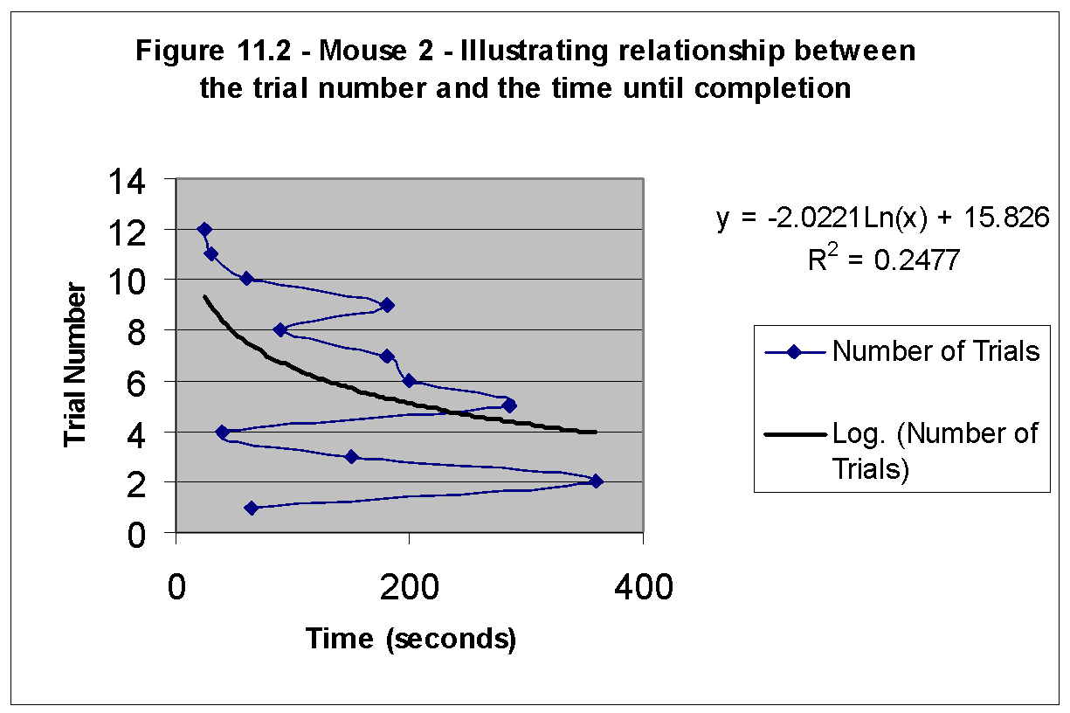

Here again, remember not to consider trials 1 and 2. The trend line here clearly illustrates the memorization of the maze by mouse 2, however, the slope of the curve is continually getting steeper and it takes longer and longer with each successive trial to memorize more of the maze configuration. The steep slope indicates that with the current Morphic field strength it takes relatively more trials for this mouse to memorize the maze than the next mouse, mouse 3, but less than the previous mouse, mouse 1. (According to the hypothesis of formative causation)

Mouse 3:

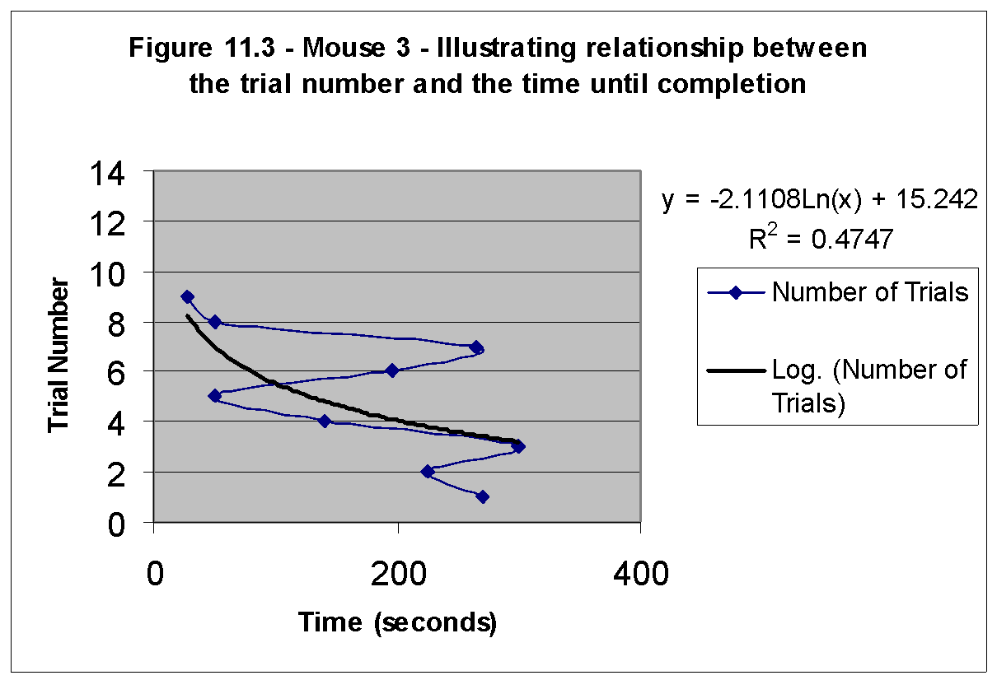

It seems that there was not much change in the slope of this curve, from the one prior to it, where the hypothesis of formative causation would have predicted such a decrease. This may be a result of experimental error, or counter evidence against the theory of formative causation.

Mouse 4: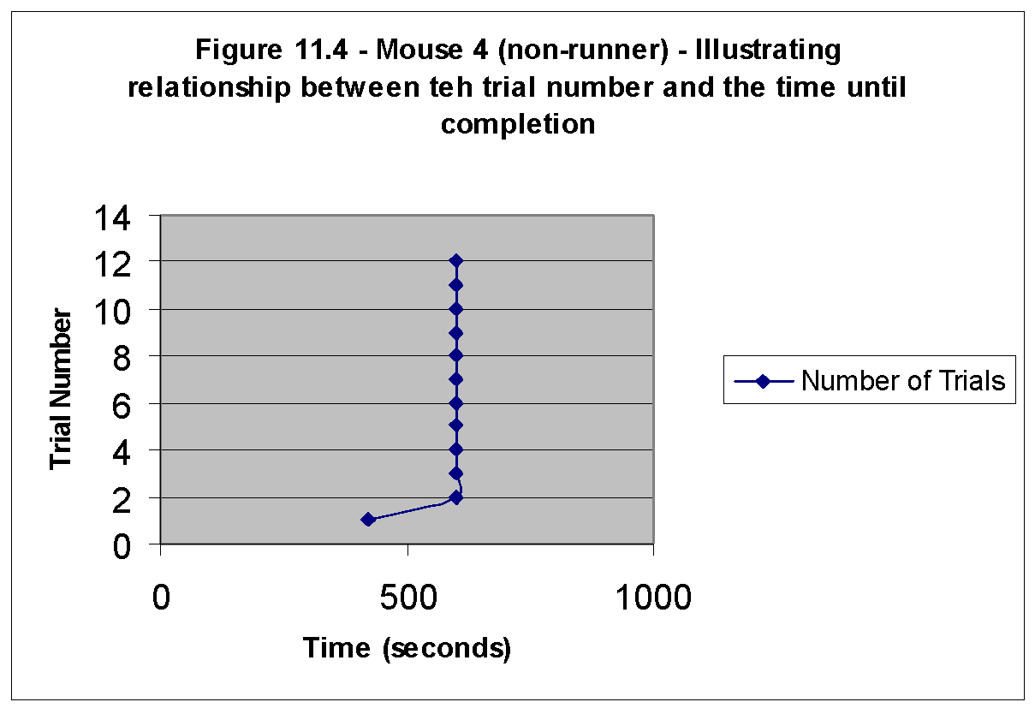

Mouse 4 was labeled a non-runner and the evidence it provided is meaningless. It appears that this is a behavioral trait in some mice and avoiding these mice in experiments involving running would be most conducive to the accuracy of results. There is no meaningful trend line that can be drawn here, but something to note is that evidence for my statement that the first two trials of a mouse are influenced by factors other than resonance (Ex: hyperactivity due to unfamiliarity of surroundings) is given when analysis of mouse 4’s first two trials are acknowledged. This mouse was a non-runner and he sat motionless for all trials until the conclusion of the 10min period, except the first two where he was more agitated because of the new surroundings and this caused him to actually explore and eventually complete the maze.

Mouse 5:

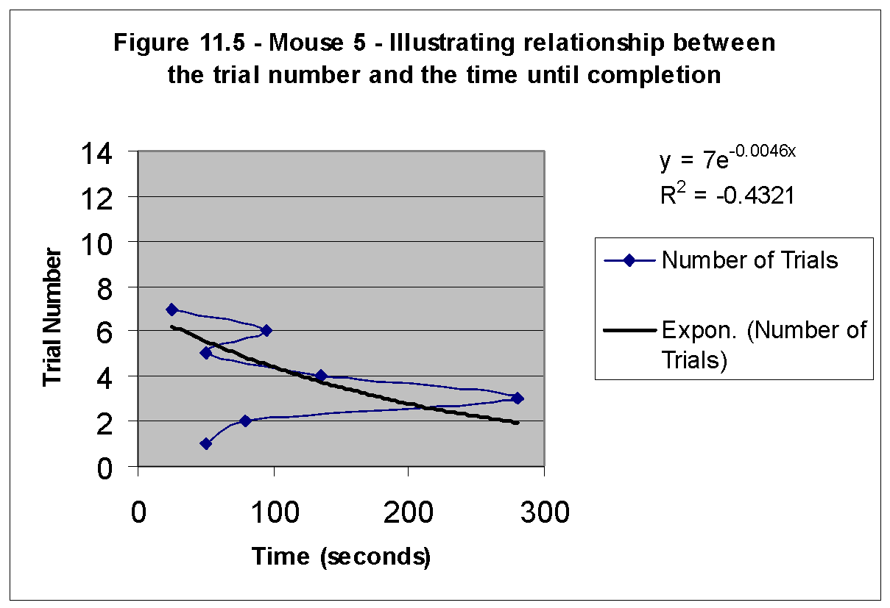

The same trend continues here, as the trend line of mouse 5 appears to have a not so rapid rate of change of slope as mouse 3 did. It appears as though this trend line approaches the 30second vertical line more quickly than the trend line of mouse 3. This means that as the trials continue it takes subsequent mice after mouse 3 less trials to achieve the same level of memorization of the maze.

Mouse 6:

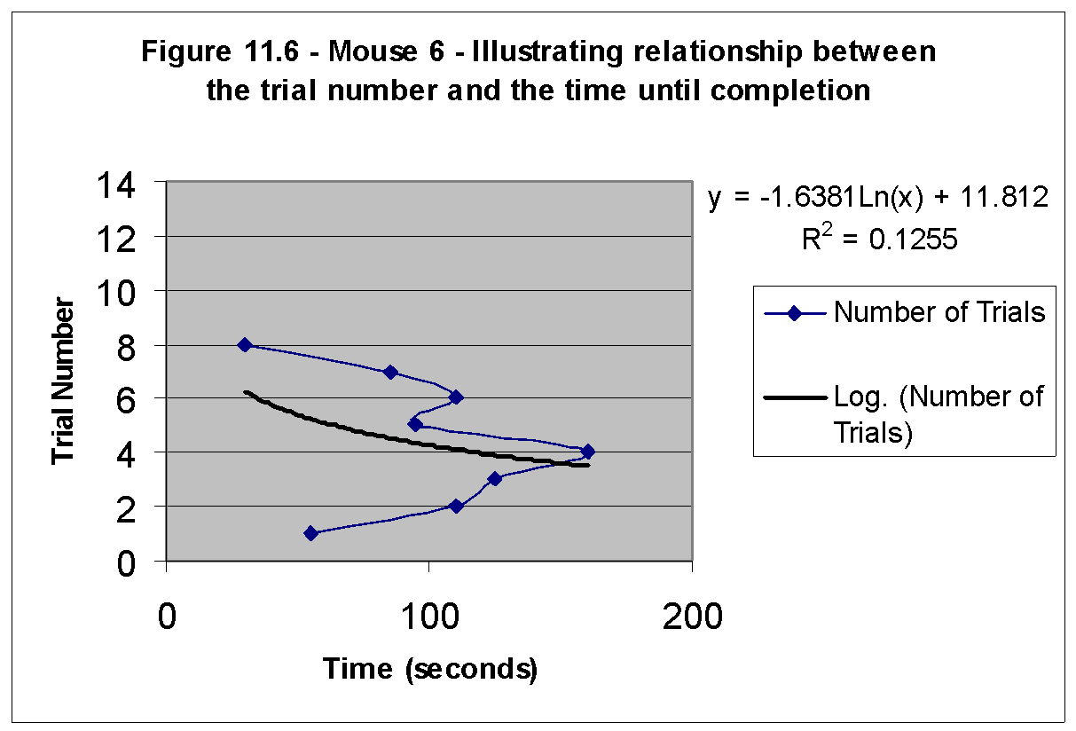

Here for mouse 6, evidence would suggest that the first 3 trials of his runs were affected by hyperactivity outside the norm, not just the first 2, and therefore producing uncontrolled implications; but this may also merely be a coincidence. And for the sake of consistency, and a lack of conclusive evidence to support this belief, we will leave the third trial included in the conclusion considerations. Again I would like to point out that the rate of change of the slope of the trend line is less than that of the previous mouse, supporting the implication that Morphic fields, regarding this maze configuration, have grown stronger.

Mouse 7:

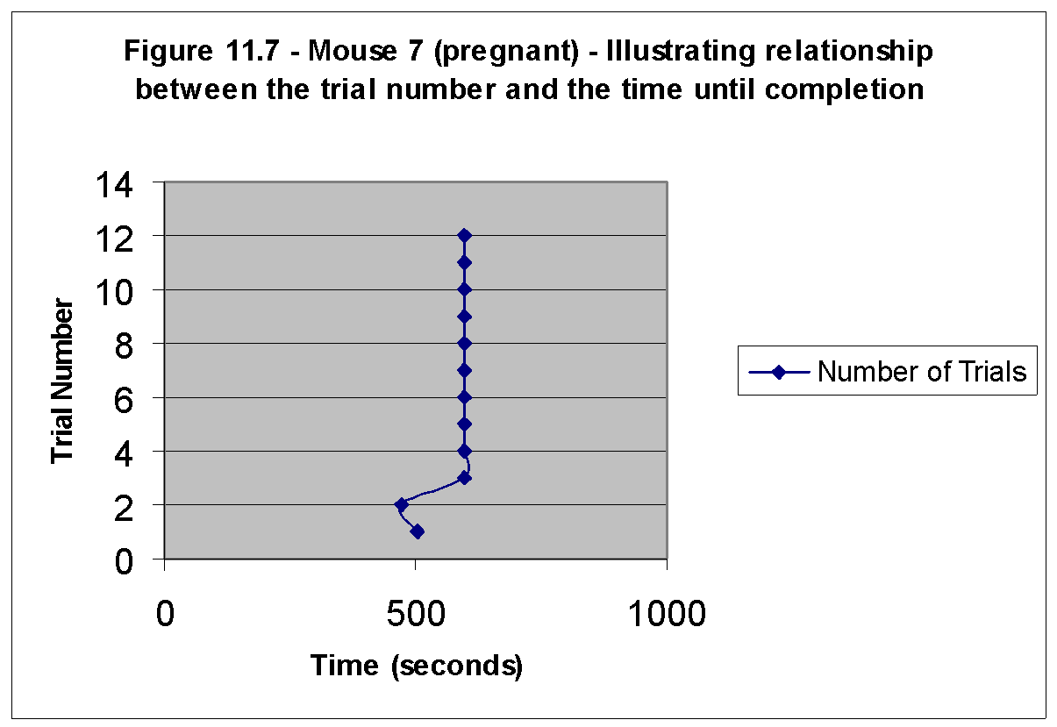

A terrible inconvenience occurred when I discovered that the poor performance of mouse 7 was due to an external uncontrolled factor that renders mouse seven’s contributed data meaningless. When such a small sample size is used, the loss of one test subject is a crucial blow to the conclusiveness of my findings. It turns out that mouse seven was pregnant from when it was bought from the pet store and this not only was a burden on the one carrying out the experiment (taking care of the newborns) but it also thwarted my results for this mouse’s maze times. Nevertheless, it also, as mouse 4 did, serves as proof that the first two trials of each mouse should be overlooked in terms of arriving at a definitive and accurate conclusion.

Mouse 8:

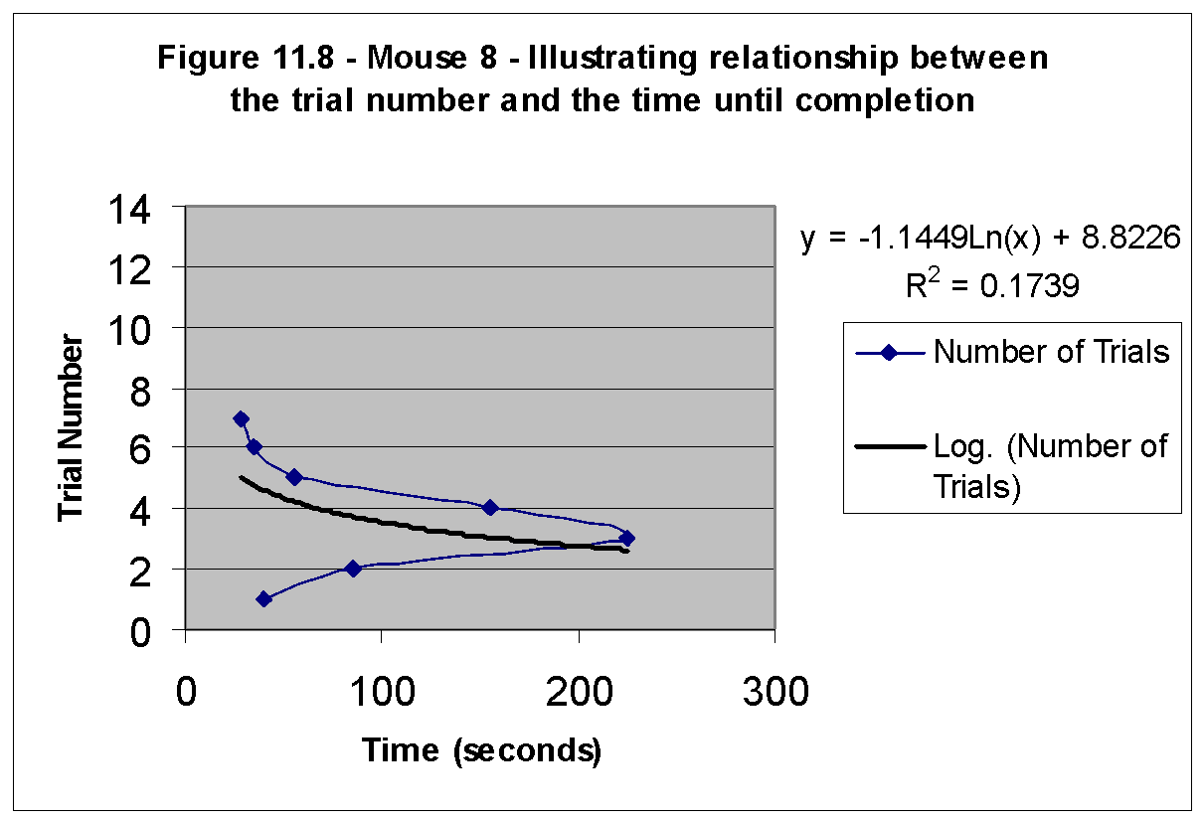

Mouse 8’s results were of an extraordinary standard, representing many of the scientific views concerning memory today. It show that the mouse’s ability to learn follows the smooth exponential curve as see on the graph between trials 3 and 7 –a smooth and distributed learning process. The trend line again follows the expected pattern supporting the hypothesis of formative causation. Now it appears to show that in a matter of 3 or 4 trials a mouse can learn this maze configuration to the same extent that a mouse previously (mouse 1) would have learnt it in approximately 5 trials. I say this by counting the rise in the trend line representing number of trials and comparing it to the run (distance across) representing the distance from the point of zero knowledge of the maze configuration until the point of memorization at less than 30seconds for completion.

Mouse 9:

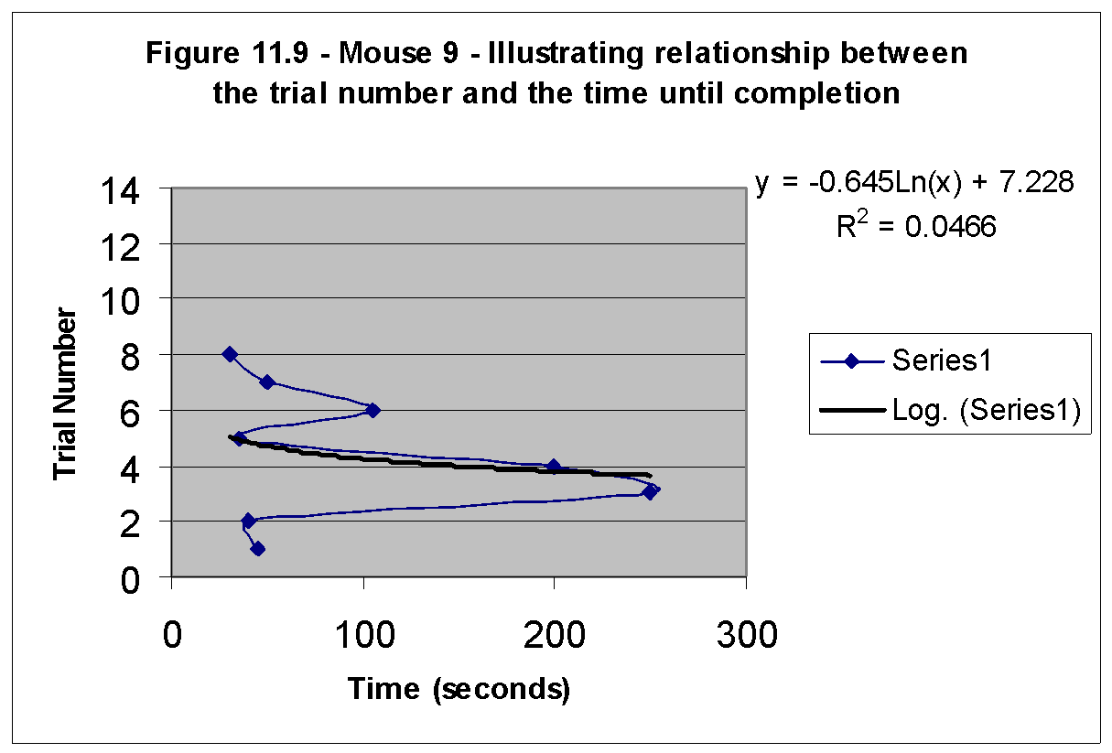

Mouse 9 illustrates a similar rate as the previous mouse did in learning the maze. This indicates that not much improvement in the rate of learning (for mouse 9) the maze occurred or resulted from the strengthening of the Morphic field regarding the configuration of this maze from mouse 8.Human error and experimental inaccuracy may also account for this.

Analysis –part 2, in S.A.

Mouse 1:

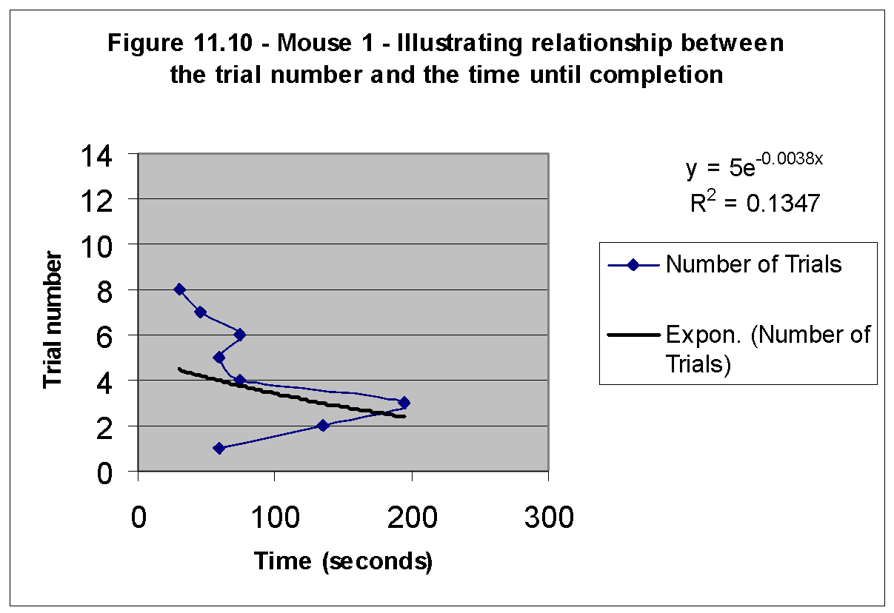

By switching the axes of the figure 11.10, we can conduct the following calculations: (explained down below in sections 11.12-11.13. Remember, for now, we are only switching the axes for this calculation.)

slope 9 (U.S.) : slope 1 (S.A.)

rise : run

(250-30) seconds / 8 trials : (195-30) seconds / 8 trials

* 1. : 20.625

3 : 2 (approximately)

Remember, these slopes are not representative of the style of the graphs above, they are slopes of time on the y-axis and trials on the x-axis. To get an idea of their approximate implications on the above graphs, invert them. Yielding 1/3 : 1/2 = 2 : 3. Meaning that their relative slopes are: Mouse 9 in the U.S. had slope of approximately 2 and mouse 1 in S.A. had a slope of approximately 3. Here a dilemma arises, it does not appear that mouse 1 in Africa continued with the trend of continually decreasing slopes of trend lines. Meaning that mouse 1 in S.A. represented that mice will learn the maze with approximately as many trials as mouse 6 which had a similar slope of trend line of approximately 3. (Judging by comparing the trend lines of this mouse to that of mouse 6) This means that as the number of trials increases the mouse memorizes it with as great an ease as mouse 6 did. Implying that Morphic resonance (as it influenced mouse 6 because of the mice that preceded it) influenced mouse 1 in S.A. to the same extent. Therefore, from this recent development it would appear that Morphic resonance played a role in this subject’s ability, but not to the same extent as it was predicted to, by the hypothesis of formative causation. This was understood because it did not follow the same rate of decrease of slope of subsequent test subjects’ runs’ –it’s trend had a basic smaller slope than mouse 1 (U.S.), which means some Morphic resonance applies, but not lower than mouse 9 (U.S.), meaning it did not continue with the ongoing trend of decreasing slope which means that some morphic resonance may have faded over the distance, or this is simply an example of experimental error. The latter is the excepted explanation because there is so far only one new test subject and, just one contradictory example does not constitute evidence enough to refute the theory or the rest of the data here that supports it.

Mouse 2:

On the other hand there is the data supplied by mouse 2, which indicates a continuance of the pattern of decrease in the general slope of subsequent mouse runs. Comparison of the slope of mouse 2 S.A. to mouse 9 U.S. will show that the trend has continued. 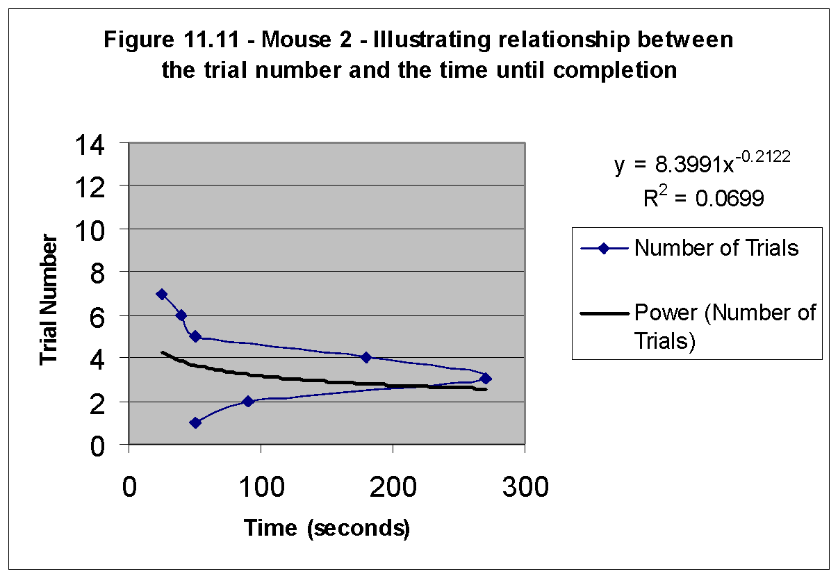

Comparative: U.S. experiment

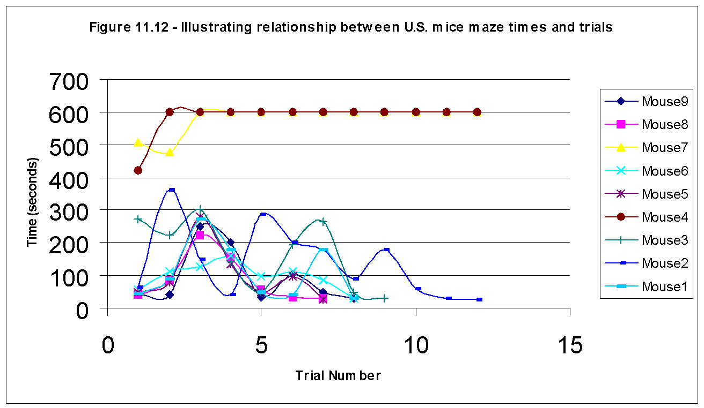Now the axes have been switched permanently, and one can trace that the general trend established is that the larger the mouse number in the key, the shorter its graph spreads out along the x- axes. This means that the more mice that committed this maze configuration to memory, the fewer trials it would take subsequent mice to do the same. The graph of mouse 2 (dark blue) stretches far and wide across the plane, until the twelfth trial with a noted gradual decrease in its y-value (seconds) as the trial number increases. This slope can be crudely thought of (from trials 3 to 12) as a rise of negative (360-30) seconds over a run of 12 trials = a slope of negative 27.5 but then when compared to the graph of mouse 8 (pink) which is very concise, with a relatively steeper slope (from trials 3 to 8) being a rise of (325-28) seconds over a run of 7 trials = 42.42857. Clearly the general trend is that the slope of seconds/trial number is decreasing for each subsequent test-subject –note we have switched the axes!!! Do not be confused, also: all the slopes are negative, and this was demonstrated here, because the y-axes has a rise of a negative number from it’s starting time /trials until it reached the 30second mark, after this point we will no longer include the negative in our calculations, merely consider the absolute values of the slope for comparison. From the calculations above, we conclude that there is an approximate ratio between (8-2) 6 test-subjects of 27.5 to 42.42857. Now let us calculate the approximate ratio between 2 test-subjects’ slope (mice 2 and 3 –U.S.):

slope2 : slope3

(150-25) seconds / 12 trials : (300-28) seconds / 9 trials

10.4166 : 30.2222

1 : 3 (approximately)

This is a single example, I am aware, but it approximates the ratio well enough to be compared with the slope ratios in S.A. –Caution: The purpose of these calculation is not to be numerically accurate, but to have the number represent the correct concept. It would be much more difficult to produce exact, numerically accurate results. That would involve working not with the simple linear equations I am doing in these calculations, but rather, the use of the complex logarithmic and exponential curves on the graphs above. I merely put those trend lines in so we could see visually what the gist of the relationship was, to simply grasp the concept. But for the purposes of my calculations, I will use simple linear equations. Now that we have switched the axes, the opposite of what we expected above should happen, subsequent mice should show an increase, not a decrease in the slope of the graph of their results. (Recall: in one of the calculations above, we inverted the ratio, this was to convert the ratio so it could be compared to the flipped axes of that graph, that inversion is not necessary here anymore, because we have flipped the axes on the graphs.)

Comparative: S.A. Experiment

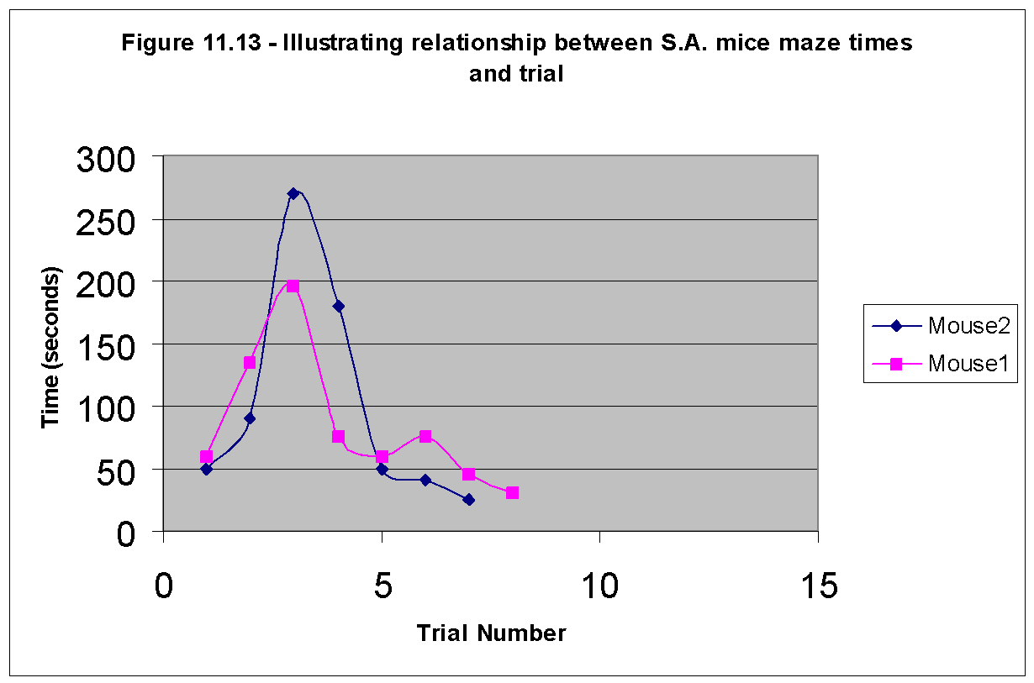

This trend continues here when mouse 1 took 8 trials to learn the maze and mouse 2 took 7 trials to learn the maze -a continuation of the trend line despite spatial differentiation.

slope1 : slope 2

(195-30) seconds / 8 trials : (270-25) seconds / 7 trials

20.625 : 30

2 : 3 (approximately)

Comparing the trend line of mice 1 through 9 reveals a flattening out of the line’s slope, indicating fewer “trials per memorization.” The continuation of this trend was observed in one of the mice (mouse 2) that were spatially separated, but the other test subject was not on either side of line, it was simply inconclusive. Mouse 1 was not a continuation of the trend, nor was a complete violation of the trend, opposing the theory of Morphic resonance, it provides some counter evidence, but it digresses by so little that it can be considered unsubstantial and therefore negligible.) It supported the theory but not to the expected degree –most probably because of experimental error as in the trend line of mouse 3 which also did not conclusively follow the trend.

However, there is some doubt when it comes to the apparent conclusion of my experiment. And due to the highly volatile nature of this experiment, lacking quantitatively, it would be very difficult to carry out an objective, numerical ANOVA or Chi-Square test of significance. Therefore, in lieu of such things I conducted a bit of research to put my results in perspective and allow some measure of confirmation or rejection of the hypothesis by testing the significance of the findings verbally, and against a very convincing counter argument. So here is my test of significance: Can my result truly be so conclusive with such a small sample size? Already to start with, in the U.S. a sample size of 9 mice was too little. But due to lack of better alternatives we made due. But then in South Africa due to a severe lack of experimental resources that number feel from nine to two. Possibly crippling the significance of my experimental conclusions. A counter example as to why, perhaps, by evidence is wrong is the following: Changes in human performance over time. Testing for Morphic resonance could come in the form of comparing quantitative data on human performance over the years. Not in skills or technology, but in basic ability. Not in developing fields like computer programming but in fixed controlled situations like the I.Q. test. I.Q. scores should by on the rise because of the increasing millions of people who have done them before and the ever-strengthening Morphic field for them. (Note: not because human’s are getting smarter.) In Japan, average I.Q. scores had been increasing, since the Second World War, by three percent per decade. A similar rate is true here in the U.S. No one had noticed this trend because testers routinely compared an individual’s scores with others of the same age, tested at the same time and because of this at any given time the average I.Q. score is arbitrarily set to 100. James Flynn first realized this when he found that army recruits who were average compared to their contemporaries are actually above average when compared to previous generations. No valid explanations has come forth for the “Flynn effect.” Neither practice nor educational improvements could be associated with this effect. It is proposed that Morphic resonance is responsible for this phenomenon. And if indeed the Flynn effect is explicable in terms of Morphic resonance, then such effects are relatively small. If millions of people taking I.Q. tests lead to increased scores of only a few percent, then the morphic resonance effects of eleven mice may be too small to detect against the random influences that could not be controlled. This means that my results may simply be due to wide variations in performance from subject to subject. This is certainly implied by this example. On the other hand, the results are somewhat conclusive and evaluating the chances of obtaining results of this certainty by chance would probably lead one to believe the opposite, that my results are two one-sided to merely be a result of chance. This was simple thought experiment I conducted which lent support of my results: I had eleven test-subjects, two of which shall not be considered, therefore: I had nine test-subjects, 6 of which followed a definitive trend of a decrease in number of trials required to reach the 30seconds memorization mark. This simply means that there was a six out of nine chance that my results were not chance. That is to say there is a 66.66% chance that my results are conclusive. This number is not scientifically adequate, nor is very convincing, but it does mean that the chances are greater that the hypothesis is correct, than the chances that it is incorrect. Nevertheless, because there lacks a series of quantitative numerical ratios between the average values of the trend lines (something another researcher might be willing to do in the future) I am unable to accurately give a definite value for the significance of this experiment. To do so would involve the use of greater resources than were at my disposal. It would involve, highly complex mathematical equations developed through the comparison of the different trend lines/curves that were formed in the U.S. and then comparing this to the same method of numerical evaluation for the S.A. trials and trend lines –by integrations of the functions displayed in the figures in section 10 over the desired interval, trials three through eight, which determines the average values of the complex equations for the curves and then by developing a trend for those cumulative trends one could possibly come up more definitive conclusion. . My comparison of the trend lines lacked any definitive conclusions, which could then be fed through the ANOVA test yielding much more conclusive and convincing data conclusions and a numerical value for the significance thereof. But, because I compared them without associating their elaborate equations to each other (a very difficult task), I simply conducted a visual observatory comparative study of their slopes and their change in slopes and used their relative comparisons to form conclusions my discussion will be lacking to that degree. It will have the same outcomes as the numerical analysis, however it will be more palliate with regard to the conclusions and less decisive in it’s findings.

More opposition came towards Shledrake’s theory of the non-local effects of Morphic resonance by Robert Todd Carol contributing to [www.SkepDic.com](http://www.skepdic.com), a scientific dictionary for skeptic beliefs in these kinds of matters. He says the following in an attempt to refute Shledrake’s claims, however I found it interesting to note that he however eloquent he may be, provided to counter evidence for a highly researched and evidenced field of study. And by simply blowing off hot steam in an attempt to ridicule Sheldrake, he attempts to refute his theories. At first reading this has a convincing affect on the reader, but further analysis of the substance of the views expressed yields a lack of respect for his arguments:

Morphic resonance is a term coined by [Rupert Sheldrake](http://www.sheldrake.org/intro/index3.html) for what he thinks is "the basis of memory in nature....the idea of mysterious telepathy-type interconnections between organisms and of collective memories within species."

Sheldrake has been trained in 20th century scientific models--he has a Ph.D. in biochemistry from Cambridge University (1967)--but he prefers [Goethe](http://german.about.com/homework/german/library/blgoethe.htm) and 19th century [vitalism](http://skepdic.com/vitalism.html). Sheldrake prefers teleological to mechanistic models of reality. Rather than spend his life, say, trying to develop a way to increase crop yields, he prefers to study and think in terms outside of the paradigms of science, i.e., inside the paradigms of the occult and the paranormal. One of his books is entitled *Dogs That Know When Their Owners Are Coming Home: And Other Unexplained Powers of Animals.* One of his studies is on whether people can tell when someone is staring at them. (He says they can; others have been unable to duplicate his results.[*](http://www.csicop.org/si/2000-09/staring.html)) He prefers a romantic vision of the past to the bleak picture of a world run by technocrats who want to control Nature and destroy much of the environment in the process. In short, he [prefers metaphysics](http://www.sheldrake.org/interviews/quest_interview.html) to science, though he seems to think he can do the former but call it the latter.

'Morphic resonance' (MR) is put forth as if it were an empirical term, but it is no more empirical than L. Ron Hubbard's '[engram](http://skepdic.com/dianetic.html)',  the alleged source of all mental and physical illness. The term is more on par with the Stoic's notion of the [Logos](http://www.utm.edu/research/iep/s/stoicism.htm) or Plato's notion of the [Eidos](http://www.philosophypages.com/dy/e.htm#eidos) than it is with any scientific notion of the laws of nature. What the rest of the scientific world terms *lawfulness*--the tendency of things to follow patterns we call laws of nature--Sheldrake calls morphic resonance. He describes it as a kind of memory in things determined not by their inherent natures, but by repetition. He also describes MR as something, which is transmitted via "morphogenic fields." This gives him a conceptual framework wherein information is transmitted mysteriously and miraculously through any amount of space and time without loss of energy, and presumably without loss or change of content through something like mutation in DNA replication. Thus, room is made for psychical as well as physical transmission of information. Thus,

it is not at all necessary for us to assume that the physical characteristics of organisms are contained inside the genes, which may in fact be analogous to transistors tuned in to the proper frequencies for translating invisible information into visible form. Thus, morphogenetic fields are located invisibly in and around organisms, and may account for such hitherto unexplainable phenomena as the regeneration of severed limbs by worms and salamanders, phantom limbs, the holographic properties of memory, telepathy, and the increasing ease with which new skills are learned as greater quantities of a population acquire them.

While this metaphysical proposition does seem to make room for telepathy, it does so at the expense of ignoring [Occam's](http://skepdic.com/occam.html) razor. [Telepathy](http://skepdic.master.com/texis/master/search/?q=telepathy&s=SS) and such things as [phantom limbs](http://skepdic.master.com/texis/master/search/?s=SS&q=phantom+limbs), for example, can be explained without adding the metaphysical baggage of morphic resonance. So can [memory](http://skepdic.com/memory.html), which does not require a holographic paradigm, by the way. The notion that new skills are learned with increasing ease as greater quantities of a population acquire them, known as the [hundredth monkey phenomenon](http://skepdic.com/monkey.html), is bogus.

In short, although Sheldrake commands some respect as a scientist because of his education and degree, he has clearly abandoned science in favor of theology and philosophy. This is his right, of course. However, his continued pose as a scientist is unwarranted. He is one of a growing horde of "alternative" scientists whose resentment at the aspiritual nature of modern scientific [paradigms](http://skepdic.com/paradigm.html), as well as the obviously harmful and seemingly indifferent applications of modern science, have led them to create their own paradigms. These paradigms are not new, though the terminology is. These alternative paradigms allow for angels, telepathy, psychic dogs, and hope for a future world where we all live in harmony and love, surrounded by blissful neighbors who never heard of biological warfare, nuclear bombs, or genetically engineered corn on the cob.

I realized the inconclusiveness of the above essay, when I attempted to summarize it for representation here, and was unable to do so because there are no concrete solid facts raised within it. It is merely the ramblings of an opinionated skeptic. He seems to have no problem with criticizing Sheldrake for his lack of scientific evidence in his theories (which by the way are being tested by hundreds of scientists around the world today) but he is able to refute and condemn these theories in this essay without a shred of evidence. However, after some research I was able to find some research papers countering many of the claims of Morphic resonance. The links are below:

* [The Psychic Staring Effect An Artifact of Pseudo Randomization](http://www.csicop.org/si/2000-09/staring.html) by David F. Marks and John Colwell
* [Rupert Sheldrake: The delightful crackpot](http://www.salon.com/people/feature/1999/11/23/sheldrake/print.html) by David Bowman
* [The amazing ideas of Rupert Sheldrake](http://www.ntskeptics.org/1998/1998january/january1998.htm#sheldrake) by John Blanton
* [Two Shaky Experiments](http://www.skeptics.com.au/journal/jrw-shaky.htm) by Sir Jim R Wallaby