Materials:

Part 1 –in the U.S.

1. Washable Crayola markers, at least 9 different colors.
2. Cheese (natural cheddar) and knife
3. Wristwatch or other timing device.
4. Large, clear cup and sheet of paper
5. 9 white, female, pet mice
6. 4x 2ft^3 mouse cages
7. Large supply of wood chips
8. Large supply Shredded paper
9. 4x Water bottle and holster
10. 4x Small dish
11. 3-weeks worth of mouse food
12. Small hand saw
13. 1 role Duck Tape
14. Regular hand Scissors
15. 4 foot by 2 foot perforated wooden wallboard –1/8 inch thick and perforations 3/16 inches in diameter.
16. Two 6 inch, by 2 foot, by ¼ inch planks of wood
17. Two 6 inch, by 4 foot, by ¼ inch planks of wood
18. 1 pack of 11/16 inch yellow, zinc plated, linoleum nails
19. Wooden handled, steel Hammer
20. 4 foot by 3 foot plastic sheet –1/8 inches thick
21. 3 thin wooden rods, 3/16 inches in diameter and 48 inches long.
22. Many card board boxes
23. Hand held retractable razor blade
24. Digital Camera, Sony Digital Mavica Still and motion picture camera
25. 10 Verbatim, 2HD stiffy disks
26. Work Bench

All of the above can be bought from your standard local hardware stores and pet stores.

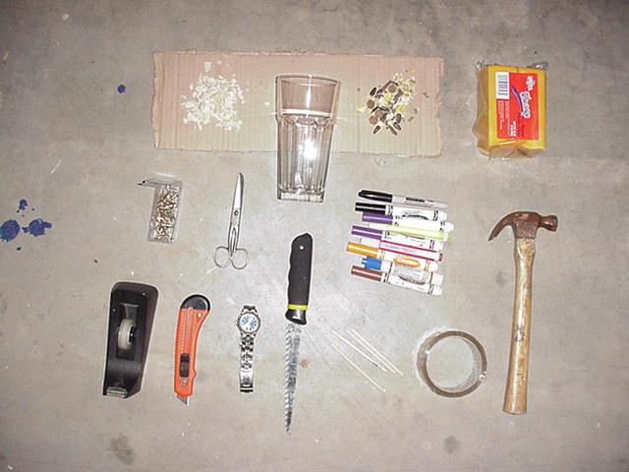

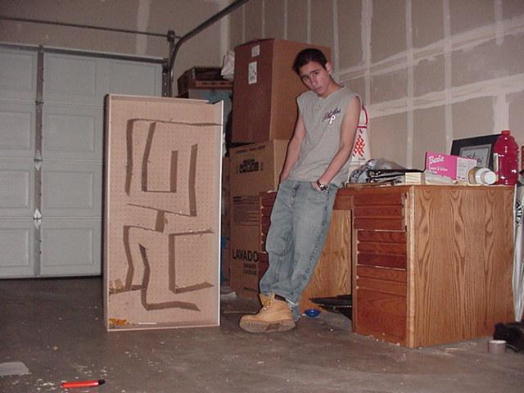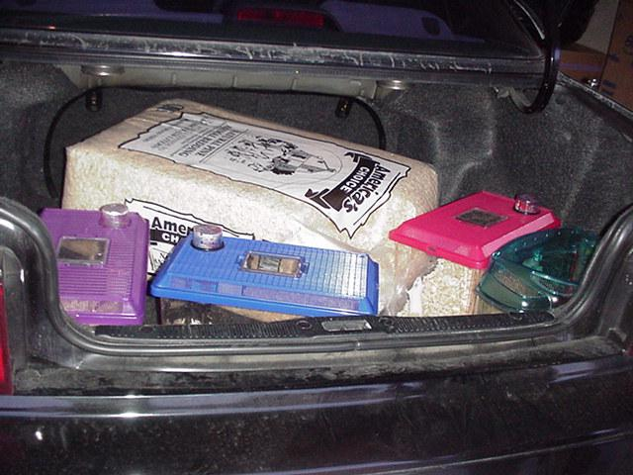

Part 2 –South Africa

1. Return plane ticket to South Africa
2. 10 Verbatim, 2HD stiffy disks
3. Digital Camera, Sony Digital Mavica Still and motion picture camera
4. Thin plank of perforated wood. 1cm thick, 120cm long and 8cm wide.
5. Thick planks of wood. 2cm thick, 120cm long and 10cm wide. 2x
6. Thick planks of wood. 2cm thick, 80cm long and 10cm wide. 2x
7. Role of duck tape.
8. Pack of Nails, 500g, 100mm long (these nail must fir through the perforations of the perforated plank.)
9. Female, Red eyed, pet mice. 2x
10. Washable Crayola markers, at least 2 different colors
11. Hand saw/knife
12. Mouse cage.
13. Sawdust. (enough for 1 cage)
14. Mouse food. (enough for 1 week)
15. Small dish. (for food)
16. Water bottle and holster.
17. Card board box

All of the above can be purchased from any South African Hardware and Pet Store.



