Procedure: Preliminary: Part 1 –in California, U.S.

1. To build the maze:
   * 1. Nail the two 6 inches, by 2 foot, by ¼ inch planks perpendicular, to the two 6 inch, by 4 foot, by ¼ inch planks.
     2. Nail the 4-foot by 2 foot perforated wooden wallboard to it, as it’s base.
     3. Mark the 3 thin wooden rods at 4 inch intervals
     4. Using the hand saw, cut the rods at these locations (creating 36, 4 inch rods)
     5. Place these smaller rods in the perforations at desired locations
     6. Using the blade cut strips out of the hard cardboard and place them between the rods, forming the pattern of the desired maze configuration.
     7. Finally, place the plastic sheet over the apparatus
2. Label the corridors of the maze, A through N and decide upon the orientation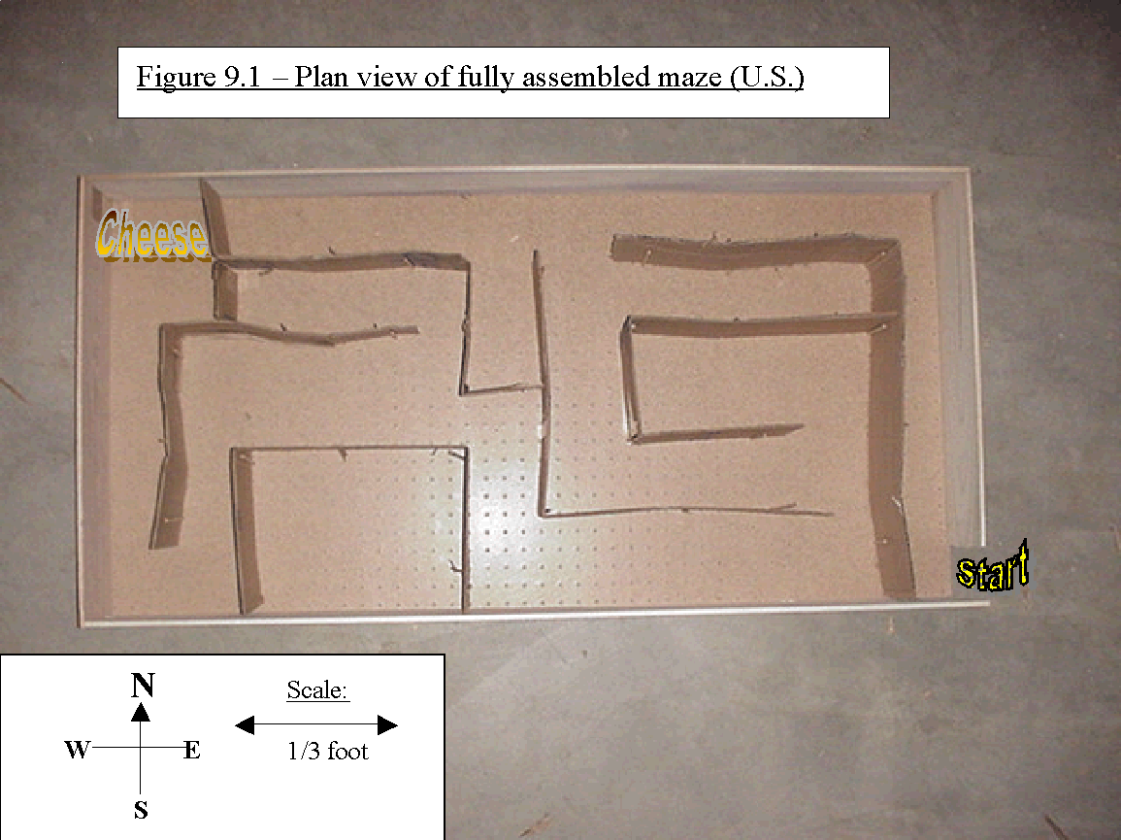
3. To prepare mouse residences:
   * 1. Fill the bottom 2-3 inches of each cage with the wood chips/sawdust.
     2. Place a small crumpled sheet of paper in the cage (for the mice to chew up and make bedding with)
     3. Place the water bottle in its holster and connect it to the cage.
     4. Fill the small dishes with a hand full of food and place it in the cage.
     5. Open the appropriate holes in the cage lid and fit the water bottle through it as you clasp it around the edges of the cage. Secure it and check for loose sections.
     6. It is necessary to have so many cages, and accessories, in order to ensure the health of the mice. Avoiding overcrowding will increase the individual’s chances of optimum health which would be an essential component of ensuring accurate data and results.
4. Maintenance of mice throughout experiment:
   * 1. Feed the mice once a day by putting one hand full of food in the dish.
     2. Do not worry about overfeeding them –it is not possible, they will eat until they are satisfied and then stop.
     3. After filling their water bottle the first time, you will only have to fill it again about once every 1-2 weeks.
     4. Clean their cage out once every 2 weeks.



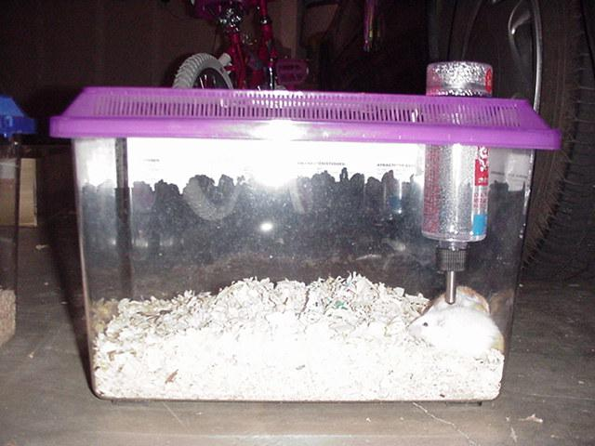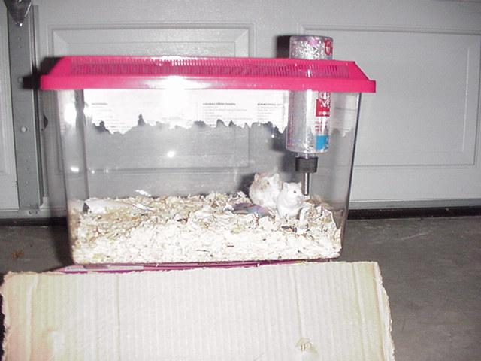

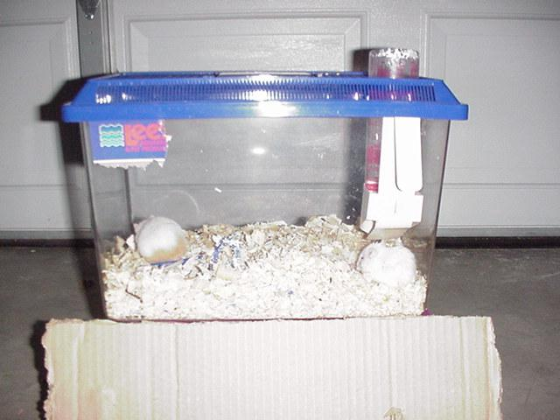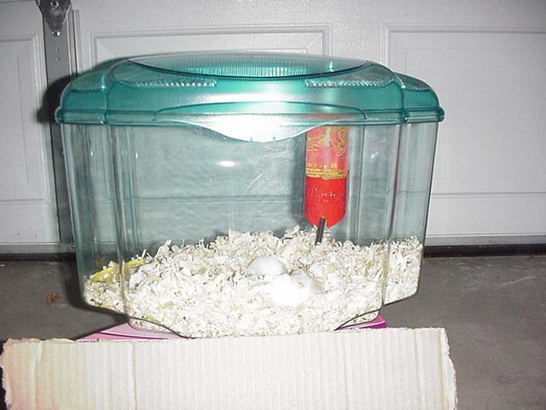

Procedure: Experimental: Part 1 –in California, U.S.

1. Label the mice 1 through 9:
   * 1. Grab mouse from front
     2. Make sure his inner side is not exposed and secure his legs remote from the marking zone
     3. Make sure the area being tagged has a high fur content
     4. Be sure the mark is not made too deep and against the mouse’s skin –this could be detrimental towards his health and hence his performance and your results.
     5. The mouse may attempt to wipe the mark off his back by licking and rubbing it so be mindful of this and if needs be, re-apply the colors.
2. Baiting: -providing the mouse with some incentive to run the maze:
   * 1. Place a small chunk of cheese at the end of the maze.
     2. Approximately 20g
     3. Be sure not to completely satisfy the mouse’s hunger. Because you will depend upon this hunger for further experimentation.
3. Take mouse 1 from his cage and hold him at the start of the maze.
   * 1. Remove the mouse from his cage and place him in a large, clear, cup.
     2. To ensure the mouse’s continued presence in the cup, cover it with a sheet of paper and hold firmly.
     3. Put the cup against the door of the maze.
     4. Ensure that there is not enough room for the mouse to escape between the cup and doorway.
4. Release and timing:

i. As you pull the paper out from between the mouse and the maze, also begin timing.

ii. You may see that some mice will not run. This may be due to a variety of reasons. (E.g.: lack of incentive, pregnancy, illness, etc.) Sometimes it is necessary to make the mice go without food for a day or two before actually conducting the experiment in order to ensure their hunger for the food at the end of the maze and thereby create some incentive for them to run it.

1. Observations:
   * 1. Observe it’s behavior, (e.g.: motivation, confidence, or whether it hesitates, etc.)
     2. Observe it’s habits and mannerisms, (e.g.: method of search, or whether it gets lost, etc.)
     3. Observe its speed and agility (e.g.: timing)
     4. Observe the course chosen as it runs the maze.

6. Repeat steps 2 through 5 for the same mouse until he has committed the maze to memory.

i. We have arbitrarily set the point at which the mouse has officially memorized the maze, to be when the mouse completes the maze in less than 30 seconds.

1. After the mouse completes the maze, which is the point at which he enters the chamber of the maze containing the cheese, remove him fairly quickly so as not to allow him to satisfy his hunger.
2. Scoop him out of the maze using the clear cup and be sure to close the top as soon as you do so. (Caution: take care not to allow the mouse to escape at any point in conducting the experiment because it is almost guaranteed that you will not be able to retrieve it.)
3. 12 trials is a copious number, however, the mouse may not have committed the maze to memory by this time and this should be recorded.
4. Repeat steps 2 through 6 for the rest of the 9 mice. Using the same maze configuration. Conduct this testing procedure over a period of 4 weeks, equally dividing the testing that should be done each day.
5. After you have recorded all you data, use the plane ticket and go to a location very distant from the location you are at now and from the test subjects. The location I have chosen is as far away from the original location as is experimentally possible –South Africa. (A distance of approximately 11 x 10^6 meters. If morphic fields do in fact fall off with distances greater than this, then the effects of spatial decay on morphic fields is so small it can be considered negligible.)

Procedure: Preliminary: Part 2 –South Africa

Note: there are several differences between the maze built in the U.S. and the maze built here. However I managed to maintain the integrity of the maze configuration, the only differences arose with regard to the materials and the method of construction. A setback was encountered when attempting to acquire the correct dimensions of the materials. South Africa has adopted the SI unit system and this therefore posed a challenge with regard to maintaining the correct dimensions of the maze. A useful conversion factor was used to compensate for this inconvenience: 2.5cm=1inch. It became necessary to purchase materials with larger dimensions then desired and then cut it down yourself.

1. To Build Maze:
   * 1. Calculate the ratio of the 80cm side of the perforated plank to 2 feet and mark off the desired location. This will ensure that the maze has the same width as it did in the U.S.
     2. Place the 80cm planks in parallel along the corresponding edges of the perforated plank.
     3. Perpendicular to these planks, place the 120cm planks at the locations marked in step (i).
     4. Using the Duck tape, secure these two sets of parallel planks perpendicular to each other.
     5. Flip the entire apparatus over, 180degrees.
     6. Secure the newly constructed “I” shaped plank assemblage to the perforated wallboard with strips of duck tape at several locations.
     7. Stand the maze upright, lengthwise, by lifting it 90 degrees
     8. Insert several nails through the back of the maze, and through the perforations, forming the same maze configuration as in the U.S. maze
     9. Lay the maze back down (be sure no nails fall out as you do this.)
     10. Using the knife/hand saw, and cut the cardboard box into strips that are equal in width to the planks forming the boundaries of the maze.
     11. Place these strips of cardboard onto/in-between the nails forming the desired maze configuration.

Tape any nails that may be protruding into the maze, back against the cardboard. Tape the cardboard down against the perforated wallboard in locations where the mouse may be able to squeeze under.

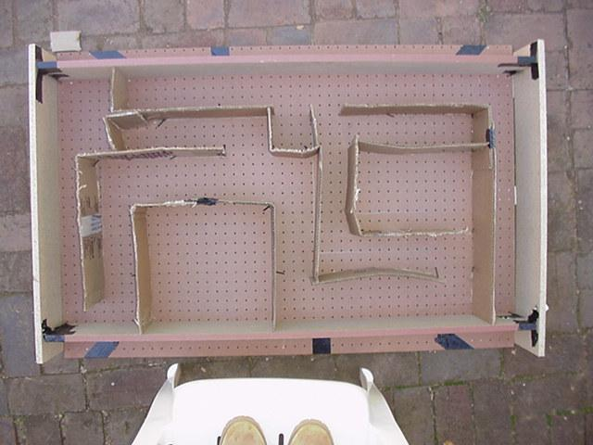

1. Label the corridors of the maze, A through N exactly as it was in the U.S. maze, and ensure that the orientation is also the same.

3. To prepare mouse residences:

i. Fill the bottom 2-3 inches of the cage with the wood chips/sawdust.

1. Place a small crumpled sheet of paper in the cage (for the mice to chew up and make bedding with)
2. Place the water bottle in its holster and connect it to the cage.
3. Fill the small dish with a hand full of food and place it in the cage.
4. Open the appropriate holes in the cage lid and fit the water bottle through it as you clasp it around the edges of the cage. Secure it and check for loose sections.

It is not necessary to have as many cages as we did in the U.S. experiment because we only have 2 mice in this case.

4. Maintenance of mice throughout experiment:

1. Feed the mice once a day by putting one hand full of food in the dish.
2. Do not worry about overfeeding them –it is not possible, they will eat until they are satisfied and then stop.
3. After filling their water bottle the first time, you will not have to fill it again.
4. You do not have to worry about cleaning their cage out because the experiment duration is only one week.

Procedure: Experimental: Part 2 –South Africa (in both parts of this experiment, wait at

least 3 days after purchasing the mice, before handling them.)

1. Label the mice 1 and 2:

* + 1. Grab mouse from front
    2. Make sure his inner side is not exposed and secure

his legs remote from the marking zone

* + 1. Make sure the area being tagged has a high fur

content

* + 1. Be sure the mark is not made too deep and against

the mouse’s skin –this could be detrimental towards

his health and hence his performance and your results.

* + 1. The mouse may attempt to wipe the mark off his

back by licking and rubbing it so be mindful of this and if needs be, re-apply the colors.

vi. It may be easier to distinguish between these two mice by simply recording a certain outstanding characteristic. But if this is not possible the above procedure is an alternative option. In the case of these two mice I was able to find two characteristics that distinguished them.

2. Baiting: -providing the mouse with some incentive to run the maze:

* + 1. Place a small chunk of cheese at the end of the

Maze along with some regular mouse food.

* + 1. Approximately 20g of food is sufficient
    2. Be sure not to completely satisfy the mouse’s

hunger, because you will depend upon this hunger for further experimentation.

3. Take mouse 1 from his cage and hold him at the start of the maze.

* + 1. Remove the mouse from his cage and place him in a

large, clear, cup.

* + 1. To ensure the mouse’s continued presence in the

cup, cover it with a sheet of paper and hold firmly.

* + 1. Hold the cup over the start of the maze. (This is

done because this maze lacks a door.)

* + 1. Ensure that there is not enough room for the mouse

to escape between the cup and the top of the walls of the maze.

4. Release and timing:

i. As you pull the paper out from between the mouse and the maze, also begin timing.

1. You may see that some mice will not run. This may be due to a variety of reasons. (E.g.: lack of incentive, pregnancy, illness, etc.) Sometimes it is necessary to make the mice go without food for a day or two before actually conducting the experiment in order to ensure their hunger for the food at the end of the maze and thereby create some incentive for them to run it.

5. Observations:

* + 1. Observe his behavior, (e.g.: motivation, confidence,

or whether it hesitates, etc.)

* + 1. Observe his habits and mannerisms, (e.g.: method

of search, or whether it gets lost, etc.)

* + 1. Observe its speed and agility (e.g.: timing)
    2. Observe the course chosen as he runs the maze.

(Using corridor identifications)

6. Repeat steps 2 through 5 for the same mouse until he has committed the maze to memory.

i. We have arbitrarily set the point at which the mouse has officially memorized the maze, to be when the mouse completes the maze in less than 30 seconds.

1. After the mouse complete the maze, which is the point at which he enters the chamber of the maze containing the cheese, remove him fairly quickly so as not to allow him to satisfy his hunger.
2. Scoop him out of the maze using the clear cup and be sure to close the top as soon as you do so. (Caution: take care not to allow the mouse to escape at any point in conducting the experiment because it is almost guaranteed that you will not be able to retrieve it.)

7. Repeat steps 2 through 6 for the other mouse. Using the same maze configuration. Conduct this testing procedure over a period of 1 week; equally dividing the testing that should be done each day.