Recommendations:

1. Clearly, the only flaw (and a rather consequential flaw as it turned out) was the restrictions posed by limited resources on sample size. My recommendation would be to repeat this experiment exactly as it is, just modifying the sample sizes in the U.S. and South Africa to over 50 test subjects.
2. Make every effort not to end up with pregnant mice:

Already my sample size was lacking due to limited resources and the pregnancy of one of the mice further contributed to the problem. The pregnant mouse had to be excluded from the data and the experiment was made slightly less conclusive because of this. The pet store owners may make a mistake and sell and you pregnant mice, but be sure to specify, anyway, that you are looking for mice that are not pregnant. (It is often difficult to differentiate between a mouse that is pregnant and one that is not, until the later stages of its pregnancy.)

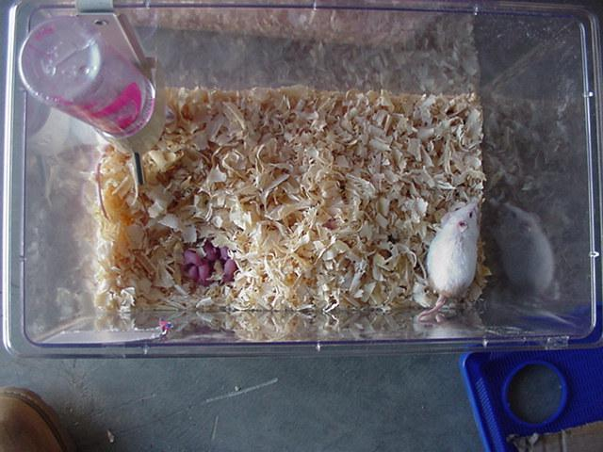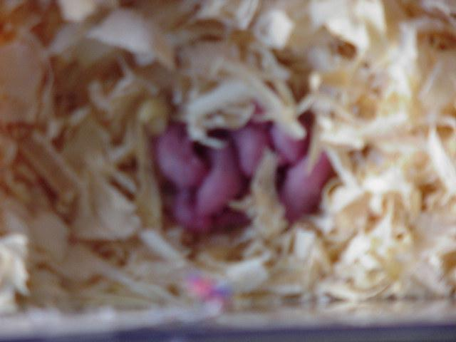



1. Sort out those mice that run, from those that do not. If possible, do some preliminary runs with each mouse and test whether it is a ‘runner’ or not, be sure not to use your experiment maze configuration or this will make your results inconclusive because of the possibility that morphic fields were set up as a result of this.
2. Make sure that the mouse cannot slip under any parts of the maze, because this may have detrimental effects in testing Morphic resonance: Such a mistake could be very counterproductive because it would establish Morphic fields working oppositely to the one you are trying to establish. It will confuse the mice that are affected by drawing on the collective memory and they will continue to use the same method of running the maze, once you change that, the Morphic field for the maze is changed and it will be confusing for the mice that are influenced by that Morphic field, this will disturb the accuracy of your data.
3. Make sure the mouse is hungry to provide incentive. Some mice may not run because they are not hungry, they may scurry around aimlessly through the maze, only entering corridor N by chance. And if this is the case, you results will be random scurrying of mice and not a test of morphic resonance.
4. It may be helpful to use partners in this experiment, this will undoubtedly improve the accuracy of the results, because when taking time readings the increased man power will allow you to eliminate the 5sec inaccuracy that arose in my experiment because I could not control the mouse and take readings at the same time whilst holding the digital camera.
5. Have either only adult, or only adolescent mice, do not mix. Due to lack of resources in South Africa, the mice I bought there had not reached the same level of maturity as the ones in the U.S. this was a cause for their relatively higher level of activity. This dissimilarity between the U.S. mice and the S.A. mice causes greater inconclusiveness of data because of the implications of the requirement of morphic resonance to act from like upon like. The greater the dissimilarities between the test-subjects, the greater the inconclusiveness of the results.
6. This is also why I recommend using young adults for the whole experiment; it will make the experimental part of this project more efficient because of a higher level of activity in the young adults when compared to the full adults means quicker and easier data collection