Procedure: Preliminary:

1. To build the maze:
   * 1. Nail the two 6 inches, by 2 foot, by ¼ inch planks perpendicular, to the two 6 inch, by 4 foot, by ¼ inch planks of wood.
     2. Nail the 4-foot by 2 foot perforated wooden wallboard –1/8 inch thick to it, as it’s base.
     3. Mark the 3 thin wooden rods at 4 inch intervals
     4. Using the hand saw, cut the rod at these locations (creating 3x12, 4 inch rods)
     5. Place these smaller rods in the proliferations at desired locations
     6. Using the blade cut strips out of the hard cardboard and place them between the rods, forming the pattern of the desired maze configuration.
     7. Finally, place the plastic sheet over the apparatus
2. Label the corridors of the maze, A through N and decide upon the orientation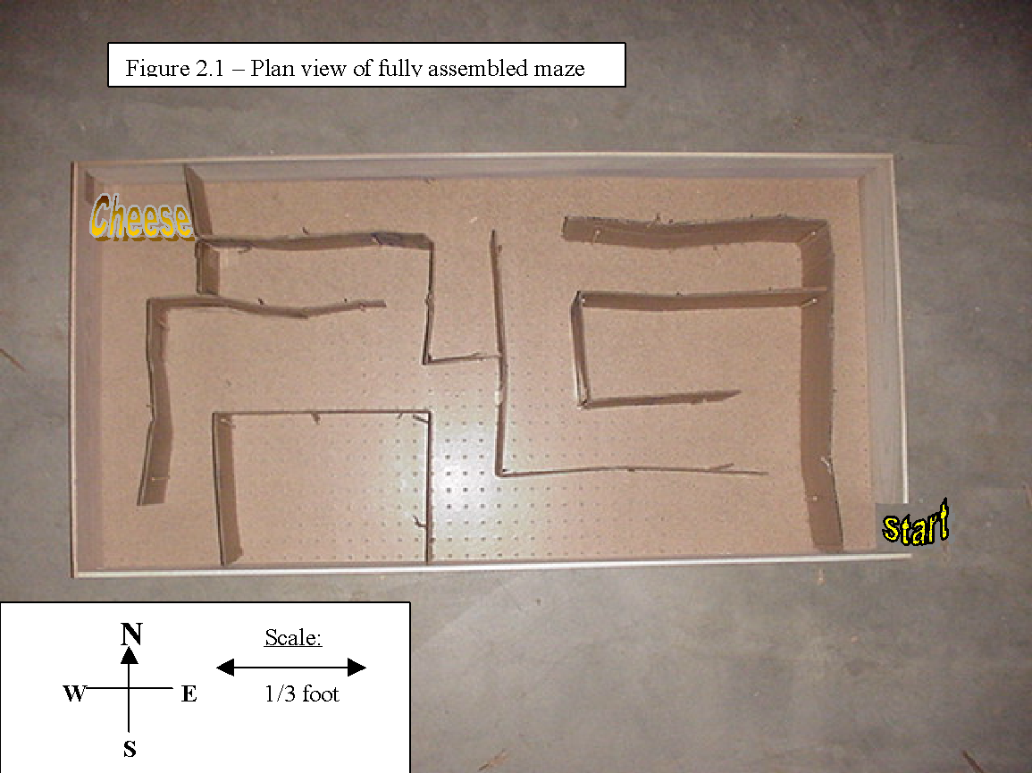
3. To prepare mouse residences:
   * 1. Fill the bottom 2-3 inches of each cage with the wood chips.
     2. Place a small crumpled sheet of paper in the cage (for the mice to chew up and make bedding with)
     3. Place the water bottle in it’s holster and connect it to the cage.
     4. Fill the small dishes with a hand full of food and place it in the cage.
     5. Open the appropriate holes in the cage lid and fit the water bottle through it as you clasp it around the edges of the cage. Secure it and check for loose sections.
     6. It is necessary to have so many cages, and accessories, in order to ensure the health of the mice. Avoiding overcrowding will increase the individuals chances of survival which would be an essential component of ensuring accurate data and results.
4. Maintenance of mice throughout experiment:
   * 1. Feed the mice once a day by putting one hand full of food in the dish.
     2. Do not worry about overfeeding them –it is not possible, they will eat until they are satisfied and then stop.
     3. After filling their water bottle the first time, you will only have to fill it again about once every 1-2 weeks.
     4. Clean their cage out once every 2 weeks.

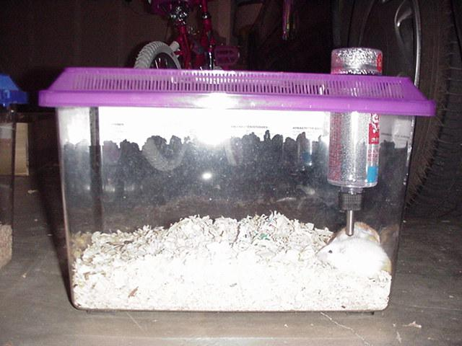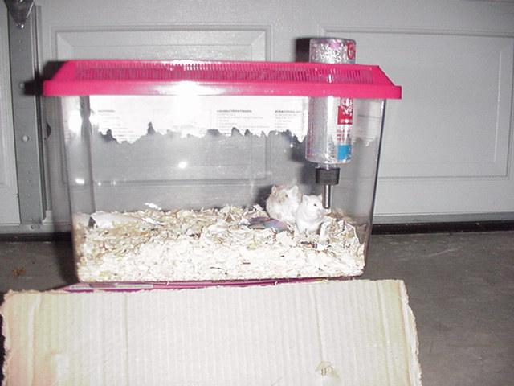

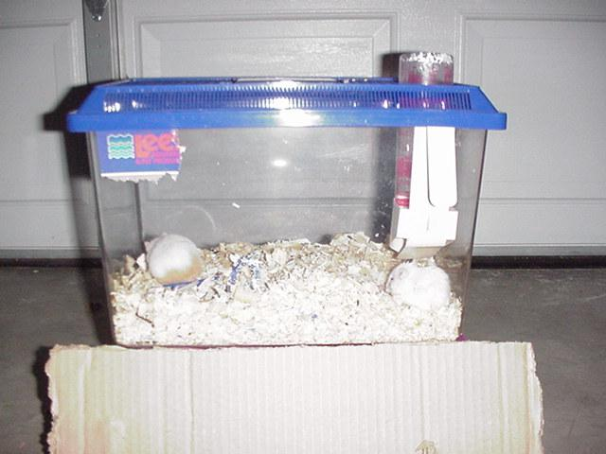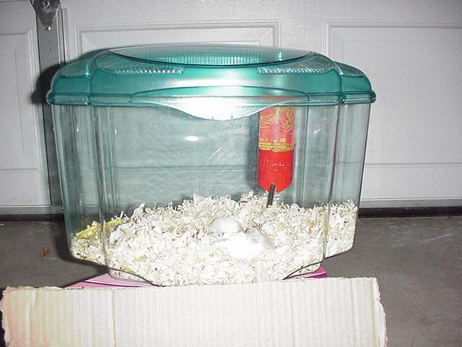

Procedure: Experimental

1. Label the mice 1 through 9:
   * 1. Grab mouse from front
     2. Make sure his inner side is not exposed and secure his legs remote from the marking zone
     3. Make sure the area being tagged has a high fur content
     4. Be sure the mark is not made too deep and against the mouse’s skin –this could be detrimental towards his health and hence his performance and your results.
     5. The mouse m ay attempt to wipe the mark off his back by licking and rubbing it so be mindful of this and if needs be, re-apply the colors.
2. Baiting: -providing the mouse with some incentive to run the maze:
   * 1. Place a small chunk of cheese at the end of the maze.
     2. Approximately 20g
     3. Be sure not to completely satisfy the mouse’s hunger. Because u will depend upon this hunger later.
3. Take mouse 1 from his cage and hold him at the start of the maze.
   * 1. Remove the mouse from his cage and place him in a large, clear, cup.
     2. To ensure the mouse’s continued presence in the cup, cover it with a sheet of paper and hold firmly.
     3. Put the cup against the door of the maze.
     4. Ensure that there is not enough room for the mouse to escape between the cup and doorway.
4. Release and timing: As you pull the paper out from between the mouse and the maze, also begin timing.
5. Observations:
   * 1. Observe his behavior, (e.g.: motivation, confidence, or whether it hesitates, etc.)
     2. Observe his habits and mannerisms, (e.g.: method of search, or whether it gets lost, etc.)
     3. Observe its speed and agility (e.g.: timing)
     4. Observe the course chosen as he runs the maze.
6. Repeat steps 2 through 5 for the same mouse until he has committed the maze to memory. We have arbitrarily set the point at which the mouse has officially memorized the maze, to be when the mouse completes the maze in less than X seconds.
7. Repeat steps 2 through 6 for the rest of the 9 mice. Using the same maze configuration.
8. Change the maze configuration 3 times so that it has no semblance of the previous configuration. After doing this, repeat steps 1 through 7 for each new configuration.