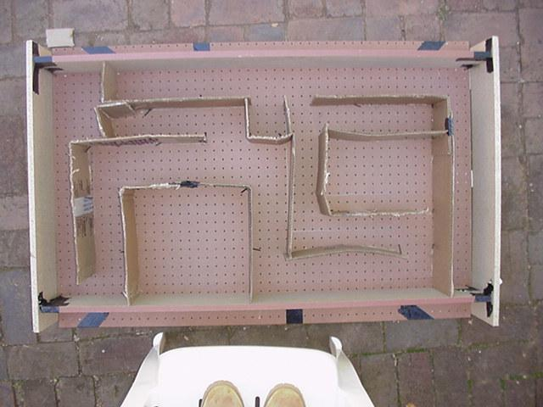

1. Label the corridors of the maze, A through N exactly as it was in the U.S. maze, and ensure that the orientation is also the same.  
   3. To prepare mouse residences:   
   i. Fill the bottom 2-3 inches of the cage with the wood chips/sawdust.   
   Place a small crumpled sheet of paper in the cage (for the mice to chew up and make bedding with)  
   Place the water bottle in its holster and connect it to the cage.  
   Fill the small dish with a hand full of food and place it in the cage.  
   Open the appropriate holes in the cage lid and fit the water bottle through it as you clasp it around the edges of the cage. Secure it and check for loose sections.  
   It is not necessary to have as many cages as we did in the U.S. experiment because we only have 2 mice in this case.   
   4. Maintenance of mice throughout experiment:  
   Feed the mice once a day by putting one hand full of food in the dish.   
   Do not worry about overfeeding them –it is not possible, they will eat until they are satisfied and then stop.  
   After filling their water bottle the first time, you will not have to fill it again.  
   You do not have to worry about cleaning their cage out because the experiment duration is only one week.  
     
   Procedure: Experimental: Part 2 –South Africa  
   1. Label the mice 1 and 2:   
   Grab mouse from front  
   Make sure his inner side is not exposed and secure   
   his legs remote from the marking zone  
   Make sure the area being tagged has a high fur   
   content  
   Be sure the mark is not made too deep and against   
   the mouse’s skin –this could be detrimental towards   
   his health and hence his performance and your results.  
   The mouse may attempt to wipe the mark off his   
   back by licking and rubbing it so be mindful of this and if needs be, re-apply the colors.  
   vi. It may be easier to distinguish between these two mice by simply recording a certain outstanding characteristic. But if this is not possible the above procedure is an alternative option. In the case of these two mice I was able to find two characteristics that distinguished them.   
   2. Baiting: -providing the mouse with some incentive to run the maze:  
   Place a small chunk of cheese at the end of the   
   Maze along with some regular mouse food.   
   Approximately 20g of food is sufficient  
   Be sure not to completely satisfy the mouse’s   
   hunger, because you will depend upon this hunger for further experimentation.   
   3. Take mouse 1 from his cage and hold him at the start of the maze.  
   Remove the mouse from his cage and place him in a   
   large, clear, cup.  
   To ensure the mouse’s continued presence in the   
   cup, cover it with a sheet of paper and hold firmly.   
   Hold the cup over the start of the maze. (This is   
   done because this maze lacks a door.)   
   Ensure that there is not enough room for the mouse   
   to escape between the cup and the top of the walls of the maze.   
   4. Release and timing:   
   i. As you pull the paper out from between the mouse and the maze, also begin timing.   
   You may see that some mice will not run. This may be due to a variety of reasons. (E.g.: lack of incentive, pregnancy, illness, etc.) Sometimes it is necessary to make the mice go without food for a day or two before actually conducting the experiment in order to ensure their hunger for the food at the end of the maze and thereby create some incentive for them to run it.   
   5. Observations:  
   Observe his behavior, (e.g.: motivation, confidence,   
   or whether it hesitates, etc.)  
   Observe his habits and mannerisms, (e.g.: method   
   of search, or whether it gets lost, etc.)  
   Observe its speed and agility (e.g.: timing)  
   Observe the course chosen as he runs the maze.   
   (Using corridor identifications)  
   6. Repeat steps 2 through 5 for the same mouse until he has committed the maze to memory.   
   i. We have arbitrarily set the point at which the mouse has officially memorized the maze, to be when the mouse completes the maze in less than 30 seconds.  
   After the mouse complete the maze, which is the point at which he enters the chamber of the maze containing the cheese, remove him fairly quickly so as not to allow him to satisfy his hunger.  
   Scoop him out of the maze using the clear cup and be sure to close the top as soon as you do so. (Caution: take care not to allow the mouse to escape at any point in conducting the experiment because it is almost guaranteed that you will not be able to retrieve it.)  
   7. Repeat steps 2 through 6 for the other mouse. Using the same maze configuration.