Question:

What gives rise to the complex biological organisms and ecosystems we see around us today? Surely it is something more than four letters built into a code for protein synthesis –and only the primary structure of these proteins mind you. What is there, besides the DNA that is responsible for the differentiation of organisms in a colony functioning as a single super organism? What is the formative force that makes a duck look like a duck time and time again? You can’t tell me that four letters coding for primary protein structure alone, has the formative, purposive, predetermined principals and forces required for the standardized regeneration of starfish limbs. What else is there?

[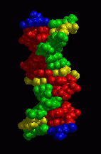](http://fusionanomaly.net/doublehelix.html) 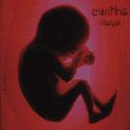

Hypothesis:

Prediction: