# **Introduction**

*The term allelopathy is stated as “a function of plant-produced chemicals to inhibit or promote growth and activity of other life... ①"*

If you don't like your neighbors you always have the option of moving. But what about trees? If they don't like that plants growing next to their trunk, knowing if it strives in their environment it could one day starve them of sunlight, what can they do?

Many plants have found different ways to compete against other plants in their surrounding environment. One characteristic that has become a successful way of competition, is allelopathy.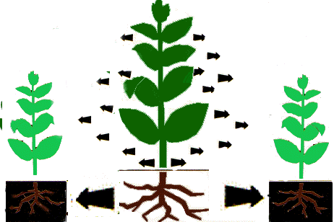

Figure 1.1②

Allelopathy is known in the scientific world as the chemicals produced by plants to keep other plants in their vicinity from taking over. Today allelopathy can be seen as a competitive characteristic for plants to maintain the maximum benefits from their environment. If a plant contains allelopathic characteristics it is a crucial benefit for the plant to keep other producers from taking their current food and water source. Allelopathic characteristics can be found in all types of plants, including “angiosperms, gymnosperms, and lower plants like ferns and micro-organisms. ③”

_________________________

① Academic Press Dictionary of Science and Technology © All rights reserved.

② Courtesy of Jeff G. Nelson, <http://miavx1.muohio.edu>

③Aliotta, Giovanni, "Allelopathy," University of Naples, June 30th 2000

Allelopathy has sparked the interest of many scientists in the field of agriculture today because of the unique benefits allelopathy may have to the interactions of plant-plant, plant-insect, and plant-microorganism. Scientists at the University of Vigo, in Europe, have been studying the agriculture aspects of allelopathy and believe that allelopathy may play a role as a “chemical-free weed and insect preventant to promote more beneficial

crops.④”

A main department in the United States government has also been studying the effects of allelopthic chemicals, the United States Department of Agriculture (USDA). Dr. Henry Gilbert, of the USDA members, has found that allelopathic chemicals are prevalent in many trees found through out the United States. Recently Dr. Henry Gilbert has found that the plant, Baccharis Coridifolia (a plant found at the border of America and Mexico), kills other competing producers through the production of the phytotoxins in its leaves. Dr. Gilbert believes that if further research continues in this field of study, it maybe used to help kill competitors in the farming fields found all over the United States.

Dr. Gilbert’s research has given way to over one hundred experiments pertaining to allelopathy in the USDA. Jane Gates, another scientist at the USDA, is using her knowledge of allelopathy to "play a crucial role in the production of man-made forests. ⑤" Gates believes that if certain trees are placed together, do to the fact that they can with stand the allelopathic chemicals of the area around them, it would enable the United States to plant more trees that will have a higher percentage of living. This would benefit many Americans, through the production of wood (making it cheaper) and also preserving and rebuilding our national forests.

________________

④ Yoshiharu FUJII-Chairman of the Organizing Committee, “Allelopathy” Japan

⑤ Gates, Jane “ Allelopathy: The Effects of Chemicals Produced by Plants” USDA September 1994

Not only is the United States researching allelopathy, but research is also taking place through out the world. People want to explore the unique benefits to allelopathic characteristics. Some scientists, like Dr. Gilbert, believe the more we study allelopathy, the more benefits it may have to the human race, such as helping to improve gardens and agriculture.

Although the study of allelopathy has become more common just recently, the idea has been around for quite some time. The effects of allelopathy was first studies and discovered by a Japanese philosopher of Confucianism Kumazawa Banzan. “He described in his book ‘Dewdrops from red pine are harmful against crop and weed under the tree’ about 300-years ago.”The Japanese philosopher proved to the government that if they planted red pines as a wood source through out the land, they would be killing the native plants and scrubs around them. He also proved that if they were to plant the red pines it would decreasing the water supply in the soil, because of the trees major desire for water. After the government experimented with the idea they found the philosopher to be correct. The pines killed all seedlings and living plants around it.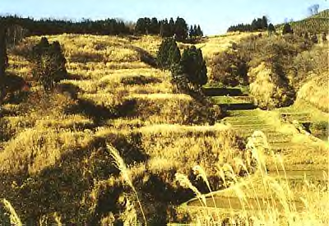

_______________________

⑥ Yoshiharu FUJII-Chairman of the Organizing Committee, “Allelopathy” Japan

⑦ “Japan Terrestrial” Courtesy of Division of Vegetation Science, http://www.niaes.affrc.go.html

Many other governments began to wonder if they could be planting “killers.” So many officials from countries all over the world called on their scientists to find other plants that might contribute to killing of other plants.

After several centuries the idea of allelopathy faded, but never forgotten. The idea was said to be resparked, in the United States

, during the dust bowl in the 1920’s. Scientists started studying areas that dealt with agriculture and came across allelopathy.

For my research project I will use the research of many scientists and test the effects of allelopathy, by placing Eucalyptus leaves in the water supply of rye grass. If there is allelopathic properties in Eucalyptus leaves I may see results in the growth of rye grass seedslings   
Figure 1.3(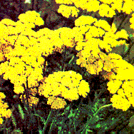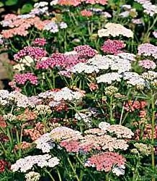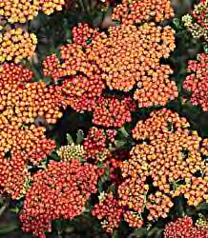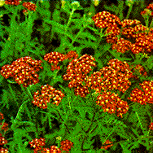

The History of Eucalyptus  
 Eucalyptuses are evergreen trees and are native to Tasmania and Australia. These trees were brought to the United States

over a hundred years ago by explorers because they were known to be pest resistant and have a profound odor.   
Eucalyptus leaves are also known to be mildly allelopathic. Kam Watson a professor of the Environmental Sciences Program - College of Natural Resources at University of California, Berkeley

⑨ has experimented with ___________________

⑨ Watson, Kim “The Effect of Eucalyptus on California Native Plants” University of California Berkley, February, 1998  
( Courtesy of Botany.com

extracts of Eucalyptus globulus and investigated its effects on germination and seedling growth of Achillea millefolium, Bromus carinatus, and Elymus glaucus(common household garden plants, shown in figure 1.3). Watson stated that the percentage of Achillea seeds germinatedwas significantly less in the Eucalyptus treatment than in the control. Achillea are also known to be hardy plants that can survive in depleted nutrient areas.  
  
Watson believes these plants are allelopathic and help to keep weeds away from their trunks through chemicals found in its leaves.

History of Rye Grass  
 L. Perenne also known as Rye Grass is apart of the grass family and was brought to America from Europe and is now grown all over the country. It is known to be very “hardy” and can with stand water depletion for a lengthened amount of time. Rye grass can strive in any range of light conditions and can grow up to two feet tall. It can be grown at any time of the year.Rye grass is also known to take over a yard if it is not cut and maintained well.

##### **Method of Experimentation**

I will be studying the effects of Eucalyptus on rye grass by placing different concentrations of Eucalyptus leaves in a petri-dishe with rye grass seeds.