**INTRODUCTION**

Some alternative cancer therapies recommend the use of soy to suppress cancer growth. it has been suggested that isoflavones in soy are the substance that suppress cancer growth because isoflavones structurally resemble estradiol, which has been observed to stimulate cell proliferation. Thus, our experiment is designed to investigate this claim. We will compare the effect of varying concentrations of soy on the growth of two human breast cancer cell lines MCF-7 and MDA-MB-231. We will also examine the effects of diadzein on these cells.

**Problem:**

Does soy have an adverse effect on breast cancer cell proliferation? If so, is diadzein, an isoflavone found in soy, responsible for this effect? Do soy and isoflavones inhibit cell proliferation by competitively inhibiting estradiol from binding to the estrogen receptors?

**Hypothesis:**

If soy and diadzein have an adverse effect on human breast cancer cell proliferation, then cells treated with soy will have lower levels of proliferation than the control. Furthermore, if isoflavones such as diadzein are the active ingredient in soy, then the similar results will be observed in cells treated with diadzein. Finally, if soy and isoflavones inhibit cancer growth by competing with estradiol for estrogen receptors, then soy and isoflavones will have no effect on cell proliferation in estrogen-receptor negative MDA-MB-231 cells.

**LITERATURE REVIEW**

In the United States alone, over one million new cases of cancer are diagnosed each year. Cancer is currently the second leading cause of death in the United States today, claiming more than 1500 victims each day. Breast cancer is the second leading cause of death in women, and prostate cancer is the second most common cancer in men. Current treatment for cancer involves radiotherapy and chemotherapy, in which X-rays and drugs are directed toward the tumor with the goal of mutating the growing cells’ DNA sequence to prevent the tumor from growing further. However, cancer therapy can cause damage and infertility to those with cancer in the reproductive organs, and chemotherapy can damage healthy cells along with the cancer cells. Furthermore, with average overall costs reaching over $900,000 per patient, patients are often left with a heavy financial burden. Yet, this burden does not necessarily ensure absolute cancer eradication. While statistics show that cancer rates are beginning to stabilize due to improved detection methods and treatments, current treatments do not ensure absolute elimination of cancer. Therefore, scientists and cancer patients alike have been seeking adjunct methods to cancer prevention.

As Dr. Maurice Bennink stated, “diet and lifestyle are considered important factors contributing to the geographical variability in cancer” (Bennink, 1). This is significant when considering the rates of prostate cancer incidence in Asia, as can be seen in the graphs below (Prostate Cancer Center – Soy):

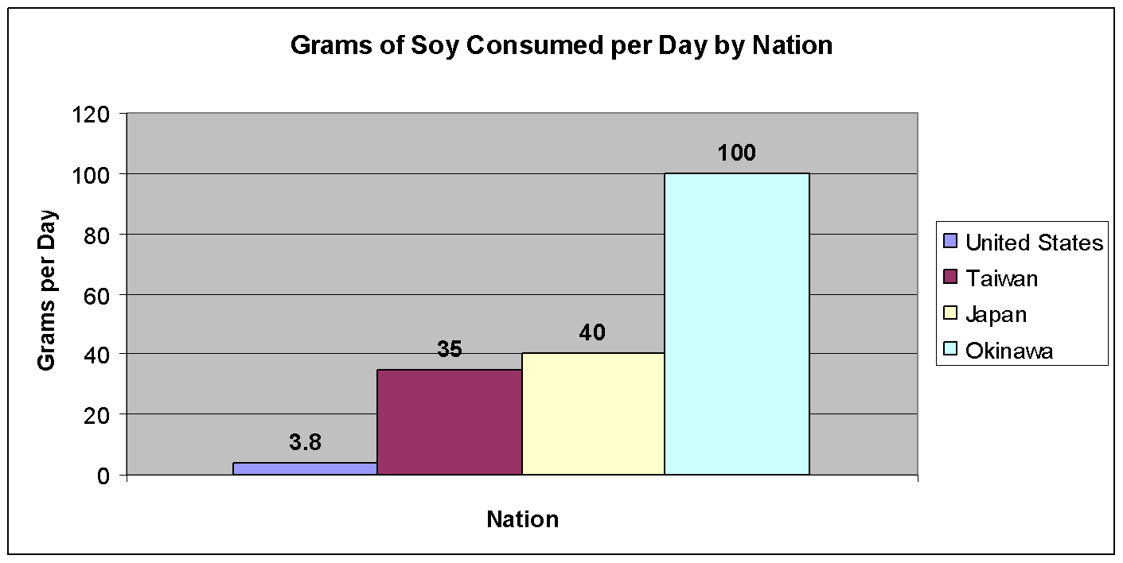

**Fig A. Average Amount of Soy Consumption per Person by Nation**

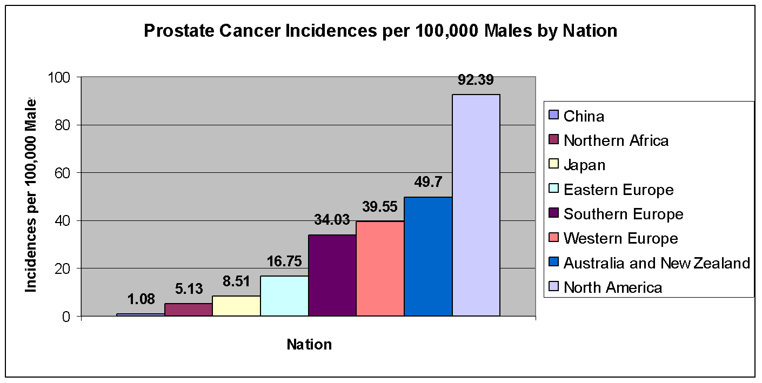

**Fig B Prostate Cancer Incidence in Males by Nation. Countries consuming large amounts of soy, such as Japan and China, have lower prostate cancer incidences than countries consuming low amounts of soy, such as countries in North America.**

Studies show that prostate cancer incidence and mortality rates are significantly lower in Asian countries such as China, Japan, and Taiwan when compared to the United States. Studies also show that breast cancer incidence is lower in Hong Kong and Singapore as well. Yet, people who migrate from low-risk countries, such as China and Japan, to the United States have the same risk for breast cancer and prostate cancer as the rest of those who live in the United States. Researchers attribute this increase in cancer risk to the change in lifestyle. Although there are many aspects to consider, it has been suggested that a change in diet can at least partially explain the increase in cancer risk. One notable difference in diet is that these countries consume over twenty times the amount of soybeans than that in the United States. Thus, perhaps soybeans will be found to be an adjunct treatment for cancer, which is the objective of our experiment.

Soybeans have been valued in Asia for centuries. Soybeans, commonly referred to as soy or soya, originated in northern China and Inner Mongolia in the eleventh century BC. The soy plant is a hairy plant that ranges from 2 to 5 feet tall. The soy beans come from the soy plant’s pods, which drop at maturity and release the beans. Soybeans were used as a staple food in times of famine in China, Korea and Japan. In addition, soy was also used for making preserved or fermented foods, such as tofu, miso, and tempeh. The Chinese also appreciated soy for its medicinal value. Chinese Emperor Shen-Nong conducted research on the soybean’s healing properties and recorded it in *The Medical Bible of the Yellow Emperor*, declaring soy one of the five sacred grains. A 16th century physician Li-Shi-Zhen added that:

“it can be used medicinally mainly to 'kill bad/evil chi….' It stops bodily pain, eliminates water [reduces edema], dispels heat in the stomach, reduces bad blood, and is an antidote to poisonous drugs and kidney disease...” (Special Exhibit Museum of Soy)

Europeans discovered soy later in the 16th century. Explorers and missionaries traveling to China and Japan became intrigued as they noticed the use of soy in various foods. In 1665, Friar Domingo Navarrete mistook tofu for cheese. “They drew the milk out of the Kidney-Beans and turning it, make great Cakes of it like Cheeses . . . All the Mass is as white as the very Snow . . . Alone it is insipid, but very good dress'd as I say and excellent fry'd in Butter” (NSRL: About Soy). In 1957, Florentine explorer Francesco Carletti discovered the use of soy sauce in Japan, which the Europeans came to call gravy. By the 17th century, soy sauce had become a common trade item from Asia to Europe, and soybeans were cultivated all over Europe.

Soy was then introduced to the United States in 1851 by the Japanese. However, Americans valued soy more for its industrial value than its nutritional value. They used soy as a source of oil, especially during the shortage of inexpensive oils during World War II. Thus, by the 20th century, the soybean had spread throughout the world, with its nutritional and industrial worth recognized around the globe,.

Perhaps a look at the chemical properties of soybean will reveal its healthful benefits. Soybeans contain both soluble and insoluble fiber that can help regulate intestinal function and reduce cholesterol levels. In addition, soybeans contain a significant amount of calcium, magnesium, and zinc, and are a source of B-complex vitamins, such as thiamine, niacin, riboflavin, and vitamin-B6.

A possible explanation for the anti-cancer effects seen with soy is that soy contains nutritionally significant amounts of the genestein and diadzein, as seen in the table below (The Soy Report):

|  |  |  |  |  |
| --- | --- | --- | --- | --- |
| **FOOD** | **Serving Size** | **Total(mg/g) Isoflavones** | **% Genistein** | **% Diadzein** |
| **Soymilk powder** | 1 cup | 1.25 | 56 | 44 |
| **Tempeh** | 1/2 cup | 0.64 | 60 | 40 |
| **Cooked soybeans** | 1/2 cup | 0.58 | 54 | 46 |
| **Tofu** | 1/2 cup | 0.46 | 57 | 53 |
| **TVP (soy protein)** | 1/4 cup | 0.42 | 54 | 46 |

**Table A - Average Isoflavone Content in Various Soy Foods**

Genestein and diadzein are two types of isoflavones, which are phytoestrogens, or plant estrogens. They are believed to enhance the survival of soybeans because they possess antifungal, antimicrobial, and antioxidant properties. Isoflavones structurally resemble estradiol, which is the primary estrogen in mammals. Among its many functions, estradiol can stimulate cell proliferation. In estrogen-responsive cells, estradiol enters the cell and binds to intracellular estrogen receptors, or ERs. This new complex moves to DNA and acts as a transcription factor to initialize transcription. Since isoflavones closely resemble mammalian estrogen, it is possible that soy isoflavones can bind to the ERs of cancer cells and prevent estradiol from binding to the ER and stimulating growth.

**Test Subject: MCF-7 & MDA-MB-231**

Since dietary studies suggest that soy can possibly be effective in preventing prostate cancer, we wanted to see if it is also effective in preventing breast cancer. We used two types of breast cancer cells: MCF-7 and MDA-MB-231. Both human cell lines were obtained from human breast tumors. They are frequently used in labs and experiments as models for estrogen responsive and non-responsive breast cancer; this is because MCF-7 is ER-positive, which means that they have estrogen receptors, and MDA-MB-231 is ER-negative, and don’t have estrogen receptors. Therefore, since the soy and isoflavones are causing an effect exclusively through the ER, they should produce an effect in MCF-7 cells, but not in MDA-MB-231. Also, since these cell lines have not been observed to mutate, they are consistent models for experimentation.

**PROCEDURES**

**Materials:**

|  |  |  |
| --- | --- | --- |
| 50 mL tubes (10) | Maxilife Mega Soy (1 200 mg capsule) | Spectrophotometer |
| 15 mL tubes (3) | 96-well cell plate (16) | Tissue Culture Hood |
| Minimal essential medium with OPTI-MEM with 10% charcoal stripped FBS, 1% penicillin streptomycin  and 1% L-glutamine | Surgical Gloves | Micro pipette |
| Dimethyl Sulfoxide (DMSO) | Weigh Boat | Micro pipette tips |
| Estradiol (10-7 M concentrations) | Goggles | Weight Scale |
| Diadzein | MTS cell proliferation assay | 70% Ethanol |
| Mass spectrometer | Reaction vessel | Vortex Mixer |
| Centrifuge | Methanol |  |

*Remember to wear gloves and goggles, and remember to spray down everything with ethanol to prevent any contamination. Also, replace the tips or tubes on the micro pipette every time you pipette a different solution, so as to prevent contamination.

**ALL WORK SHOULD BE DONE IN THE TISSUE CULTURE HOOD TO MINIMIZE CONTAMINATION.

**MASS SPECTROMETER ANALYSIS**

1. Add 4.2 mg of Maxilife Mega Soy, 2.1 mL of water, and 2.1 mL of methanol into a reaction vessel.
2. Use the vortex mixer to ensure that the contents dissolve. To further dissolve the contents, place the reaction vessel in a warm water bath and centrifuge.
3. Place the reaction vessel in the mass spectrometer to be analyzed.

**PREPARING SOY SOLUTIONS**

1. Twist open the gelatin capsule of Mega Soy, and measure out 7.2 mg onto a piece of filter paper. Pour these contents into a 15 mL tube.
2. In the Tissue Culture hood, add 7.2 mL of DMSO into the 15 mL tube. Cap the tube and mix well to make sure the contents dissolve. This is the soy stock solution with a concentration of 1 mg/mL. Be very careful with the DMSO, because it is a highly toxic solvent. (This part of the procedure was performed by our mentors at LLNL)
3. Using a micro pipette, dispense 12 µL of soy stock into a 50 mL tube. Then, using a pipette, add 20 mL of growth medium into the tube. This is soy solution #1, with a concentration of 0.6 µg/mL.

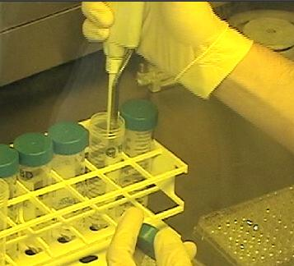

**Fig C. Dispensing Soy Solution**

1. Dispense 5 mL of soy solution #1 and 5 mL of growth medium into another 50 mL tube. This is soy solution #2, with a concentration of 0.3 µg/mL.
2. Using a pipette, pipette out 1 mL of soy solution #1, and dispense into another 50 mL tube. Then, pipette 9 mL of medium and dispense it into the tube. This is soy solution #3, with a concentration of 0.06 µg/mL.
3. Using a pipette, pipette out 5 mL of soy solution #3, and dispense into another 50 mL tube. Then, pipette 5 mL of medium and dispense it into the tube. This is soy solution #4, with a concentration of 0.03 µg/mL.
4. Using a pipette, pipette out 1 mL of soy solution #3, and dispense into another 50 mL tube. Then, pipette 9 mL of medium and dispense it into the tube. This is soy solution #5, with a concentration of 0.006 µg/mL.

**PREPARING DIADZEIN SOLUTIONS**

1. Measure out 5.6 mg diadzein onto a piece of filter paper. Pour these contents into a 15 mL tube.
2. In the Tissue Culture hood, pipette out 5.6 mL of DMSO, and add it into the 15 mL tube. Cap the tube and swirl it around to make sure the contents dissolve. This is the diadzein stock solution with a concentration of 1 mg/mL. Once again, be very careful with the DMSO, because it is a highly powerful solvent. (Again, this part of the procedure was performed by our mentors at LLNL)
3. Using a micro pipette, obtain 2 µL of diadzein stock and dispense it into a 50 mL tube. Then, using a pipette, pipette 20 mL of growth medium and dispense it into the tube. This is diadzein solution #1, with a concentration of 0.1 µg/mL.
4. Using a pipette, pipette out 5 mL of diadzein solution #1, and dispense into another 50 mL tube. Then, pipette 5 mL of medium and dispense it into the tube. This is diadzein solution #2, with a concentration of 0.05 µg/mL.
5. Using a pipette, pipette out 1 mL of diadzein solution #1, and dispense into another 50 mL tube. Then, pipette 9 mL of medium and dispense it into the tube. This is diadzein solution #3, with a concentration of 0.01 µg/mL.
6. Using a pipette, pipette out 5 mL of diadzein solution #3, and dispense into another 50 mL tube. Then, pipette 5 mL of medium and dispense it into the tube. This is diadzein solution #4, with a concentration of 0.005 µg/mL.
7. Using a pipette, pipette out 1 mL of diadzein solution #3, and dispense into another 50 mL tube. Then, pipette 9 mL of medium and dispense it into the tube. This is diadzein solution #5, with a concentration of 0.001 µg/mL.

**PREPARING ESTRADIOL CONTROL**

Using a pipette, measure out 0.1 mL of Estradiol, and place into a 15 mL tube. Then, add 9.9 mL of medium into the tube to obtain 10 mL of Estradiol at a concentration of 10-9 M. (This part of the procedure was performed by our mentors at LLNL)

**TREATING CELLS**

1. Plate 4 96-well plates with 2 * 104 of MCF-7 cells, and plate another 4 96-well plates with 2 * 104 of MDA-MB-231 cells, imposed with 100 mL of growth medium (This was performed by our mentors at LLNL). Incubate for several hours at 37° C and 5% CO2.
2. After the cells have attached to the well, aspirate the wells of the growth medium.
3. Add 100 µL of each treatment to the appropriate wells according to the chart and diagram below:

|  |  |
| --- | --- |
| Column | Solution |
| 1 | Soy – Solution 1 (0.6 µg/mL) |
| 2 | Soy – Solution 2 (0.3 µg/mL) |
| 3 | Soy – Solution 3 (0.06 µg/mL) |
| 4 | Soy – Solution 4 (0.03 µg/mL) |
| 5 | Soy – Solution 5 (0.006 µg/mL) |
| 6 | Growth Medium |
| 7 | Estradiol |
| 8 | Diadzein – Solution 1 (0.1 µg/mL) |
| 9 | Diadzein – Solution 2 (0.05 µg/mL) |
| 10 | Diadzein – Solution 3 (0.01 µg/mL) |
| 11 | Diadzein – Solution 4 (0.005 µg/mL) |
| 12 | Diadzein – Solution 5 (0.001 µg/mL) |

**Table B - Soy or Diadzein Treatment Concentration by Column**

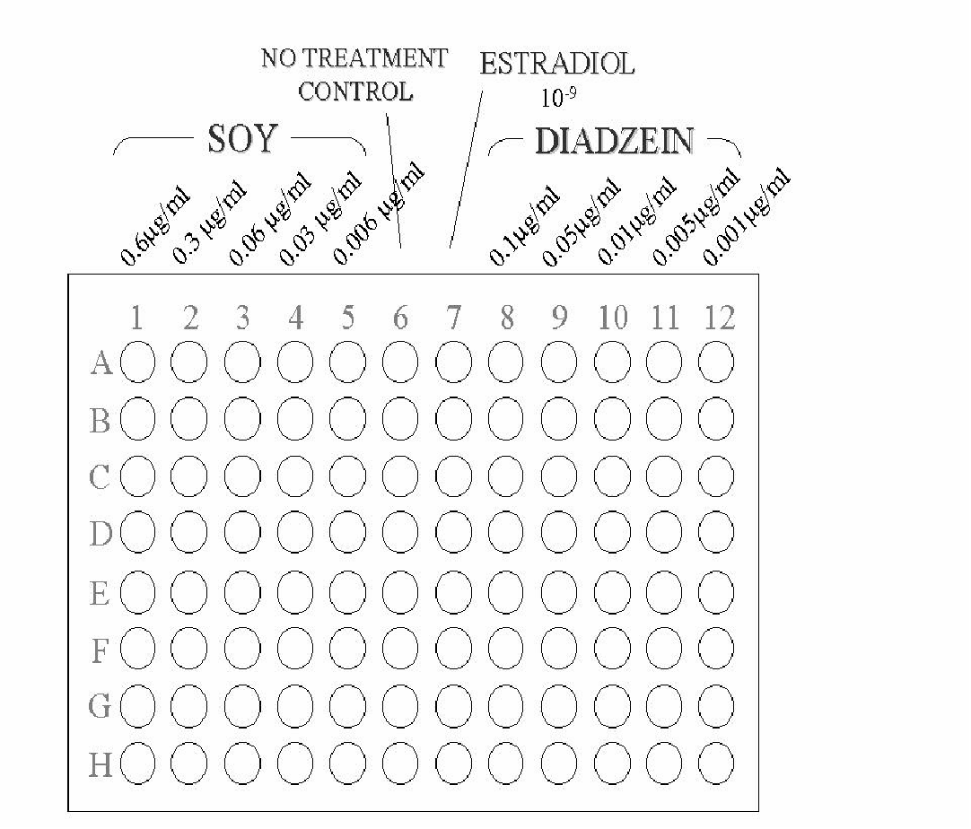

**Diagram 1 - Soy or Diadzein Treatment Concentration per Column**

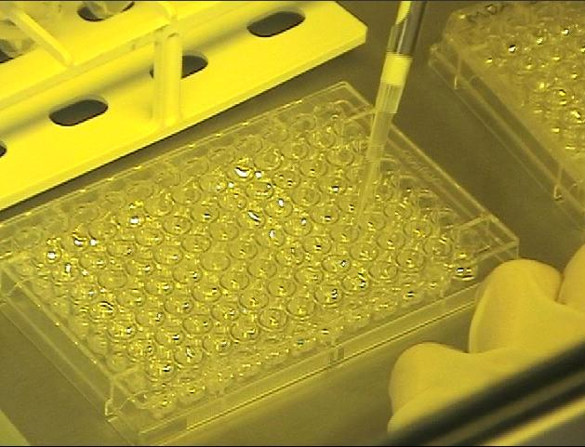

**Fig D. Treating Cells**

1. Incubate these plates at 37° C and 5% CO2.
2. Change growth medium every 48 hours to ensure optimal cell survival. Aspirate the old medium and replenish with 100 µL of each treatment solution to the appropriate wells.

**MEASURING CELL PROLIFERATION**

Every 24 hours, remove one plate of MCF-7 and MDA-MB-231 from the incubator and perform the MTS Cell Proliferation Assay:

1) Using a micro pipette, add 20 µL of MTS cell proliferation assay into each well.

2) Incubate for 4 hours at 37° C and 5% CO2.

3) Place the plate into the spectrophotometer and record absorbance at 490 nm.

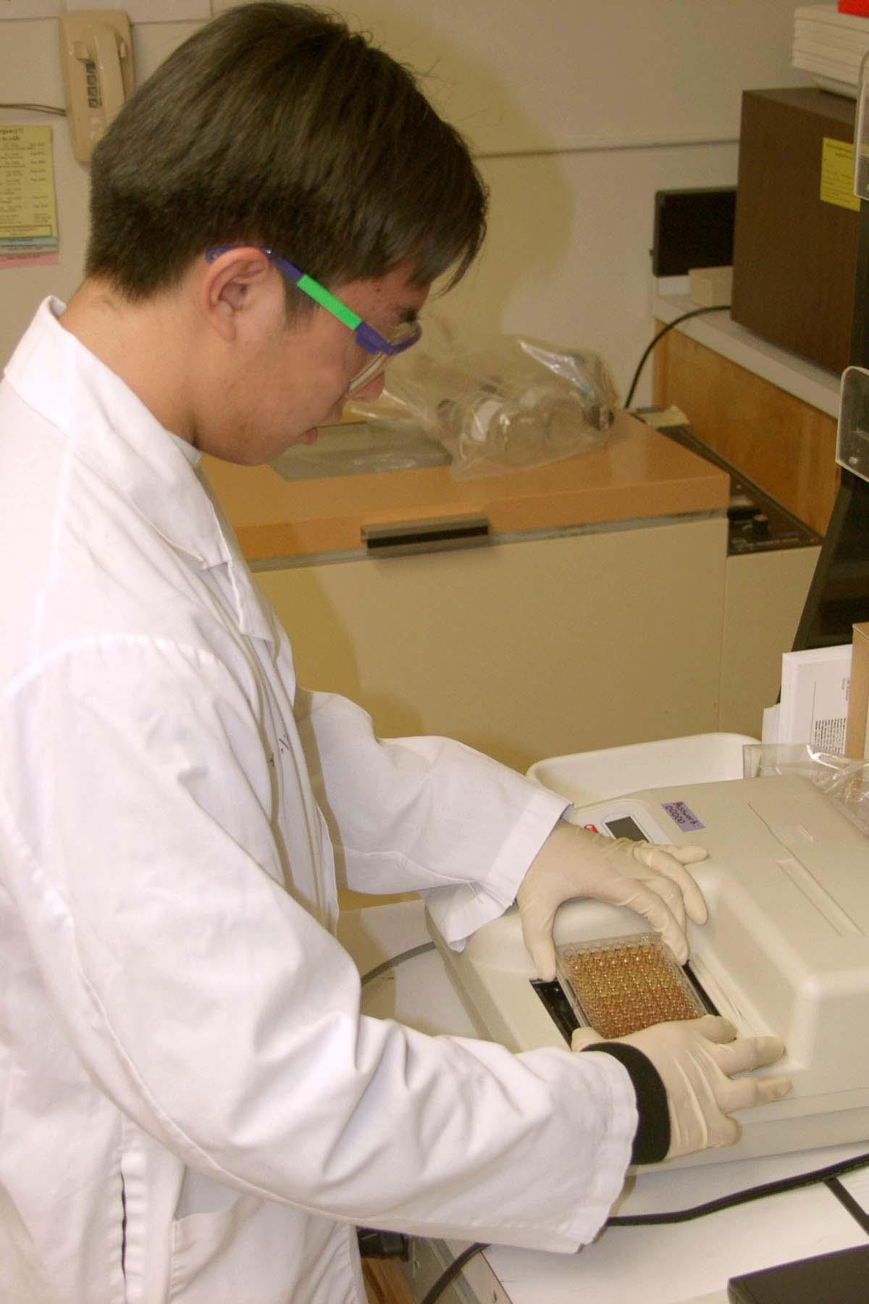

**Fig E. Measuring Cell Proliferation**

4)Dispose of the cells by treating the plates with bleach and placing them in a biohazard bin.

5) To clean up each day, wipe down the tissue culture hood with 70% ethanol and dispose of any used tubes or pipette tips in a biohazard waste disposal.

6) Repeat all procedures a second time to collect more data.

**DATA & FINDINGS**

Instead of using an actual soybean as the treatment, we decided to use soy protein, a processed soy product. We believe that processed soy products are more directly applicable to our experiment because it is more commonly consumed. The mass spectrometer analysis was performed to ensure that the basic isoflavones are present in our soy protein; compounds in the soy protein were separated by size and charge using liquid chromatography. Then, these molecules are directed to a mass spectrometer to measure the molecular weight of each molecule. We found the molecular weights of the soy isoflavones genestein, diadzein, and glycitein, and analyzed the soy protein in the mass spectrometer to determine if those molecular weights were present.

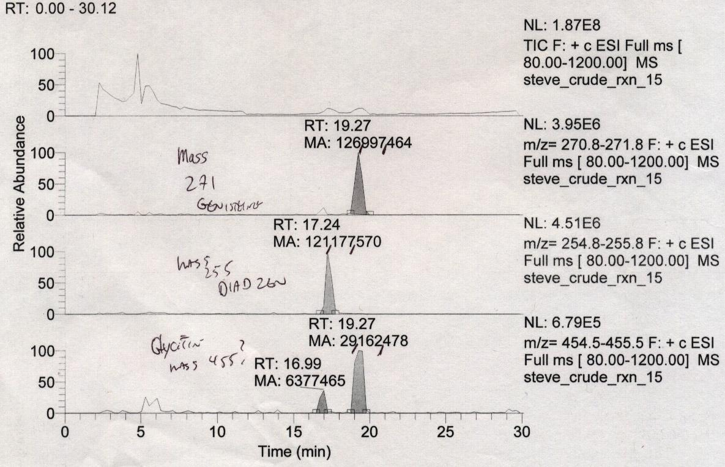

**Fig F. Mass Spectrometer Analysis of Soy Protein. The first graph shows the overall analysis of chemicals found in the soy protein. The three graphs below it depict the chemicals found in the soy protein at 19.27 minutes, 17.24 minutes, and 16.99 minutes.**

The peaks in the printout above indicate the molecular mass and amount of a certain molecule by time. The first graph shows an overview of all the peaks, or masses of the molecules found within the soy protein. As there are many peaks in this graph, the mass spectrometer analysis suggests that there are many other compounds in the soy protein besides isoflavones. The other graphs show the peaks of molecules found within the soy protein at specific times. The second graph shows a peak at 270.8 to 271.8 Daltons, which matches genestein’s molecular weight of 271 Daltons. This molecule was read by the spectrometer at 19.27 minutes, with a cumulative molecular weight of 126,997,464 Daltons. The third graph shows a peak at 254.8 to 255.8 Daltons, which matches diadzein’s molecular weight of 255 Daltons. This molecule was read at 17.24 minutes, and the total amount of this molecule was 121,177,570 Daltons. The fourth graph shows a peak at 454.5 to 455.5 Daltons, which is slightly less than glycitein’s molecular weight of 447 Daltons. However, the smaller peaks to the left of the main peak could be parts of the glycitein molecule that were separated during the analysis. These molecules were read at 19.27 minutes, with a cumulative amount of 29,162,478 Daltons. As the peaks in the soy protein analysis matched the molecular weights of genestein, diadzein and glycitein, the mass spectrometer analysis confirmed that the isoflavones are present in the soy protein.

In each of our two trials, cell proliferation was measured in two human breast cancer cell lines, MCF-7 and MDA-MB-231, in response to soy and diadzein. Data was collected at four time points spanning 96 hours. For each time point, there were 8 samples of each treatment. Over the two trials, there were 16 samples for each treatment and time point. However, due to procedural errors, the data from the first trial were invalid and inexplicable. We unfortunately did not have the opportunity to repeat the experiment to collect more data. Therefore, our study only makes use of the data collected from the second trial, reducing the sample size for each treatment group to 8.

To measure proliferation, the MTS cell proliferation assay was implemented. The assay utilizes Owen's reagent [(3-(4, 5-dimethylthiazol-2-yl)-5-(3-carboxymethoxyphenyl)-2-(4-sulfophenyl)-2H-tetrazolium,inner salt, MTS], which can be reduced by metabolically active cells into a colored product. The amount of colored product is directly proportional to the amount of cell proliferation, and the amount of colored product is determined by light absorbance at 490 nm using a spectrophotometer. Higher absorbance suggests a greater amount of cell proliferation. Cell proliferation was measured every 24 hours and compared by observing the percent proliferation relative to control. These results are shown in the graphs and tables below:

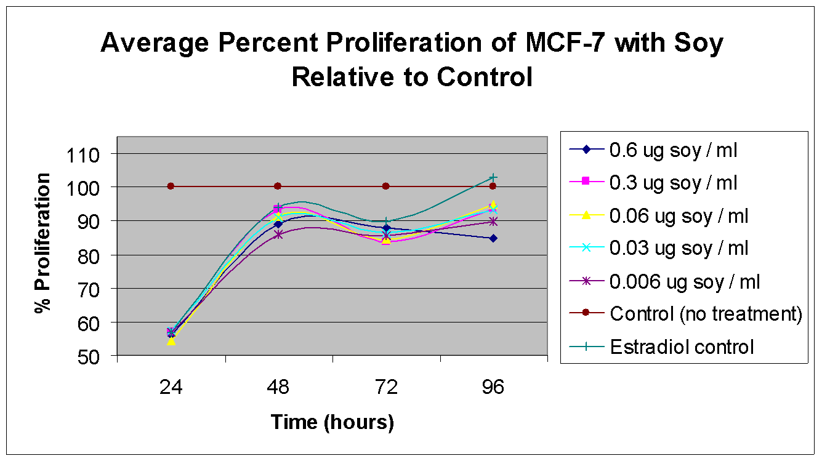

**Fig 1. Average Percent Proliferation of MCF-7 (estrogen positive) treated with soy relative to control over 96 hours. Estradiol, the positive control, is expected to stimulate cell proliferation in estrogen-receptor positive MCF-7. The control with no treatment is the negative control because of the absence of substances that could affect cell proliferation.**

|  |  |  |  |  |  |  |  |
| --- | --- | --- | --- | --- | --- | --- | --- |
| **Hours** | **Percent Proliferation Relative to Control** | | | | | | |
| **0.6 µg soy / mL** | **0.3 µg soy / mL** | **0.06 µg soy / mL** | **0.03 µg soy / mL** | **0.006 µg soy / mL** | **Control (no treatment)** | **Estradiol control** |
| 24 | 56 | 57 | 54 | 57 | 57 | 100 | 57 |
| 48 | 89 | 93 | 91 | 91 | 86 | 100 | 94 |
| 72 | 88 | 84 | 84 | 86 | 86 | 100 | 90 |
| 96 | 85 | 93 | 95 | 93 | 90 | 100 | 103 |

**Table 1. Average Percent Proliferation of MCF-7 (estrogen positive) treated with soy relative to control over 96 hours**

A significant difference in the amount of proliferation can be observed for MCF-7 treated with various concentrations of soy and the control.Beginning at 24 hours, the percent proliferation increased for all treatments, and peaked at 48 hours. From 48 hours to 72 hours, the percent proliferation decreased for all treatments, and increased again from 72 hours to 96 hours. Initially at 24 hours, all treatments exhibited relatively minimal difference in percent proliferation relative to the control. 0.006 µg/mL and 0.3 µg/mL exhibited the lowest percent proliferation at 48 hours and 72 hours respectively. At 96 hours, the soy treatment concentrated at 0.6 µg/mL exhibited the lowest percent proliferation. Meanwhile, all treatments exhibited lower percent proliferation than the control from 24 hours to 72 hours; but the estradiol control exhibited the greatest percent proliferation at 96 hours.

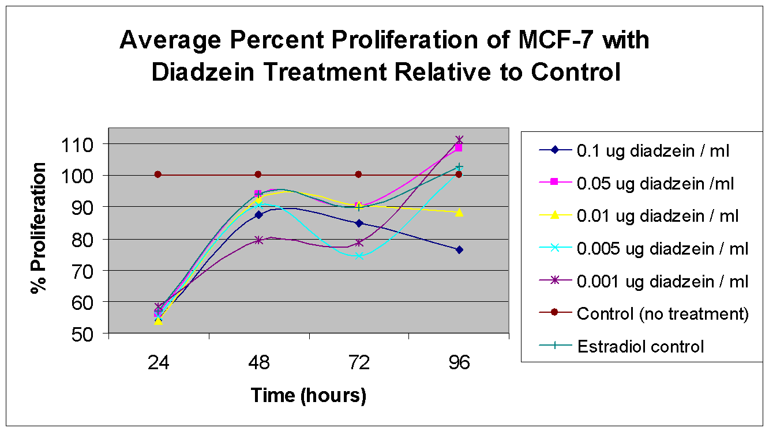**Fig 2. Average Percent Proliferation of MCF-7 (estrogen positive) treated with diadzein relative to control over 96 hours. Estradiol, the positive control, is expected to stimulate cell proliferation in estrogen-receptor positive MCF-7. The control with no treatment is the negative control because of the absence of substances that could affect cell proliferation.**

|  |  |  |  |  |  |  |  |
| --- | --- | --- | --- | --- | --- | --- | --- |
| **Hours** | **Percent Proliferation Relative to Control** | | | | | | |
| **0.1 µg diadzein / mL** | **0.05 µg diadzein /mL** | **0.01 µg diadzein / mL** | **0.005 µg diadzein / mL** | **0.001 µg diadzein / mL** | **Control (no treatment)** | **Estradiol control** |
| 24 | 54 | 56 | 54 | 55 | 58 | 100 | 57 |
| 48 | 88 | 94 | 93 | 91 | 80 | 100 | 94 |
| 72 | 85 | 90 | 91 | 75 | 79 | 100 | 90 |
| 96 | 76 | 109 | 88 | 101 | 111 | 100 | 103 |

**Table 2. Average Percent Proliferation of MCF-7 (estrogen positive) treated with diadzein relative to control over 96 hours**

MCF-7 treated with the diadzein concentrations of 0.05 µg/mL, 0.005 µg/mL, and 0.001 µg/mL exhibited the same growth curve as the MCF-7 treated with soy, increasing in proliferation from 24 to 48 hours, decreasing from 48 to 72 hours, and increasing again from 72 to 96 hours. However, the cells treated with concentrations 0.1 µg/mL and 0.01 µg/mL increased from 24 to 48 hours, and gradually decreased from 48 to 96 hours. All treatments exhibited lower percent proliferation than the control from 24 hours to 72 hours, but the diadzein concentrations at 0.05 µg/mL and 0.001 µg/mL resulted in the greatest percent proliferation at 96 hours. Again at 24 hours, all treatments exhibited relatively minimal difference in percent proliferation relative to the control. Meanwhile the treatment with diadzein concentration 0.001 µg/mL exhibited the lowest percent proliferation at 48 hours, and the concentration 0.005 µg/mL exhibited the lowest percent proliferation at 72 hours. Ultimately at the end of 96 hours, the concentration at 0.1 µg/mL exhibited the lowest percent proliferation.

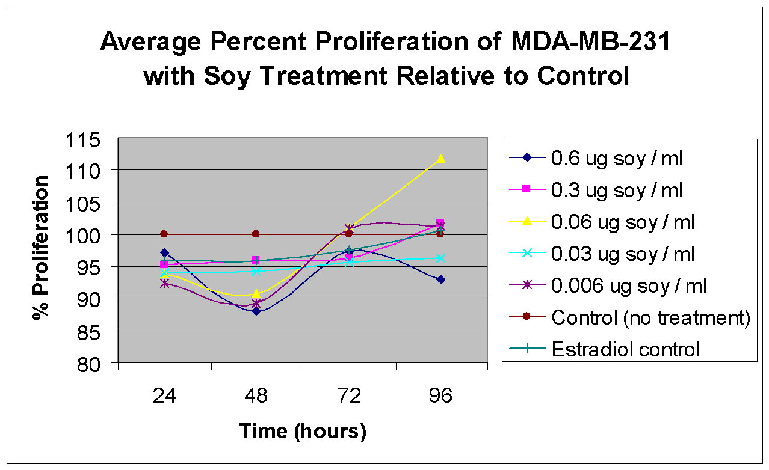

**Fig 3. Average Percent Proliferation of MDA-MB-231 (estrogen negative) treated with soy relative to control over 96 hours. MDA-MB-231 was a control to examine the effects of soy on estrogen-receptor negative cells.**

|  |  |  |  |  |  |  |  |
| --- | --- | --- | --- | --- | --- | --- | --- |
| **Hours** | **Percent Proliferation Relative to Control** | | | | | | |
| **0.6 µg soy / mL** | **0.3 µg soy / mL** | **0.06 µg soy / mL** | **0.03 µg soy / mL** | **0.006 µg soy / mL** | **Control (no treatment)** | **Estradiol control** |
| **24** | 97 | 95 | 94 | 94 | 92 | 100 | 96 |
| **48** | 88 | 96 | 91 | 94 | 89 | 100 | 96 |
| **72** | 97 | 96 | 101 | 96 | 101 | 100 | 98 |
| **96** | 93 | 102 | 112 | 96 | 101 | 100 | 101 |

**Table 3. Average Percent Proliferation of MDA-MB-231 (estrogen negative) treated with soy relative to control over 96 hours**

Although differences in the amount of proliferation were observed for MDA-MB-231 treated with various concentrations of soy relative to the control, such differences were not statistically significant. In general, the treatments decreased from 24 to 48 hours, increased from 48 to 72 hours, and decreased again from 72 to 96 hours. However, concentration 0.06 µg/mL, 0.03 µg/mL and the estradiol control exhibited a gradual increase over all 96 hours. The diadzein treatment at concentration 0.6 µg/mL exhibited the lowest percent proliferation over all 96 hours. Meanwhile, the control exhibited the highest percent proliferation at 24 and 48 hours, but the diadzein treatment at concentration 0.06 µg/mL exhibited the highest percent proliferation at 72 and 96 hours.

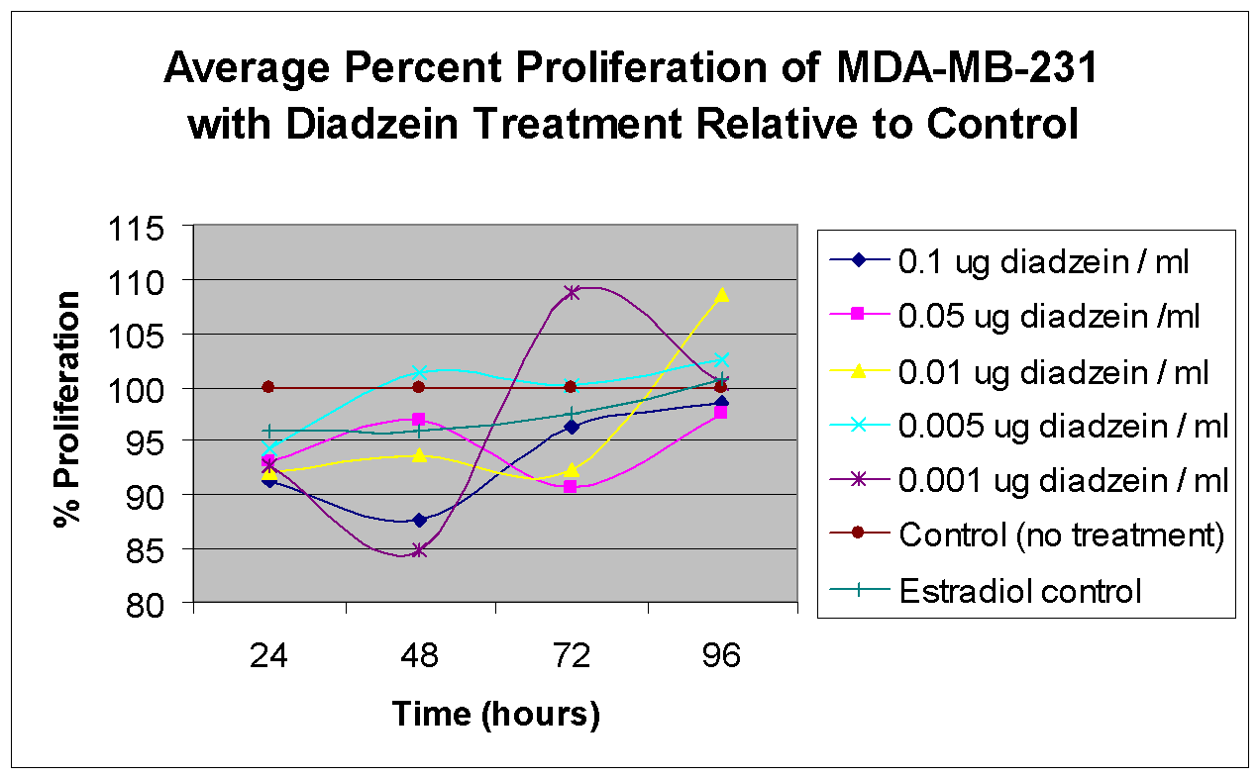

**Fig 4. Average Percent Proliferation of MDA-MB-231 (estrogen negative) treated with diadzein relative to control over 96 hours. MDA-MB-231 was a control to examine the effects of soy on estrogen-receptor negative cells**

|  |  |  |  |  |  |  |  |
| --- | --- | --- | --- | --- | --- | --- | --- |
| **Hours** | **Percent Proliferation Relative to Control** | | | | | | |
| **0.1 µg diadzein / mL** | **0.05 µg diadzein /mL** | **0.01 µg diadzein / mL** | **0.005 µg diadzein / mL** | **0.001 µg diadzein / mL** | **Control (no treatment)** | **Estradiol control** |
| **24** | 91 | 93 | 92 | 94 | 93 | 100 | 96 |
| **48** | 88 | 97 | 94 | 101 | 85 | 100 | 96 |
| **72** | 96 | 91 | 92 | 100 | 109 | 100 | 98 |
| **96** | 98 | 97 | 109 | 103 | 100 | 100 | 101 |

**Table 4. Average Percent Proliferation of MDA-MB-231 (estrogen negative) treated with diadzein relative to control over 96 hours**

The treatments show minimal difference compared to the control. There was no discernable trend among the treatments. Concentrations 0.1 µg/mL and 0.001 µg/mL decreased between 24 to 48 hours, increased between 48 and 72 hours, and decreased again between 72 and 96 hours; meanwhile, concentrations 0.005 µg/mL, 0.05 µg/mL, and 0.01 µg/mL exhibited the opposite pattern. The treatment at concentration at 0.1 µg/mL exhibited the lowest percent proliferation at 24 hours, but 0.001 µg/mL exhibited the lowest percent proliferation at 48 hours. At 72 hours and 96 hours, the treatment at concentration 0.05 µg/mL exhibited the lowest percent proliferation. The control with no treatment exhibited the highest percent proliferation at 24 hours, while concentration 0.005 µg/mL, 0.001 µg/mL and 0.01 µg/mL exhibited the highest percent proliferation at 48 hours, 72 hours, and 96 hours respectively.

To analyze the statistical significance of our collected data, we performed stacked ANOVA tests by treatment and hour. In order to perform the ANOVA tests we must assume the population is normal, and that there is equal standard deviation among each treatment. The hypotheses for the test are: 1) The means of each treatment are equal; 2) At least one mean is different from the other treatments. A P-value or probability less than 0.05 will prove the second hypothesis because the probability of obtaining such difference in the treatments is so low that it cannot by random. Therefore, there would be statistical significance in the treatments. In addition, by comparing the 95% confidence intervals, we can observe which treatments are significant. The bars in the 95% confidence intervals show what range the means could deviate by random chance. If these experiments were repeated, there would be a 95% chance of getting values in those intervals. Therefore, if the confidence intervals for the treatments do not contain the same values, then it is not a random occurrence that the results were different for each treatment.

|  |  |
| --- | --- |
| **Treatment** | **P-Value at 96 hours** |
| **MCF-7 soy** | 0.001 |
| **MCF-7 diadzein** | 0.000 |
| **MDA-MB-231 soy** | 0.148 |
| **MDA-MB-231 diadzein** | 0.288 |

**Table 5. P-Values for soy and diadzein treatments on MCF-7 (estrogen-receptor positive) and MDA-MB-231 (estrogen-receptor negative).**

The ANOVA tests for MCF-7 treated with soy and diadzein showed P-values of 0.001 and 0 respectively, meaning that there is close to 0% chance of getting such differences in comparison to the control if the experiment was repeated. This means that there was statistically significant difference among the soy and diadzein treatments. Primarily, the 95% confidence intervals (refer to appendix indicate that Soy 1 (0.6 µg/mL) and Dia 1 (0.1 µg/mL) are most significant, as those intervals do not overlap with their control intervals.

The ANOVA test for MDA-MB-231 treated with diadzein showed no statistical significance, as the P-value was extremely high at 0.288. This means that there is a 29% chance of getting such differences if the experiment was repeated. The ANOVA test for MDA-MB-231 treated with soy protein also showed no statistical significance, as the P-value was high at 0.148. This means that there is a 15% chance of getting such differences if the experiment were repeated. This data is plausible, as the rates of proliferation were quite similar among all the MDA-MB-231 treatments.

The results that this data reveals are suggestive of the inhibiting effects of soy on the proliferation of breast cancer cells. The results showed an overall trend in which MCF-7 cells treated with soy exhibited significantly lower percent proliferation relative to the control. This suggests that soy has the ability to suppress the proliferation of breast cancer cells. Furthermore, MCF-7 treated with the highest soy concentration, 0.6 µg/mL, exhibited the lowest percent proliferation at 96 hours. Generally, this group also exhibited lower percent proliferation than most of the other treatments over all 96 hours. This would suggest that higher concentrations soy further suppress the rate of proliferation in cancer cells. Meanwhile, the results indicated that MDA-MB-231 treated with soy had neither discernable trends nor significant difference in proliferation relative to control, suggesting that soy has no effect on breast cancer cells without estrogen receptors.

In addition, the results suggest that diadzein has inhibitive effects on the proliferation of breast cancer cells as well. An overall trend was observed in which MCF-7 cells treated with diadzein exhibited significantly lower percent proliferation relative to the control. It is noted that MCF-7 cells treated with diadzein treatments 0.05 µg/mL and 0.001 µg/mL exhibited greater percent proliferation relative to control. However, because the difference in percent proliferation for these treatments was not significant, the results could have occurred by random chance. Overall, the data suggests that diadzein is an active ingredient in soy’s ability to suppress the proliferation of breast cancer cells. Furthermore, MCF-7 treated with the highest diadzein concentration, 0.1 µg/mL, exhibited the lowest percent proliferation at 96 hours. Generally, this group also exhibited lower percent proliferation than most of the other treatments over all 96 hours. This would suggest that higher concentrations diadzein further suppress the rate of proliferation in cancer cells. On the other hand, MDA-MB-231 treated with diadzein exhibited no significant difference, suggesting that diadzein has no effect on breast cancer cells without estrogen receptors.

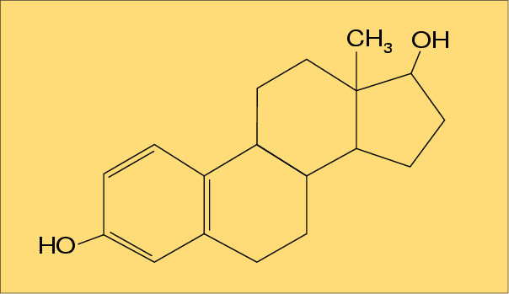

**Figure 5. Chemical Structure of Estradiol. *(Image provided by “Oestrogenen”)***

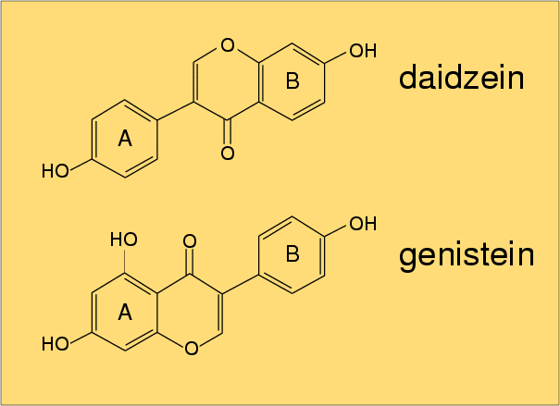

**Figure 6. Chemical Structure of diadzein and genestein, isoflavones found in soy.**

**Genestein and diadzein have chemical structures that closely resemble estradiol.**

***(Image provided by “Oestrogenen”)***

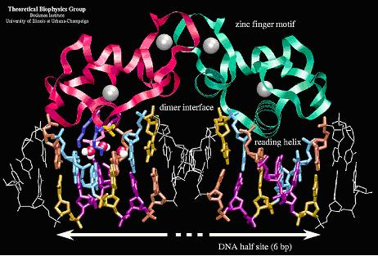

**Fig 7. Chemical Structure of the Estrogen Receptor. Estradiol binds to the estrogen receptor to stimulate cell proliferation. Because isoflavones structurally resemble estradiol, they can bind to the estrogen receptors as well, thereby competitively inhibiting estradiol from binding to the estrogen receptor.** *(Image provided by David Shattuck)*

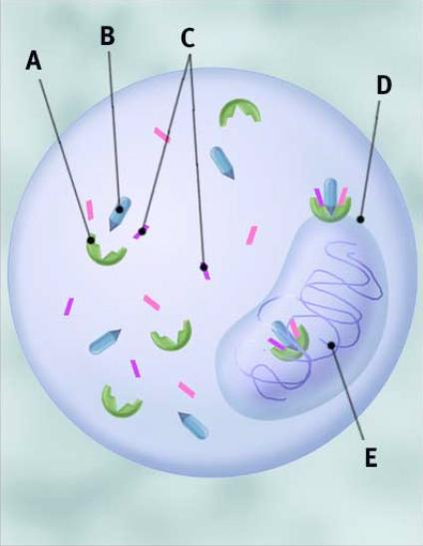

**Fig 8. Mechanism of Action in Estrogen Receptors. A: Estrogen receptor; B: Estrogen; C: Estrogen helper proteins; D: Nucleus; E: DNA genetic material. Estrogen and helper proteins bind to the estrogen receptors, which then move to the genetic material to initiate transcription and cell proliferation. *(Image provided by David Shattuck)***

Because the results showed that soy and diadzein have significant effects on MCF-7 but not MDA-MB-231, it suggests that soy and diadzein only have an effect on the proliferation of breast cancer cells with estrogen receptors. Isoflavones such as diadzein structurally resemble estradiol, which stimulates cell growth by binding to the estrogen receptors; perhaps the isoflavones in the soy competitively inhibit the estradiol from binding to the estrogen receptors, thus preventing the cancer cells from proliferating. However, the results indicated that estradiol did not stimulate growth in MCF-7; in fact, it appeared that estradiol limited the proliferation of MCF-7 cells. This data could be because the estradiol was degenerated, or the concentration of estradiol was too low to be effective. Nevertheless, because the results indicated that soy and diadzein lower the percent proliferation in MCF-7 cells, the data is still valid, and we can speculate that soy and diadzein suppresses growth in breast cancer cells through the estrogen receptor.

It is interesting to note that all of the MCF-7 treated with soy and some of the MCF-7 treated with diadzein had the trend of increasing in percent proliferation between 24 to 48 hours and 72 to 96 hours, while decreasing in percent proliferation between 48 to 72 hours. Since we replenish the cells with the soy and diadzein treatments at 48 hours, this trend suggests that the soy and diadzein degraded. Degradation would mean the cells were not suppressed as much, allowing the cells to proliferate between 24 to 48 hours and 72 to 96 hours, while growth was suppressed at 48 to 72 hours because the cells were replenished with soy and diadzein treatments at 48 hours. Future experiments should measure proliferation at 0 hours to confirm this idea. Also, the soy protein concentrations were set so that they would contain approximately the same amount diadzein as in the diadzein concentrations. Yet, the results for the two treatments were very different. The discrepancy between the diadzein treatment and the soy treatment may be due to other substances and chemicals in the soy protein. The mass spectrometer analysis showed many other peaks, suggesting that there are chemicals in the soy protein other than isoflavones. These chemicals could stimulate growth or counteract the isoflavones’ inhibiting effect.

**CONCLUSIONS**

Our study supports the hypothesis that soy has the potential to suppress the rate of breast cancer cell proliferation. The results indicated that the higher concentrations of soy protein led to lower rates of cell proliferation. Diadzein, an isoflavone, appears to be an active ingredient in soy’s ability to inhibit proliferation in breast cancer cells with estrogen receptors. Higher concentrations of diadzein led to lower rates of cell proliferation. In addition, MCF-7 cells treated with soy or diadzein showed a trend of increasing percent proliferation between 24 to 48 hours and 72 to 96 hours, but decreasing percent proliferation between 48 to 72 hours, suggesting that soy and diadzein degrade within 24 hours.

Because our study showed that soy and diadzein significantly affected estrogen-positive MCF-7 cells, but not estrogen negative MDA-MB-231 cells, we conclude that soy and diadzein suppress breast cancer cell proliferation through the estrogen receptor. In addition, conclude that soy and isoflavones competitively inhibit estradiol from binding to estrogen receptors and stimulating growth.

The experiment was designed so that the soy protein concentrations would contain approximately the same amount diadzein as in the diadzein concentrations. Yet, the results for the two treatments were very different. The discrepancy between the diadzein treatment and the soy treatment may be due to other substances and chemicals in the soy protein. These chemicals could stimulate growth or counteract the isoflavones’ inhibiting effect.

Overall, from this study, we can draw certain conclusions:

1. Soy has the ability to inhibit or decrease proliferation of cancer cells.
2. Diadzein, and isoflavone, is an active ingredient in soy’s ability to suppress cancer cell proliferation.
3. Soy and diadzein suppress cell proliferation by competitively inhibiting estradiol from binding to estrogen receptors and stimulating cell proliferation.
4. Soy and diadzein degrade within 24 hours.

This experiment is not conclusive because of the limited data set. However, our study suggests that soy and isoflavones have the potential to suppress cancer growth, and further studies should be conducted to evaluate this potential. Higher concentrations of estradiol could be used for the control. Radioactive markers could be used in vitro to trace the actual metabolic path of soy and isoflavones to better understand the mechanism on cancer cells. More concentrations of soy and diadzein should be tested to get a more comprehensive growth curve. To confirm the idea of degradation, cells could be plated and treated after 24 hours so an initial proliferation measurement before treatment can be observed; this would allow a better understanding of how the proliferation rate is affected by the addition of soy and diadzein. Indeed, if scientists discover further research suggesting that soy and isoflavones have the ability to suppress cancer without harmful or negative effects on healthy tissue, soy could become an adjunct treatment for cancer. Women could benefit from a soy or isoflavone treatment, which could become a means of breast cancer treatment or a preventative measure. As studies have shown that the people of Okinawa consume an average of 100 grams of soy per day, and exhibit very low rates of prostate cancer, 100 grams per day of soy would likely show beneficial results towards inhibiting cancer cell growth. Moreover, soy concentration 0.6 µg/mL was observed to be most beneficial among the soy treatments; this means that an average human would have to consume approximately 900 grams of soy protein per day to achieve the same effect. Therefore, consuming more than 100 grams of soy would be likely to show even greater results, but it is probably not advisable to consume such large amounts of soy per day.

In broader speculation, soy could possibly be one aspect of the American lifestyle to improve on. If Americans relied more on soy proteins than the proteins in meat, perhaps the rates of cancer will decrease to the rates that are observed in Asian countries. In addition, the decreased dependence on meat could mean less grazing, thus preserving the natural habitat and environment. We believe that scientists should seriously consider research in the direction of soy as a possible adjunct treatment or even a means of cancer prevention. With more research in this direction, possible animal and human studies could be conducted in the future for further evaluation on the effectiveness of soy in treating or preventing cancer.

Soy has many benefits toward diet and nutrition. Not only does it exhibit properties that decrease the rate of cancer growth, but it also reduces cholesterol, and its high calcium level helps prevent osteoporosis. Although there is much more research to be done on the effects of soy, our study provides the preliminary data supporting the claim that soy can inhibit cancer. With further research, we believe that soy and diadzein have the potential of being adjunct treatments for cancer.

**RECOMMENDATIONS & FUTURE STUDIES**

We recognize that there are flaws in our experimental design. Here are some ways that we realized that could improve the design and provide more accurate data:

1. For the first week of the experiment, we did not aspirate the cells before adding the treatment solutions. This altered the concentrations of soy and diadzein, causing some deviations in our data. Instead, we should have aspirated the cells for each time that we imposed the treatment.
2. It would be beneficial to find an alternative solvent for the soy protein and diadzein, rather than DMSO. DMSO is such a strong substance that it could potentially harm the cancer cells. Otherwise, we should have included a vehicle control, in which we impose DMSO in the amounts used in each treatment on a row in each of our plates.
3. We could have tested the cancer cells with a treatment that consisted of unprocessed or raw soybeans, rather than soy protein.
4. We should have measured the proliferation at 0 hours. We should have plated the cells and added the treatments after 24 hours so that we can obtain an initial proliferation measurement before treatment.
5. Varying concentrations of estradiol should have been tested for an extended period of time to better understand the effects of estradiol on cell proliferation.

In addition, we developed several extensions based on our experiment that could further examine the potential of soy and isoflavones as an adjunct treatment for cancer:

1. More concentrations of soy and diadzein could be tested to see an expanded growth curve.
2. Tests could be performed to observe the effects of soy and isoflavones on healthy human tissue. While it is beneficial that soy and isoflavones halt the proliferation of cancer cells, it is unknown whether they will have the same effect on healthy human tissue.
3. An experiment could be conducted to see the effects of various other isoflavones on cancer cells.
4. It is uncertain whether the soy or isoflavones bind through the ER, or through another receptor. Also, it is uncertain whether the soy and isoflavones affect genes or protein expression. Thus, radioactive markers could be tagged onto soy and isoflavones to trace the actual metabolic path and observe the actual mechanism by which soy and isoflavones affect the cells.

# **REFERENCES**

1. Witorsch, Raphael J. Endocrine Disruptors: Can Biological Effects and Environmental

Risks be Predicted? Richmond, VA: Elsevier Science 2002.

1. Holt, Stephen. The Soy Revolution: The Food of the Next Millennium. New York, NY:

M. Evans and Company, Inc 1998.

1. American Cancer Society, Inc. Cancer Facts and Figures 2003. Atlanta, GA 2003
2. Brenner, David J. & Hall, Eric J. Making the Radiation Therapy Decision. Los Angeles,

CA: RGA Publishing Group 1997

1. Messina, Mark. “Soy and Health: Isoflavones.” (Online) Available

<http://www.talksoy.com/pdfs/IsofavonesFactSheet.pdf> Sept. 23, 2003

1. Bennink, Maurice. “Soy and Health: Soy and Prostate and Colon Cancers.” (Online)

Available <http://www.talksoy.com/pdfs/SoyFctShtCancer.pdf> Sept. 23, 2003

1. “Prostate Cancer Center – Soy” (Online) Available http://www.cedars-

sinai.edu/3421.htmL Sept. 23, 2003

1. “Taxonomy Browser: Glycine max” (Online) Available

<http://www.ncbi.nlm.nih.gov/Taxonomy/Browser/wwwtax.cgi?id=3847> Sept. 23,

2003

1. “Imaginis - Breast Cancer Statistics on Incidence, Survival, and Screening” (Online)

Available <http://imaginis.com/breasthealth/statistics.asp#1> Jan. 3, 2004

1. “Special Exhibit Museum of Soy - Chronology of Green Vegetable Soybeans and

Edamame” (Online) Available

<http://www.thesoydailyclub.com/MOSedamame/MOSedamame1.asp> Jan 3, 2004

1. “NSRL: About Soy” (Online) Available [http://www.nsrl.uiuc.edu/aboutsoy/history2.htmL](http://www.nsrl.uiuc.edu/aboutsoy/history2.html)

Jan 3, 2004

1. “Introduction to Mass Spectrometry” (Online) Available

[http://masspec.scripps.edu/information/intro/chapter1.htmL](http://masspec.scripps.edu/information/intro/chapter1.html) Jan 11, 2004

1. “The Soy Report” (Online) Available [http://goddessdiet.com/Reports/soy.htm Jan 11](http://goddessdiet.com/Reports/soy.htm%20Jan%2011),

2004

1. “Catalog Detail” (Online) Available

[http://www.atcc.org/SearchCatalogs/longview.cfm?view=ce,5292393,HTB-](http://www.atcc.org/SearchCatalogs/longview.cfm?view=ce,5292393,HTB-22&text=mcf%2D7&max=20)

[22&text=mcf%2D7&max=20](http://www.atcc.org/SearchCatalogs/longview.cfm?view=ce,5292393,HTB-22&text=mcf%2D7&max=20) Jan 25, 2004

1. “Catalog Detail” (Online) Available

<http://www.atcc.org/SearchCatalogs/longview.cfm?view=ce,5309912,HTB->

26&text=MDA%2DMB%2D231&max=20 Jan 25, 2004

1. “Oestrogenen” (Online) Available

http://europe.obgyn.net/nederland/mp/overgang/overgangli38.htmlMarch 13, 2004

**APPENDIX**

**STATISTICAL ANALYSIS**

ANOVA tests on Soy and Diadzein

Stacked ANOVA tests by treatment and hour can be performed to analyze the statistical significance of data. In order to perform the ANOVA tests we must assume the population is normal, and that there is equal standard deviation among each treatment. The hypotheses for the test are: 1) The means of each treatment are equal; 2) At least one mean is different from the other treatments. A P-value of 0.05 or lower will prove the second hypothesis and show that there is some statistical significance in the treatments.

By comparing the 95% confidence intervals, we can observe which treatments are significant. The bars in the 95% confidence intervals show the error in our experiment; If these experiments were to be repeated, there would be a 95% chance of getting values in those intervals.

**Key**

soy 1 = 0.6 µg soy / mL

soy 2 = 0.3 µg soy / mL

soy 3 = 0.06 µg soy / mL

soy 4 = 0.03 µg soy / mL

soy 5 = 0.006 µg soy / mL

Dia 1 = 0.1 µg diadzein / mL

Dia 2 = 0.05 µg diadzein / mL

Dia 3 = 0.01 µg diadzein / mL

Dia 4 = 0.005 µg diadzein / mL

Dia 5 = 0.001 µg diadzein / mL

CO = Control (No Treatment)

E2 = Estradiol Control

**MCF-7 treated with Soy**

**One-way ANOVA: 24 hours MCF-7 treated with Soy**

Analysis of Variance for 24 hrs

Source DF SS MS F **P-value**

24 hrs 6 0.139299 0.023217 46.34 **0.000**

Error 49 0.024549 0.000501

Total 55 0.163848

**Individual 95% CIs For Mean**

**Based on Pooled StDev**

Level N Mean StDev --------+---------+---------+--------

CO 8 0.32625 0.04045 (--*--)

E2 8 0.18513 0.01898 (--*--)

soy 1 8 0.18338 0.02179 (---*--)

soy 2 8 0.18600 0.01440 (--*--)

soy 3 8 0.17688 0.02039 (--*---)

soy 4 8 0.18700 0.01500 (--*---)

soy 5 8 0.18563 0.01368 (--*--)

--------+---------+---------+--------

Pooled StDev = 0.02238 0.200 0.250 0.300

Fisher's pairwise comparisons

Family error rate = 0.422

Individual error rate = 0.0500

Critical value = 2.010

Intervals for (column level mean) - (row level mean)

CO E2 soy 1 soy 2 soy 3 soy 4

E2 0.11863

0.16362

soy 1 0.12038 -0.02074

0.16537 0.02424

soy 2 0.11776 -0.02337 -0.02512

0.16274 0.02162 0.01987

soy 3 0.12688 -0.01424 -0.01599 -0.01337

0.17187 0.03074 0.02899 0.03162

soy 4 0.11676 -0.02437 -0.02612 -0.02349 -0.03262

0.16174 0.02062 0.01887 0.02149 0.01237

soy 5 0.11813 -0.02299 -0.02474 -0.02212 -0.03124 -0.02112

0.16312 0.02199 0.02024 0.02287 0.01374 0.02387

**One-way ANOVA: 48 hours MCF-7 treated with Soy**

Analysis of Variance for 48 hrs

Source DF SS MS F **P-value**

48 hrs 6 0.005205 0.000867 1.32 **0.270**

Error 42 0.027637 0.000658

Total 48 0.032842

**Individual 95% CIs For Mean**

**Based on Pooled StDev**

Level N Mean StDev -+---------+---------+---------+-----

CO 7 0.25386 0.01803 (-------*------)

E2 7 0.23814 0.02225 (-------*-------)

soy 1 7 0.22586 0.02684 (------*-------)

soy 2 7 0.23629 0.01893 (-------*------)

soy 3 7 0.23200 0.03873 (-------*-------)

soy 4 7 0.23071 0.02635 (-------*-------)

soy 5 7 0.21829 0.02265 (-------*-------)

-+---------+---------+---------+-----

Pooled StDev = 0.02565 0.200 0.225 0.250 0.275

Fisher's pairwise comparisons

Family error rate = 0.419

Individual error rate = 0.0500

Critical value = 2.018

Intervals for (column level mean) - (row level mean)

CO E2 soy 1 soy 2 soy 3 soy 4

E2 -0.01196

0.04338

soy 1 0.00033 -0.01538

0.05567 0.03996

soy 2 -0.01010 -0.02581 -0.03810

0.04524 0.02953 0.01724

soy 3 -0.00581 -0.02153 -0.03381 -0.02338

0.04953 0.03381 0.02153 0.03196

soy 4 -0.00453 -0.02024 -0.03253 -0.02210 -0.02638

0.05081 0.03510 0.02281 0.03324 0.02896

soy 5 0.00790 -0.00781 -0.02010 -0.00967 -0.01396 -0.01524

0.06324 0.04753 0.03524 0.04567 0.04138 0.04010

**One-way ANOVA: 72 hours MCF-7 treated with Soy**

Analysis of Variance for 72 hrs

Source DF SS MS F **P-value**

72 hrs 6 0.007805 0.001301 4.17 **0.002**

Error 49 0.015271 0.000312

Total 55 0.023076

**Individual 95% CIs For Mean**

**Based on Pooled StDev**

Level N Mean StDev -+---------+---------+---------+-----

CO 8 0.22863 0.01804 (-----*------)

E2 8 0.20538 0.02145 (------*-----)

soy 1 8 0.20113 0.01158 (------*-----)

soy 2 8 0.19113 0.01374 (------*-----)

soy 3 8 0.19313 0.02410 (------*-----)

soy 4 8 0.19750 0.01973 (------*-----)

soy 5 8 0.19588 0.01015 (-----*-----)

-+---------+---------+---------+-----

Pooled StDev = 0.01765 0.180 0.200 0.220 0.240

Fisher's pairwise comparisons

Family error rate = 0.422

Individual error rate = 0.0500

Critical value = 2.010

Intervals for (column level mean) - (row level mean)

CO E2 soy 1 soy 2 soy 3 soy 4

E2 0.00551

0.04099

soy 1 0.00976 -0.01349

0.04524 0.02199

soy 2 0.01976 -0.00349 -0.00774

0.05524 0.03199 0.02774

soy 3 0.01776 -0.00549 -0.00974 -0.01974

0.05324 0.02999 0.02574 0.01574

soy 4 0.01338 -0.00987 -0.01412 -0.02412 -0.02212

0.04887 0.02562 0.02137 0.01137 0.01337

soy 5 0.01501 -0.00824 -0.01249 -0.02249 -0.02049 -0.01612

0.05049 0.02724 0.02299 0.01299 0.01499 0.01937

**One-way ANOVA: 96 hours MCF-7 treated with Soy**

Analysis of Variance for 96 hrs

Source DF SS MS F **P-value**

96 hrs 6 0.018163 0.003027 4.90 **0.001**

Error 49 0.030275 0.000618

Total 55 0.048438

Individual 95% CIs For Mean

Based on Pooled StDev

Level N Mean StDev -+---------+---------+---------+-----

CO 8 0.31500 0.01965 (------*------)

E2 8 0.32338 0.03401 (------*------)

Soy 1 8 0.26675 0.02245 (------*------)

Soy 2 8 0.29438 0.02109 (------*------)

Soy 3 8 0.29900 0.02326 (------*------)

Soy 4 8 0.29313 0.02712 (------*------)

Soy 5 8 0.27913 0.02359 (------*------)

-+---------+---------+---------+-----

Pooled StDev = 0.02486 0.250 0.275 0.300 0.325

Fisher's pairwise comparisons

Family error rate = 0.422

Individual error rate = 0.0500

Critical value = 2.010

Intervals for (column level mean) - (row level mean)

CO E2 Soy 1 Soy 2 Soy 3 Soy 4

E2 -0.03336

0.01661

Soy 1 0.02327 0.03164

0.07323 0.08161

Soy 2 -0.00436 0.00402 -0.05261

0.04561 0.05398 -0.00264

Soy 3 -0.00898 -0.00061 -0.05723 -0.02961

0.04098 0.04936 -0.00727 0.02036

Soy 4 -0.00311 0.00527 -0.05136 -0.02373 -0.01911

0.04686 0.05523 -0.00139 0.02623 0.03086

Soy 5 0.01089 0.01927 -0.03736 -0.00973 -0.00511 -0.01098

0.06086 0.06923 0.01261 0.04023 0.04486 0.03898

**MCF-7 treated with Diadzein**

**One-way ANOVA: 24 hours MCF-7 treated with Diadzein**

Analysis of Variance for 24 hrs

Source DF SS MS F **P-value**

24 hrs 6 0.144042 0.024007 39.08 **0.000**

Error 49 0.030102 0.000614

Total 55 0.174144

**Individual 95% CIs For Mean**

**Based on Pooled StDev**

Level N Mean StDev ----+---------+---------+---------+--

CO 8 0.32625 0.04045 (--*--)

Dia 1 8 0.17725 0.01123 (--*-)

Dia 2 8 0.18275 0.01322 (-*--)

Dia 3 8 0.17600 0.02017 (--*--)

Dia 4 8 0.18000 0.02079 (--*--)

Dia 5 8 0.19013 0.03411 (--*--)

E2 8 0.18513 0.01898 (--*--)

----+---------+---------+---------+--

Pooled StDev = 0.02479 0.180 0.240 0.300 0.360

Fisher's pairwise comparisons

Family error rate = 0.422

Individual error rate = 0.0500

Critical value = 2.010

Intervals for (column level mean) - (row level mean)

CO Dia 1 Dia 2 Dia 3 Dia 4 Dia 5

Dia 1 0.12409

0.17391

Dia 2 0.11859 -0.03041

0.16841 0.01941

Dia 3 0.12534 -0.02366 -0.01816

0.17516 0.02616 0.03166

Dia 4 0.12134 -0.02766 -0.02216 -0.02891

0.17116 0.02216 0.02766 0.02091

Dia 5 0.11122 -0.03778 -0.03228 -0.03903 -0.03503

0.16103 0.01203 0.01753 0.01078 0.01478

E2 0.11622 -0.03278 -0.02728 -0.03403 -0.03003 -0.01991

0.16603 0.01703 0.02253 0.01578 0.01978 0.02991

**One-way ANOVA: 48 hours MCF-7 treated with Diadzein**

Analysis of Variance for 48 hrs

Source DF SS MS F **P-value**

48 hrs 6 0.010875 0.001813 2.76 **0.024**

Error 42 0.027599 0.000657

Total 48 0.038474

**Individual 95% CIs For Mean**

**Based on Pooled StDev**

Level N Mean StDev -------+---------+---------+---------

CO 7 0.25386 0.01803 (-------*------)

Dia 1 7 0.22229 0.03270 (-------*-------)

Dia 2 7 0.23843 0.03139 (------*-------)

Dia 3 7 0.23500 0.02501 (-------*-------)

Dia 4 7 0.22986 0.02127 (-------*-------)

Dia 5 7 0.20214 0.02543 (-------*-------)

E2 7 0.23814 0.02225 (-------*-------)

-------+---------+---------+---------

Pooled StDev = 0.02563 0.200 0.225 0.250

Fisher's pairwise comparisons

Family error rate = 0.419

Individual error rate = 0.0500

Critical value = 2.018

Intervals for (column level mean) - (row level mean)

CO Dia 1 Dia 2 Dia 3 Dia 4 Dia 5

Dia 1 0.00392

0.05922

Dia 2 -0.01222 -0.04379

0.04308 0.01151

Dia 3 -0.00879 -0.04036 -0.02422

0.04651 0.01494 0.03108

Dia 4 -0.00365 -0.03522 -0.01908 -0.02251

0.05165 0.02008 0.03622 0.03279

Dia 5 0.02406 -0.00751 0.00864 0.00521 0.00006

0.07936 0.04779 0.06394 0.06051 0.05536

E2 -0.01194 -0.04351 -0.02736 -0.03079 -0.03594 -0.06365

0.04336 0.01179 0.02794 0.02451 0.01936 -0.00835

**One-way ANOVA: 72 hours MCF-7 treated with Diadzein**

Analysis of Variance for 72 hrs

Source DF SS MS F **P-value**

72 hrs 6 0.120334 0.020056 49.29 **0.000**

Error 49 0.019937 0.000407

Total 55 0.140271

**Individual 95% CIs For Mean**

**Based on Pooled StDev**

Level N Mean StDev -----+---------+---------+---------+-

CO 8 0.22863 0.01804 (--*--)

Dia 1 8 0.19425 0.02157 (--*--)

Dia 2 8 0.20588 0.01823 (--*--)

Dia 3 8 0.20738 0.01825 (-*--)

Dia 4 8 0.29975 0.01329 (--*--)

Dia 5 8 0.31675 0.02748 (--*--)

E2 8 0.20538 0.02145 (--*--)

-----+---------+---------+---------+-

Pooled StDev = 0.02017 0.200 0.250 0.300 0.350

Fisher's pairwise comparisons

Family error rate = 0.422

Individual error rate = 0.0500

Critical value = 2.010

Intervals for (column level mean) - (row level mean)

CO Dia 1 Dia 2 Dia 3 Dia 4 Dia 5

Dia 1 0.01410

0.05465

Dia 2 0.00248 -0.03190

0.04302 0.00865

Dia 3 0.00098 -0.03340 -0.02177

0.04152 0.00715 0.01877

Dia 4 -0.09140 -0.12577 -0.11415 -0.11265

-0.05085 -0.08523 -0.07360 -0.07210

Dia 5 -0.10840 -0.14277 -0.13115 -0.12965 -0.03727

-0.06785 -0.10223 -0.09060 -0.08910 0.00327

E2 0.00298 -0.03140 -0.01977 -0.01827 0.07410 0.09110

0.04352 0.00915 0.02077 0.02227 0.11465 0.13165

**One-way ANOVA: 96 hours MCF-7 treated with Diadzein**

Analysis of Variance for 96 hrs

Source DF SS MS F **P-value**

96 hrs 6 0.07018 0.01170 6.64 **0.000**

Error 49 0.08637 0.00176

Total 55 0.15654

**Individual 95% CIs For Mean**

**Based on Pooled StDev**

Level N Mean StDev --------+---------+---------+--------

CO 8 0.31500 0.01965 (-----*-----)

Dia 1 8 0.24075 0.04732 (-----*-----)

Dia 2 8 0.34213 0.03274 (-----*-----)

Dia 3 8 0.27788 0.02314 (-----*-----)

Dia 4 8 0.31888 0.06748 (-----*-----)

Dia 5 8 0.35038 0.04895 (-----*-----)

E2 8 0.32338 0.03401 (-----*-----)

--------+---------+---------+--------

Pooled StDev = 0.04198 0.250 0.300 0.350

Fisher's pairwise comparisons

Family error rate = 0.422

Individual error rate = 0.0500

Critical value = 2.010

Intervals for (column level mean) - (row level mean)

CO Dia 1 Dia 2 Dia 3 Dia 4 Dia 5

Dia 1 0.03206

0.11644

Dia 2 -0.06932 -0.14357

0.01507 -0.05918

Dia 3 -0.00507 -0.07932 0.02206

0.07932 0.00507 0.10644

Dia 4 -0.04607 -0.12032 -0.01894 -0.08319

0.03832 -0.03593 0.06544 0.00119

Dia 5 -0.07757 -0.15182 -0.05044 -0.11469 -0.07369

0.00682 -0.06743 0.03394 -0.03031 0.01069

E2 -0.05057 -0.12482 -0.02344 -0.08769 -0.04669 -0.01519

0.03382 -0.04043 0.06094 -0.00331 0.03769 0.06919

**MDA-MB-231 Soy**

**One-way ANOVA: 24 hour MDA-MB-231 treated with Soy**

Analysis of Variance for 24 hrs

Source DF SS MS F **P-value**

24 hrs 6 0.001040 0.000173 0.96 **0.464**

Error 49 0.008874 0.000181

Total 55 0.009915

**Individual 95% CIs For Mean**

**Based on Pooled StDev**

Level N Mean StDev --------+---------+---------+--------

CO 8 0.18650 0.01421 (--------*---------)

E2 8 0.17875 0.00826 (---------*--------)

Soy 1 8 0.18100 0.01244 (---------*---------)

Soy 2 8 0.17775 0.01760 (---------*--------)

Soy 3 8 0.17500 0.01272 (---------*---------)

Soy 4 8 0.17525 0.01160 (--------*---------)

Soy 5 8 0.17238 0.01539 (--------*---------)

--------+---------+---------+--------

Pooled StDev = 0.01346 0.170 0.180 0.190

Fisher's pairwise comparisons

Family error rate = 0.422

Individual error rate = 0.0500

Critical value = 2.010

Intervals for (column level mean) - (row level mean)

CO E2 Soy 1 Soy 2 Soy 3 Soy 4

E2 -0.00577

0.02127

Soy 1 -0.00802 -0.01577

0.01902 0.01127

Soy 2 -0.00477 -0.01252 -0.01027

0.02227 0.01452 0.01677

Soy 3 -0.00202 -0.00977 -0.00752 -0.01077

0.02502 0.01727 0.01952 0.01627

Soy 4 -0.00227 -0.01002 -0.00777 -0.01102 -0.01377

0.02477 0.01702 0.01927 0.01602 0.01327

Soy 5 0.00060 -0.00715 -0.00490 -0.00815 -0.01090 -0.01065

0.02765 0.01990 0.02215 0.01890 0.01615 0.01640

**One-way ANOVA: 48 hour MDA-MB-231 treated with Soy**

Analysis of Variance for 48 hrs

Source DF SS MS F **P-value**

48 hrs 6 0.004306 0.000718 1.19 **0.327**

Error 49 0.029559 0.000603

Total 55 0.033865

**Individual 95% CIs For Mean**

**Based on Pooled StDev**

Level N Mean StDev -+---------+---------+---------+-----

CO 8 0.22200 0.03568 (--------*--------)

E2 8 0.21275 0.02442 (-------*--------)

Soy 1 8 0.19550 0.01333 (--------*-------)

Soy 2 8 0.21288 0.02222 (-------*--------)

Soy 3 8 0.20138 0.03385 (--------*-------)

Soy 4 8 0.20900 0.01726 (--------*-------)

Soy 5 8 0.19813 0.01545 (--------*--------)

-+---------+---------+---------+-----

Pooled StDev = 0.02456 0.180 0.200 0.220 0.240

Fisher's pairwise comparisons

Family error rate = 0.422

Individual error rate = 0.0500

Critical value = 2.010

Intervals for (column level mean) - (row level mean)

CO E2 Soy 1 Soy 2 Soy 3 Soy 4

E2 -0.01543

0.03393

Soy 1 0.00182 -0.00743

0.05118 0.04193

Soy 2 -0.01556 -0.02481 -0.04206

0.03381 0.02456 0.00731

Soy 3 -0.00406 -0.01331 -0.03056 -0.01318

0.04531 0.03606 0.01881 0.03618

Soy 4 -0.01168 -0.02093 -0.03818 -0.02081 -0.03231

0.03768 0.02843 0.01118 0.02856 0.01706

Soy 5 -0.00081 -0.01006 -0.02731 -0.00993 -0.02143 -0.01381

0.04856 0.03931 0.02206 0.03943 0.02793 0.03556

**One-way ANOVA: 72 hour MDA-MB-231 treated with Soy**

Analysis of Variance for 72 hrs

Source DF SS MS F **P-value**

72 hrs 6 0.000847 0.000141 0.37 **0.895**

Error 49 0.018724 0.000382

Total 55 0.019571

**Individual 95% CIs For Mean**

**Based on Pooled StDev**

Level N Mean StDev ----+---------+---------+---------+--

CO 8 0.18588 0.00822 (-----------*----------)

E2 8 0.18125 0.01428 (-----------*-----------)

Soy 1 8 0.18075 0.01977 (-----------*----------)

Soy 2 8 0.17875 0.01297 (-----------*-----------)

Soy 3 8 0.18788 0.01708 (-----------*----------)

Soy 4 8 0.17763 0.03438 (-----------*-----------)

Soy 5 8 0.18738 0.01926 (----------*-----------)

----+---------+---------+---------+--

Pooled StDev = 0.01955 0.168 0.180 0.192 0.204

Fisher's pairwise comparisons

Family error rate = 0.422

Individual error rate = 0.0500

Critical value = 2.010

Intervals for (column level mean) - (row level mean)

CO E2 Soy 1 Soy 2 Soy 3 Soy 4

E2 -0.01502

0.02427

Soy 1 -0.01452 -0.01915

0.02477 0.02015

Soy 2 -0.01252 -0.01715 -0.01765

0.02677 0.02215 0.02165

Soy 3 -0.02165 -0.02627 -0.02677 -0.02877

0.01765 0.01302 0.01252 0.01052

Soy 4 -0.01140 -0.01602 -0.01652 -0.01852 -0.00940

0.02790 0.02327 0.02277 0.02077 0.02990

Soy 5 -0.02115 -0.02577 -0.02627 -0.02827 -0.01915 -0.02940

0.01815 0.01352 0.01302 0.01102 0.02015 0.00990

**One-way ANOVA: 96 hour MDA-MB-231 treated with Soy**

Analysis of Variance for 96 hrs

Source DF SS MS F **P-value**

96 hrs 6 0.01055 0.00176 1.67 **0.148**

Error 49 0.05154 0.00105

Total 55 0.06209

Individual 95% CIs For Mean

Based on Pooled StDev

Level N Mean StDev ---------+---------+---------+-------

CO 8 0.25463 0.02287 (-------*-------)

E2 8 0.25625 0.03244 (------*-------)

Soy 1 8 0.23675 0.01240 (-------*-------)

Soy 2 8 0.25875 0.02022 (------*-------)

Soy 3 8 0.28450 0.06261 (-------*-------)

Soy 4 8 0.24488 0.02283 (-------*------)

Soy 5 8 0.25775 0.02799 (-------*-------)

---------+---------+---------+-------

Pooled StDev = 0.03243 0.240 0.270 0.300

Fisher's pairwise comparisons

Family error rate = 0.422

Individual error rate = 0.0500

Critical value = 2.010

Intervals for (column level mean) - (row level mean)

CO E2 Soy 1 Soy 2 Soy 3 Soy 4

E2 -0.03422

0.03097

Soy 1 -0.01472 -0.01309

0.05047 0.05209

Soy 2 -0.03672 -0.03509 -0.05459

0.02847 0.03009 0.01059

Soy 3 -0.06247 -0.06084 -0.08034 -0.05834

0.00272 0.00434 -0.01516 0.00684

Soy 4 -0.02284 -0.02122 -0.04072 -0.01872 0.00703

0.04234 0.04397 0.02447 0.04647 0.07222

Soy 5 -0.03572 -0.03409 -0.05359 -0.03159 -0.00584 -0.04547

0.02947 0.03109 0.01159 0.03359 0.05934 0.01972

**MDA-MB-231 Diadzein**

**One-way ANOVA: 24 hour MDA-MB-231 treated with Diadzein**

Analysis of Variance for 24 hrs

Source DF SS MS F **P-value**

24 hrs 6 0.0014726 0.0002454 2.48 **0.036**

Error 49 0.0048522 0.0000990

Total 55 0.0063249

**Individual 95% CIs For Mean**

**Based on Pooled StDev**

Level N Mean StDev -------+---------+---------+---------

CO 8 0.18650 0.01421 (------*-------)

Dia 1 8 0.17025 0.00459 (------*------)

Dia 2 8 0.17350 0.00699 (------*-------)

Dia 3 8 0.17175 0.00959 (------*------)

Dia 4 8 0.17588 0.01440 (------*------)

Dia 5 8 0.17288 0.00734 (------*------)

E2 8 0.17875 0.00826 (------*------)

-------+---------+---------+---------

Pooled StDev = 0.00995 0.170 0.180 0.190

Fisher's pairwise comparisons

Family error rate = 0.422

Individual error rate = 0.0500

Critical value = 2.010

Intervals for (column level mean) - (row level mean)

CO Dia 1 Dia 2 Dia 3 Dia 4 Dia 5

Dia 1 0.006249

0.026251

Dia 2 0.002999 -0.013251

0.023001 0.006751

Dia 3 0.004749 -0.011501 -0.008251

0.024751 0.008501 0.011751

Dia 4 0.000624 -0.015626 -0.012376 -0.014126

0.020626 0.004376 0.007626 0.005876

Dia 5 0.003624 -0.012626 -0.009376 -0.011126 -0.007001

0.023626 0.007376 0.010626 0.008876 0.013001

E2 -0.002251 -0.018501 -0.015251 -0.017001 -0.012876 -0.015876

0.017751 0.001501 0.004751 0.003001 0.007126 0.004126

**One-way ANOVA: 48 hour MDA-MB-231 treated with Diadzein**

Analysis of Variance for 48 hrs

Source DF SS MS F **P-value**

48 hrs 6 0.008977 0.001496 2.14 **0.066**

Error 49 0.034304 0.000700

Total 55 0.043281

**Individual 95% CIs For Mean**

**Based on Pooled StDev**

Level N Mean StDev ---+---------+---------+---------+---

CO 8 0.22200 0.03568 (-------*------)

Dia 1 8 0.19450 0.02141 (-------*------)

Dia 2 8 0.21513 0.02724 (------*-------)

Dia 3 8 0.20775 0.02276 (------*-------)

Dia 4 8 0.22513 0.01974 (------*-------)

Dia 5 8 0.18825 0.03038 (------*-------)

E2 8 0.21275 0.02442 (------*-------)

---+---------+---------+---------+---

Pooled StDev = 0.02646 0.175 0.200 0.225 0.250

Fisher's pairwise comparisons

Family error rate = 0.422

Individual error rate = 0.0500

Critical value = 2.010

Intervals for (column level mean) - (row level mean)

CO Dia 1 Dia 2 Dia 3 Dia 4 Dia 5

Dia 1 0.00091

0.05409

Dia 2 -0.01972 -0.04722

0.03347 0.00597

Dia 3 -0.01234 -0.03984 -0.01922

0.04084 0.01334 0.03397

Dia 4 -0.02972 -0.05722 -0.03659 -0.04397

0.02347 -0.00403 0.01659 0.00922

Dia 5 0.00716 -0.02034 0.00028 -0.00709 0.01028

0.06034 0.03284 0.05347 0.04609 0.06347

E2 -0.01734 -0.04484 -0.02422 -0.03159 -0.01422 -0.05109

0.03584 0.00834 0.02897 0.02159 0.03897 0.00209

**One-way ANOVA: 72 hour MDA-MB-231 treated with Diadzein**

Analysis of Variance for 72 hrs

Source DF SS MS F **P-value**

72 hrs 6 0.005918 0.000986 7.10 **0.000**

Error 49 0.006809 0.000139

Total 55 0.012727

**Individual 95% CIs For Mean**

**Based on Pooled StDev**

Level N Mean StDev ----+---------+---------+---------+--

CO 8 0.18588 0.00822 (-----*-----)

Dia 1 8 0.17913 0.01023 (----*-----)

Dia 2 8 0.16850 0.00665 (----*-----)

Dia 3 8 0.17163 0.00526 (----*-----)

Dia 4 8 0.18600 0.01818 (-----*-----)

Dia 5 8 0.20225 0.01393 (-----*----)

E2 8 0.18125 0.01428 (-----*----)

----+---------+---------+---------+--

Pooled StDev = 0.01179 0.165 0.180 0.195 0.210

Fisher's pairwise comparisons

Family error rate = 0.422

Individual error rate = 0.0500

Critical value = 2.010

Intervals for (column level mean) - (row level mean)

CO Dia 1 Dia 2 Dia 3 Dia 4 Dia 5

Dia 1 -0.00510

0.01860

Dia 2 0.00553 -0.00122

0.02922 0.02247

Dia 3 0.00240 -0.00435 -0.01497

0.02610 0.01935 0.00872

Dia 4 -0.01197 -0.01872 -0.02935 -0.02622

0.01172 0.00497 -0.00565 -0.00253

Dia 5 -0.02822 -0.03497 -0.04560 -0.04247 -0.02810

-0.00453 -0.01128 -0.02190 -0.01878 -0.00440

E2 -0.00722 -0.01397 -0.02460 -0.02147 -0.00710 0.00915

0.01647 0.00972 -0.00090 0.00222 0.01660 0.03285

**One-way ANOVA: 96 hour MDA-MB-231 treated with Diadzein**

Analysis of Variance for 96 hrs

Source DF SS MS F **P-value**

96 hrs 6 0.004211 0.000702 1.27 **0.288**

Error 49 0.027053 0.000552

Total 55 0.031264

Individual 95% CIs For Mean

Based on Pooled StDev

Level N Mean StDev -----+---------+---------+---------+-

CO 8 0.25463 0.02287 (-------*--------)

Dia 1 8 0.25075 0.02035 (-------*--------)

Dia 2 8 0.24813 0.01700 (-------*-------)

Dia 3 8 0.27663 0.02658 (-------*--------)

Dia 4 8 0.26100 0.02594 (--------*-------)

Dia 5 8 0.25525 0.01440 (--------*-------)

E2 8 0.25625 0.03244 (-------*-------)

-----+---------+---------+---------+-

Pooled StDev = 0.02350 0.240 0.260 0.280 0.300

Fisher's pairwise comparisons

Family error rate = 0.422

Individual error rate = 0.0500

Critical value = 2.010

Intervals for (column level mean) - (row level mean)

CO Dia 1 Dia 2 Dia 3 Dia 4 Dia 5

Dia 1 -0.01974

0.02749

Dia 2 -0.01711 -0.02099

0.03011 0.02624

Dia 3 -0.04561 -0.04949 -0.05211

0.00161 -0.00226 -0.00489

Dia 4 -0.02999 -0.03386 -0.03649 -0.00799

0.01724 0.01336 0.01074 0.03924

Dia 5 -0.02424 -0.02811 -0.03074 -0.00224 -0.01786

0.02299 0.01911 0.01649 0.04499 0.02936

E2 -0.02524 -0.02911 -0.03174 -0.00324 -0.01886 -0.02461

0.02199 0.01811 0.01549 0.04399 0.02836 0.02261