LOOP GAIN CALCULATION WITH SPICE
Alberto Petrini

When you have to check the loop gain of a circuit with a feedback loop, the first attempt is to break the loop, reconstruct the impedance and, after that, calculate the loop gain T. Obviously, this is not a good idea, because the DC operating point is lost and an AC analysis of the circuit gives incongruous results.

A better approach is to break the loop by means of a huge inductor. Then you have to reconstruct the impedance seen after the cut, put it before the cut and decouple with a huge capacitor. The signal is injected after the cut, decoupling the test signal generator by means of a huge capacitor. The results are, unfortunately, inaccurate.

There is another method, found by Professor Middlebroook of Caltech (who passed away on 16 April 2010): the GFT (General Feedback Theorem) that gives exact results. See the website www.ardem.com of Professor Middlebrook where the theoretical analysis is explained. I think that the documents on this website should be studied before reading the following text. The figures in my article were also taken from this website.

The theoretical approach of Professor Middlebrook was implemented by Intusoft (ICAP/4). The first step requested is a cut in the loop where the circuit in the picture is inserted. Observe that the DC operating point isn’t affected because v_{z} and i_{z} are AC generators.
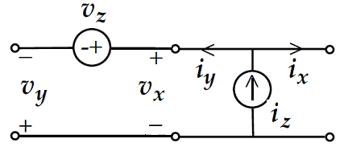
This circuit can be inserted anywhere in the loop, but if you have many feedback paths, the circuit must be added where the different paths join together (otherwise the results will obviously be incorrect). The best you can do is to add this circuit after the summing point of the feedback, on the error signal path. If you do this, the transfer functions that will be calculated will have a physical significance.

Professor Middlebrook, in order to find the transfer functions defined in the theory, regulates the amplitude of v_{IN}, v_{z} and i_{z} simultaneously with some SPICE templates developed by Intusoft.

A simpler and clever application of the GFT has been proposed by Frank Wiedmann: thanks to Frank, the GFT can be applied with any SPICE simulator. The key of Frank Wiedmann’s approach is to perform three AC simulations on the same circuit, each time with a different active source:
- Simulation #1 with v_{z} = 1 (active), u_{i} = 0 (not active) and i_{z} = 0 (not active).
- Simulation #2 with u_{i} = 1 (active), v_{z} = 0 (not active) and i_{z} = 0 (not active).
- Simulation #3 with i_{z} = 1 (active), u_{i} = 0 (not active) and v_{z} = 0 (not active).
It does not matter if u_{i} is a voltage or a current generator.

Obviously, in a linear circuit, the superposition principle can be applied: see in the following paragraphs how the three simulations are wisely mixed together in order to find the transfer functions defined by the theory.

Calculation of H and H∞
The first step is the calculation of H∞. H∞ is the transfer function of the circuit when T, the loop gain, → ∞ or with error signal = 0 (this happens when T → ∞).
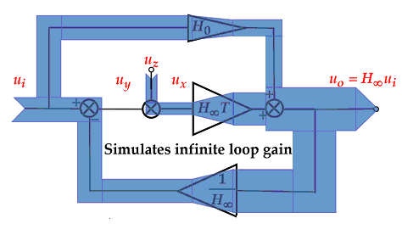
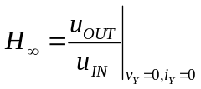where v_{Y} and i_{Y} are the error signals at the summing point.

Let x_{v} be a scaling factor with respect to v_{z} = 1 and x_{i} a scaling factor with respect to i_{z} = 1. x_{i} and x_{v} will be calculated so that the conditions v_{Y} = 0 and i_{Y} = 0 are met.

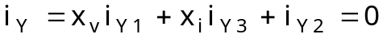

Indices 1, 2 and 3 are for simulations 1, 2 and 3 respectively.
Solve for x_{v} and x_{i} with Cramer’s rule (if 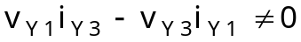)

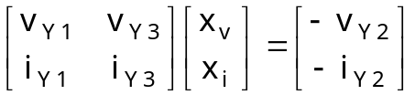

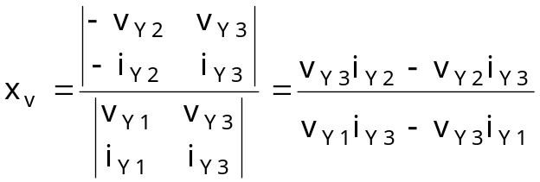
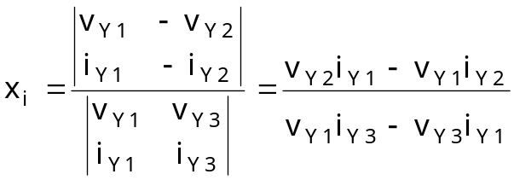

Then H∞ can be easily derived: the scaling factors x_{v} and x_{i} apply to all variables (voltage or current) of the circuit.

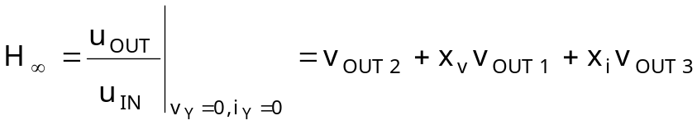
or
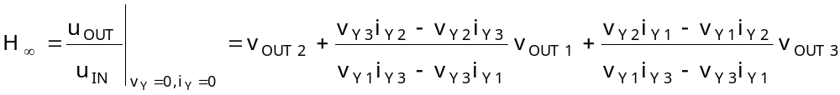

and, by definition, 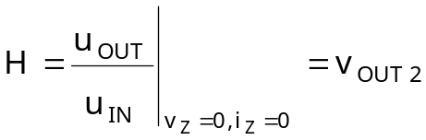
Calculation of T
The next step is the calculation of T. The formulas of Professor Middlebrook are

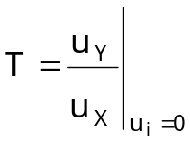(*)
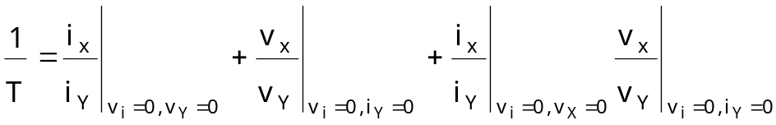

Look at the loop gain definition (*): observe that for the calculation of T, u_{i} = 0 and, therefore, the variables with index 2 will not appear. The simulation #2 isn’t useful for loop gain calculation.

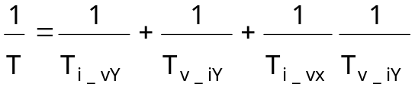

a) 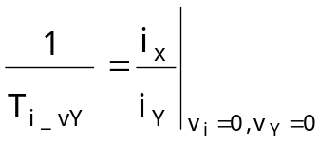

In this case, i_{X} and i_{Y} must be expressed with the condition v_{Y} = 0.

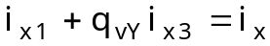
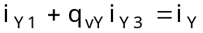
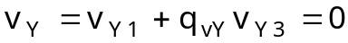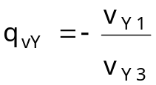

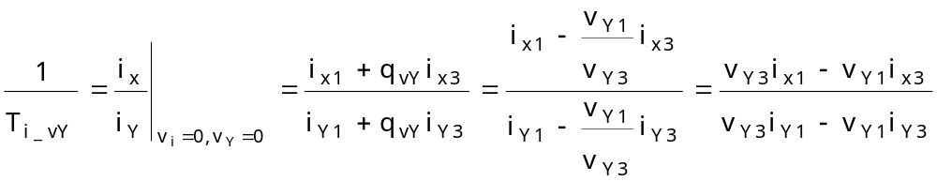

b) 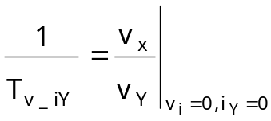

In this case, v_{X} and v_{Y} must be expressed with the condition i_{Y} = 0.

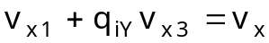
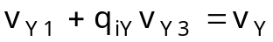
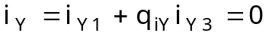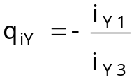

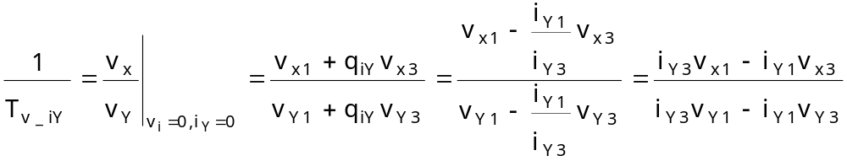

c) 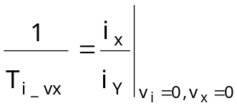

In this case, i_{X} and i_{Y} must be expressed with condition v_{X} = 0.

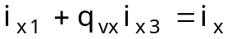
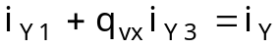

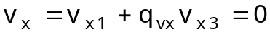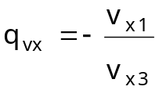

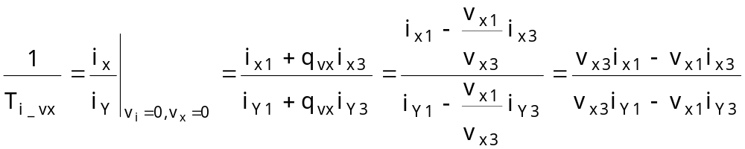

In conclusion, the expression for the loop gain is

A first simplification can be done on the last term:

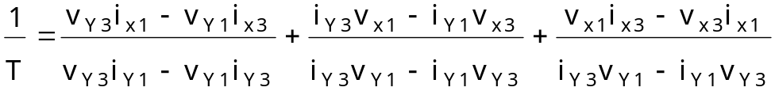

An aid to reduce this complicated formula comes from the topologic relations related to the circuit.

In the first simulation (i_{z} = 0, v_{z} = 1):
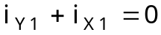 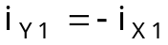 (t1)
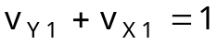

In the third simulation (v_{z} = 0, i_{z} = 1):
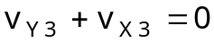 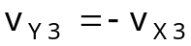 (t2)
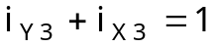

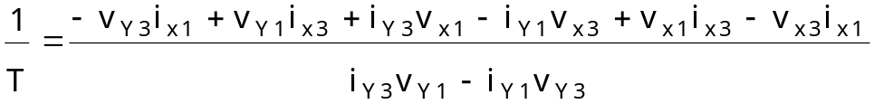

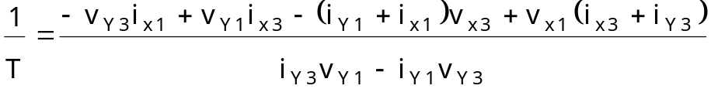

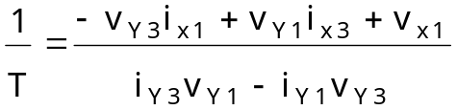

A further simplification can be done with the topologic relations (t1) and (t2):

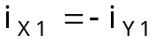
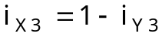

And the expression for the loop gain is simplified:

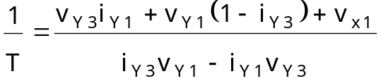

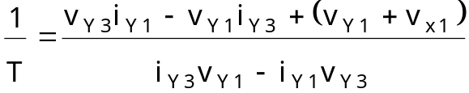

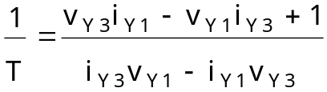

Now, if 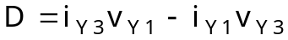 is introduced:

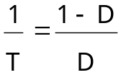

A very nice expression can be written:

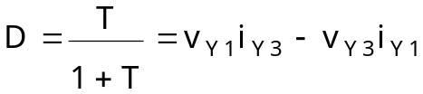

D_{n} derives directly from the GFT (see Middlebrook’s GFT manual):

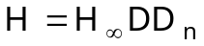

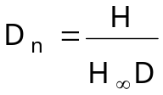

And, after D_{n}, also T_{n} can be calculated:

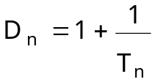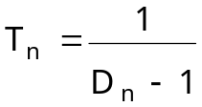

H₀ is a very easy calculation (GFT):

