UrbanAir AI — Market Estimate
Target Market & Sizing (Validated)
Primary beachhead: Hong Kong municipal environmental monitoring + large commercial estates + health/education institutions. Bottom-up validated addressable market ~HKD 95M annual recurring revenue at scale.
Expansion: Greater Bay Area second-tier cities + ESG reporting demand. Asia-Pacific environmental sensor + data services market growing >12% CAGR.
Business Model (Tested with Pilot Customers)
• Hardware: Sell nodes at ~HKD 2,150 (volume) — gross margin 55–60% at scale.
• SaaS: Tiered subscription HKD 650–850 per node per month.
• Additional: Data licensing to insurers/healthtech and government tenders.
5-Year Conservative Financial Projection
Year 1 (2026): 220 nodes → HKD 1.4M revenue, 58% gross margin
Year 2: 780 nodes → HKD 5.8M revenue, 61% gross margin, EBITDA positive
Year 3: 1,800 nodes → HKD 14.2M revenue, 63% gross margin
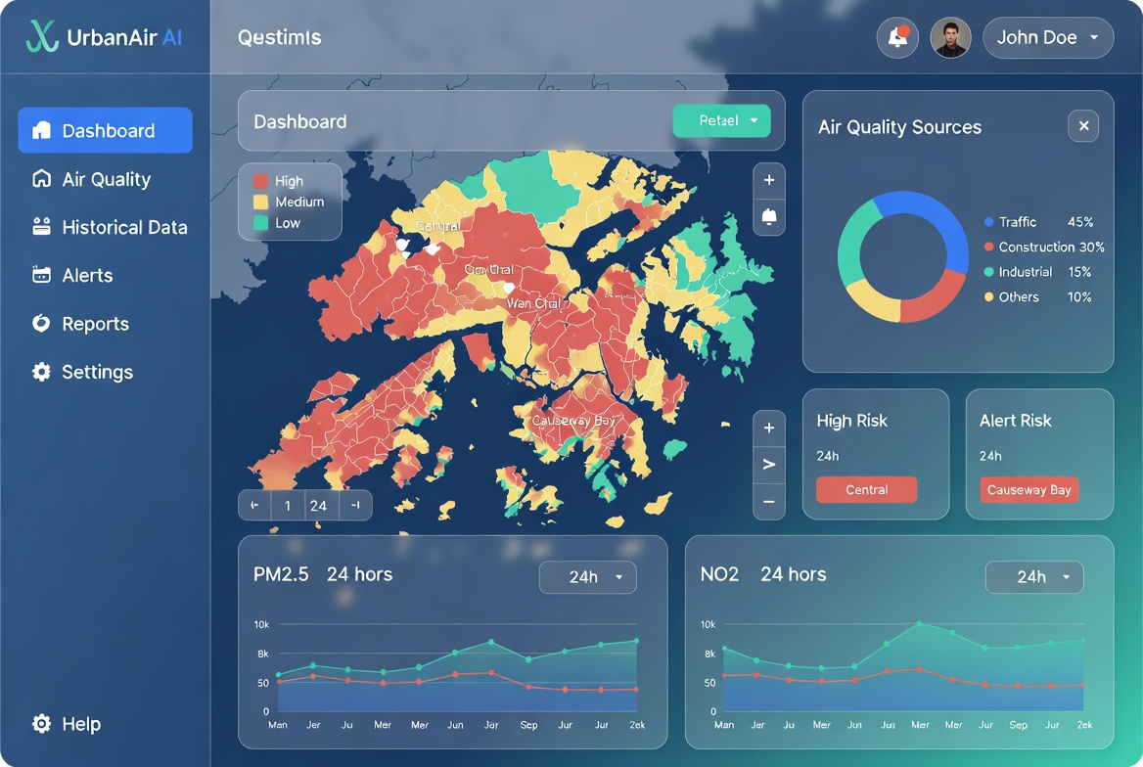
Figure: UrbanAir AI Dashboard — Interactive map with source attribution and alerts

