UrbanAir AI — Startup Team
We are a complete founding team with deep technical expertise, proven commercialization experience, and strong execution velocity.
Prof. Elena K. Lau — Co-founder & CTO
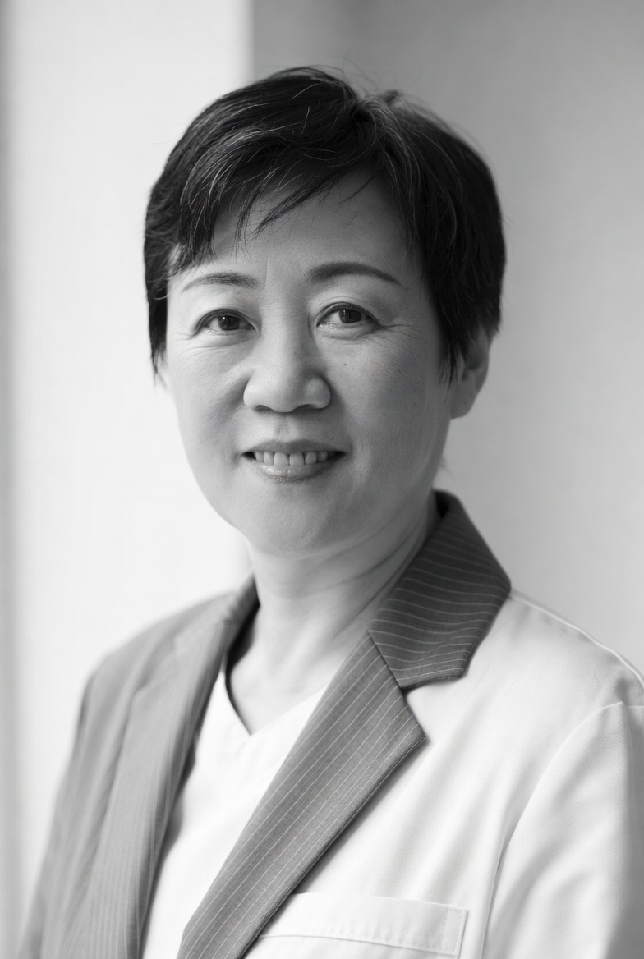
Education: PhD in Electrical Engineering (City University of Hong Kong, 2012), MSc in Electronic Engineering (HKUST), BEng (First Class).
Current: Professor, Department of Electrical Engineering, CityU. PI of multiple RGC and ITVF grants in IoT sensing and edge AI. 85+ publications, h-index 38.
Role: Overall technical vision, hardware architecture, TinyML development, pilot leadership, and IP strategy.
Dr. Marcus Wong — Co-founder & CEO
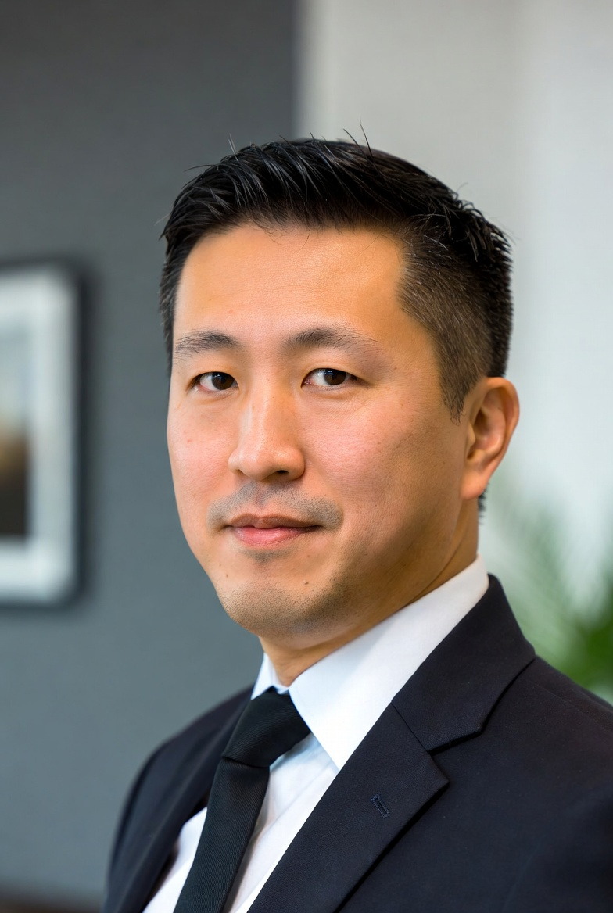
Education: DBA (HK PolyU, 2023), MBA (HKUST), BEng in Computer Engineering (CityU).
Current: Full-time CEO. Previously Founder & CEO of CleanTech Solutions Ltd (CityU incubator, raised HKD 4.2M seed, exited 2025).
Role: Fundraising, government & enterprise partnerships, go-to-market strategy, operations, and investor relations.
Ms. Priya Sharma — Co-founder & CPO
Education: MSc in Human-Computer Interaction (UCL), BEng in Electronic & Information Engineering (CityU).
Current: Full-time CPO. Previously Senior Product Manager at multinational IoT company with 3 successful smart city product launches.
Role: Product roadmap, user research, dashboard & alert UX, customer success, and regulatory positioning.

