Stat 3302 Project: Employee Attrition

Avery Warner

4/20/2020

The dataset consists of 16 continuous and 17 categorical predictors that may contribute to attrition rates. These predictors span ordinal, binomial, count, and rate variables among other types. The response in this data is a binomial Yes or No for whether or not an employee left the company. We are interested in this data because understanding attrition habits can improve a companies retention rates. While some factors that lead to employee attrition are out of others’ control, it may be possible to better understand patterns that lead to employees switching their job. Therefore, this data is worth exploring in order to find out more.

**Scientific Question:** What are some of the factors that lead to employee attrition? What factors, or interaction thereof, are more likely to lead to attrition than others?

# Exploratory Data Analysis

In the following plots the size of the point is determined by the size of the group the respective point represents.

### Logit of the Proportion of Employee Attrition over…

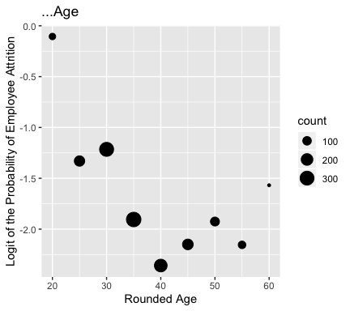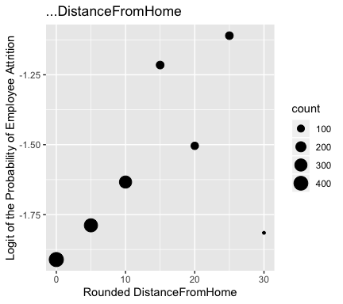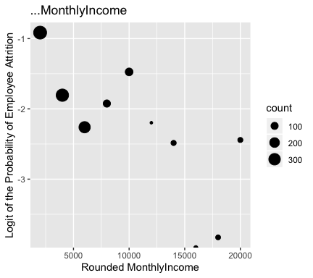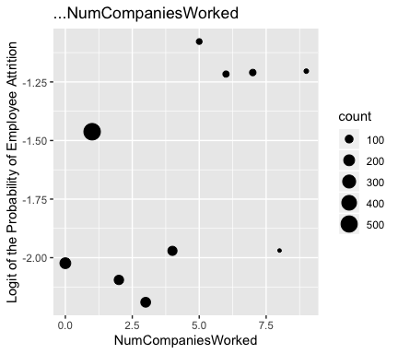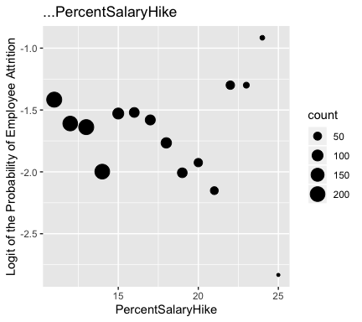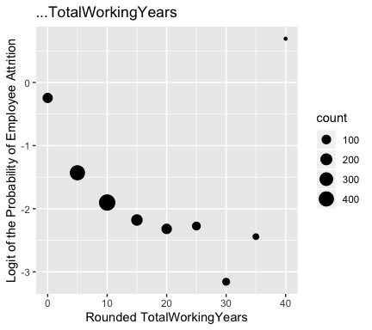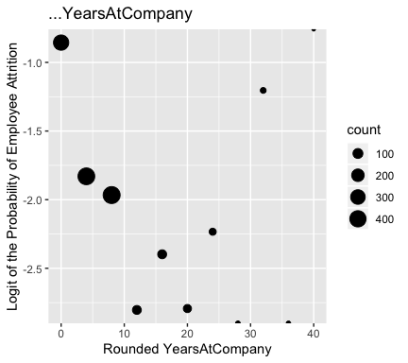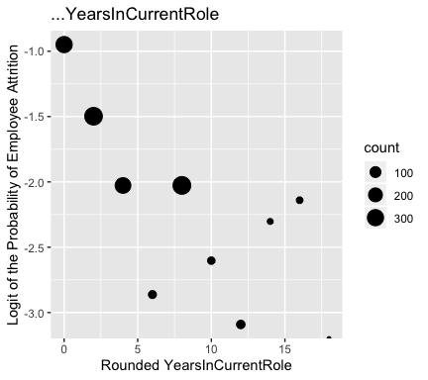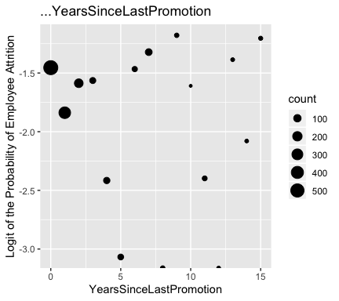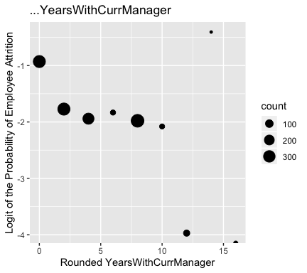

It may be worth looking at the relationship between the logit of the probability and an inverse transformation of TotalWorkingYears due to the exponential trend. However, TotalWorkingYears includes values of ‘0’ and the inverse of these are NaN. The current trend is not too exponential and is still reasonably linear enough to suggest a relaionship.

We can see from these plots that several of the covariates appear to have a linear relationship with the logit of the probability of employee attrition. In particular, age, distance from home, monthly income, total working years, and years in current role look to be associated with the logit. Additionally, the points in these plots that follow the linear trend are typically larger in size and the size is based on the size of the group. This suggests that the other smaller points that deviate from the linear trend may be doing so as a result of their small grouping size, as opposed to failing to follow the same pattern.

Beyond this, it is worth exploring possible interactions between terms that may be taking place:

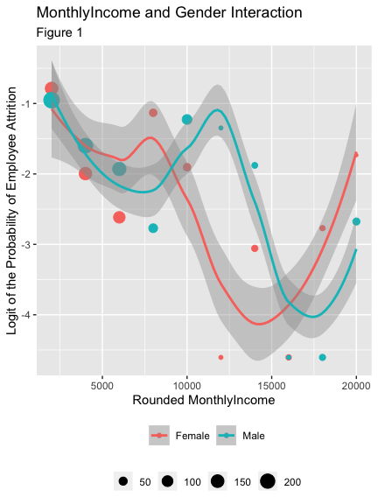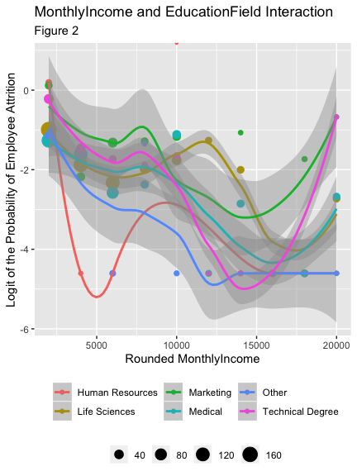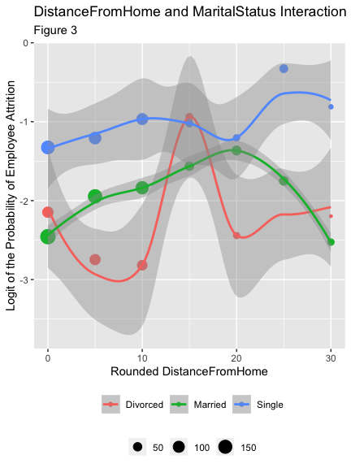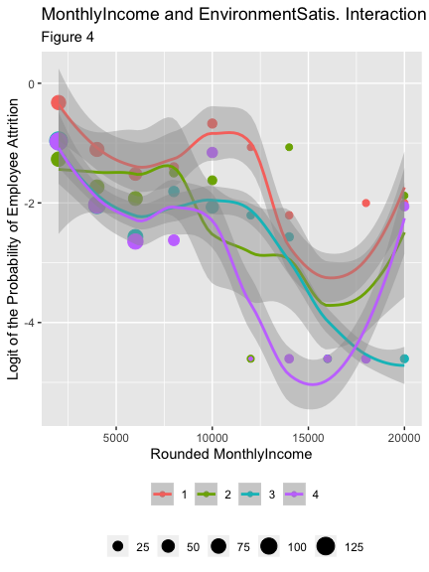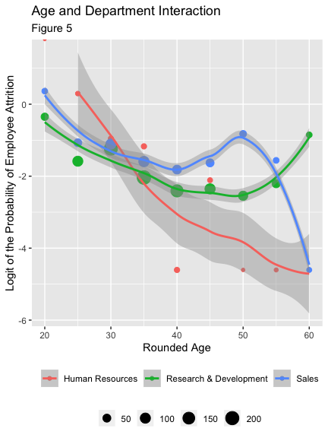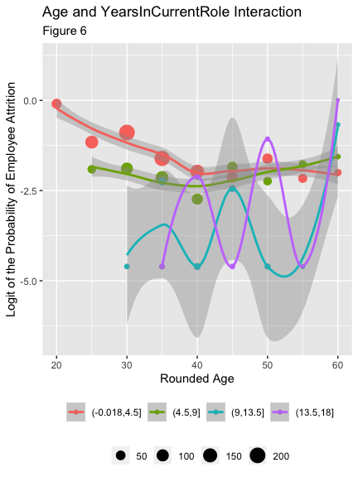

These interaction plots are able to provide us with some more insight into how the covariates may be interacting with each other, or not, in determining the logit of the probability of employee attrition. All of these plots include confidence interval shading at the 50% confidence level.

There does not appear to be much of an interaction in figure 1 between the monthly income of an employee and their gender for the logit of the probability. There may be some linear trends present for each individual gender but the slope of those look to be similar for any linear trend.

When looking at the plot in figure 2 with an employee’s monthly income and their education there doesn’t seem to be any linear associations present. There looks to be a potential cubic trend for the life sciences field, but overall monthly income doesn’t appear to interact with education field for the logit.

In figure 3, an employee’s marital status does appear to be correlated with their distance from home and possess a linear relationship with the logit. However, the slopes for those who are single or married appear to be similar or the some. There isn’t a strong linear relationship for those who have been divorced but the presence of linear relationships across factor values is still promising.

There does appear to be some differing correlations between the logit and monthly income based on am employee’s environment satisfaction (with 1 being the lowest and 4 being the highest) in figure 4. In order words, there is reason to believe there may be different slopes for each different satisfaction level’s relationship between monthly income and logit of the probability of attrition. However, the points are still scattered and scarce enough to prevent certainty.

Another interaction looked at was between the age and department of an employee in figure 5. The interaction plot shows linear relationships between the logit and age for each department. However, the slope of the trend for each department looks to be similar. Therefore, there may not be much of an interaction going on between age and department, but age still looks to be associated with the logit.

Lastly in figure 6, there looks to be some linear trends going on across age for each color, or cut of 4.5 years for years that an employee has been in their current role. Furthermore, the slopes for these linear trends across age appear to be different for each year group. The number of points for the two longest tenured group is small so we can’t be completely confident, but the current look may suggest an interaction between age and years in current role.

# Model Building

Based on our insight from the marginal and joint interaction plots against the logit we begin with an initial model and build off of it using model summaries and ANOVA tables to determine the useful and less impactful variables and interactions in the model. We will use model building to better understand what seems to lead to employee attrition.

### Initial Model

Our initial model will include each continuous main effect that looked to be correlated in the marginal logit plots (age, distance from home, monthly income, years in current role, and total working years). Additionally, we will include an interaction between distance from home and marital status. This interaction showed linear relationships but potentially similar slopes in its plot, so it is worth exploring more.

The only significant covariates in this model are the marital status of single factor variable, age, monthly income, and years in current role (all at $α=0.05$ level) and the intercept at the $α=0.01$ level. Also, the AIC of this model is 1199.4. The analysis of deviance tells us that the sequential addition of each variable is useful in the model except for total working years and the interaction term. Since the individual terms in the interaction are significant we will only drop their interaction, along with the total working years term.

### Remove TotalWorkingYears, add BusinessTravel, remove interaction

Since we have assessed many of the continuous variables with the logit plots it will be helpful to consider the impact of the factor variables in the data when model building. Therefore, our next model includes the business travel factor variable in place of the total working years variable and no interaction between distance from home and marital status.

Every term in this model is significant at the $α=0.05$ level except for the marital status of married factor variable (which has no significance). The AIC of this model is an improvement at 1173.5. Additionally, our analysis of deviance tells us that the addition of each variable in the model is significant. With the impact of each individual factor level in mind we will alter the marital status variable into an isSingle variable that indicates ‘1’ for cases when an employee is single and ‘0’ otherwise.

### Switch out MaritalStatus for isSingle

This model is the same as the previous except for the replacement of the MaritalStatus term with the isSingle variable.

Every term in this model is still significant, including the new isSingle factor variable that remains as significant as the ‘single’ factor level did in the marital status variable. The AIC of this model is a slight improvement at 1172.7. The switching of the factor term was not exactly necessary then but it may help to simplify the model overall. The analysis of deviance continues to signify that the addition of each variable in the model is worthy.

### Add Department

Although the department of an employee didn’t appear to interact with age, the department factor still appears to be associated with the logit of the probability when it is looked at through an employees age. Therefore, we will add the department factor variable into the model.

After adding this variable the AIC drops from 1172 to 1162. However, the only variables that aren’t significant in the model are the two department factor variable that aren’t the baseline. The analysis of deviance shows that the addition of the department variable after all others is still significant in the model. The AIC suggests this model is a better mix of model fit and model complexity but with so many covariate options we would prefer to only choose those that are significant for explaining the logit of the probability of attrition. Another variable to consider is how many companies an employee has worked for. The marginal plot for this variable did not possess a linear relationship with the logit, but there does look to be two separate chunks in the plot. These chunks tell the story that those who have worked at more companies are more likely to leave the current company and, again, work for another company. The other chunk represents those who have worked for less companies and are correspondingly less likely to leave the company.

### Remove Department, add NumCompaniesWorked

This model possess all other covariates as before excpet the department term and includes the number of companies an employee has worked for instead.

The AIC for this model with number of companies worked for instead of department is also at 1162. This time all of the variables are significant in the model, and the deviance analysis confirms that the inclusion of each variable (including NumCompaniesWorked after everything else) is significant in the model.

### Add YearsSinceLastPromotion

Another variable that makes sense to try in the model that could lead to an employee leaving a company in how long it has been since the employee has been promoted. There are several variables with the same theme as this one in YearsAtCompany, YearsInCurrentRole, and YearsWithCurrManager. The marginal plot of years since promotion and the logit doesn’t suggest a strong linear relationship but it is still worth checking if we can explain more of the variability.

The AIC for this model with the addition of YearsSinceLastPromotion variable is 1146.3. This is lower then the model we previously had which is good. All of the variables in this model seem to be significant and the deviance analysis confirms that the addition of YearsSinceLastPromotion seems to be significant in the model. The next variable we would want to look at is JobSatisfaction and see if that variable is significant or not in attrition.

### Add JobSatisfaction as a factor variable

Another factor variable that is worth checking on in the model that was not looked at in the EDA is how satisfied an employee is with their job. It makes sense that an employee who is less satisfied with their job is more likely to leave the company, and vice versa.

When we make JobSatisfaction a factor variable, the AIC in this model becomes 1130.9. Again, the AIC is decreasing which is showing signs of improvement in our model building. All of the variables in the model seem to be significant and the deviance analysis confirms this as well. This model analysis tells us that making JobSatisfaction a factor variable is significant and necessary. To help make understand and interpreting this model easier, we want to see if looking at a specific JobSatisfaction rating has an impact on attrition.

### Replace JobSatisfaction variable with isSatisfied

Since job satisfaction ratings of 2 and 3 (on a scale from 1 to 4) were significant at the $α=0.05$ level and a satisfaction rating of 4 was significant at the $α=0.001$ level we created an isSatisfied term to signal if an employee was either fully satisfied with a rating of 4, or not.

In this model, we replaced JobSatisfaction with isSatisfied. With this switch, our AIC became 1133.6 which is a little higher compared to the AIC in the previous model. Even though the AIC is a bit higher, the deviance analysis confirms that all the variables are significant and neccesary in the model and the model arguably becomes more simple with less overall main effect terms. Even though this is a good model, there are no intereaction terms so the next model would have Age and YearsInCurrentRole as interaction variables to see if there is an interaction between the two and if there is a significance.

### Include interaction between Age and YearsInCurrentRole

Out of the interactions that we looked at in EDA one of the plots that showed potential for an interaction was between age and the number of years an employee has been in their current role. These are two significant variables that we already have in our model, therefore we will add an interaction between them to assess the impact.

In the final model that we created, we included an interaction between Age and YearsInCurrentRole. With this interaction term added, the AIC dropped down to 1119.5. This is the lowest AIC thus far when comaparing to all the other models that were created. All of the variables in this model are highly significant. The analysis of the deviance table support the addition of the interaction term between Age and YearsInCurrentRole, as it is still seen as useful after the addition and variability explained by the prior covariates.

### Add WorkLifeBalance factor variable

Lastly, we consider another factor variable to add into the model. This variable measures on a scale from 1 to 4 what an employee’s work-life balance is. This term is reasonable to consider because those with a less healthy work-life balance may be more inclined to change who they work for. Similarly, those who note a more healthy work-life balance may be less likely to leave a company.

Every variable in this model is significant at least at the $α=0.05$ level, while most are significant at the $α=0.001$ level. Additionally, the analysis of deviance again confirms that the addition of this factor term is useful in the model. The AIC for this model makes another drop to 1110.8. We now have 10 variables in our model and have continued to move are AIC down while maintaining significant variables. We will move forward with this model for diagnostics.

# Model Selection

We choose to move forward with the last model including the DistanceFromHome continuous, isSingle factor, Age continuous and YearsInCurrentRole continuous interaction, MonthlyIncome continuous, BusinessTravel factor, NumCompaniesWorked continuous, YearsSinceLastPromotion continuous, isSatisfied factor, and WorkLifeBalance factor variables. The AIC for this final model is 1110.8. Each term in the model is significant at the $α=0.05$ level, and the analysis of deviance confirms that the sequential inclusion of each covariate in the model is significant (at the $α=0.01$ level). The following table shows what the significance of each covariate in the model is after accounting for the variables that come before it. This deviance analysis for each model helps to understand which terms contribute to the unexplained variability in what leads to an employee leaving a company.

Variable

Significance

DistanceFromHome

0.010

isSingle

0.001

Age

0.001

YearsInCurrentRole

0.001

MonthlyIncome

0.010

BusinessTravel

0.001

NumCompaniesWorked

0.001

YearsSinceLastPromotion

0.001

isSatisfied

0.001

WorkLifeBalance

0.010

Age:YearsInCurrentRole

0.001

# Diagnostics

We will now plot the residuals of our model against several variables in the data that are not included in the model. This is done in order to see if a variable has a (higher order) relationship with the deviance residuals and should be included in the model:

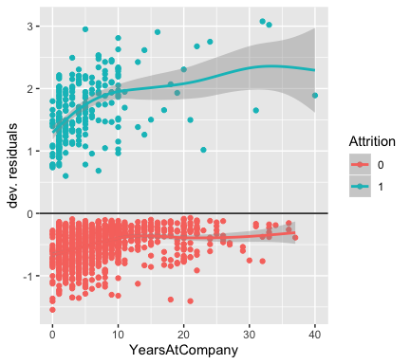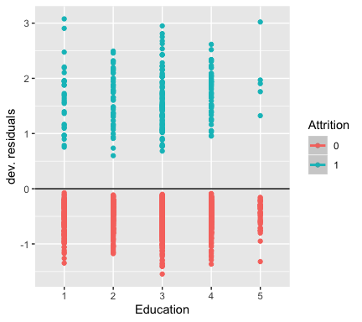

There looks to be a potential linear trend between the number of years an employee has been at the company and the residuals (for those who did end up leaving). This trend could suggest that YearsAtCompany may be useful in the model and is worth looking into. The plot for education versus the residuals is like many of the other plots left out of the report. The variance of the residuals over each factor level looks to be consistent and does not suggest the respective variable (Education in this case) is necessary in the model.

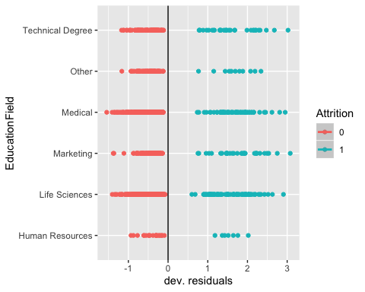

The deviance residuals don’t appear to vary much over the different education fields and so this variable is likely not very useful in the model.

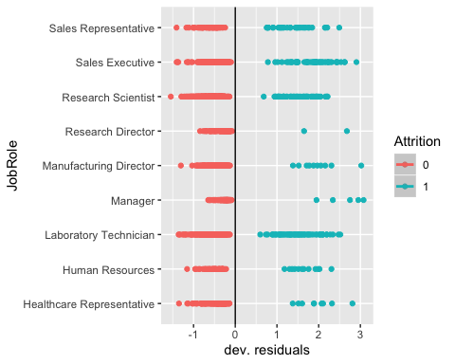

Similarly, the residuals appear to vary consistently over the different job roles. The only noticeable pattern is that those in higher level positions (managers/directors) do not appear to leave the company as often as other roles. The inclusion of a factor variable that separates managers and directors from other roles may be useful in determining employee attrition but we are content with our current model.

We will now add YearsAtCompany into our chosen model in order to assess its impact.

The AIC for this model with all of the prior terms and YearsAtCompany increases from 1110 to 1112. Furthermore, the model summary shows that the only variable that is not significant in the model is this newly added term. The deviance analysis also shows that this YearsAtCompany variable is the only variable not worth adding into the model after considering the impact of prior covariates. Therefore, we will remove this term and keep our other model that seems to explain decent variability.

# Results

An increase in age of one year is associated with a multiplicative change of $e^{−.07132+.01039×YearsInCurrentRole}$ in employee attrition for a given YearsInCurrentRole.