

**F RAUNHOF**  **ER**  **-** DEVELOPMENT **CENTRE**  **FOR**  **X-RAY TECHNOLOGY**  **EZRT**

**AN AREA**  **OF THE**  **MS**  **NHOF**  **ER**  **-**  **INSTITUT**  **FÜR**   **INTEGRI**  **ERTE**  **SCHAL**  **TUNGEN**  **I**  **IS**  **IN**  **COOPERATION**  **WITH**  **D**  **EM**  **FRAUNHOF**  **ER**  **IZF**  **P**

3D-FELDSCANNER

# Systemdokumentation

Preliminary and incomplete version !!!

© 2015 Fraunhofer EZRT All rights reserved.

# Fraunhofer EZRT

**Dr Andreas**  **Jobst**

Fraunhofer Development Center X-ray Technology EZRT Flughafenstraße 75

D – 90768 Fürth, Germany

Phone +49 911 58061-7233

Fax +49 911 58061-7299

E-Mail  [andreas.jobst@iis.fraunhofer.de](mailto:andreas.jobst@iis.fraunhofer.de)

[http://www.iis.fraunhofer.de](http://www.iis.fraunhofer.de/)

## Content

1. **Introduction 4**
2. **Lasersicherheit 5**
3. **Technical data 7** 
   1. Laser 8
   2. Cable 9

**Introduction**

The 3D field scanner is used to obtain 3D data from plants. The measurement technology used is the laser light section method. The components of the sensors are designed in such a way that an Scan of the plants is possible even in sunlight.

The system consists of two light section sensors and software that is used to record the measurement data and reconstruct the data into a 3D point cloud.

## Lasersicherheit

The following safety instructions must be observed:

* + - For the light section measurements, a class 3B laser (classification according to EN 60825) is installed in the sensor (500 mW, 810 nm). The instructions in the accident prevention regulation BGV B2 Laser Radiation (previously VBG 93) and BGI 832 Operation of laser devices ([www.bgfe.de)](http://www.bgfe.de/) must be complied with. Never see directly or with the use of optical instruments in the laser beam, a reflection of the laser or in diffuse stray light of the laser!
    - In particular, the operator must take technical and organisational measures to ensure that no person can be endangered or harmed by the laser radiation.
    - If the sensors are mounted in such a way that the laser warnings cannot be detectedon the sensorhousings, further warnings must be placed in the area of the sensors in such a way that they are easily recognizable. The warnings shown in  Figure  1 to  Figure  3 are affixed to the sensors.

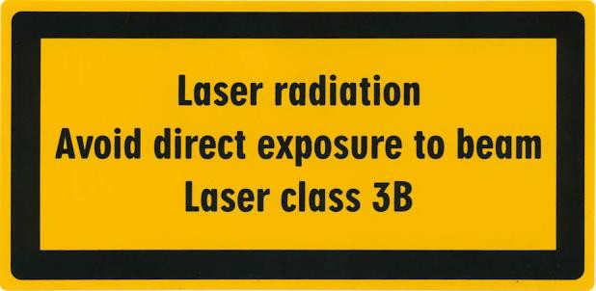

**Figure 1:**  **Laser Warning Shield**  **–** Laser **Safety Class**

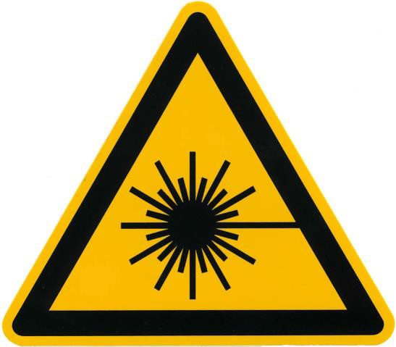

**Figure 2 -**  **Laser Warning Shield**  **-**  **Symbol**  **for** Laser **Radiation**

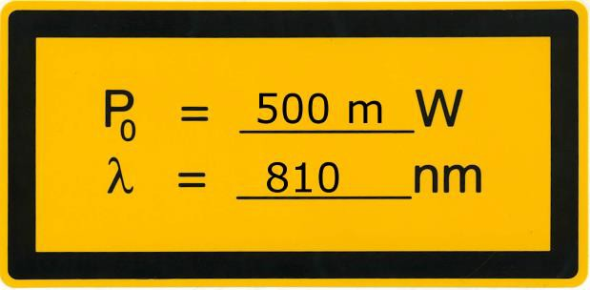

**Figure 3:**  **Laser Warning Shield**  **-**   **Power**  **and**  **Wavelength Data**

## Technical data

Figure  4 shows the beam path of the two sensors. The slightly fanned out blue area represents the camera's field of view. The beam path of the laser is shown as a simple line. The laser is fanned out in a plane perpendicular to the drawing level.

The upper edge of the mounting plate is 2460 mm above the middle of the height measurement range of the two sensors. The fanned outlaser beam is inclinedabout 31.5° relative to the vertical.

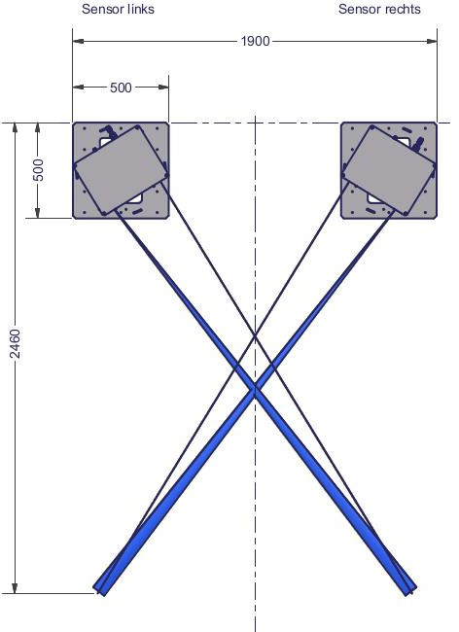

**Figure 4:**  **Drawing** of **the**  **arrangement**  **and** beam path **of**   **the**  **two**  **sensors**

The concept of measurement provides that one of the two sensors (master) is triggered by a encoder signal. The second sensor (slave) is triggered by the first sensor. Both sensors are internally identically wired. The configuration of the camera parameters alone determines which of the two sensors acts as master and which as slave.

|  |  |
| --- | --- |
| Laser |  |
| Lasertyp | L2S-SL-810-500-RS24V-C-15-VL |
| Wavelength | type. 810 nm |
| Diodenleistung | 500 mW |
| Laser class | 3B |
| Opening angle  (Opening angle of the complete fan beam) | 15° |
| Fokusoption | C |
| Light path in the sensor | 265 mm |
| Length of the laser line at the exit window | 70 mm |
| Focus distance to exit window (distance with minimum line width) | 2600 mm |
| Line width at focus distance (minimum line width) | 0,5 mm |
| Tiefenschärfebereich lasers | 500 mm |

All values given in this list are based on manufacturer's specifications or are derived from the construction. Actual values may vary slightly from sensor to sensor due to manufacturing tolerances.

According to the manufacturer, the line width is defined from the reductionofthe intensity of the laser to 1/e2 in relation to the maximum intensity.

Within the depth of field range, the line width is a maximum of √2times the minimum line width.

The sensors are designed in such a way that the switched on laser only radiates under two conditions. At the interlock of the laser (see  Table  2; Pin 1 and 7) must have a voltage of min. 10 V. This may only be the case if no person can be in the beam area of the laser. The laser is triggered by the built-in camera. The consequence of this is that the laser only shines when the camera records data.

### Cable

For the operation of the sensor, the following cables or cables with a comparable specification are recommended.

* + - Sensor-/Aktor-Kabel - SAC-12P-MS/ 5,0-35T SH SCO - 1430064
    - Sensor-/Actor-Cable - SAC-8P- 5.0-PUR/M12FS SH - 1522888
    - GigE cable Cat. 6 S/FTP 1 - 1 (T568B) with RJ45 to RJ45 E-DAT Industry IP67 V1 metal plug housing System Steadytec

**Table 1 -**   **8-pin**  **cable** pin **assignment**

|  |  |
| --- | --- |
| Pin | Description |
| 1 | Kamera Gnd |
| 2 | VCC Camera (24 V) |
| 3 + 4 | Laser Gnd |
| 5 + 7 | Laser VCC (24V) |
| 6 | ISO VCC (24 V) |
| 8 | ISO Gnd |

The voltage 'ISO' applied between pin 6 and pin 8 is necessary for the synchronisation between the two sensors to work.

**Table 2 -**   **12-pin**  **cable**  **pin assignment**

|  |  |  |
| --- | --- | --- |
| Pin | Description | Remark |
| 1 | Monitoring Gnd |  |
| 3 | Diode Current Monitor | optional |
| 5 | Diode Temp | optional |
| 7 | Interlock + |  |
| 10 | Opt. Power Monitor | optional |
| 8 | ISO Gnd |  |
| 2 | ISO_IN0 | Positionssignal |
| 4 | ISO_INC0_N | not in use |
| 6 | ISO_INC0_P | not in use |
| 11 | ISO_INC1_N | not in use |
| 12 | ISO_INC1_P | not in use |
| 9 | - |  |

Relative to 'Monitoring Gnd' (pin 1), various operating states (pin 3, 5 and 10) of the laser can be determined in the form of a voltage. Information on this can be found in the manufacturer's data sheet.

The operation of the laser is activated via a voltage applied between pin 1 and pin 7 (between 10 V and 24 V).

The encoder signal for triggering the master camera is fed in the form of a rectangular torque via ISO_IN0 (pin 2) relative to ISO_Gnd (pin 8). The level of the rectangular signal can be between 5 V and 24 V.