WAHA vs Evolution API
Comparison & recommendation (WhatsApp POC)

Overview
Both POCs share the same Flask product flow: login → QR connect → sync contacts → compose/campaign. Only the WhatsApp engine behind the API differs.

Shared Flask flow
Step | Flow
1 | Login admin / admin123
2 | Connect — start session/instance, scan QR
3 | Contacts — sync from WhatsApp
4 | Compose — free-text message
5 | Campaign — queue send to selected contacts

POC folders & ports
Folder | Engine | Flask app | Engine port
poc/waha-poc/ | WAHA | http://127.0.0.1:5001 | 3000
poc/evolution-poc/ | Evolution API | http://127.0.0.1:5002 | 8080

Admin UIs (screenshots)

WAHA — built-in dashboard
URL: http://127.0.0.1:3000/dashboard/
Auth: Username + password from waha-env/.env; link worker with WAHA_API_KEY.
WAHA dashboard — workers and sessions
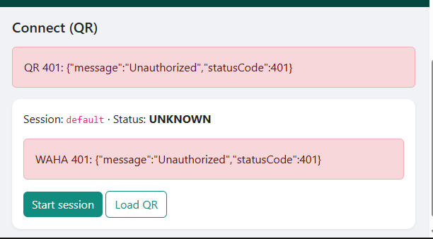

Evolution — Evolution Manager
URL: http://127.0.0.1:8080/manager
Auth: Global API key only (same as EVOLUTION_API_KEY).
Evolution Manager login
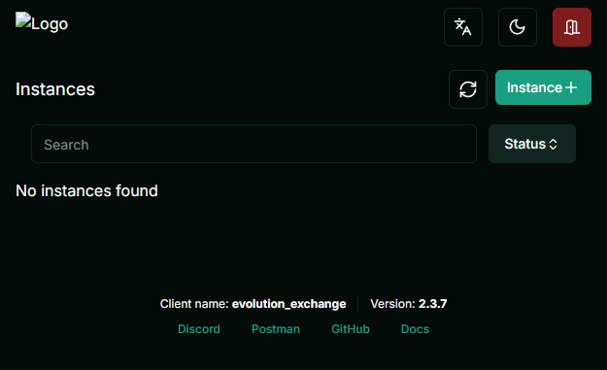

Evolution Manager — instances

Flask demo (both POCs)
Same UX on ports 5001 (WAHA) and 5002 (Evolution): Connect, Contacts, Compose, Campaigns. Use for stakeholder demos; use native UIs for engine debugging.

Side-by-side comparison
Criteria | WAHA | Evolution API
Docker footprint | 1 container (WAHA only) | 3 containers (API + Postgres + Redis)
First-time setup | init-waha.bat + sync API key to Flask .env | Matching API key in compose + .env; longer first pull
Admin login | Username + password + API key for worker | API key only on Manager
Session model | Named sessions (default) | Named instances (default)
QR connect | Works; 422 if QR while STARTING | Works; create/start instance first
Contact sync | Straightforward API in our client | v2 POST findContacts with {"where":{}}
API auth header | X-Api-Key | apikey
Multi-instance / SaaS | Sessions + namespace | Strong fit — DB, Manager, Redis
Best for one number bulk | Excellent | Good
Best for many numbers | Good | Better

POC scorecard
Criteria | WAHA | Evolution
Install time | ~5 min (after Docker) | ~10–15 min (DB + Redis + image)
QR connected | Yes | Yes
Contact sync | Yes | Yes (after POST fix)
Single send | Yes | Yes
Campaign queue | Yes | Yes
Stability (short demo) | Stable | Stable
Docs / ease for devs | Easier (fewer services) | More moving parts
Native admin UX | Workers/sessions dashboard | Polished Manager
Pick for this product | Recommended | Strong alternate

Legal & operations (both)
- Uses WhatsApp Web / Baileys-class linking — not the official Meta Cloud API.
- Free-text is possible but policy and ban risk still apply.
- Use a dedicated test number, rate limits, and opt-in/consent for marketing.
- For compliance-first production, evaluate legacy-cloud-api/ (Cloud API) separately.

Recommendation: what should we use?

Primary choice: WAHA
For one web app, one WhatsApp number, QR login, contact sync, and bulk/campaign sends, WAHA is the better default engine:
- Simpler operations — one Docker service, no Postgres/Redis on a laptop or small VPS.
- Faster onboarding — init-waha.bat + one API key; clear 401 when keys mismatch.
- Enough admin UI — dashboard + Swagger for support staff.
- Lower POC friction after credentials were fixed.

When to choose Evolution instead
- Many WhatsApp instances (multi-tenant) with Manager as ops console.
- Team already on Evolution webhooks or evoapicloud in production.
- Need Evolution ecosystem (chatbots, n8n, etc.) without rebuilding on WAHA.

Decision summary
Question | Answer
Which engine for v1 product? | WAHA
Which Flask POC to demo first? | http://127.0.0.1:5001
Keep Evolution POC? | Yes — reference & multi-instance evaluation
Official Meta path? | Separate decision; see legacy-cloud-api/

Next steps (optional)
- Merge one Flask app + configurable engine (WAHA / EVOLUTION / MOCK).
- Improve Connect page: poll until QR-ready (fix WAHA 422 UX).
- Stakeholder sign-off using this doc + live demo on 5001.
- Production hardening: rotate API keys, HTTPS reverse proxy, secrets not in git.

Generated from poc/COMPARISON.md — WhatsApp POC repository.

